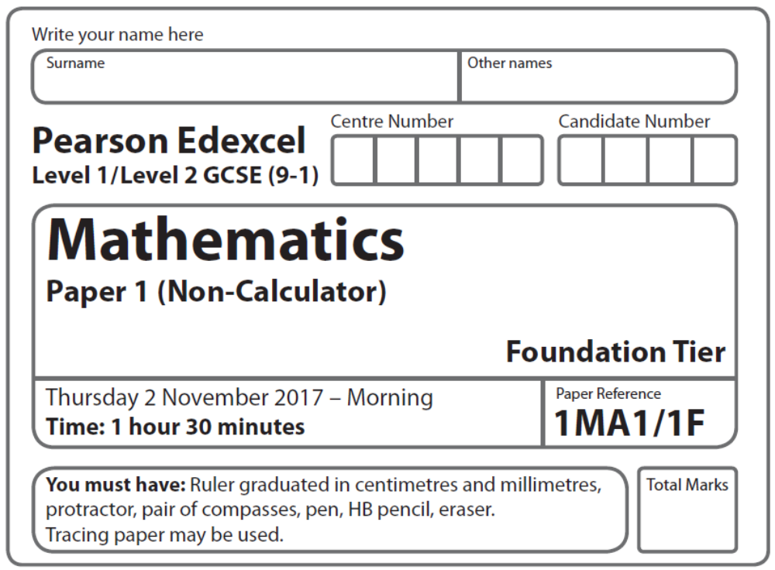
Aiming for 4
Summer 2019 Practice Paper
Instructions
- Use black ink or ball-point pen.
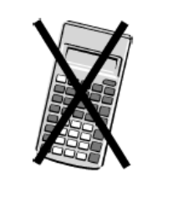
  - Fill in the boxes at the top of this page with your name,
centre number and candidate number.
- Answer all questions.
- Answer the questions in the spaces provided
– there may be more space than you need.
- You must show all your working.
- Diagrams are NOT accurately drawn, unless otherwise indicated.
- Calculators may not be used.

Information
- The total mark for this paper is 80. There are 42 questions.
- Questions have been arranged in an ascending order of mean difficulty, as found by Grade 4 students in the June 2017 and November 2018 examinations
- Questions marked with an asterisk (*) also appear on the Higher Tier paper.
- The marks for each question are shown in brackets
– use this as a guide as to how much time to spend on each question.

Advice
- Read each question carefully before you start to answer it.
- Keep an eye on the time.
- Try to answer every question.
- Check your answers if you have time at the end.
Answer ALL questions.

Write your answers in the spaces provided.

You must write down all the stages in your working.

1 Sammy spins a fair 4-sided spinner.

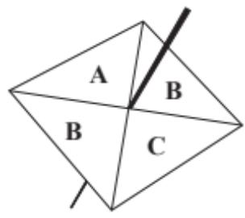

On the probability scale, mark with a cross (×) the probability that the spinner will land on F.

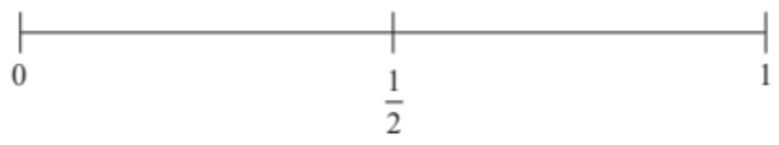
(Total for Question 1 is 1 mark)
___________________________________________________________________________

2 g = 9
h = 4

Work out the value of 2g + 3h

......................................................
(Total for Question 2 is 2 marks)
___________________________________________________________________________

3
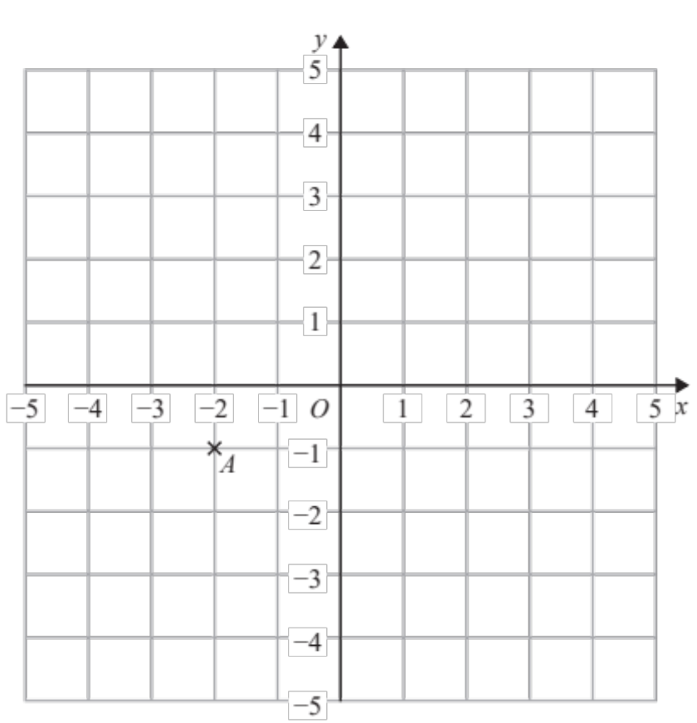
On the grid, mark with a cross (×) the point (2, 3)
Label this point B.
(Total for Question 3 is 1 mark)
___________________________________________________________________________

4 Write 7829 to the nearest 1000

......................................................
(Total for Question 4 is 1 mark)
___________________________________________________________________________

5 Work out 2³

......................................................
(Total for Question 5 is 1 mark)
___________________________________________________________________________

6 There are only apple trees, cherry trees, pear trees and plum trees in an orchard.
The pictogram shows information about the numbers of apple trees, cherry trees and
pear trees in the orchard.

Apple | 
Apple |  |  |   Key:  represents 4 trees
Cherry | 
Pear | 
Plum

There is a total of 30 trees in the orchard.
Complete the pictogram.

(Total for Question 6 is 3 marks)
___________________________________________________________________________

7 Work out 60% of 70.

.......................................................
(Total for Question 7 is 2 marks)
___________________________________________________________________________

8 Work out 3 × 5 + 7

......................................................
(Total for Question 8 is 1 mark)
___________________________________________________________________________

9
Write down the coordinates of point A.

( .......................... , ..........................)
(Total for Question 9 is 1 mark)
___________________________________________________________________________

10 Here are some fractions.

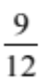 |  | 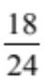 | 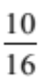 | 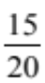

One of these fractions is not equivalent to 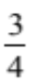
Which fraction?

......................................................
(Total for Question 10 is 1 mark)
___________________________________________________________________________

11 80 people are asked if they like coffee.
48 of these people are women.
61 of the 80 people like coffee.
8 of the men do not like coffee.
Use this information to complete the frequency tree.
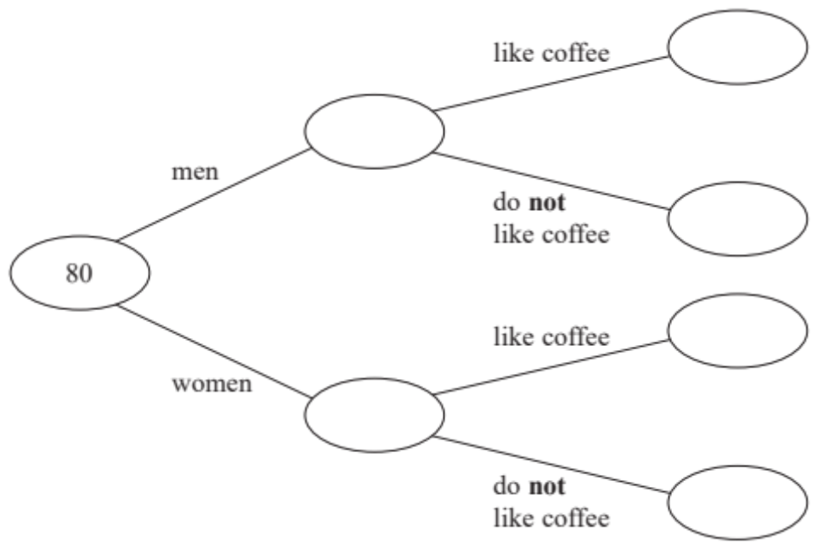

(Total for Question 11 is 3 marks)
___________________________________________________________________________
12 Write brackets ( ) in this statement to make it correct.
7 × 2 + 3 = 35

(Total for Question 12 is 1 mark)
___________________________________________________________________________

13 There are only 7 blue pens, 4 green pens and 6 red pens in a box.
One pen is taken at random from the box.
Write down the probability that this pen is blue.

.......................................................
(Total for Question 13 is 2 marks)
___________________________________________________________________________

14 Write 0.6 as a percentage.

...................................................... %
(Total for Question 14 is 1 mark)
___________________________________________________________________________

15 The scatter graph shows the maximum temperature and the number of hours of sunshine
in fourteen British towns on one day.

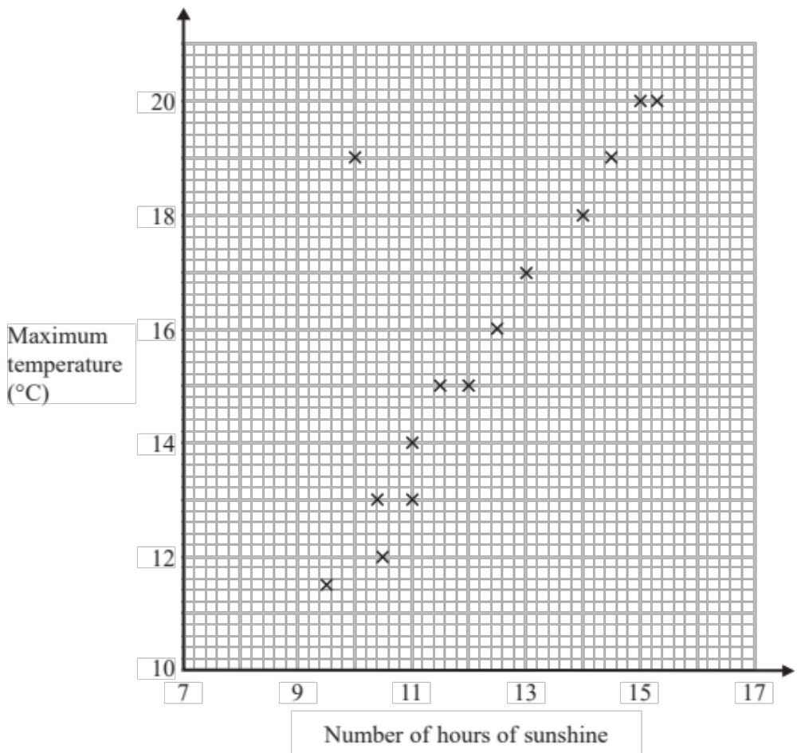

One of the points is an outlier.
(a) Write down the coordinates of this point.

( .......................... , ..........................)
(1)
(b) For all the other points write down the type of correlation.

.......................................................
(1)

On the same day, in another British town, the maximum temperature was 16.4 °C.
(c) Estimate the number of hours of sunshine in this town on this day.

...................................................... hours
(2)

A weatherman says,
“Temperatures are higher on days when there is more sunshine.”
(d) Does the scatter graph support what the weatherman says?
Give a reason for your answer.

......................................................................................................................................................

......................................................................................................................................................
(1)
(Total for Question 15 is 5 marks)
___________________________________________________________________________

16 Work out the value of 2⁴

.......................................................
(Total for Question 16 is 1 mark)
___________________________________________________________________________

17 Fahima buys
2 packets of bread rolls costing £1.50 for each packet
1 bottle of ketchup costing £1.60
3 packets of sausages
Fahima pays with a £10 note.
She gets 30p change.
Fahima works out that one packet of sausages costs £2.30.
Is Fahima right?
You must show how you get your answer.

(Total for Question 17 is 3 marks)
___________________________________________________________________________

18 Write 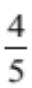 as a percentage.

.......................................................%
(Total for Question 18 is 1 mark)
___________________________________________________________________________

19 A sequence of patterns is made from circular tiles and square tiles


Here are the first three patterns in the sequence.

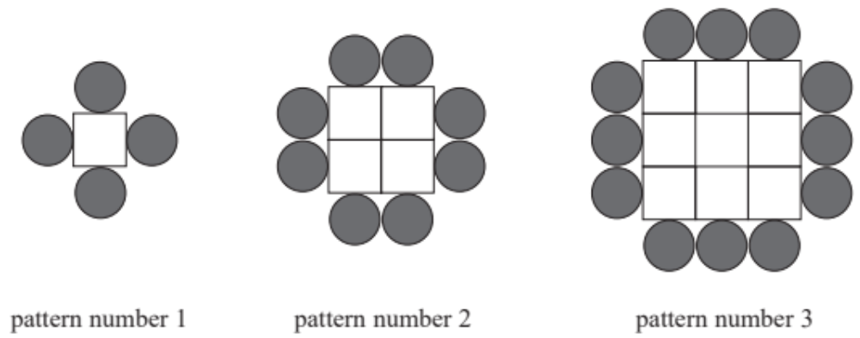

How many circular tiles are needed to make pattern number 20?

.......................................................
(Total for Question 19 is 2 marks)
___________________________________________________________________________

20 Azmol is paid £1500 per month.
He is going to get a 3% increase in the amount of money he is paid.
Work out how much money Azmol will be paid per month after the increase.

£......................................................
(Total for Question 20 is 2 marks)
___________________________________________________________________________

21 Here is a list of numbers.

3 | 5 | 7 | 12 | 15 | 18 | 20

From the list, write down a factor of 10

......................................................
(Total for Question 21 is 1 mark)
___________________________________________________________________________

22 Amina has two bags.
In the first bag there are 3 red balls and 7 green balls.
In the second bag there are 5 red balls and 4 green balls.
Amina takes at random a ball from the first bag.
She then takes at random a ball from the second bag.
Complete the probability tree diagram.

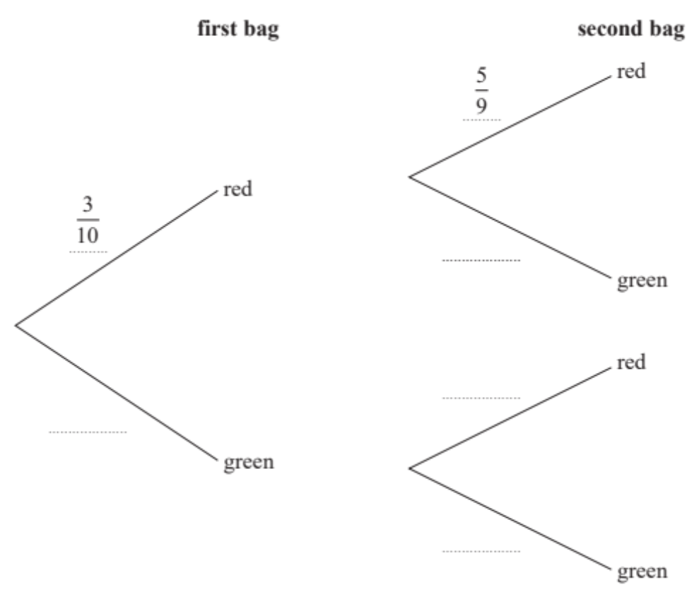

(Total for Question 22 is 2 marks)
___________________________________________________________________________
23 5 tins of soup have a total weight of 1750 grams.
4 tins of soup and 3 packets of soup have a total weight of 1490 grams.
Work out the total weight of 3 tins of soup and 2 packets of soup.

...................................................... grams
(Total for Question 23 is 4 marks)
___________________________________________________________________________

24 Tom uses his lorry to deliver bricks.
You can use this graph to find the delivery cost for different distances.
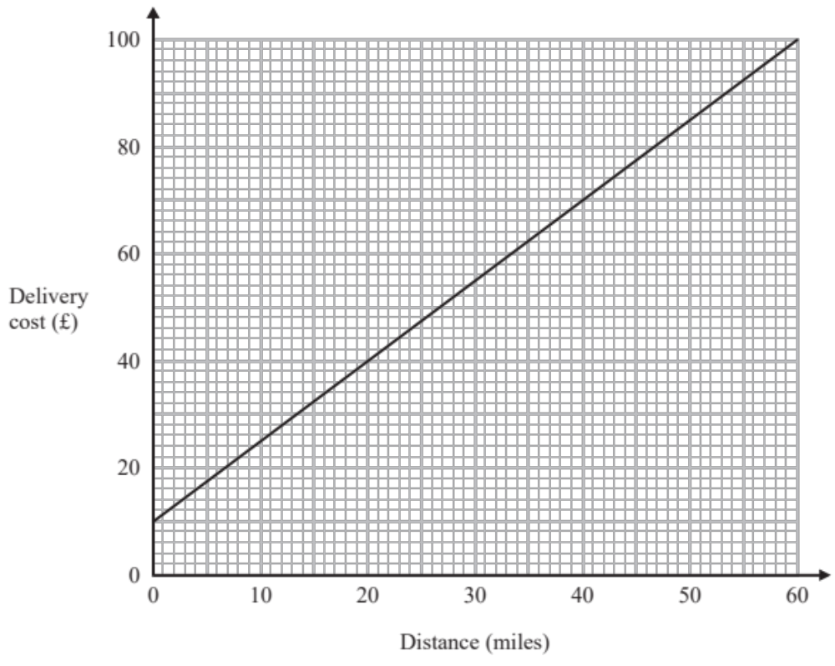

For each delivery, there is a fixed charge plus a charge for the distance.
(a) How much is the fixed charge?

£ ......................................................
(1)

Tom makes two deliveries of bricks.
The distance of one delivery is 20 miles more than the distance of the other delivery.
(b) Work out the difference between the two delivery costs.

£ ......................................................
(2)
(Total for Question 24 is 3 marks)
___________________________________________________________________________
25 − 3 < t ≤ 2

t is an integer.
Write down all the possible values of t.

...............................................................................................
(Total for Question 25 is 2 marks)
___________________________________________________________________________

26 Write the following numbers in order of size.
Start with the smallest number.

0.4 | 0.02 | 0.37 | 0.152 | 0.2

......................................................................................................................................................
(Total for Question 26 is 1 mark)
___________________________________________________________________________

27 Sue has 2 cats.
Each cat eats  of a tin of cat food each day.
Sue buys 8 tins of cat food.
Has Sue bought enough cat food to feed her 2 cats for 14 days?
You must show how you get your answer.

(Total for Question 27 is 3 marks)
___________________________________________________________________________
28 A sequence of patterns is made from circular tiles and square tiles
Here are the first three patterns in the sequence.

How many square tiles are needed to make pattern number 6?

.......................................................
(Total for Question 28 is 2 marks)
___________________________________________________________________________
29 Work out 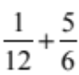

......................................................
(Total for Question 29 is 2 marks)
___________________________________________________________________________

30 Azmol, Ryan and Kim each played a game.
Azmol’s score was four times Ryan’s score.
Kim’s score was half of Azmol’s score.
Write down the ratio of Azmol’s score to Ryan’s score to Kim’s score.

......................................................
(Total for Question 30 is 2 marks)
___________________________________________________________________________

31 Write down two prime numbers that have a sum of 32

........................... , ...........................
(Total for Question 31 is 2 marks)
___________________________________________________________________________

32 Sean works for a company.
His normal rate of pay is £12 per hour.
When Sean works more than 8 hours a day, he is paid overtime for each hour he works
more than 8 hours.
Sean’s rate of overtime pay per hour is 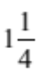 times his normal rate of pay per hour.
On Monday Sean worked for 10 hours.
Work out the total amount of money Sean earned on Monday.

£.......................................................
(Total for Question 32 is 4 marks)
___________________________________________________________________________

33
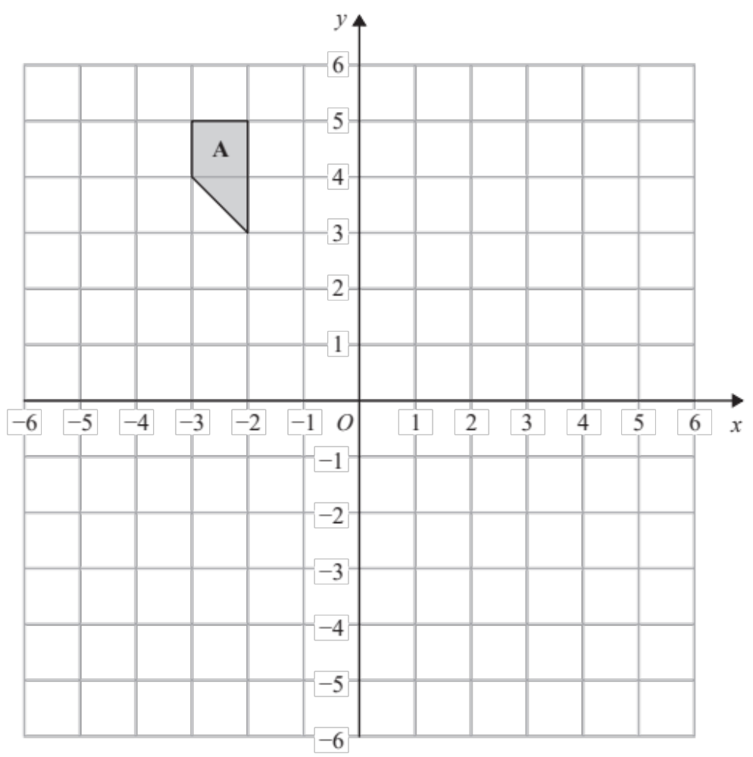

Rotate shape A 180° about (1, 0)
(Total for Question 33 is 2 marks)
___________________________________________________________________________

34 Work out 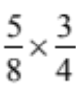

.......................................................
(Total for Question 34 is 1 mark)
___________________________________________________________________________

35 80 people are asked if they like coffee.
48 of these people are women.
61 of the 80 people like coffee.
8 of the men do not like coffee.

One of the people who like coffee is chosen at random.
Find the probability that this person is a woman.

......................................................
(Total for Question 35 is 2 marks)
___________________________________________________________________________

36 Work out 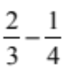

.......................................................
(Total for Question 36 is 2 marks)
___________________________________________________________________________

37 Write 7.264 51 correct to 3 decimal places.

.......................................................
(Total for Question 37 is 1 mark)
___________________________________________________________________________

38 Express 56 as the product of its prime factors.

.......................................................
(Total for Question 38 is 2 marks)
___________________________________________________________________________

39 Sammy spins a fair 4-sided spinner.

On the probability scale, mark with a cross (×) the probability that the spinner will land on B.

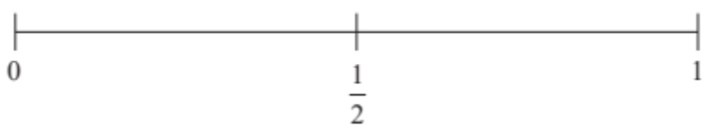
(Total for Question 39 is 1 mark)
___________________________________________________________________________

40 Here are a triangle and a rectangle.

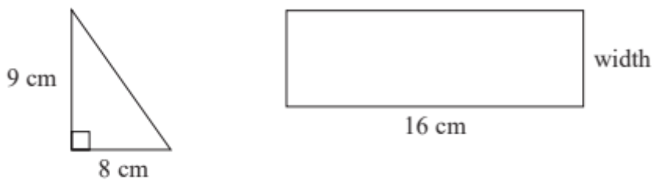

The area of the rectangle is 6 times the area of the triangle.
Work out the width of the rectangle.

...................................................... cm
(Total for Question 40 is 4 marks)
___________________________________________________________________________

41 Simplify 7 × e × f × 8

.......................................................
(Total for Question 41 is 1 mark)
___________________________________________________________________________

42
On the grid, draw the line with equation x = −4
(Total for Question 42 is 1 mark)

TOTAL FOR PAPER IS 80 MARKS

BLANK PAGE

