**Over-lap Questions June 2019 Paper 1**

**22/1** There are only blue cubes, red cubes and yellow cubes in a box.

The table shows the probability of taking at random a blue cube from the box.

|  |  |  |  |
| --- | --- | --- | --- |
| **Colour** | blue | red | yellow |
| **Probability** | 0.2 |  |  |

The number of red cubes in the box is the same as the number of yellow cubes in the box.

(*a*)Complete the table.

**(2)**

There are 12 blue cubes in the box.

(*b*)Work out the total number of cubes in the box.

.......................................................

**(2)**

**_______________________________________________________________________________________**

**24/3** Find the highest common factor (HCF) of 72 and 90

.......................................................

**(2)**

**_______________________________________________________________________________________**

**23/2** Deon needs 50 g of sugar to make 15 biscuits.

She also needs three times as much flour as sugar

two times as much butter as sugar

Deon is going to make 60 biscuits.

(*a*)Work out the amount of flour she needs.

....................................................... g

**(3)**

Deon has to buy all the butter she needs to make 60 biscuits.

She buys the butter in 250 g packs.

(*b*)How many packs of butter does Deon need to buy?

.......................................................

**(2)**

**_______________________________________________________________________________________**

**25/4** The diagram shows the plan, front elevation and

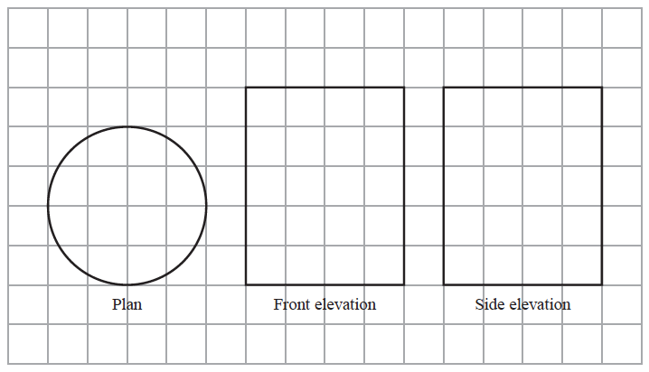

side elevation of a solid shape, drawnon a centimetre grid.

In the space below, draw a sketch of the solid shape.

Give the dimensions of the solid on your sketch.

**(2)**

**_______________________________________________________________________________________**

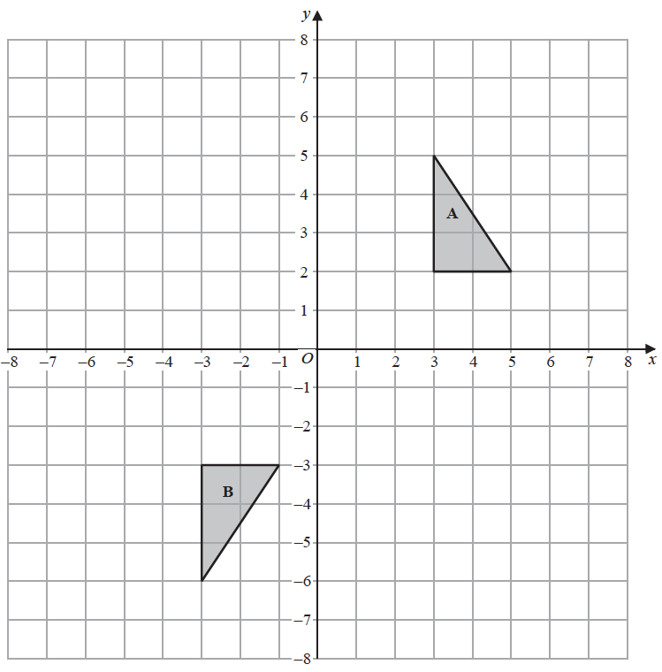

**26/5**

Shape **A** can be transformed to shape **B**

by a reflection in the *x*-axis followed by a translation



Find the value of *c* and the value of *d*.

*c* = .............................................

*d* = ..............................................

**(3)**

**27/6** A shop sells packs of black pens, packs of red pens and packs of green pens.

There are 2 pens in each pack of black pens

5 pens in each pack of red pens

6 pens in each pack of green pens

On Monday,

|  |  |  |  |  |  |
| --- | --- | --- | --- | --- | --- |
| number of packs  of black pens sold | : | number of packs  of red pens sold | : | number of packs  of green pens sold | = 7 : 3 : 4 |

A total of 212 pens were sold.

Work out the number of green pens sold.

.......................................................

**(4)**

**_______________________________________________________________________________________**

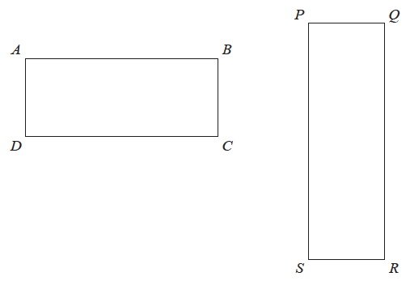

**28/7** Here are two rectangles.

*QR* = 10 cm

*BC* = *PQ*

The perimeter of *ABCD* is 26 cm

The area of *PQRS* is 45 cm2

Find the length of *AB*.

....................................................... cm

**(4)**

**TOTAL FOR PAPER IS 24 MARKS**