**Over-lap Questions June 2019 Paper 2**

**20/1** (*a*)Solve 14*n* > 11*n* + 6

.......................................................

**(2)**

(*b*)On the number line below, show the set of values of *x* for which –2 < *x* + 3 ⩽ 4



**(3)**

**_______________________________________________________________________________________**

**21/2** On the grid below, draw the graph of *y* = 2*x* – 3 for values of *x* from –2 to 4

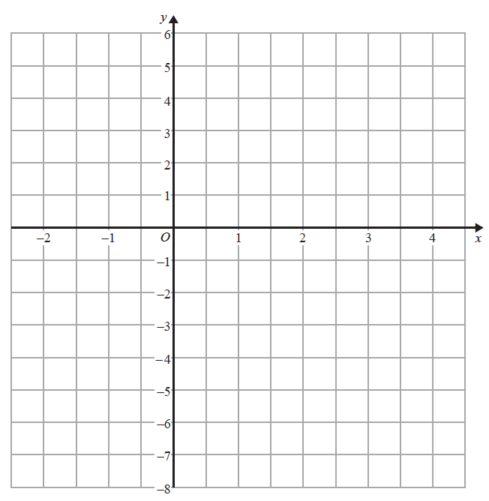

**(3)**

**22/3** Hannah is planning a day trip for 195 students.

She asks a sample of 30 students where they want to go.

Each student chooses one place.

The table shows information about her results.

|  |  |
| --- | --- |
| **Place** | **Number of students** |
| Theme Park | 10 |
| Theatre | 5 |
| Sports Centre | 8 |
| Seaside | 7 |

(i) Work out how many of the 195 students you think will want to go to the Theme Park.

.......................................................

**(2)**

(ii) State any assumption you made **and** explain how this may affect your answer.

......................................................................................................................................................

......................................................................................................................................................

......................................................................................................................................................

**(1)**

**_______________________________________________________________________________________**

**25/6** Sally used her calculator to work out the value of a number *y*.

The answer on her calculator display began

8.3

Complete the error interval for *y*.

............................ ⩽ *y* < ............................

**(2)**

**_______________________________________________________________________________________**

**23/4** A container is in the shape of a cuboid.

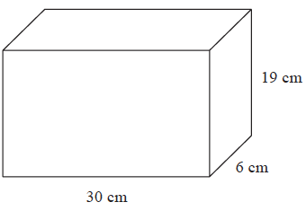

The container is full of water.



A cup holds 275 m*l* of water.

What is the greatest number of cups that can be completely filled with water from the container?

.......................................................

**(4)**

**_______________________________________________________________________________________**

**24/5** *ABC* is a right-angled triangle.

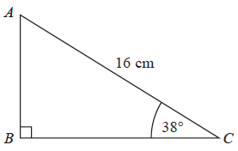

Calculate the length of *AB*.

Give your answer correct to 2 decimal places.

.......................................................cm

**(2)**

**_______________________________________________________________________________________**

**26/7** £360 is shared between Abby, Ben, Chloe and Denesh.

The ratio of the amount Abby gets to the amount Ben gets is 2 : 7

Chloe and Denesh each get 1.5 times the amount Abby gets.

Work out the amount of money that Ben gets.

£.......................................................

**(4)**

**_______________________________________________________________________________________**

**_______________________________________________________________________________________**

**27/8** (*a*)Write 0.00562 in standard form.

.......................................................

**(1)**

(*b*)Write 1.452 × 103 as an ordinary number.

.......................................................

**(1)**

**_______________________________________________________________________________________**

**TOTAL FOR PAPER IS 25 MARKS**