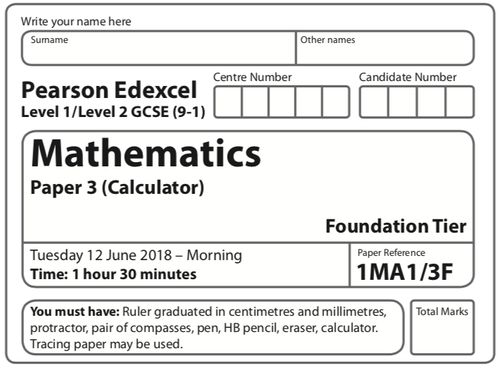
Aiming for 4
Autumn 2019 Practice Paper
Instructions
- Use black ink or ball-point pen.
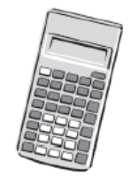
  - Fill in the boxes at the top of this page with your name,
centre number and candidate number.
- Answer all questions.
- Answer the questions in the spaces provided
– there may be more space than you need.
- You must show all your working.
- Diagrams are NOT accurately drawn, unless otherwise indicated.
- Calculators may be used.
- If your calculator does not have a π button, take the value of π to be 3.142
unless the question instructs otherwise.
Information
- The total mark for this paper is 80. There are 42 questions.
- Questions have been arranged in an ascending order of mean difficulty, as found by all students in the June 2019 examinations
- The marks for each question are shown in brackets
– use this as a guide as to how much time to spend on each question.
Advice
- Read each question carefully before you start to answer it.
- Keep an eye on the time.
- Try to answer every question.
- Check your answers if you have time at the end.

Answer ALL questions.

Write your answers in the spaces provided.

You must write down all the stages in your working.

1 The table shows the distance, in kilometres, from London to each of five cities.

City | Distance (km)
Rio de Janeiro | 9280
New York | 5567
Manila | 10 734
Sydney | 16 983
Kolkata | 7962

(a) Which of the five cities is seven thousand nine hundred and sixty two kilometres
from London?

.......................................................
(1)

(b) Write the number 9280 in words.

......................................................................................................................................................
(1)

(c) Which of the five cities is nearest to London?

.......................................................
(1)
(Total for Question 1 is 3 marks)
___________________________________________________________________________

2 The pictogram shows information about the number of naan breads sold in a restaurant
each day from Wednesday to Saturday.

Wednesday |  |  |   represents  8 naan  breads
Thursday | 
Friday | 
Saturday | 
Sunday

How many naan breads were sold on Wednesday?

.......................................................
(Total for Question 2 is 1 mark)
___________________________________________________________________________

3 Write 478 to the nearest hundred.

.......................................................
(Total for Question 3 is 1 mark)
___________________________________________________________________________

4
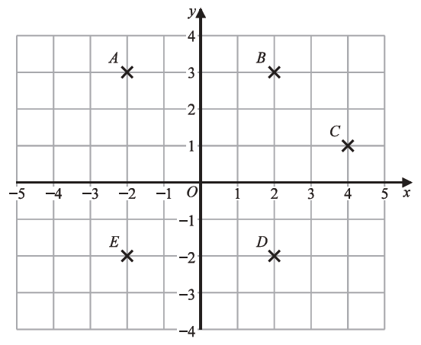

(a) Write down the coordinates of point B.

(.................................. , ..................................)
(1)

(b) Write down the letter of the point with coordinates (2, −2)

.......................................................
(1)
(Total for Question 4 is 2 marks)
___________________________________________________________________________

5 You can use this rule to work out the total hire charge, in pounds (£), for hiring a 3D printer for a number of weeks.

Total hire charge (£) = number of weeks × 70 + 50

Mia wants to hire a 3D printer for 4 weeks.
Work out the total hire charge.

£.......................................................
(Total for Question 5 is 2 marks)
___________________________________________________________________________
6 Write down a multiple of 8 that is between 41 and 60

.......................................................
(Total for Question 6 is 1 mark)
___________________________________________________________________________

7 The table shows the costs of sending a parcel by the Express service and by the Rapid service.

Type of service | Cost
Express | £15.25
Rapid | £35.38

Brendan has to send 12 parcels.
It will be cheaper to send the parcels by the Express service than by the Rapid service.

How much cheaper?

.......................................................
(Total for Question 7 is 1 mark)
___________________________________________________________________________

8 The first term of a sequence of numbers is 24
The term-to-term rule of this sequence is ‘add 8’

Josie says,

“No number in this sequence is in the 5 times table.”

Give an example to show that Josie is wrong.

.......................................................
(Total for Question 8 is 1 mark)
___________________________________________________________________________

9 Here is a list of eight numbers.

10 | 23 | 27 | 30 | 42 | 52 | 74 | 81

From the list, write down a factor of 50

.......................................................
(Total for Question 9 is 1 mark)
___________________________________________________________________________

10 Write 19% as a fraction.

.......................................................
(Total for Question 10 is 1 mark)
___________________________________________________________________________

11 Write the number 16983 correct to the nearest thousand.

.......................................................
(Total for Question 11 is 1 mark)
___________________________________________________________________________

12 Write down the value of the 7 in 10734

.......................................................
(Total for Question 12 is 1 mark)
___________________________________________________________________________

13 Imran throws an ordinary fair dice.

(a) On the probability scale, mark with a cross (×) the probability that the dice will land
on 10
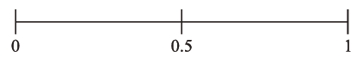
(1)
(b) On the probability scale, mark with a cross (×) the probability that the dice will land
on an odd number.

(1)
(Total for Question 13 is 2 marks)
___________________________________________________________________________
14 Work out 20% of 80

.......................................................
(Total for Question 14 is 2 marks)
___________________________________________________________________________

15 (a) Work out the value of 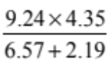

Give your answer as a decimal.
Write down all the figures on your calculator display.

.......................................................
(2)

(b) Give your answer to part (a) correct to 2 significant figures.

.......................................................
(1)

(Total for Question 15 is 3 marks)
___________________________________________________________________________

16 Simplify 4e + 6f + 7e − f

.......................................................
(Total for Question 16 is 2 marks)
___________________________________________________________________________

17 You can use this rule to work out the total hire charge, in pounds (£), for hiring a 3D printer for a number of weeks.

Total hire charge (£) = number of weeks × 70 + 50

Zahir hires a 3D printer.
The total hire charge is £680

For how many weeks does Zahir hire the 3D printer?

....................................................... weeks
(Total for Question 17 is 2 marks)
___________________________________________________________________________

18 Sandeep has £12 to spend on pencils.
Each pencil costs 45 pence.

Sandeep buys as many pencils as he can.

Work out how much change Sandeep should get.

(Total for Question 18 is 3 marks)
___________________________________________________________________________

19 Here is the gauge for the fuel tank of a car.

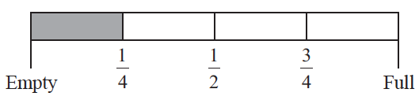

The fuel tank holds 52 litres of fuel when the tank is full.
The tank is  full of fuel.
Work out how many more litres of fuel are needed to fill the tank.

....................................................... litres
(Total for Question 19 is 3 marks)
___________________________________________________________________________

20 Here is a pentagon.

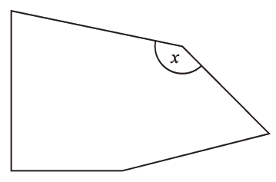

acute | obtuse | reflex | right

Write down the word from the box that describes the angle marked x.

....................................................... angle
(Total for Question 20 is 1 mark)
___________________________________________________________________________

21 Expand w(w + 3)

.......................................................
(Total for Question 21 is 1 mark)
___________________________________________________________________________

22 Here is a list of eight numbers.

10 | 23 | 27 | 30 | 42 | 52 | 74 | 81

From the list, write down a square number

.......................................................
(Total for Question 22 is 1 mark)
___________________________________________________________________________

23 Bill has 400 counters in a bag.

He gives
35 of the counters to Sameena
50 of the counters to Henry
75 of the counters to Lucas

What fraction of the 400 counters is left in Bill’s bag?
Give your fraction in its simplest form.

.......................................................
(Total for Question 23 is 3 marks)
___________________________________________________________________________

24 The first term of a sequence of numbers is 24
The term-to-term rule of this sequence is ‘add 8’

Is 85 a number in this sequence?
Give a reason for your answer.

......................................................................................................................................................

......................................................................................................................................................
(Total for Question 24 is 1 mark)
___________________________________________________________________________

25 Solve 3f − 5 = 11

f = .......................................................
(Total for Question 25 is 2 marks)
___________________________________________________________________________

26

Find the coordinates of the midpoint of AC.

(.................................. , ..................................)
(Total for Question 26 is 2 marks)
___________________________________________________________________________

27 There are four types of counter in a bag.
The table shows the number of each type of counter in the bag.

Type of counter | red circle | green circle | red square | green square
Number of counters | 16 | 26 | 11 | 7

There are more green counters than red counters.
How many more?

.......................................................
(Total for Question 27 is 2 marks)
___________________________________________________________________________

28 Here is a list of eight numbers.

10 | 23 | 27 | 30 | 42 | 52 | 74 | 81

From the list, write down a prime number.

.......................................................
(Total for Question 28 is 1 mark)
___________________________________________________________________________

29 The diagram shows kite ABCD.
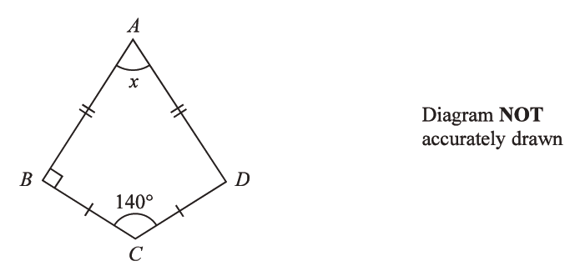

Work out the size of the angle marked x.

....................................................... °
(Total for Question 29 is 2 marks)
___________________________________________________________________________

30 Ali, Ben and Cathy share an amount of money in the ratio 6 : 9 : 10
What fraction of the money does Ben get?

.......................................................
(Total for Question 30 is 2 marks)
___________________________________________________________________________
31 Write down the mathematical name of this polygon.


.......................................................
(Total for Question 31 is 1 mark)
___________________________________________________________________________

32 There are some ice lollies in a freezer.
The flavour of each ice lolly is banana or strawberry or mint or chocolate.

Julius takes at random an ice lolly from the freezer.

The table shows the probabilities that the flavour of the ice lolly that Julius takes is banana or strawberry or chocolate.

Flavour | banana | strawberry | mint | chocolate
Probability | 0.35 | 0.32 |  | 0.12

Work out the probability that the flavour of the ice lolly that Julius takes is either strawberry or mint.

.......................................................
(Total for Question 32 is 3 marks)
___________________________________________________________________________

33 Change 1.5 kilometres to metres.

....................................................... metres
(Total for Question 33 is 1 mark)
___________________________________________________________________________

34 Liz goes on holiday to South Africa.

Liz wants to change £850 into South African rand.
She wants to get as many 200 rand notes as possible.

The exchange rate is £1 = 18.53 rand.

Work out the greatest number of 200 rand notes that Liz can get for £850

.......................................................
(Total for Question 34 is 3 marks)
___________________________________________________________________________

35 E = {1, 2, 3, 4, 5, 6, 7, 8, 9}
A = {1, 5, 6, 8, 9}
B = {2, 6, 9}

E
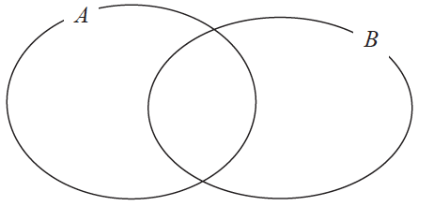

Complete the Venn diagram to represent this information.

(Total for Question 35 is 3 marks)
___________________________________________________________________________

36 Complete the table of values for y = 1 + 5x − x²

x | −1 | 0 | 1 | 2 | 3 | 4 | 5 | 6
y |  | 1 |  | 7 | 7 |  | 1

(Total for Question 36 is 2 marks)
___________________________________________________________________________

37 Here is a rectangle.

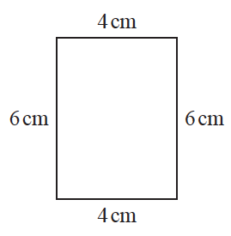

The 6-sided shape below is made from two of these rectangles.

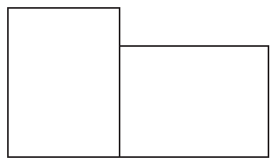

Work out the perimeter of this 6-sided shape.

....................................................... cm
(Total for Question 37 is 3 marks)
___________________________________________________________________________
38 The table shows information about the numbers of points scored by 30 students in a quiz.

Number of points | Frequency
0 | 4
1 | 3
2 | 7
3 | 5
4 | 6
5 | 5

Work out the total number of points scored.

.......................................................
(Total for Question 38 is 2 marks)
___________________________________________________________________________

39 Anjali travels from Beijing to Shanghai by train.

The train leaves Beijing at 07 25
The train arrives in Shanghai at 13 15 the same day.

Work out how long the train takes to travel from Beijing to Shanghai.
Give your answer in hours and minutes.

............................ hours ............................ minutes
(Total for Question 39 is 2 marks)
___________________________________________________________________________

40 Karl has 5700 bricks.
He wants to put all the bricks into crates.

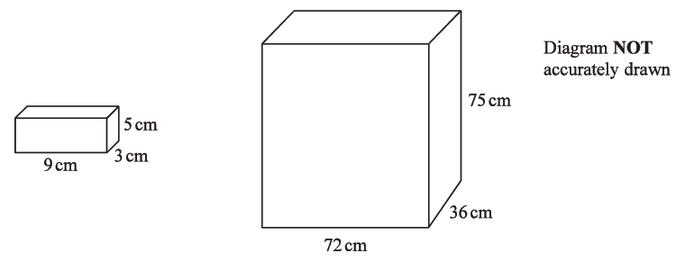

Each brick is a cuboid measuring 9 cm by 3 cm by 5 cm.

Each crate is a cuboid measuring 72 cm by 36 cm by 7 cm.

Karl has 4 crates.

Is there enough room in the 4 crates for 5700 bricks?
Show your working clearly.

(Total for Question 40 is 4 marks)
___________________________________________________________________________

41 A football team played 55 games.
Each game was won, drawn or lost.

number of games won: number of games drawn: number of games lost = 6 : 3 : 2

Work out how many more games the team won than the team lost.

(Total for Question 41 is 3 marks)
___________________________________________________________________________

42 y = 5c² + 20
Work out the value of y when c = −3

y = .......................................................
(Total for Question 41 is 3 marks)

TOTAL FOR PAPER IS 80 MARKS

BLANK PAGE

