Over-lap Questions June 2019 Paper 3

24/1 E = {1, 2, 3, 4, 5, 6, 7, 8, 9}
A = {1, 5, 6, 8, 9}
B = {2, 6, 9}

E
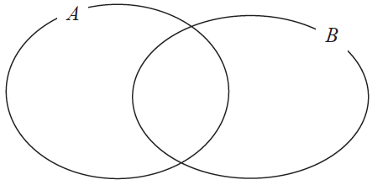

(a) Complete the Venn diagram to represent this information.
(3)

A number is chosen at random from the universal set E.
(b) Find the probability that the number is in the set A B

.......................................................
(2)
_________________________________________________________________________

25/2 Katy invests £200 000 in a savings account for 4 years.
The account pays compound interest at a rate of 1.5 % per annum.
Calculate the total amount of interest Katy will get at the end of 4 years.

£.......................................................
(3)
______________________________________________________________________________
26/3 The table shows information about the heights of 80 plants.

Height (h cm) | Frequency
10 < h ⩽ 20 | 7
20 < h ⩽ 30 | 13
30 < h ⩽ 40 | 14
40 < h ⩽ 50 | 12
50 < h ⩽ 60 | 16
60 < h ⩽ 70 | 18

(a) Find the class interval that contains the median.

..................................................................................
(1)
(b) On the grid, draw a frequency polygon for the information in the table.
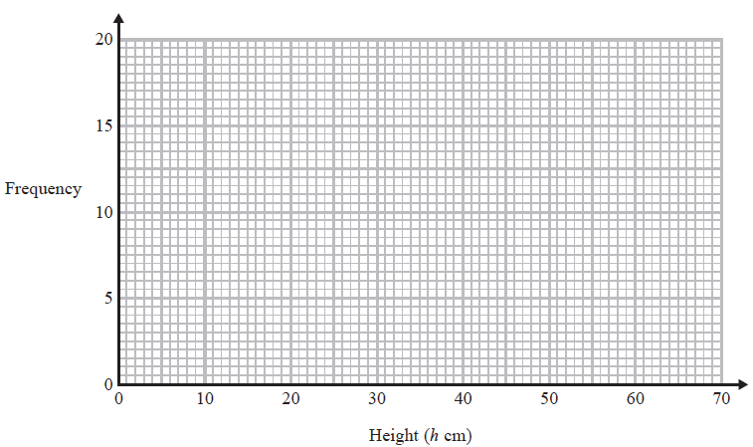
(2)
___________________________________________________________________________

27/4 Sean has drawn a time series graph to show the numbers, in thousands, of visitors to a
fun park.
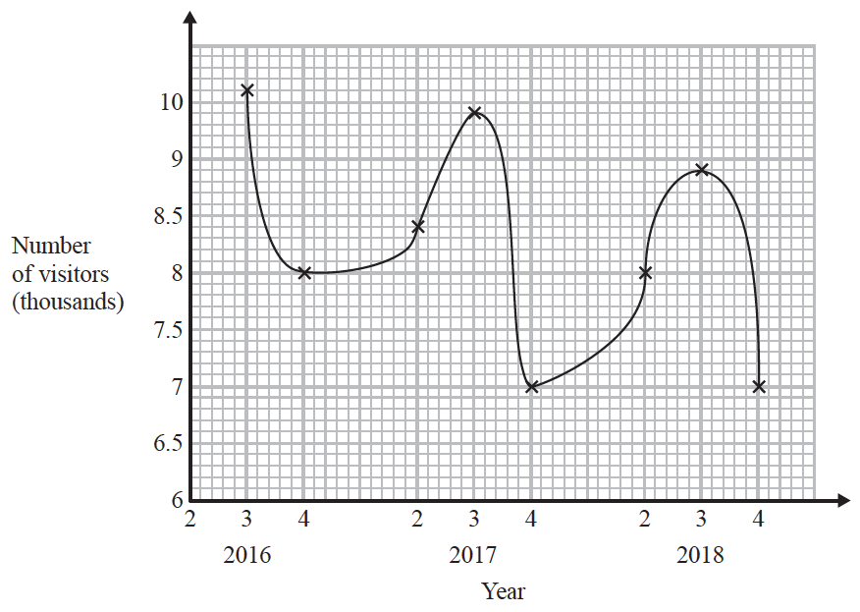
Write down two things that are wrong or could be misleading with this graph.

1 ...................................................................................................................................................

......................................................................................................................................................

2 ...................................................................................................................................................

......................................................................................................................................................
(2)
___________________________________________________________________________
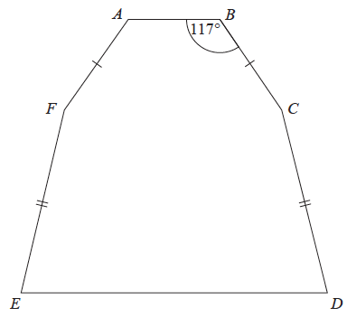
28/5 The diagram shows a hexagon.
The hexagon has one line of symmetry.

FA = BC
EF = CD
Angle ABC = 117°
Angle BCD = 2 × angle CDE
Work out the size of angle AFE.
You must show all your working.

.......................................................°
(4)

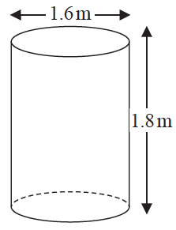
29/6 Jeremy has to cover 3 tanks completely with paint.
Each tank is in the shape of a cylinder with a top and a bottom.
The tank has a diameter of 1.6 m and a height of 1.8 m.
Jeremy has 7 tins of paint.
Each tin of paint covers 5 m²
Has Jeremy got enough paint to cover completely the 3 tanks?
You must show how you get your answer.

(Total for Question 29/6 is 5 marks)
______________________________________________________________________________
TOTAL FOR PAPER IS 22 MARKS

