Calculator Overlap questions June 18 Paper 1

19/1 (a) Work out $2\frac{1}{7} + 1\frac{1}{4}$

.......................................................(2)
(b) Work out $1\frac{1}{5} ÷ \frac{3}{4}$
Give your answer as a mixed number in its simplest form.

.......................................................(2)
___________________________________________________________________________________________________________________________________________________________________________________________________________________________________________________________________________________________________________________________________________________________________________________________________________________________________________________________________________

20/2 In a village
the number of houses and the number of flats are in the ratio 7 : 4

the number of flats and the number of bungalows are in the ratio 8 : 5

There are 50 bungalows in the village.
How many houses are there in the village?

.......................................................
(Total for Question 20/2 is 3 marks)
___________________________________________________________________________________________________________________________________________________________________________________________________________________________________________________________________________________________________________________________________________________________________________________________________________________________________________________________________________

21/3 Renee buys 5 kg of sweets to sell.
She pays £10 for the sweets.
Renee puts all the sweets into bags.
She puts 250 g of sweets into each bag.
She sells each bag of sweets for 65p.
Renee sells all the bags of sweets.
Work out her percentage profit.

.......................................................%
(4)
___________________________________________________________________________________________________________________________________________________________________________________________________________________________________________________________________________________________________________________________________________________________________________________________________________________________________________________________________________

22/4 A cycle race across America is 3069.25 miles in length.
Juan knows his average speed for his previous races is 15.12 miles per hour.
For the next race across America he will cycle for 8 hours per day.
(a) Estimate how many days Juan will take to complete the race.

.......................................................(3)
Juan trains for the race.
The average speed he can cycle at increases.
It is now 16.27 miles per hour.
(b) How does this affect your answer to part (a)?
..................................................................................................................................
.............................................................................................................................(1)
23/5 Here is a solid square-based pyramid, VABCD.
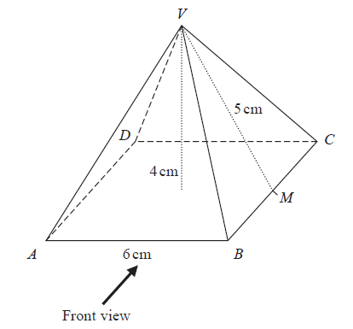
The base of the pyramid is a square of side 6 cm.
The height of the pyramid is 4 cm.
M is the midpoint of BC and VM = 5 cm.
- Draw an accurate front elevation of the pyramid from the direction of the arrow.
(2)

(b) Work out the total surface area of the pyramid.

.......................................................(4)
___________________________________________________________________________________________________________________________________________________________________________________________________________________________________________________________________________________________________________________________________________________________________________________________________________________________________________________________________________

24/6 A pattern is made from four identical squares.
The sides of the squares are parallel to the axes.
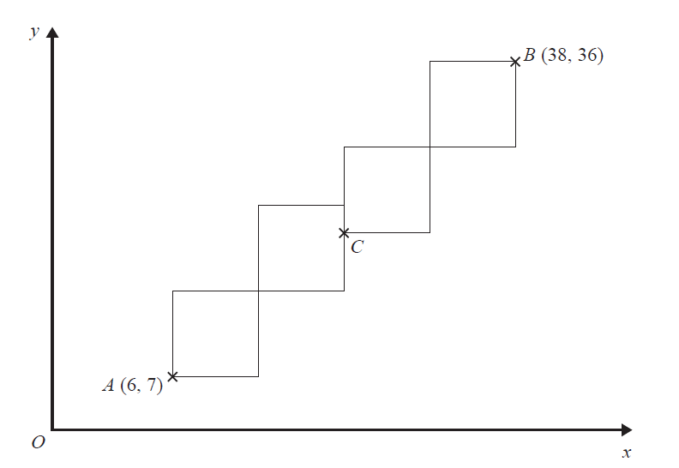
Point A has coordinates (6, 7)
Point B has coordinates (38, 36)
Point C is marked on the diagram.
Work out the coordinates of C.

(................................ , ................................)
(5)

