Calculator Overlap questions June 18 Paper 2

20/1 (a) Simplify m³ × m⁴

...................................................... (1)
(b) Simplify (5np³)³

...................................................... (2)
(c) Simplify $\frac{32q^{9}r^{4}}{4q^{3}r}$

...................................................... (2)
___________________________________________________________________________________________________________________________________________________________________________________________________________________________________________________________________________________________________________________________________________________________________________________________________________________________________________________________________________

21/2 (a) Find the lowest common multiple (LCM) of 40 and 56

...................................................... (2)
A = 2³ × 3 × 5 B = 22 × 3 × 52
(b) Write down the highest common factor (HCF) of A and B.

...................................................... (1)
___________________________________________________________________________________________________________________________________________________________________________________________________________________________________________________________________________________________________________________________________________________________________________________________________________________________________________________________________________

22/3 The line L is shown on the grid.
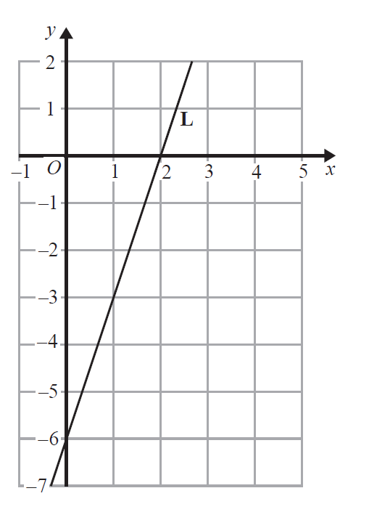
Find an equation for L.
......................................................
(Total for Question 22/3 is 3 marks)
___________________________________________________________________________________________________________________________________________________________________________________________________________________________________________________________________________________________________________________________________________________________________________________________________________________________________________________________________________

23/4 Raya buys a van for £8500 plus VAT at 20%
Raya pays a deposit for the van.
She then pays the rest of the cost in 12 equal payments of £531.25 each month.
Find the ratio of the deposit Raya pays to the total of the 12 equal payments.
Give your answer in its simplest form.

......................................................
(Total for Question 23/4 is 5 marks)
24/5 (a) Complete the table of values for y = x² – x – 6
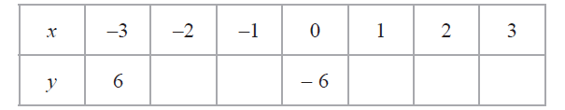
(2)
(b) On the grid, draw the graph of y = x² – x – 6 for values of x from –3 to 3
(2)
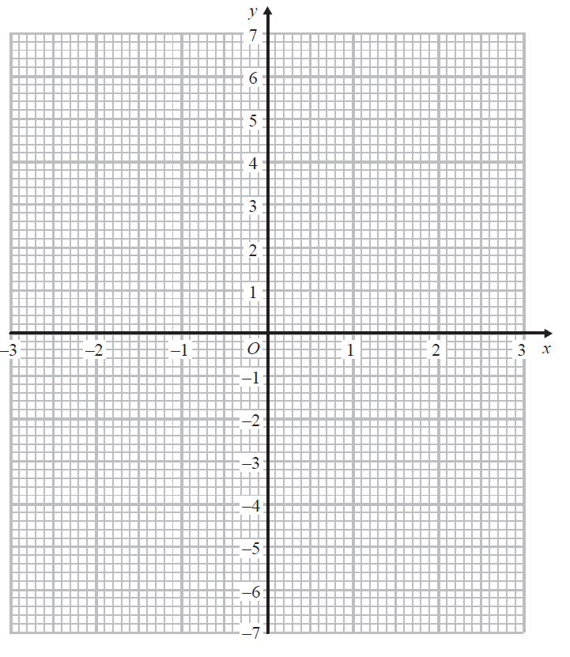
(c) Use your graph to find estimates of the solutions to the equation x² – x – 6 = –2

................................................................................. (2)
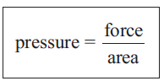
25/6 A force of 70 newtons acts on an area of 20 cm²
The force is increased by 10 newtons.
The area is increased by 10 cm²
Helen says, “The pressure decreases by less than 20%”
Is Helen correct?
You must show how you get your answer.

(3)

