Calculator Overlap questions June 18 Paper 3

1/19 The scatter diagram shows information about 12 girls.
It shows the age of each girl and the best time she takes to run 100 metres.
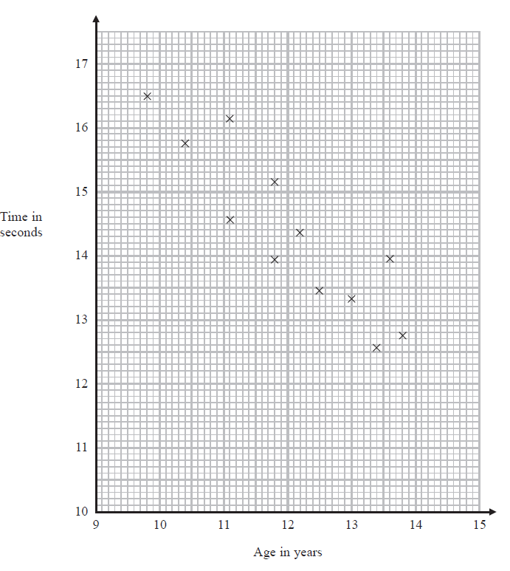
(a) Write down the type of correlation. .........................................................................(1)

Kristina is 11 years old. Her best time to run 100 metres is 12 seconds.
The point representing this information would be an outlier on the scatter diagram.
(b) Explain why.
...............................................................................................................................................................................................................................................
....................................................................................................................................................................................................................................(1)

Debbie is 15 years old. Debbie says:
“The scatter diagram shows I should take less than 12 seconds to run 100 metres.”
(c) Comment on what Debbie says.
..............................................................................................................................................................................................................................................
.....................................................................................................................................................................................................................................(1)
2/20 Expand and simplify 5( p + 3) – 2(1 – 2p)

....................................................
(2)
___________________________________________________________________________________________________________________________________________________________________________________________________________________________________________________________________________________________________________________________________________________________________________________________________________________________________________________________________________

3/21 Here is a trapezium drawn on a centimetre grid.
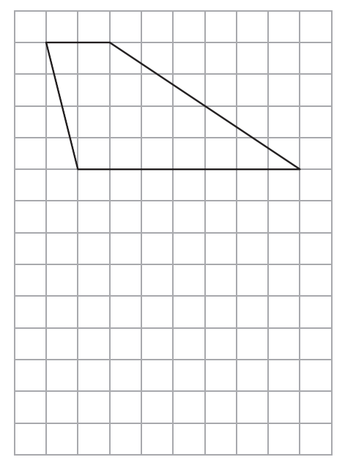

On the grid, draw a triangle equal in area to this trapezium.
(2)

___________________________________________________________________________________________________________________________________________________________________________________________________________________________________________________________________________________________________________________________________________________________________________________________________________________________________________________________________________

4/22 When a biased 6-sided dice is thrown once, the probability that it will land
on 4 is 0.65
The biased dice is thrown twice.
Amir draws this probability tree diagram.
The diagram is not correct.
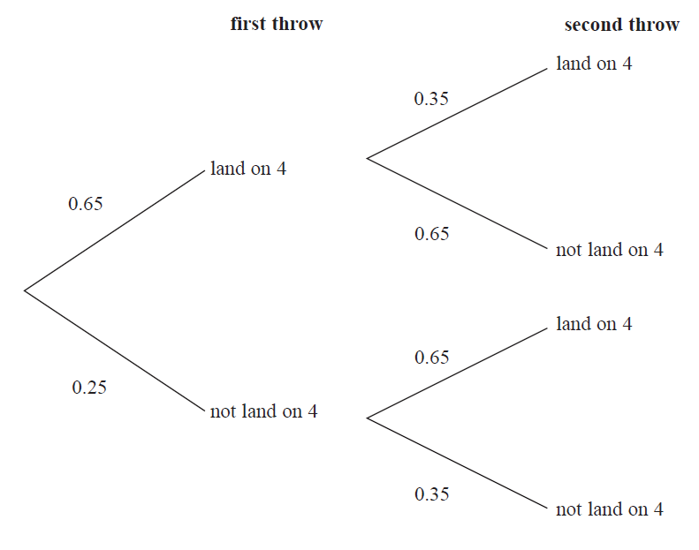
Write down two things that are wrong with the probability tree diagram.
1 .......................................................................................................................................................................................................................................
...............................................................................................................................................................................................................................................
2 .......................................................................................................................................................................................................................................
...............................................................................................................................................................................................................................................
(2)
___________________________________________________________________________________________________________________________________________________________________________________________________________________________________________________________________________________________________________________________________________________________________________________________________________________________________________________________________________

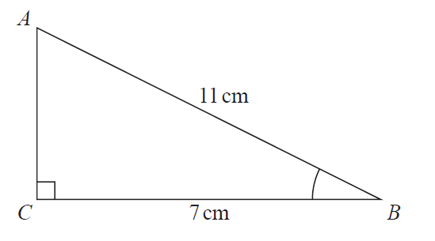
5/23 ABC is a right-angled triangle.

(a) Work out the size of angle ABC. Give your answer correct to 1 decimal place.

.......................................................º (2)

The length of the side AB is reduced by 1 cm.
The length of the side BC is still 7 cm.
Angle ACB is still 90º

(b) Will the value of cos ABC increase or decrease? You must give a reason for your answer.
...............................................................................................................................................................................................................................................
.....................................................................................................................................................................................................................................(1)
___________________________________________________________________________________________________________________________________________________________________________________________________________________________________________________________________________________________________________________________________________________________________________________________________________________________________________________________________________
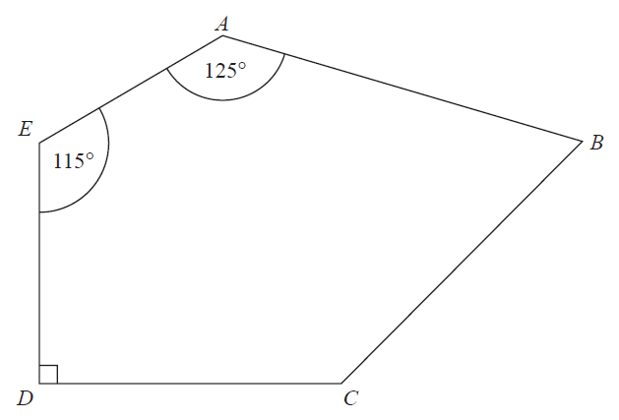
6/26 ABCDE is a pentagon.

Angle BCD = 2 × angle ABC
Work out the size of angle BCD.
You must show all your working.

.......................................................º
(5)
7/24 There are some counters in a bag.
The counters are red or white or blue or yellow.
Bob is going to take at random a counter from the bag.
The table shows each of the probabilities that the counter will be blue or will be yellow.

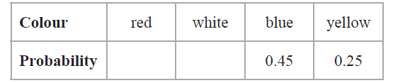
There are 18 blue counters in the bag.
The probability that the counter Bob takes will be red is twice the probability
that the counter will be white.

(a) Work out the number of red counters in the bag.

....................................................... (4)
A marble is going to be taken at random from a box of marbles.
The probability that the marble will be silver is 0.5
There must be an even number of marbles in the box.
(b) Explain why.
...............................................................................................................................................................................................................................................
.....................................................................................................................................................................................................................................(1)

___________________________________________________________________________________________________________________________________________________________________________________________________________________________________________________________________________________________________________________________________________________________________________________________________________________________________________________________________________

8/25 Solve $\frac{5 - x}{2}=2x-7$

x = .......................................................
(3)
___________________________________________________________________________________________________________________________________________________________________________________________________________________________________________________________________________________________________________________________________________________________________________________________________________________________________________________________________________

