Year 10 Enhanced Standard: Assessment 2 Revision
Circle theorems | /20 | Proportion | /25 | Sequences | /20 | Probability | /25

 | Topic 5: Circle Theorems | Mark
1. | 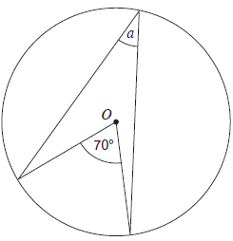  O is the centre of the circle.  Work out the size of angle a.  Give a reason for your answer. | 2
2. | 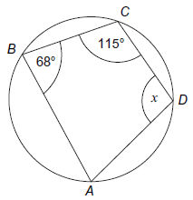  A, B, C and D are points on the circumference of a circle.  Work out the size of angle x.  Give a reason for your answer. | 2
3. | 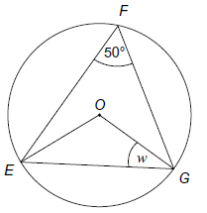  E, F and G are points on a circle, centre O.  Work out the size of angle w.  Give a reason for your answer. | 4
4. | 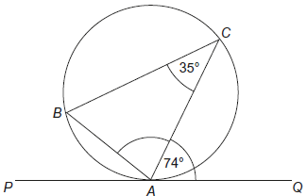  A, B and C are points on a circle.  PAQ is a tangent to the circle.  Work out the size of CAB. | 2
5. | 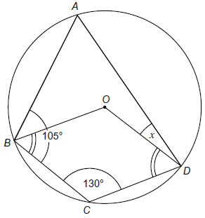  ABCD are points on the circumference of the circle  with centre 0.  Angle BCD = 130°,  angle ABC = 105° and  angle OBC = angle ODC.  Work out the size of angle x. | 4
6. | 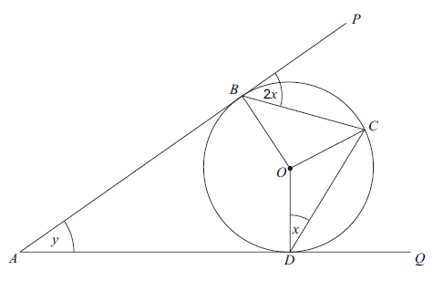  ABP and ADQ are tangents to the circle, centre O.  C lies on the circumference of the circle.  Prove that y = 2x.  Give reasons for any statements you make. | 6

 | Topic 6: Direct and Inverse Proportion | Mark
1. | y is directly proportional to x.  Sketch a graph showing the relationship between x and y. | 2
2. | a is inversely proportional to b.  When a = 9, b = 7.  - Write an equation linking a and b.  - Work out the value of b when a = 21. | 3  2
3. | y is directly proportional to $\sqrt{x}$.  When x = 36, y = 2.  Calculate the value of x when y = 5. | 4
4. | y is directly proportional to R².  When R = 4, y = 24.  Work out the value of R when y = 1350. | 5
5. | y is inversely proportional to the square of x.  When x = 3, y = 8.  - Work out an equation connecting y and x.  - Work out the value of y when x = 12. | 3  2
6. | At a constant temperature, the volume of a gas V is inversely proportional to its pressure P.  By what percentage will the pressure of a gas change it its volume increases by 25%? | 4

 | Topic 7: Sequences | Mark
1. | Find the n^{th} term of the sequence 6, 13, 20, 27, … | 2
2. | The nth term of a sequence is 25 – 3n.  - Work out the first three terms of the sequence.  - Work out the value of the first negative term of the sequence. | 2  1
3. | The nth term of a sequence is $\frac{3n^{2}}{2}$  - Find the second term of the sequence.  - Find the 5th term of the sequence.  - Which term in the sequence is the first to have a value higher than 50? | 1  1  1
4. | Find the n^{th} term of this sequence:  3, 8, 15, 24, 35, … | 3
5. | Find the n^{th} term of this sequence:  3, 11, 25, 45, … | 3
6. | A Fibonacci sequence starts e, 2f, e + 2f, …  What is the 5th term of this sequence? | 3
7. | In a sequence of four numbers, the difference between each number is 7.  The sum of the four numbers is 6.  What are the numbers in the sequence?  You must show all of your working. | 3

 | Topic 8: Probability | Mark
1. | A bag contains counters that are red, blue, green or yellow.  Red Blue Green Yellow  Number of counters 9 3 x x - 5 2x  A counter is chosen at random. The probability that it is red is 0.09.  Work out the probability it is green. | 4
2. | There are only white, purple, green and black counters in a bag.  The table shows the probabilities of picking at random a red counter and of picking at random a yellow counter.  Colour White Purple Green Black  Probability 0.24 0.32  The probability of picking a purple counter is the same as the probability of picking a green counter.  - What is the probability of picking a purple counter?  - What is the probability of picking a white or green counter? | 2  1
3. | Ethan rolls an ordinary fair dice.  His brother Dan tries to predict the number showing on the dice.  Ethan and Dan do this 300 times.  How many correct predictions would you expect Dan to make? | 2
4. | A bag contains 10 counters. 4 of the counters are black and 6 are white.  Two counters are picked at random.  Work out the probability that they are both black. | 3
5. | A team has 7 boys and 3 girls. Stevie choses 2 of the team at random.  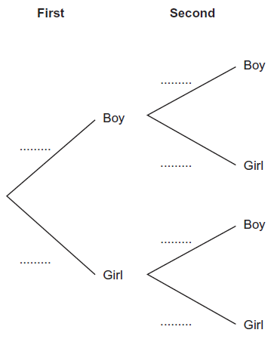  - Copy and complete the probability tree diagram.  - Work out the probability that he chooses one boy and one girl. | 2  3
6. | Two bags, A and B, contain beads.  Bag A contains 7 red beads and 2 yellow beads.  Bag B contains 1 red bead and 4 yellow beads.  One bead is taken at random from bag A and put into bag B.  On bead is then taken at random from bag b and put into bag A.  Work out the probability that bag A still contains exactly 7 red beads. | 4
7. | John has an empty box.  He puts some red counters and some blue counters into the box.  The ratio of the number of red counters to the number of blue counters is 1 : 4.  Linda takes at random 2 counters from the box.  The probability that she takes 2 red counters is $\frac{6}{155}$.  How many red counters did John put into the box? | 4

