YEAR 11 TEST 6 Revision CALCULATOR ENHANCED

Graphs + tangents | /15 | Equation of circle | /10 | Frequency Tree | /5 | Transformation | /10

 | Graphs and Tangents
1. | The distance around a cycle track is 400 metres.  Robin cycles on the track.  Here is his speed-time graph.  Show that Robin cycles exactly once around the track in 110 seconds.  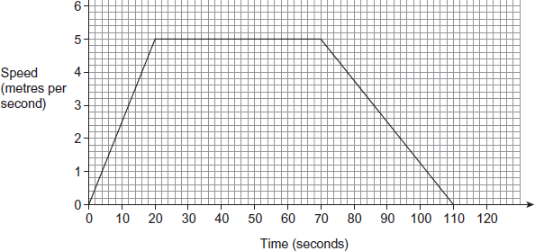  …………………………………………………………………………………………………………………………………………………………………  …………………………………………………………………………………………………………………………………………………………………  ………………………………………………………………………………………………………………………………………………………………… | (2)
2. | 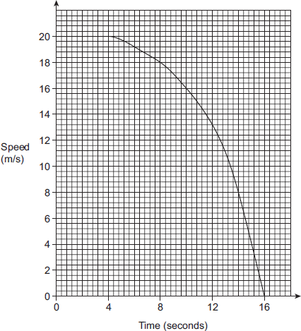  The graph shows the speed of  a train for 16 seconds.  Work out an estimate for the  distance travelled by the train  during the 16 seconds.  ………………… m | (6)
3. | The speed-time graph for a car’s journey is shown.  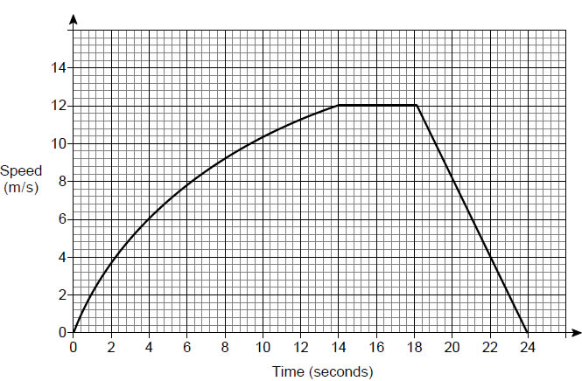a) Estimate the acceleration at 6 seconds. You must show your working.  …………………………………………………………………………………………………………………………………………………………………  …………………………………………………………………………………………………………………………………………………………………  …………………………………………………………………………………………………………………………………………………………………  ………………… m/s²  b) Estimate the distance travelled by the car for the journey.  You must show your working.  …………………………………………………………………………………………………………………………………………………………………  …………………………………………………………………………………………………………………………………………………………………  …………………………………………………………………………………………………………………………………………………………………  …………………………………………………………………………………………………………………………………………………………………  …………………………………………………………………………………………………………………………………………………………………  …………………………………………………………………………………………………………………………………………………………………  ………………… | (3)  (4)
 | Equation of a circle
1. | A circle has equation x² + y² = 4  a) What is the radius of the circle?  ……………  b) What is the gradient of the tangent to the curve at the point ( 1, $\sqrt{3}$ )  …………… | (1)  (1)
2. | 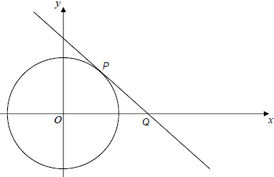  The diagram shows the circle x² + y² = 25  P lies on the circle and has  x-coordinate 4  The tangent at P intersects the  x -axis at Q.  a) Work out the equation of the tangent to the circle at the point P.  …………………………………………………………………………………………………………………………………………………………………  …………………………………………………………………………………………………………………………………………………………………  …………………………………………………………………………………………………………………………………………………………………  …………………………………………………………………………………………………………………………………………………………………  …………………………………………………………………………………………………………………………………………………………………  ………………………  b) Work out the coordinates of Q.  …………………………………………………………………………………………………………………………………………………………………  …………………………………………………………………………………………………………………………………………………………………  …………………………………………………………………………………………………………………………………………………………………  ( …………… , …………… )  c) Work out the area of triangle OQP.  …………………………………………………………………………………………………………………………………………………………………  …………………………………………………………………………………………………………………………………………………………………  ……………………… | (4)  (2)  (2)
 | Frequency Trees
1. | 200 people live in a village.  35% of people do not have a garden.  $\frac{3}{5}$ of the people without a garden are male.  $\frac{21}{40}$ of the people are female.  a) Use this information to complete the frequency tree.  b) One of the people who does have a garden is chosen at random.  What is the probability that this person is female?  ………… | (3)  (2)
 | Transformations
1. | 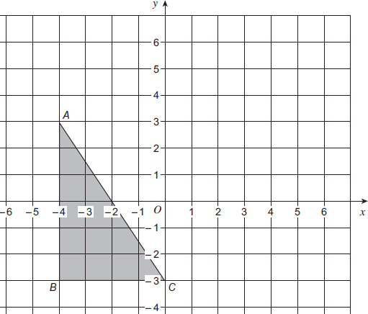  Enlarge triangle ABC  by scale factor -1, centre (1, 2). | (2)
2. | 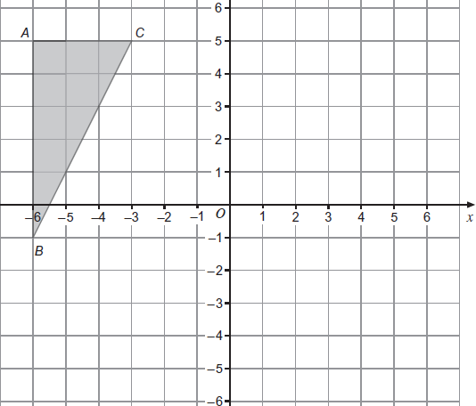  Enlarge triangle ABC by  scale factor $-\frac{2}{3}$ centre (0, 2). | (3)
3. | 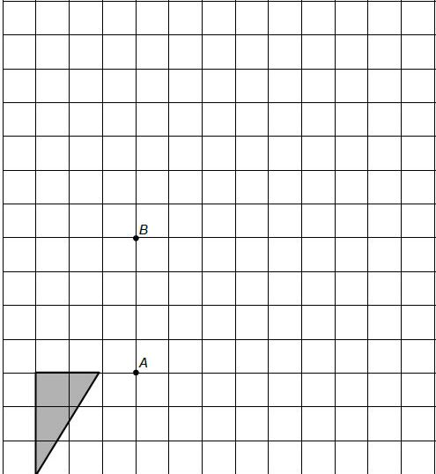  The shape is rotated 90° clockwise about point A.  It is then enlarged by scale factor −2, centre B.  Draw the final shape on the diagram. | (5)

