YEAR 11 Assessment Review Homework covering TEST 5 Non-calculator ENHANCED

Common Graphs | /15 | Inequalities | /12 | Loci Vectors | /15 | Algebraic  fractions | /20

 | Algebra: Graphs
1.  S | Sketch the graph of  a) $$y=x^{2}$$ b) $$y=-\frac{1}{x}$$ c) $$y=x^{3}$$ | (3)
2.  S | - Which is the correct equation for the graph shown below.  y = cos x y = sin x y = 2^{x} y = tan x  b) Which is the correct equation for the graph shown below.  y = cos x y = sin x y = 2^{x} y = tan x | (2)
3.  F | A B C  Match up the graph with the correct equation  y − 7 = x² + 8x y + x² = 7x - 10 y + 18 = x² + 3x | (3)
4.  F | The diagram shows a sketch of the graph of y = x² + ax + b  The graph crosses the x-axis at (1, 0) and (6, 0).  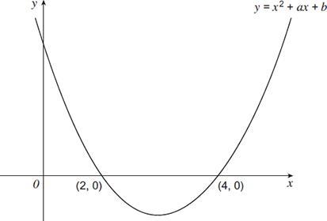  (6, 0)  (1, 0)  Work out the values of a and b.  You must show your working. | (3)
5.  M | 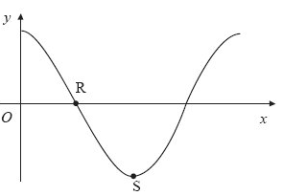  The diagram is a sketch of part of the graph of y = cos x°.  Work out the coordinates of  (i) R,  (ii) S  (iii) What is the value of cos 45?  (iv) What is the value of cos 225? | (4)
 | TOTAL | 15
 | Algebra: Inequalities
1.  S | a) Solve 3 x − 9 ≤ 23  b) The values -3, -2, −1, 0, 1, and 2 satisfy one of the inequalities below.  Select the correct inequality.  −4 < 2y ≤ 4 −6 ≤ 2y < 4 −9 ≤ 3y ≤ 6 | (1)  (1)
2.  F | Work out all the integers that satisfy the inequality  3 < 3n - 2 ≤ 17 | (2)
3.  F | Solve 3x − 7 ≤ 5x + 14 | (2)
4.  F | 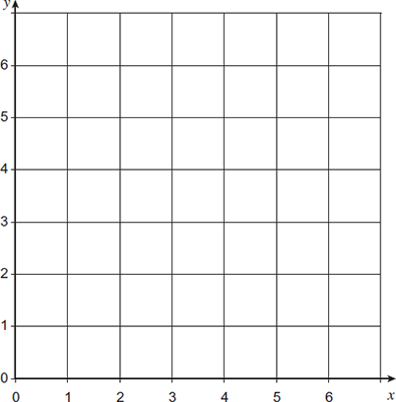  On a copy of the axes shown, draw lines to show the region satisfied by the three inequalities.  y ≥ 1  y ≤ 6 - x  y − x ≤ 4  Label the region clearly with the letter R | (3)
5.  M | Solve $x^{2} >x+20$ | (3)
 | TOTAL | 12
 | Geometry: Loci and Vectors
1.  S | Use ruler and compasses to construct an angle of 30° | (3)
2.  S | a = $\left(\begin{aligned}-3 \\ -5\end{aligned}\right)$ and b = $\left(\begin{aligned}4 \\ -1\end{aligned}\right)$  a) Find the vector –b  b) Find the vector b – a  c) Find the vector 2b | (3)
3.  F | 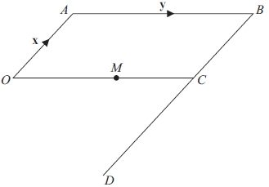  OABC is a parallelogram.  BCD is a straight line.  BD = 3BC.  M is the midpoint of OC.  $$\vec{OA}=x and \vec{AB}=Y$$  a) Find, in terms of x and y,  (i) $\vec{AM}$ (ii) $\vec{OD}$  b) Use your answers to (a) (i) and (ii) to write down two different geometric  facts about the lines AM and OD. | (2)  (2)
4.  M | 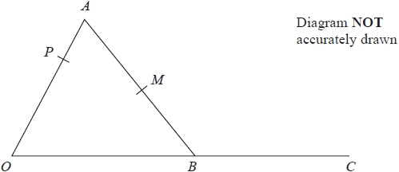  OAB is a triangle.  P is the point on OA such that  OP : PA = 2 : 1  C is the point such that B  is the midpoint of OC.  M is the midpoint of AB.  $\vec{OA}$ = 6a $\vec{OB}$ = 4b  Show that PMC is a straight line. | (5)
 | TOTAL | 15
 | Algebra: Algebraic fractions
1.  S | Simplify $\frac{x+2}{4}-\frac{x-6}{3}$ | (3)
2.  S | Write as a single fraction $\frac{5}{x-3}-\frac{2}{x+2}$ | (3)
3.  F | Express $\frac{3}{2x+3}-\frac{1}{2x-3}+\frac{6}{{4x}^{2}-9}$ as a single fraction in its simplest form. | (4)
4.  F | Simplify fully $\frac{2x^{2}+3x+1}{x^{2}-3x-4}$ | (3)
5.  M | Show that $\frac{2x-4}{x^{2}+2x-8}÷\frac{x-4}{{(x}^{2}-16)}$ simplifies to a where a is an integer. | (3)
6.  M | Write $5-\left[\left(x+5\right)÷\frac{x^{2}+7x+10}{x-3}\right]$ as a single fraction in its simplest form. | (4)
 | TOTAL | 20

