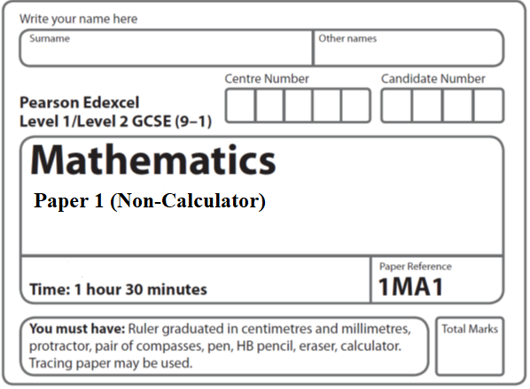

**Paper 1 - Aiming for 7**

**Instructions**

* Use **black** ink or ball-point pen.
  + **Fill in the boxes** at the top of this page with your name,  
    centre number and candidate number.
* Answer **all** questions.
* Answer the questions in the spaces provided  
  *– there may be more space than you need.*
* You must **show all your working.**
* Diagrams are **NOT** accurately drawn, unless otherwise indicated.
* **Calculators may NOT be used.**
* If your calculator does not have a *π* button, take the value of *π* to be3.142

unless the question instructs otherwise.

**Information**

* The total mark for this paper is **80**. There are **23** questions.
* Questions have been arranged in an ascending order of mean difficulty, as found by all students in the June 2019 examinations.
* The marks for **each** question are shown in brackets  
  *– use this as a guide as to how much time to spend on each question.*

**Advice**

* Read each question carefully before you start to answer it.
* Keep an eye on the time.
* Try to answer every question.
* Check your answers if you have time at the end.

**1** There are 9 counters in a bag.

7 of the counters are green.

2 of the counters are blue.

Ria takes at random two counters from the bag.

Work out the probability that Ria takes one counter of each colour.

You must show your working.

.......................................................

(**Total for Question 1 is 4 marks**)

**2** (*a*)Write down the exact value of tan 45°

......................................................

**(1)**

Here is a right-angled triangle.



cos 60° = 0.5

(*b*)Work out the value of *x*.

......................................................

**(2)**

**(Total for Question 2 is 3 marks)**

**___________________________________________________________________________**

**3** Work out the value of 

......................................................

(**Total for Question 3 is 2 marks**)

**4** The diagram shows triangle *ABC*.

**

*ADB* is a straight line.

the size of angle *DCB* : the size of angle *ACD* = 2 : 1

Work out the size of angle *BDC*.

....................................................... °

**(Total for Question 4 is 4 marks)**

**___________________________________________________________________________**

**5** A car travels for 18 minutes at an average speed of 72 km/h.

(*a*)How far will the car travel in these 18 minutes?

....................................................... km

**(2)**

David says,

“72 kilometres per hour is faster than 20 metres per second.”

(*b*)Is David correct?

You must show how you get your answer.

**(2)**

**(Total for Question 5 is 4 marks)**

**___________________________________________________________________________**

**6** can be written in the form ** where *a* is an integer.

Find the value of *a*.

*a* = .......................................................

(**Total for Question 6 is 3 marks**)

**7** Prove algebraically that  can be written as 

**(Total for Question 7 is 3 marks)**

**8** There are 10 boys and 20 girls in a class.

The class has a test.

The mean mark for all the class is 60.

The mean mark for the girls is 54.

Work out the mean mark for the boys.

.......................................................

**(Total for Question 8 is 3 marks)**

**___________________________________________________________________________**

**9** Here is the graph of *y* = sin *x*° for –180 ⩽ *x* ⩽ 180

**

On the grid, sketch the graph of *y* = sin *x*° – 2 for –180 ⩽ *x* ⩽ 180

(**Total for Question 9 is 2 marks**)

**10** A cone has a volume of 98 cm3.

The radius of the cone is 5.13 cm.

Work out an estimate for the height of the cone.

......................................................cm

(**Total for Question 10 is 3 marks**)

**11** (*a*)Factorise *a*2 − *b*2

.......................................................

(**1**)

(*b*)Hence, or otherwise, simplify fully (*x*2 + 4)2 – (*x*2 – 2)2

.......................................................

**(3)**

(**Total for Question 11 is 4 marks**)

**12** The diagram shows a right-angled triangle.

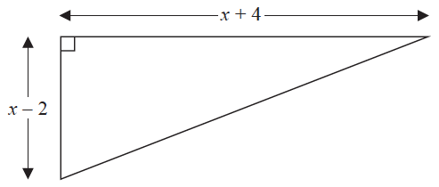

All the measurements are in centimetres.

The area of the triangle is 27.5 cm2

Work out the length of the shortest side of the triangle.

You must show all your working.

....................................................... cm

**(Total for Question 12 is 4 marks)**

**13** Simplify fully 

.......................................................

(**Total for Question 13 is 3 marks**)

**14** (a)The functions f and g are such that

f(*x*) = 3*x* – 1 and g(*x*) = *x*2 + 4

Given that fg(*x*) = 2gf(*x*),

show that 15*x*2 – 12*x* – 1 = 0

**(5)**

(b)The function f is given by

f(*x*) = 2*x*3 – 4

Show that f –1(50) = 3

**(2)**

**(Total for Question 14 is 7 marks)**

**15** There are only red counters, blue counters and purple counters in a bag.

The ratio of the number of red counters to the number of blue counters is 3 : 17

Sam takes at random a counter from the bag.

The probability that the counter is purple is 0.2

Work out the probability that Sam takes a red counter.

.......................................................

(**Total for Question 15 is 3 marks**)

**16** Prove that the square of an odd number is always 1 more than a multiple of 4.

(**Total for Question 16 is 4 marks**)

**17** *y* is inversely proportional to *d* 2

When *d* = 10, *y* = 4

*d* is directly proportional to *x*2

When *x* = 2, *d* = 24

Find a formula for *y* in terms of *x*.

Give your answer in its simplest form.

.......................................................

(**Total for Question 17 is 5 marks**)

**18** The times that 48 trains left a station on Monday were recorded.

The cumulative frequency graph gives information about the numbers of minutes the

trains were delayed, correct to the nearest minute.



The shortest delay was 0 minutes.

The longest delay was 42 minutes.

(*a*)On the grid below, draw a box plot for the information about the delays on Monday.



**(3)**

48 trains left the station on Tuesday.

The box plot below gives information about the delays on Tuesday.



(*b*)Compare the distribution of the delays on Monday with the distribution of the delays

on Tuesday.

......................................................................................................................................................

......................................................................................................................................................

......................................................................................................................................................

......................................................................................................................................................

**(2)**

(**Total for Question 18 is 5 marks**)

**19** The graph of *y* = f(*x*) is shown on the grid.



On the grid, draw the graph with equation *y* = f(*x* + 1) ̶ 3

**(Total for Question 19 is 2 marks)**

**20** Find the exact value of tan 30° × sin 60°

Give your answer in its simplest form.

.......................................................

**(Total for Question 20 is 2 marks)**

**21**

**

*A* and *B* are points on a circle, centre *O*.

*BC* is a tangent to the circle.

*AOC* is a straight line.

Angle *ABO* = *x*°.

Find the size of angle *ACB*, in terms of *x*.

Give your answer in its simplest form.

Give reasons for each stage of your working.

(**Total for Question 21 is 5 marks**)

**22** *n* is an integer greater than 1

Prove algebraically that *n*2 – 2 – (*n* – 2)2 is always an even number.

**(Total for Question 22 is 4 marks)**

**23** Simplify 

......................................................

**(Total for Question 23 is 1 mark)**

**TOTAL FOR PAPER IS 80 MARKS**