Year 11 Higher: Test 6 Revision homework

Circles /10 | Tangents /10 | Similarity /17 | Sampling /8

 | Topic 1: Circles and Pythagoras | Mark
1. | 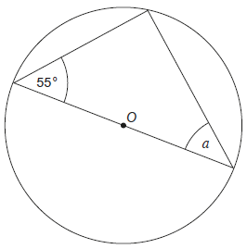  O is the centre of the circle.  Work out the size of angle a.  Give a reason for your answer.  a = ………………  ……………………………………………………………………………………  …………………………………………………………………………………… | 2
2. | 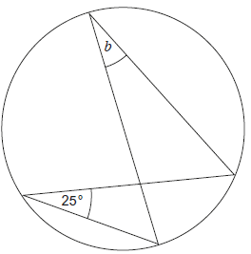  Write down the size of angle b.  Give a reason for your answer.  b = ………………  ……………………………………………………………………………………  ……………………………………………………………………………………  …………………………………………………………………………………… | 2
3. | 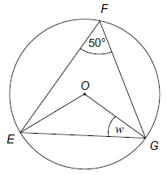  E, F and G are points on a circle, centre O..  Calculate the size of angle w  w = ………………  ……………………………………………………………………………………  ……………………………………………………………………………………  …………………………………………………………………………………… | 2
4. | 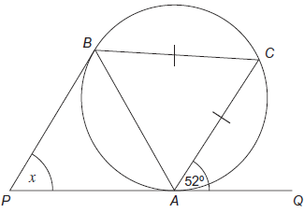  PAQ and PB are tangents to the circle.  AC = BC  Work out the size of angle x.  You must show your working out.  x = ……………… | 4
 | Topic 2 : Tangents and Area | Mark
1. | The graph shows the speed of a train for 16 seconds.  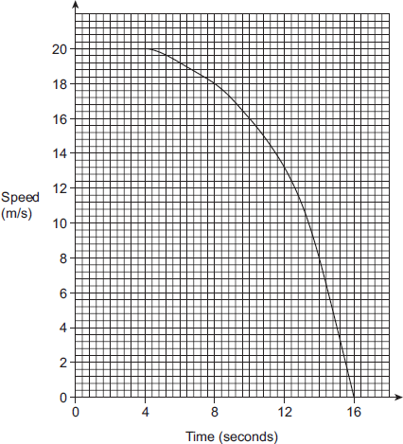  a) For how many seconds is the train travelling at a speed of less than 8 m/s?  ……………… sec  b) Using 4 strips, calculate the distance the train travelled over the 16 seconds.  …………… metres  c) Estimate of the average speed of the train during the 16 seconds  …………… m/s | 1  3  1
2. | The graph shows the speed of a Skateboarder for 2 minutes.  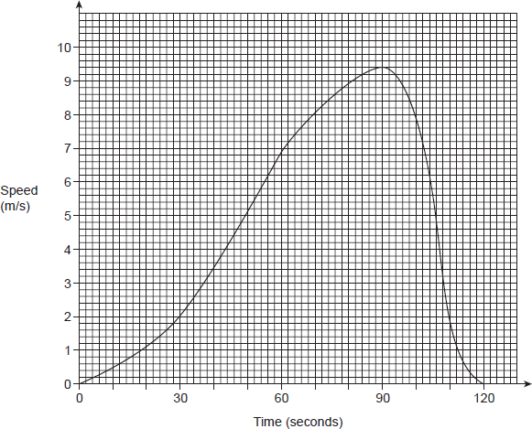  a) Using 3 strips, estimate the distance travelled in the first 90 seconds.  5  4  3  2  1  …………………… metres  b) Work out the  gradient of  the graph at  70 seconds.  ……………………  c) What does this gradient represent?  …………………………………………………………………………………………………………………………………………………… | 3  1  1
 | Topic 3: Similar shapes | Mark
1. | The diagram shows two pieces of glass which are similar.  The area of the smaller piece is 6000 cm².  Work out the area of the larger piece of glass  …………………… cm² | 3
2. | The small cylinder has a volume of 454 cm³.  The cylinder has a height of 10 cm.  A similar cylinder has a height of 15 cm.  What is the volume of the larger cylinder?  …………………… cm³ | 3
3. | 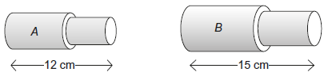  These two solid shapes are similar.  The volume of B is 3125 cm³  Work out the volume of A.  …………………… cm³ | 3
 | The diagram shows two mathematically similar vases, A and B.  Vase A has a surface area of 120 cm² Vase B has a surface area of 750 cm² and a volume of 1600 cm³ Work out the volume of vase A. A B  …………………… cm³ | 4
4. | 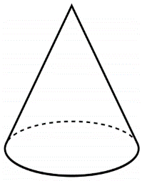  Cone A and cone B are mathematically similar.  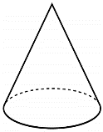  The ratio of the volume of cone A to the volume of cone B is 27 : 8  The surface area of cone A is 297 cm²  Calculate the surface area of cone B.  …………………… cm² | 4
 | Topic 4: Sampling and Frequency Trees | Mark
1. | There are 180 people who are members of a Gym.  $\frac{4}{9}$ of the members are female.  Of those female members, women attend more than 3 times a week in the ratio 3:5.  40% of people don’t attend the gym more than 3 times a week.  - Complete this frequency tree to display this information.  more than 3 times  Male  less than 3 times  more than 3 times  Female  less than 3 times  b) A male is chosen at random.  What is the probability that attends he attends the gym 3 or more times a week.  …………………… | 3  2
2. | Garage A sold 4960 vehicles.  The garage takes a sample of customers, stratified by type of vehicle sold.  Some information about the sample is shown. Complete the table.  Car People carrier Van Total  Number sold 2520 4960  Number in sample 126 44 | 3

