Year 10 Higher: Assessment 2 Revision
Shape | /15 | Proportion | /10 | Sequences | /15 | Probability | /10

 | Topic 5: Shape | Mark
1. | Mrs Smith wants to spread fertiliser all over her lawn.  18 m  8 m  9 m  6 m  2.5 m  patio  One box of fertiliser is enough for 32 m² of lawn.  How many boxes of fertiliser will she need?  You must show your working.  …………… boxes | 4
2. | 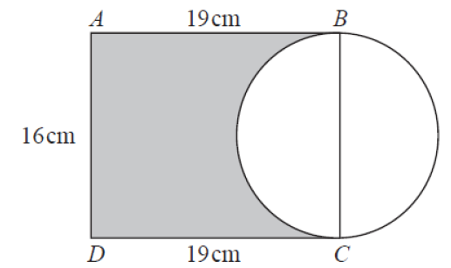  BC is the diameter of the circle.  Calculate the percentage of the area of the rectangle that is shaded.  Give your answer to 1 d.p.  …………… % | 3
3. | 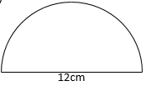  Calculate the perimeter of this semi-circle.  …………… cm | 2
4. | 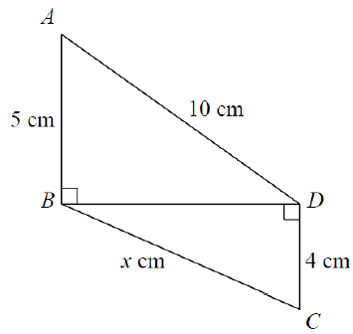  Triangles ABD and BCD are right angled triangles.  Work out the value of x.  Give your answer correct to 3 significant figures.  …………… cm | 4
5. | A radar beam sent out by an aeroplane.  120 km  150°  It reaches a distance of 120 km and covers an angle of 150º.  Calculate the area covered by the beam in terms of π.  …………… km² | 2

 | Topic 6: Ratio |  |  | Mark
1. | A solid cylinder has a radius of 6cm and a height of 20cm.  It has a mass of 2750 g.  Find the density of the cylinder.  Give your answer to 3 significant figures.  …………… g/cm³ |  |  | 3
2. | T is directly proportional to the square root of U .  T = 9 when U = 36  - Calculate a formula connecting T and U  …………………………  b) Calculate the value of T when U = 81  …………… |  |  | 2  1
3. | Jessica goes for a run.  She runs 10 km in 75 minutes, calculate her average speed in kilometres per hour.  …………… km/h |  |  | 1
4. | The shutter speed, S, of a camera varies inversely as the square of the aperture  setting, f.  When f = 8, S = 125  a) Find a formula for S in terms of f.  ……………  b) Hence, or otherwise, calculate the value of S when f = 4  S = …………… |  |  | 2  1
 | Topic 7: Sequences |  |  | Mark
1. | Here is a linear sequence 5, 8, 11, 14, 17 …  Explain why 52 is not in the sequence.  …………………………………………………………………………………………………………………………………………………………………  …………………………………………………………………………………………………………………………………………………………………  ………………………………………………………………………………………………………………………………………………………………… |  |  | 2
2. | Calculate the first 4 terms of the sequence 52 – 6n  …………… , …………… , …………… , …………… |  |  | 2
3. | Find the 5th term in the sequence 3n² + 4  …………… |  |  | 2
4. | Calculate the common ratio of the following geometric sequence  125, 100, 80, 64, …  ……………  Calculate the 6th term in the sequence,  …………… |  |  | 2  1
5. | Calculate the n^{th} term of this quadratic sequence:  3, 10, 19, 30, 43, …  ………………………… |  |  | 3
6. | Here is the start of a Fibonacci sequence.  Complete the next 3 terms.  4y , 2z , 4y + 2z , ………………………… , …………………………, ………………………… |  |  | 3
 |  | Topic 8: Probability | Mark
1. |  | The probability that Jess is on time for form is 0.8.  Calculate the probability of her not being on time.  …………… | 2
2. |  | The probability that Tottenham Hotspurs win a game of football is 3 times the probability that they don’t win.  Work out the probability of them winning.  …………… | 2
3. |  | The probability that Andy is on time for work is 0.7  The probability that Mike is on time for work is 0.5  Calculate the probability that only one of them is on time for work.  …………… | 3
4. |  | Mr Smith has a class of 26 pupils.  In the class he has 14 girls.  6 girls wear glasses and of those girls, 2 of them have brown hair.  12 pupils in the class wear glasses and of those pupils 6 have brown hair.  15 pupils have brown hair and of those pupils 8 of them are girls.  A = {Girls}, B = {Brown hair} and C = {Wears glasses}  - Complete the Venn diagram below  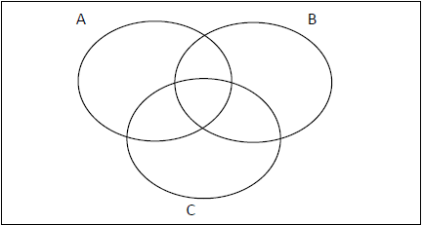  - Calculate the probability of picking a girl who doesn’t have brown hair. …………… | 2  1

