YEAR 11 TEST 5 Review Homework CALCULATOR HIGHER

Common Graphs | /10 | Inequalities | /15 | Loci Vectors | /10 | Algebraic fractions | /15

 | Algebra: Graphs
1.  S | Sketch the graphs of  $$y=\frac{2}{x}$$ $$y=sinx$$ $$y=x^{3}$$ $$y=x^{2}-3$$ |  |  |  | (4)
2.  F | A B C  Write down the letter of the graph which could have the equation:  y = x² + 2x − 3 y = 3x − 4 − x² y = x² + 5x + 4 |  |  |  | (2)
3.  M | Kaitlin runs for 12 seconds.  Her speed, in metres per second, is shown in the graph.  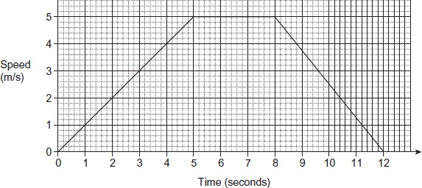  a) Work out the distance she runs.  …………  b) Work out Kaitlin’s deceleration during the last 4 seconds.  ………… m/s² |  |  |  | (2)  (2)
 | Algebra: Inequalities
1.  S | Write the inequality shown by the diagram.  …………………………………… |  |  |  | (2)
2.  F | Work out all the integers that satisfy the inequality 3 < 3 x - 2 ≤ 17  ………………………… |  |  |  | (2)
3.  F | Solve 3x − 7 ≤ 5x + 14  ………………………… |  |  |  | (3)
4.  F | 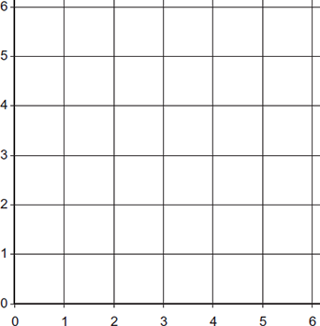  On a copy of the axes shown, draw lines to show the region satisfied by the three inequalities.  x ≤ 4  y ≥ 5 - x  y ≤ 1 + x  Label the region clearly with the letter R |  |  |  | (3)
5.  M | Solve $3x-2<\frac{7x + 9}{3}$  ………………………… |  |  |  | (3)
6.  M | 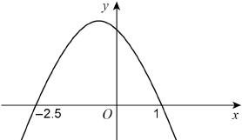  Here is a sketch of y = f(x) where  f(x) is a quadratic function.  The graph intersects the x-axis  where x = −2.5 and x = 1  Write down the solution of f(x) > 0  ………………………… |  |  |  | (2)
 | Geometry: Loci and Vectors
1.  S | Use ruler and compasses to bisect this angle. |  |  |  | (1)
2.  F | The diagram shows the plan of a living room.  A new plug socket is to be fitted to one of the walls.  It must be equidistant from the two aerial sockets  Use a ruler and compasses to show where a socket could be fitted.  Mark the positions of the new socket with the letter S.  Aerial socket  Aerial socket |  |  |  | (2)
3.  F | a = $\left(\begin{aligned}-3 \\ -5\end{aligned}\right)$ and b = $\left(\begin{aligned}4 \\ -1\end{aligned}\right)$ Find the vectors  a) b – a ………………………… b) a + 2b ………………………… |  |  |  | (2)
4.  M | 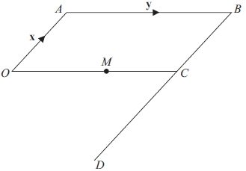  OABC is a parallelogram.  BCD is a straight line.  BD = 3BC.  M is the midpoint of OC.  $$\vec{OA}=x and \vec{AB}=Y$$  a) Find, in terms of x and y,  (i) $\vec{AM}$  …………………………  (ii) $\vec{OD}$  …………………………  b) Use your answers to write down a geometric fact about the lines AM and OD.  ……………………………………………………………………………………………………………………………………………………… |  |  |  | (2)  (2)  (1)
 | Algebra: Algebraic fractions
1.  S | Simplify fully $\frac{2x^{2} + 3x + 1}{x^{2} - 3x - 4}$  ………………………… |  |  |  | (4)
2.  F | Write as a single fraction $\frac{5}{x - 3} - \frac{2}{x + 2}$  ………………………… |  |  |  | (3)
3.  M | Simplify $\frac{2x - 4}{x^{2} + 2x - 8} ÷ \frac{x - 4}{{(x}^{2} - 16)}$  ………………………… |  |  |  | (4)
4.  M | Show that $\frac{3(x + 2)}{x^{2} - 3x - 10} × \frac{x^{2} - 25}{x + 5}$ simplifies to 3.  ………………………… |  |  |  | (4)

