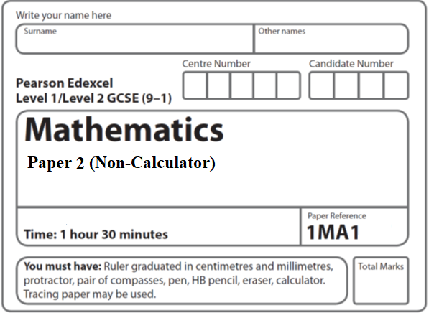

**Paper 2 - Aiming for 7**

**80**

**Instructions**

* Use **black** ink or ball-point pen.
  + **Fill in the boxes** at the top of this page with your name,  
    centre number and candidate number.
* Answer **all** questions.
* Answer the questions in the spaces provided  
  *– there may be more space than you need.*
* You must **show all your working.**
* Diagrams are **NOT** accurately drawn, unless otherwise indicated.
* **Calculators may NOT be used.**
* If your calculator does not have a *π* button, take the value of *π* to be3.142

unless the question instructs otherwise.

**Information**

* The total mark for this paper is **80**. There are **23** questions.
* Questions have been arranged in an ascending order of mean difficulty, as found by all students in the June 2019 examinations.
* The marks for **each** question are shown in brackets  
  *– use this as a guide as to how much time to spend on each question.*

**Advice**

* Read each question carefully before you start to answer it.
* Keep an eye on the time.
* Try to answer every question.
* Check your answers if you have time at the end.

**1** 3 teas and 2 coffees have a total cost of £7.80.

5 teas and 4 coffees have a total cost of £14.20.

Work out the cost of one tea and the cost of one coffee.

tea £......................................................

coffee £......................................................

**(Total for Question 1 is 4 marks)**

**___________________________________________________________________________**

**2** Show that (*x* + 1)(*x* + 2)(*x* + 3) can be written in the form *ax*3 + *bx*2 + *cx* + *d*

where *a*, *b*, *c* and *d* are positive integers.

**(Total for Question 2 is 3 marks)**

**___________________________________________________________________________**

**3** A factory makes 450 pies every day.

The pies are chicken pies or steak pies.

Each day Milo takes a sample of 15 pies to check.

The proportion of the pies in his sample that are chicken is the same as the proportion of

the pies made that day that are chicken.

On Monday Milo calculated that he needed exactly 4 chicken pies in his sample.

(*a*)Work out the total number of chicken pies that were made on Monday.

....................................................................

**(2)**

On Tuesday, the number of steak pies Milo needs in his sample is 6 correct to the nearest

whole number.

Milo takes at random a pie from the 450 pies made on Tuesday.

(*b*)Work out the lower bound of the probability that the pie is a steak pie.

....................................................................

**(2)**

(**Total for Question 3 is 4 marks**)

**4** A bus company recorded the ages, in years, of the people on coach A and the people

on coach B.

Here are the ages of the 23 people on coach A.

|  |  |  |  |  |  |  |  |  |  |  |  |
| --- | --- | --- | --- | --- | --- | --- | --- | --- | --- | --- | --- |
| 41 | 42 | 44 | 48 | 52 | 53 | 53 | 53 | 56 | 57 | 57 | 59 |
| 60 | 61 | 63 | 64 | 64 | 66 | 67 | 69 | 74 | 77 | 79 |  |

(*a*)Complete the table below to show information about the ages of the people on coach A.

|  |  |
| --- | --- |
| Median |  |
| Lower quartile |  |
| Upper quartile |  |
| Least age | 41 |
| Greatest age | 79 |

**(2)**

Here is some information about the ages of the people on coach B.

|  |  |
| --- | --- |
| Median | 70 |
| Lower quartile | 54 |
| Upper quartile | 73 |
| Least age | 42 |
| Greatest age | 85 |

Richard says that the people on coach A are younger than the people on coach B.

(*b*)Is Richard correct?

You must give a reason for your answer.

......................................................................................................................................................

......................................................................................................................................................

......................................................................................................................................................

**(1)**

Richard says that the people on coach A vary more in age than the people on coach B.

(*c*)Is Richard correct?

You must give a reason for your answer.

......................................................................................................................................................

......................................................................................................................................................

......................................................................................................................................................

**(1)**

**(Total for Question 4 is 4 marks)**

**___________________________________________________________________________**

**5** (*a*)Rationalise the denominator of 

Give your answer in its simplest form.

.......................................................

**(2)**

(*b*)Show that  can be written in the form ** where *a* and *b* are integers.

**(3)**

**(Total for Question 5 is 5 marks)**

**___________________________________________________________________________**

**6**Find the value of 

.......................................................

(**Total for Question 6 is 2 marks**)

**7** Express  as a fraction.

You must show all your working.

.......................................................

(**Total for Question 7 is 3 marks**)

**8** The diagram shows a solid shape.

The shape is a cone on top of a hemisphere.



The height of the cone is 10 cm.

The base of the cone has a diameter of 6 cm.

The hemisphere has a diameter of 6 cm.

The total volume of the shape is *k π* cm3, where *k* is an integer.

Work out the value of *k*.

*k* = .......................................................

(**Total for Question 8 is 4 marks**)

**9** Write  as a single fraction in its simplest form.

..............................................................................................................

**(Total for Question 9 is 2 marks)**

**___________________________________________________________________________**

**10** 4 red bricks have a mean weight of 5 kg.

5 blue bricks have a mean weight of 9 kg.

1 green brick has a weight of 6 kg.

Donna says,

“The mean weight of the 10 bricks is less than 7 kg.”

Is Donna correct?

You must show how you get your answer.

**(Total for Question 10 is 3 marks)**

___________________________________________________________________________

**11** The table shows a set of values for *x* and *y*.

|  |  |  |  |  |
| --- | --- | --- | --- | --- |
| *x* | 1 | 2 | 3 | 4 |
| *y* | 9 |  | 1 |  |

*y* is inversely proportional to the square of *x*.

(*a*)Find an equation for *y* in terms of *x*.

.......................................................

**(2)**

(*b*)Find the positive value of *x* when *y* = 16

.......................................................

**(2)**

(**Total for Question 11 is 4 marks**)

**12**



*A*, *B* and *C* are points on the circumference of a circle, centre *O*.

*DAE* is the tangent to the circle at *A*.

Angle *BAE* = 56°

Angle *CBO* = 35°

Work out the size of angle *CAO*.

You must show all your working.

......................................................°

(**Total for Question 12 is 3 marks**)

**___________________________________________________________________________**

**13** *h* is inversely proportional to *p*

*p* is directly proportional to **

Given that *h* = 10 and *t* = 144 when *p* = 6

find a formula for *h* in terms of *t*

.................................................................................

**(Total for Question 13 is 4 marks)**

**___________________________________________________________________________**

**14** Here are three spheres.



The volume of sphere **Q** is 50% more than the volume of sphere **P**.

The volume of sphere **R** is 50% more than the volume of sphere **Q**.

Find the volume of sphere **P** as a fraction of the volume of sphere **R**.

.......................................................

**(Total for Question 14 is 3 marks)**

**___________________________________________________________________________**

**15** The accurate scale drawing shows the positions of port *P* and a lighthouse *L*.

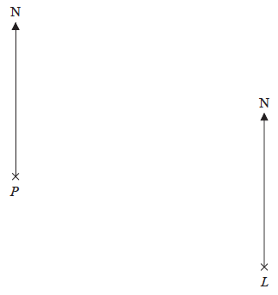

|  |
| --- |
| Scale: 1 cm represents 4 km. |

Aleena sails her boat from port *P* on a bearing of 070°

She sails for  hours at an average speed of 12 km/h to a port *Q*.

Find

(i) the distance, in km, of port *Q* from lighthouse *L*,

(ii) the bearing of port *Q* from lighthouse *L*.

distance *QL* = ....................................................... km

bearing of *Q* from *L* = ....................................................... °

**(Total for Question 15 is 5 marks)**

**___________________________________________________________________________**

**16** The functions f and g are such that

f(*x*) = 3*x* – 1 and g(*x*) = *x*2 + 4

(*a*)Find f –1(*x*)

f –1(*x*) = .......................................................

**(2)**

Given that fg(*x*) = 2gf(*x*),

(*b*)show that 15*x*2 – 12*x* – 1 = 0

**(5)**

**(Total for Question 16 is 7 marks)**

**___________________________________________________________________________**

**17** Factorise fully 50 – 2*y*2

........................................................................................

**(Total for Question 17 is 2 marks)**

**___________________________________________________________________________**

**18** There are three dials on a combination lock.

Each dial can be set to one of the numbers 1, 2, 3, 4, 5

The three digit number 553 is one way the dials can be set, as shown in the diagram.

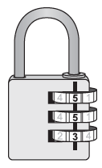

Work out the number of different three digit numbers that can be set for the combination lock.

.......................................................

**(2)**

**(Total for Question 18 is 4 marks)**

**___________________________________________________________________________**

**19** The graph of *y* = f(*x*) is shown on the grid below.



(*a*)On the grid above, sketch the graph of *y* = f(*x* – 2)

**(1)**



On the grid, graph **A** has been reflected to give graph **B**.

The equation of graph **A** is *y* = g(*x*)

(*b*)Write down the equation of graph **B**.

......................................................

**(1)**

**(Total for Question 19 is 2 marks)**

**___________________________________________________________________________**

**20**



Enlarge shape **P** by scale factor  with centre of enlargement (0, 0).

Label your image **Q**.

**(Total for Question 20 is 2 marks)**

**___________________________________________________________________________**

**21**

**

*ABCD* is a rhombus.

The coordinates of *A* are (5,11)

The equation of the diagonal *DB* is **

Find an equation of the diagonal *AC*.

.......................................................

**(Total for Question 21 is 4 marks)**

**___________________________________________________________________________**

**22** Given that *x*2 – 6*x* + 1 = (*x* – *a*)2 – *b* for all values of *x*,

(i) find the value of *a* and the value of *b*.

*a* = .......................................................

*b* = .......................................................

**(2)**

(ii) Hence write down the coordinates of the turning point on the graph of *y* = *x*2 – 6*x* + 1

(............................ , ............................)

**(1)**

**(Total for Question 22 is 3 marks)**

**___________________________________________________________________________**

**23** Here is a rectangle and a right-angled triangle.



All measurements are in centimetres.

The area of the rectangle is greater than the area of the triangle.

Find the set of possible values of *x*.

.......................................................

**(Total for Question 23 is 5 marks)**

**___________________________________________________________________________**

**TOTAL FOR PAPER IS 80 MARKS**