YEAR 11 TEST 4 REVISION HW CALCULATOR CORE

Name ____________________ Teacher ______________________

Compound measures | /15 | SA and Vol | /15 | Equations | /10 | Percentages | /10

 | Algebra: Compound measure
1.  S | A sprinter runs a distance of 350 metres in 50 seconds.  Work out the average speed of the sprinter.  ………………………… m/s | (1)
2.  S | A piece of metal has a mass of 800g and a volume of 40 cm³.  Find its density in g/cm³.  ………………………… g/cm³ | (1)
3.  F | Mary drove from Manchester to Newcastle  It took her 3 hours at an average speed of 50km/h.  Jane did the same journey.  She took 2.5 hours.  Work out Jane's average speed from Manchester to Newcastle.  ……………………………………………………………………………………………………………………………………………………  ……………………………………………………………………………………………………………………………………………………  ………………………… km/h | (2)
3. | Ryan goes for a walk.  He walks 20 miles in 7 hours.  5 miles = 8 km.  Neve says that Ryan walked more than 25 km.  Is Neve right?  You must show all your working.  ……………………………………………………………………………………………………………………………………………………  ……………………………………………………………………………………………………………………………………………………  …………………………………………………………………………………………………………………………………………………… | (2)
4.  M | The distance from Fulbeck to Ganby is 10 miles.  The distance from Ganby to Horton is 18 miles.  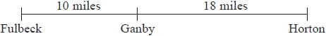  Raksha is going to drive from Fulbeck to Ganby. She will then drive from Ganby to Horton.  Raksha leaves Fulbeck at 10 00  She drives from Fulbeck to Ganby at an average speed of 40mph.  Raksha wants to get to Horton at 10:35  Work out the average speed Raksha must drive at from Ganby to Horton.  ………………………… mph | (3)
7.  M | Amina took part in a cycle race  Here is Amina’s speed-time graph from the start of the race.  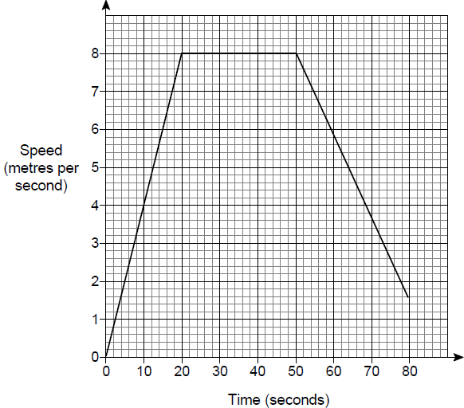  a) For how many seconds does she cycle at a constant speed? ………………… secs  b) Work out the total distance she cycles in the first 50 seconds.  ………………… m  c) Work out the gradient of the graph during the first 20 seconds.  ……………… m/s²  d) What does the gradient in part (c) represent?  Circle your answer.  time speed distance acceleration | (1)  (2)  (2)  (1)
 | TOTAL | /15
 | Geometry: Surface Area and Volume
1.  S | Draw the net of a triangular prism: | (2)
2.  S | How many vertices does a pentagonal based pyramid have? ………………… | (1)
3.  S | Calculate the volume and surface area of this solid:  3cm  5cm  7cm  Volume: Surface Area:  ………………………………………………………… …………………………………………………………  ………………………………………………………cm³ …………………………………………………………cm² | (2)  (3)
4.  F | Work out the volume of the triangular prism.  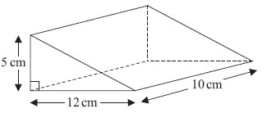  ………………………cm³ | (3)
8.  F | The diagram shows a sphere.  The radius of the sphere is 4 cm  Work out the surface area of the sphere.  …………………… cm² | (2)
9.F | A cone has a vertical height of 9 cm and a base radius of 5 cm.  Calculate the volume of the cone.  …………………… cm³ | (2)
 | TOTAL | /15
 | Algebra: Equations
1.  S  S  F  F  M | a) Solve 5x + 3 = 38  x = ………………  b) Solve 9x - 1 = 22  x = ………………  c) Solve 3(x - 5) = 18  x = ………………  d) Solve 5x – 1 = 3x + 17  x = ………………  e)  $\frac{2x+5}{3}$ = 7  x = ……………… | (1)  (1)  (2)  (2)  (2)
2.  F | Use trial and improvement to solve x² + 6x = 141 correct to 1d.p.  Guess for x Answer Comment  9 10 9² + 6 x 9 = 10² + 6 x 10 =  x = ……………… | (2)
 | TOTAL | /10
 | Number: Percentages
1.  S | Alice got 48 out of 80 in a Maths test.  She also took and French test and scored 13 out of 25.  Which test did she do better on?  Give a reason for your answer:  …………………………………………………………………………………………………………………………………………………… | (2)
2.  S | Sam wants to buy a camera for £336  He has already saved £96  Each week his pay is £80 he saves 30% of this pay.  How many more weeks must he save?  ……………weeks | (2)
3.  F | In a school, 60% of the students are girls.  50% of the girls walk to school. 20% of the boys walk to school.  What percentage of the students walk to school?  ……………………………… | (3)
4. | Sophie buys a pair of jeans in the sale. All sale items have 12% off.  The sale price of the jeans was £70.40. What was the original price of the jeans? | (3)
 | TOTAL | /10

