YEAR 11 Review Homework for assessment 4 CALCULATOR CORE

Name ____________________ Teacher ______________________

Compound measures | /15 | SA and Vol | /15 | Equations | /10 | Percentages | /10

 | Algebra: Compound measure
1.  S | A sprinter runs a distance of 200 metres in 40 seconds.  Work out the average speed of the sprinter.  ………………………… m/s | (1)
2.  S | A piece of metal has a mass of 24kg and a volume of 8m³.  Find its density in kg/m³.  ………………………… kg/m³ | (1)
3.  F | Mary drove from London to Bristol  It took her 2 hours at an average speed of 60km/h.  Jane did the same journey  She took 3 hours.  a) Work out Jane's average speed from London to Bristol.  …………………………………………………………………………………………………………………………………………………  …………………………………………………………………………………………………………………………………………………  ………………………… km/h | (2)
4.  F | The map shows distances between some junctions on a motorway.  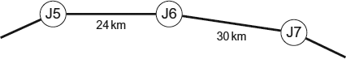  A car is travelling at a constant speed on the motorway.  The car travels between J5 and J6 in 20 minutes.  How many minutes does it take to travel between J6 and J7?  ………………………… | (3)
5. | Convert 32km into miles  ……………miles | (2)
6.  M | Amina took part in a cycle race  Here is Amina’s speed-time graph from the start of the race.  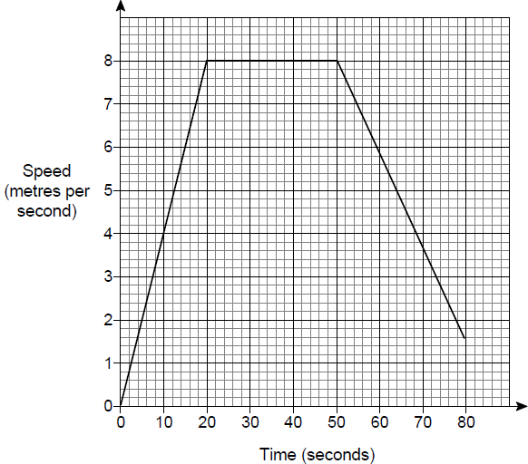  a) For how many seconds does she accelerate? ………………… secs  b) Work out the total distance she cycles between 50 and 80 seconds.  ………………… m  c) Work out the gradient of the graph between 50 and 80 seconds.  ……………… m/s²  d) What does the gradient in part (c) represent?  Circle your answer.  time speed distance acceleration | (1)  (2)  (2)  (1)
 | TOTAL | 15
 | Geometry: Surface Area and Volume
1.  S | Draw the net of a cylinder: | (2)
2. | How many edges does a hexagonal prism have? ………………… | (1)
3.  S | Calculate the volume and surface area of this solid:  9cm  4cm  3cm  Volume: Surface Area:  ………………………………………………………… …………………………………………………………  ………………………………………………………cm³ …………………………………………………………cm² | (2)  (3)
4.  F | Work out the volume of the triangular prism.  ………………………cm³ | (3)
8.  F | The diagram shows a sphere.  The radius of the sphere is 6 cm  Work out the surface area of the sphere.  …………………… cm² | (2)
9.F | A cone has a vertical height of 8 cm and a base radius of 6 cm.  Calculate the volume of the cone.  …………………… cm³ | (2)
 | TOTAL | /15
 | Algebra: Equations
1.  S | a) Solve 7x + 2 = 37  x = ………………  b) Solve 8x - 5 = 26  x = ………………  c) Solve 4(2x - 5) = 20  x = ………………  d) Solve 9x – 2 = 4x + 18  x = ………………  e) 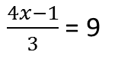  x = ……………… | (1)  (1)  (2)  (2)  (2)
2. | Use trial and improvement to solve x² + 5x = 71 correct to 1dp  Guess for x Answer Comment  6 7 6² + 5 x 6= 7² + 5 x 7 =  x = ……………… | (2)
 | TOTAL | /10
 | Number: Percentages
1.  S | Alice got 42 out of 60 in a Maths test.  She also took and French test and scored 13 out of 20.  Which test did she do better on?  Give a reason for your answer:  ………………………………………………………………………………………………………………………………………………… | (1)
2.  S | Sam wants to buy a camera for £500  He has already saved £120  Each week his pay is £90 he saves 40% of this pay.  How many more weeks must he save?  ……………weeks | (2)
3.  F | Nicola buys a car for £6000.  The value of the car depreciates by 15% each year.  Work out the value of the car after 5 years.  ……………………………… | (3)
4. | Mrs. Smith asks her Year group what kind of party they want to have to celebrate their excellent behaviour.  Out of all the students in the class, 48 want an ice cream party, 26 want a movie party, 13 want a costume party, and the rest are undecided.  If 20%, percent want an ice cream party, how many students are in the class?  ……………………………… | (2)
5. | James’ wage increased by 20%. He now gets £50.40 per shift.  What would he have received prior to his pay rise.  ……………………………… | (2)
 | TOTAL | /10

