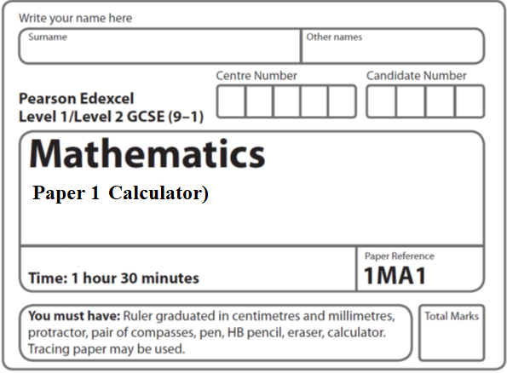

**Paper 1 - Aiming for 7**

**Instructions**

* Use **black** ink or ball-point pen.
  + **Fill in the boxes** at the top of this page with your name,  
    centre number and candidate number.
* Answer **all** questions.
* Answer the questions in the spaces provided  
  *– there may be more space than you need.*
* You must **show all your working.**
* Diagrams are **NOT** accurately drawn, unless otherwise indicated.
* **Calculators may be used.**
* If your calculator does not have a *π* button, take the value of *π* to be3.142

unless the question instructs otherwise.

**Information**

* The total mark for this paper is **80**. There are **26** questions.
* Questions have been arranged in an ascending order of mean difficulty, as found by all students in the June 2019 examinations.
* The marks for **each** question are shown in brackets  
  *– use this as a guide as to how much time to spend on each question.*

**Advice**

* Read each question carefully before you start to answer it.
* Keep an eye on the time.
* Try to answer every question.
* Check your answers if you have time at the end.

**1** Mary travels to work by train every day.

The probability that her train will be late on any day is 0.15

(*a*)Complete the probability tree diagram for Thursday and Friday.

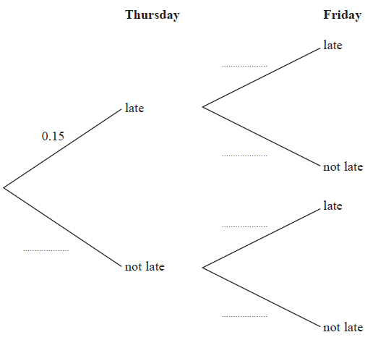

**(2)**

(*b*) Work out the probability that her train will be late on at least one of these two days.

.......................................................

**(3)**

**(Total for Question 1 is 5 marks)**

**___________________________________________________________________________**

**2** f(*x*) = 4sin *x*°

(*a*)Find f(23)

Give your answer correct to 3 significant figures.

.......................................................

**(1)**

g(*x*) = 2*x* – 3

(*b*)Find fg(34)

Give your answer correct to 3 significant figures.

.......................................................

**(2)**

h(*x*) = (*x* + 4)2

Ivan needs to solve the following equation h(*x*) = 25

He writes

(*x* + 4)2 = 25

*x* + 4 = 5

*x* = 1

This is not fully correct.

(*c*)Explain why.

......................................................................................................................................................

......................................................................................................................................................

**(1)**

**(Total for Question 2 is 4 marks)**

**___________________________________________________________________________**

**3** In a restaurant there are

9 starter dishes

15 main dishes

8 dessert dishes

Janet is going to choose one of the following combinations for her meal.

a starter dish and a main dish

or a main dish and a dessert dish

or a starter dish, a main dish and a dessert dish

Show that there are 1335 different ways to choose the meal.

**(Total for Question 3 is 3 marks)**

**___________________________________________________________________________**

**4** In May 2019, the distance between Earth and Mars was 3.9 × 107 km.

In May 2019, a signal was sent from Earth to Mars.

Assuming that the signal sent from Earth to Mars travelled at a speed of 3 × 105 km per second,

(*a*)how long did the signal take to get to Mars?

....................................................... seconds

**(2)**

The speed of the signal sent from Earth to Mars in May 2019 was actually less than

3 × 105 km per second.

(*b*)How will this affect your answer to part (*a*)?

......................................................................................................................................................

......................................................................................................................................................

......................................................................................................................................................

**(1)**

**(Total for Question 4 is 3 marks)**

**___________________________________________________________________________**

**5** *A* is the point with coordinates (5, 9)

*B* is the point with coordinates (*d*, 15)

The gradient of the line *AB* is 3

Work out the value of *d*.

.......................................................

**(Total for Question 5 is 3 marks)**

**___________________________________________________________________________**

**6**

**

The graphs of *y* against *x* represent four different types of proportionality.

Match each type of proportionality in the table to the correct graph.

|  |  |
| --- | --- |
| **Type of proportionality** | **Graph letter** |
| *y*  *x* |  |
| *y*  *x*2 |  |
| *y* |  |
| *y* |  |

(**Total for Question 6 is 2 marks**)

**___________________________________________________________________________**

**7** The *n*th term of a sequence is given by *an*2 + *bn* where *a* and *b* are integers.

The 2nd term of the sequence is –2.

The 4th term of the sequence is 12.

Here are the first five terms of a different quadratic sequence.

|  |  |  |  |  |
| --- | --- | --- | --- | --- |
| 0 | 2 | 6 | 12 | 20 |

Find an expression, in terms of *n*, for the *n*th term of this sequence.

.......................................................

(**Total for Question 7 is 2 marks**)

**___________________________________________________________________________**

**8** Patrick has to work out the exact value of 

Patrick says,

“ of 64 is 16 so  = 16 ”

Explain what is wrong with what Patrick says.

......................................................................................................................................................

......................................................................................................................................................

......................................................................................................................................................

**(Total for Question 8 is 1 mark)**

**___________________________________________________________________________**

**9** The equation of a circle is *x*2 + *y*2 = 42.25

Find the radius of the circle.

..............................................................

**(Total for Question 9 is 1 mark)**

**___________________________________________________________________________**

**10** Naoby invests £6000 for 5 years.

The investment gets compound interest of *x*% per annum.

At the end of 5 years the investment is worth £8029.35.

Work out the value of *x*.

.......................................................

**(Total for Question 10 is 3 marks)**

**___________________________________________________________________________**

**11** Write *x*2 + 6*x* – 7 in the form (*x* + *a*)2 + b where *a* and *b* are integers.

.................................................................................

**(Total for Question 11 is 2 marks)**

**___________________________________________________________________________**

**12** There are only red counters and blue counters in a bag.

Joe takes at random a counter from the bag.

The probability that the counter is red is 0.65

Joe puts the counter back into the bag.

Mary takes at random a counter from the bag.

She puts the counter back into the bag.

What is the probability that Joe and Mary take counters of different colours?

..............................................................

(**Total for Question 12 is 2 marks**)

**___________________________________________________________________________**

**13** The diagram shows a circle and an equilateral triangle.

One side of the equilateral triangle is a diameter of the circle.

The circle has a circumference of 44 cm.

Work out the area of the triangle.

Give your answer correct to 3 significant figures.

.......................................................cm2

**(Total for Question 13 is 3 marks)**

**___________________________________________________________________________**

**14**

**

Work out the length of *AD*.

Give your answer correct to 3 significant figures.

....................................................... cm

(**Total for Question 14 is 5 marks**)

**___________________________________________________________________________**

**15** A car moves from rest.

The graph gives information about the speed, *v* metres per second, of the car *t* seconds

after it starts to move.

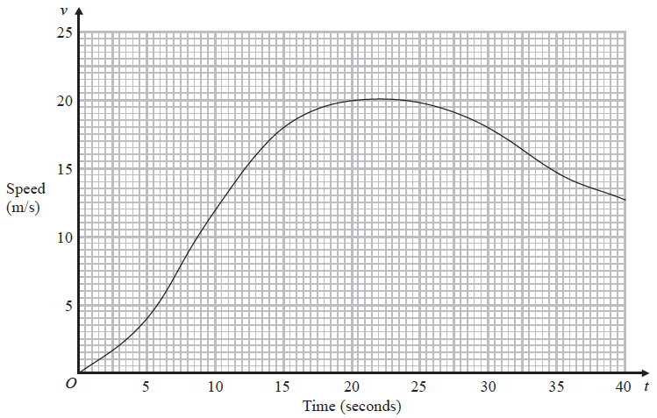

Work out an estimate for the distance the car travels in the first 20 seconds of its journey.

Use 4 strips of equal width.

.......................................................m

**(Total for Question 15 is 3 marks)**

**__________________________________________________________________________**

**16** There are 12 counters in a bag.

There is an equal number of red counters, blue counters and yellow counters in the bag.

There are no other counters in the bag.

3 counters are taken at random from the bag.

Work out the probability of taking 3 red counters.

......................................................

**(Total for Question 16 is 2 marks)**

**___________________________________________________________________________**

**17** The histogram shows some information about the ages of the 134 members of a sports club.



20% of the members of the sports club who are over 50 years of age are female.

Work out an estimate for the number of female members who are over 50 years of age.

......................................................

**(Total for Question 17 is 3 marks)**

**___________________________________________________________________________**

**18** Here is a pyramid with a square base *ABCD*.

**

*AB* = 5 m

The vertex *T* is 12 m vertically above the midpoint of *AC*.

Calculate the size of angle *TAC*.

.......................................................°

**(Total for Question 18 is 4 marks)**

**___________________________________________________________________________**

**19** Prove algebraically that the difference between the squares of any two consecutive odd

numbers is always a multiple of 8

**(Total for Question 19 is 3 marks)**

**___________________________________________________________________________**

**20** The diagram shows a triangular prism.

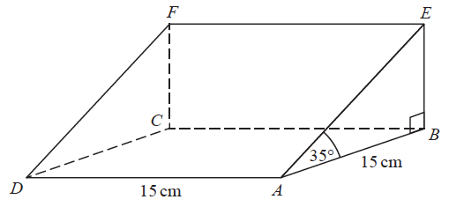

The base, *ABCD*, of the prism is a square of side length 15 cm.

Angle *ABE* and angle *CBE* are right angles.

Angle *EAB* = 35°

*M* is the point on *DA* such that

*DM* : *MA* = 2 : 3

Calculate the size of the angle between *EM* and the base of the prism.

Give your answer correct to 1 decimal place.

....................................................... °

**(Total for Question 20 is 4 marks)**

**___________________________________________________________________________**

**21** There are some small cubes and some large cubes in a bag.

The cubes are red or the cubes are yellow.

The ratio of the number of small cubes to the number of large cubes is 4 : 7

The ratio of the number of red cubes to the number of yellow cubes is 3 : 5

All the small cubes are yellow.

Work out the least possible number of large yellow cubes in the bag.

.......................................................

**(Total for Question 21 is 4 marks)**

**___________________________________________________________________________**

**22** Here is a shaded shape *ABCD*.



The shape is made from a triangle and a sector of a circle, centre *O* and radius 6 cm.

*OCD* is a straight line.

*AD* = 14 cm

Angle *AOD* = 140°

Angle *OAD* = 24°

Calculate the perimeter of the shape.

Give your answer correct to 3 significant figures.

.......................................................cm

**(Total for Question 22 is 5 marks)**

**___________________________________________________________________________**

**23** A train travelled along a track in 110 minutes, correct to the nearest 5 minutes.

Jake finds out that the track is 270 km long.

He assumes that the track has been measured correct to the nearest 10 km.

Could the average speed of the train have been greater than 160 km/h?

You must show how you get your answer.

**(Total for Question 23 is 5 marks)**

**___________________________________________________________________________**

**24** The petrol consumption of a car, in litres per 100 kilometres, is given by the formula

|  |  |
| --- | --- |
| Petrol consumption = | 100 × Number of litres of petrol used |
| Number of kilometres travelled |

Nathan’s car travelled 148 kilometres, correct to 3 significant figures.

The car used 11.8 litres of petrol, correct to 3 significant figures.

Nathan says,

“My car used less than 8 litres of petrol per 100 kilometres.”

Could Nathan be wrong?

You must show how you get your answer.

**(Total for Question 24 is 3 marks)**

**___________________________________________________________________________**

**25** Express  as a single fraction in its simplest form.

..............................................................

**(Total for Question 25 is 3 marks)**

**___________________________________________________________________________**

**26**

**

*A*, *B*, *C* and *D* are points on the circumference of a circle, centre *O*.

*FDE* is a tangent to the circle.

(*a*)Show that *y* – *x* = 90

You must give a reason for each stage of your working.

(**3**)

Dylan was asked to give some possible values for *x* and *y*.

He said,

“*y* could be 200 and *x* could be 110, because 200 – 110 = 90”

(*b*)Is Dylan correct?

You must give a reason for your answer.

......................................................................................................................................................

......................................................................................................................................................

(**1**)

(**Total for Question 26 is 4 marks**)

**___________________________________________________________________________**

**TOTAL FOR PAPER IS 80 MARKS**