YEAR 11 Revision HW for TEST 6 Foundation

Name ____________________ Teacher ______________________

Algebra | /15 | Indices & SF | /15 | Circles | /10 | Linear Graphs | /10

Q | Algebra
1. | Work out the value of 5x + 9y when x = 7 and y = –2  …………………… | (2)
2. | Work out the value of 2a² + b³ when a = 5 and b = –3  …………………… | (3)
3 | Circle the equivalent expression to 5(x + 4)  5x + 4 x⁵ + 20 5x + 20 x ⁵ + 4 | (1)
4. | - Expand 3(x − 6)  ……………………………  - Expand 4(5x + 2)  ……………………………  - Factorise 5y – 10  ……………………………  - Factorise 24y² + 16y  ……………………………  - Expand and simplify 3(4w + 1) − 5(3w − 2)  ……………………………………… | (1)  (1)  (1)  (1)  (2)
5. | Expand and simplify (2x + 1)(x − 2)  ……………………………………… | (3)
 | TOTAL | /15

Q | Indices and Standard Form
1. | Simplify  - n² × n⁶ (b) (c) (n⁶)²  ……………… ……………… ……………… | (3)
2. | Write as a single power of 9  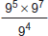 ………………… | (2)
3. | Write the following ordinary numbers in standard form:  a) 7 123 000 ………………………………  b) 0.000 789 ………………………………  c) 15.4 x 10⁷ ……………………………… | (3)
4. | Write the following standard form numbers as ordinary numbers:  a) 1.2 x 10⁻³ …………………………………  b) 8.02 x 10⁴ ………………………………… | (2)
5. | (a) Work out 2 × 10⁶ × 8 × 10⁴  Give your answer in standard form.  …………………………………  (b) Work out 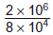  Give your answer as an ordinary number.  ………………………………… | (2)  (2)
6. | It is estimated that there are 7 500 000 000 000 000 000 grains of sand on the world’s beaches.  (Source University of Hawaii)  Write this number in standard form.  ………………………………… | (1)
 | TOTAL | /15

Q | Indices and Standard Form
1. | O is the centre of the circle. Circle the word to complete each sentence.  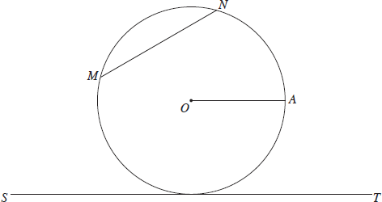  Choose from the following words:  chord circumference diameter radius tangent  (a) The line OA is a …………………………………  (b) The line MN is a …………………………………  (c) The line ST is a ………………………………… | (3)
2. | Calculate the area and circumference for this circle:  5cm  Area = ……………………….. cm²  Circumference = ………………… cm | (3)
3. | Work out the perimeter of a semi-circle of radius 6 cm. Give your answer in terms of π.  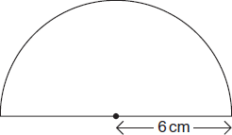  ………………… cm | (2)
4. | The diagram shows a circle inside a square. Not drawn accurately  Work out the area of the circle.  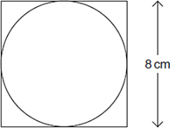 ………………… cm² | (2)
 | TOTAL | /10
Q | Linear Graphs
1. | - Complete the table for y = 3x − 1  x –3 –2 –1 0 1 2 3  y –10 –4 –1 2 8  - On the grid draw the graph of y = 3x − 1 for values of x from −3 to 3  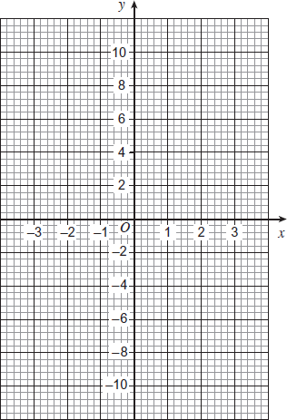 | (2)  (2)
2. | Work out the equation of line AB.  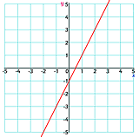 …………………………… | (2)
3. | Write down an equation which is parallel to y = 5x – 2  …………………………… | (1)
4. | Write down the coordinate where the line y = 4x + 3 crosses the y axis  (………… , …………) | (1)
5. | Work out the equation of the line passing through (2, 5) and parallel to the line y = 3x + 4  …………………………… | (2)
 | TOTAL | /10

