YEAR 11 Review Homework for assessment 4 CALCULATOR FOUNDATION

Name ____________________

Compound Measures | /10 | SA and Vol | /15 | Equations | /12 | Percentages | /10

 | Algebra: Compound measure
1. | A train timetable is shown.  Bpool South 15.16 16.16 17.16  Lytham 15.27 16.27 17.27  Preston 15.43 16.43 17.43  a) How long does it take to travel between Bpool South and Preston ………………  b) Ben has an appointment in in Preston at 16.55. What time should he get the train from Lytham station to ensure he is there on time?  ……………… | (2)
2. | A piece of metal has a mass of 800g and a volume of 40 cm³.  Find its density in g/cm³.  ………………………… g/cm³ | (1)
4. | Below is a mileage chart.  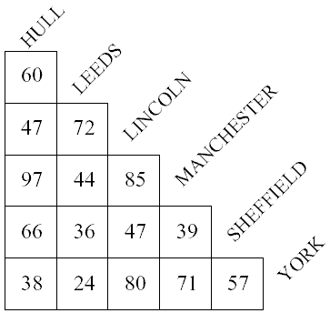  - How far is the distance between York and Leeds ………………… miles  - Jane drives from Lincoln to York. It takes her two hours. What is her averages speed?  ………………… mph | (1)  (2)
7.  F | Abbie goes for a walk.  She walks 20 miles in 6 hours.  5 miles = 8 km.  Alex says that Abbie walked more than 25 km.  Is Alex right? You must show all your working.  ……………………………………………………………………………………………………………………………………………………  ……………………………………………………………………………………………………………………………………………………  ………………………………………………………………………………………………………………………………………………… | (2)
8. | Below shows a distance time graph:  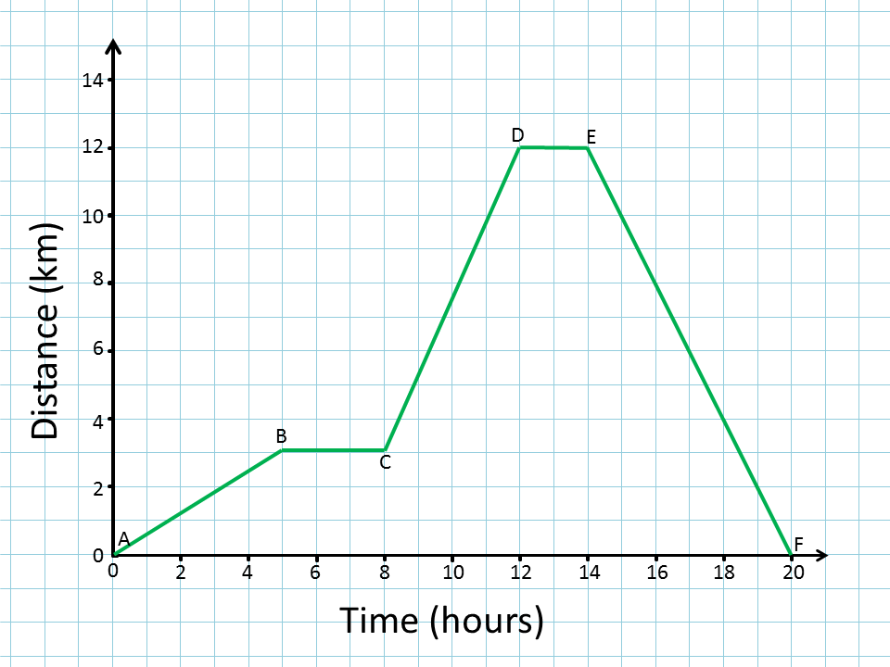  a) What is happening between points B and C  ……………………………………………………………………………  b) Calculate the speed on the return journey  …………………………………………………………………………… | (2)
 | TOTAL | /10
 | Geometry: Surface Area and Volume
1. | Sketch the net of a cylinder: | (1)
2. | How many vertices does a triangular prism have?  ……………… | (1)
3. | Find the volume of the following shape:  ………………… cm³ | (1)
4. | Calculate the volume and surface area of this solid:  4cm  5cm  6cm  Volume: Surface Area:  ………………………………………………………… …………………………………………………………  ………………………………………………………… …………………………………………………………  ………………………………………………………cm³ …………………………………………………………cm² | (2)  (3)
6. | Calculate the volume of the triangular prism:  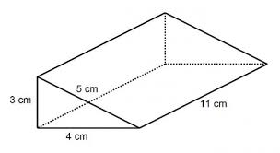  ……………cm² | (2)
 | TOTAL | /15
 | Algebra: Equations
1. | a) Solve 7x = 21  x = ………………  b) Solve x + 8 = 17  x = ………………  c) Solve  x = ………………  d) Solve 7(x - 2) = 21  x = ………………  f) Solve 8x - 6 = 3x + 39  x = ……………… | (1)  (1)  (1)  (2)  (2)
2. | Use trial and improvement to solve x² + 6x = 141 correct to 1dp  Guess for x Answer Comment  9 10 9² + 6 x 9 = 10² + 6 x 10 =  x = ……………… | (3)
 | TOTAL | /12
 | Number: Percentages
1. | a) Write 82% as a fraction (simplify your answer).  ………………  b) Write 35% as a decimal.  ……………… | (1)  (1)
2. | 42% of the students in a school travel to school by bus.  What percentage don’t travel to school by bus? ……………… % | (1)
3. | Calculate  - 15% of £80 = ………… - 45% of 320 = ………… | (4)
4. | There are 3 shops that sell the trainers that James wants. Which shop gives the best deal? You must show your working.  Shop A Shop B Shop C  £5 plus 10 payments of £4.50 20% of the usual price of £65 £50 plus 15%  ……………………………………………………………………………………………………………………………………………………  ……………………………………………………………………………………………………………………………………………………  …………………………………………………………………………………………………………………………………………………… | (3)
 | TOTAL | /10

