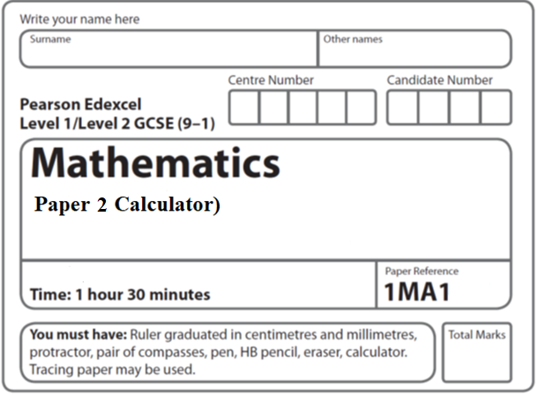

**Aiming for 7**

**Instructions**

* Use **black** ink or ball-point pen.
  + **Fill in the boxes** at the top of this page with your name,  
    centre number and candidate number.
* Answer **all** questions.
* Answer the questions in the spaces provided  
  *– there may be more space than you need.*
* You must **show all your working.**
* Diagrams are **NOT** accurately drawn, unless otherwise indicated.
* **Calculators may be used.**
* If your calculator does not have a *π* button, take the value of *π* to be3.142

unless the question instructs otherwise.

**Information**

* The total mark for this paper is 80. There are **24** questions.
* Questions have been arranged in an ascending order of mean difficulty, as found by all students in the June 2019 examinations.
* The marks for **each** question are shown in brackets  
  *– use this as a guide as to how much time to spend on each question.*

**Advice**

* Read each question carefully before you start to answer it.
* Keep an eye on the time.
* Try to answer every question.
* Check your answers if you have time at the end.

**1** A darts team is going to play a match on Saturday and on Sunday.

The probability that the team will win on Saturday is 0.45

If they win on Saturday, the probability that they will win on Sunday is 0.67

If they do **not** win on Saturday, the probability that they will win on Sunday is 0.35

(*a*)Complete the probability tree diagram.



(**2**)

(*b*)Find the probability that the team will win exactly one of the two matches.

......................................................

(**3**)

(**Total for Question 1 is 5 marks**)

**___________________________________________________________________________**

**2** *CDEF* is a quadrilateral.

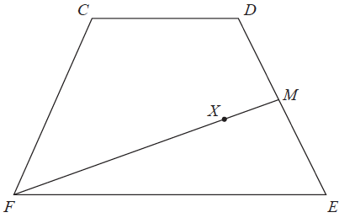

 = **a**,  = **b** and  = **a** – **b**.

Express  in terms of **a** and/or **b**.

Give your answer in its simplest form.

.......................................................

(**Total for Question 2 is 2 marks**)

**3** £360 is shared between Abby, Ben, Chloe and Denesh.

The ratio of the amount Abby gets to the amount Ben gets is 2 : 7

Chloe and Denesh each get 1.5 times the amount Abby gets.

Work out the amount of money that Ben gets.

£.......................................................

**(Total for Question 3 is 4 marks)**

**___________________________________________________________________________**

**4** At the beginning of 2009, Mr Veale bought a company.

The value of the company was £50 000.

Each year the value of the company increased by 2%.

Calculate the value of the company at the beginning of 2017.

Give your answer correct to the nearest £100.

£......................................................

(**Total for Question 4 is 2 marks**)

**5** *D* = 

*u* = 26.2 correct to 3 significant figures

*a* = 4.3 correct to 2 significant figures

Calculate the upper bound for the value of *D*.

Give your answer correct to 6 significant figures.

You must show all your working.

....................................................................

(**Total for Question 5 is 3 marks**)

**6** *OAB* is a sector of a circle with centre *O* and radius 7 cm.

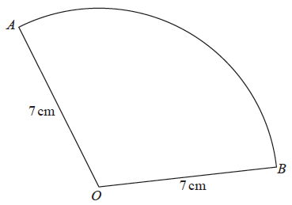

The area of the sector is 40 cm2

Calculate the perimeter of the sector.

Give your answer correct to 3 significant figures.

................................................ cm

**(Total for Question 6 is 4 marks)**

**___________________________________________________________________________**

**7** The graph shows the speed of a car, in metres per second, during the first 20 seconds of

a journey.



Work out an estimate for the distance the car travelled in the first 20 seconds.

Use 4 strips of equal width.

....................................................... metres

(**Total for Question 7 is 3 marks**)

**8** Here are the first five terms of a sequence.

|  |  |  |  |  |
| --- | --- | --- | --- | --- |
| 4 | 11 | 22 | 37 | 56 |

Find an expression, in terms of *n*, for the *n*th term of this sequence.

............................................................................................................

**(Total for Question 8 is 3 marks)**

**___________________________________________________________________________**

**9** The points *A*, *B*, *C* and *D* lie on a circle.

*CDE* is a straight line.

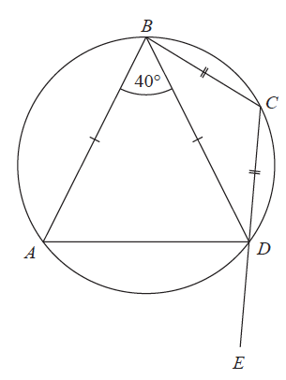

*BA* = *BD*

*CB* = *CD*

Angle *ABD* = 40°

Work out the size of angle *ADE*.

You must give a reason for each stage of your working.

**(Total for Question 9 is 5 marks)**

**___________________________________________________________________________**

**10** Using algebra, prove that  is equal in value to 

**(Total for Question 10 is 3 marks)**

**___________________________________________________________________________**

**11** Here are some graphs.



In the table below, match each equation with the letter of its graph.

|  |  |
| --- | --- |
| **Equation** | **Graph** |
| *y =* sin *x* |  |
| *y* = *x*3 + 4*x* |  |
| *y* = 2*x* |  |
| *y* = |  |

**(Total for Question 11 is 3 marks)**

**___________________________________________________________________________**

**12** (*a*)On the grid, draw the graph of *x*2 + *y*2 = 12.25

**

(**2**)

(*b*)Hence find estimates for the solutions of the simultaneous equations

*x*2 + *y*2 = 12.25

2*x* + *y* = 1

............................................................................................................

(**3**)

(**Total for Question 12 is 5 marks**)

**___________________________________________________________________________**

**13** The histogram shows information about the times taken by some students to finish a puzzle.



(*a*)Complete the frequency table for this information.

|  |  |
| --- | --- |
| **Time taken** (***t* minutes**) | **Frequency** |
| 0 < *t* ⩽ 5 | 4 |
| 5 < *t* ⩽ 15 |  |
| 15 < *t* ⩽ 25 |  |
| 25 < *t* ⩽ 30 |  |
| 30 < *t* ⩽ 50 |  |

(**2**)

(*b*)Find an estimate for the lower quartile of the times taken to finish the puzzle.

................................. minutes

(**2**)

(**Total for Question 13 is 4 marks**)

**___________________________________________________________________________**

**14** In 2003, Jerry bought a house.

In 2007, Jerry sold the house to Mia.

He made a profit of 20%

In 2012, Mia sold the house for £162 000.

She made a loss of 10%

Work out how much Jerry paid for the house in 2003.

£.......................................................

(**Total for Question 14 is 3 marks**)

**___________________________________________________________________________**

**15** Martin did this question.

|  |
| --- |
| Rationalise the denominator of |

Here is how he answered the question.

|  |  |
| --- | --- |
|  | = |
|  | = |
|  | = |
|  | = |

Martin’s answer is wrong.

(*a*)Find Martin’s mistake.

......................................................................................................................................................

......................................................................................................................................................

(**1**)

Sian did this question.

|  |
| --- |
| Rationalise the denominator of |

Here is how she answered the question.

|  |  |
| --- | --- |
|  | = |
|  | = |
|  | = |

Sian’s answer is wrong.

(*b*)Find Sian’s mistake.

......................................................................................................................................................

......................................................................................................................................................

(**1**)

(**Total for Question 15 is 2 marks**)

**___________________________________________________________________________**

**16** Make *m* the subject of the formula *f* = 

.......................................................

**(Total for Question 16 is 3 marks)**

**___________________________________________________________________________**

**17** *y* is inversely proportional to *x*3

*y* = 44 when *x* = *a*

Show that *y* = 5.5 when *x* = 2*a*

**(Total for Question 17 is 3 marks)**

**___________________________________________________________________________**

**18** Solve 22 <  < 32

Show all your working.

.............................................................................................................

**(Total for Question 18 is 5 marks)**

**___________________________________________________________________________**

**19** Show that the equation *x*3 + *x* = 7 has a solution between 1 and 2.

(**Total for Question 19 is 2 marks**)

**20** The straight line **L**1 passes through the points with coordinates (4, 6) and (12, 2)

The straight line **L**2 passes through the origin and has gradient − 3

The lines **L**1 and **L**2 intersect at point *P*.

Find the coordinates of *P*.

(................................... , ...................................)

**(Total for Question 20 is 4 marks)**

**___________________________________________________________________________**

**21** On the grid, sketch the curve with equation *y* = 2*x*

Give the coordinates of any points of intersection with the axes.



**(Total for Question 21 is 2 marks)**

**___________________________________________________________________________**

**22** On the grid, shade the region that satisfies all these inequalities.

*y* > 1 *x* + *y* < 5 *y* > 2*x*

Labe the region **R**.



**(Total for Question 22 is 3 marks)**

**___________________________________________________________________________**

**23** Show that 6 +  simplifies to where *a*, *b*, *c* and *d* are integers.

**(Total for Question 23 is 4 marks)**

**___________________________________________________________________________**

**24** Starting with *x*0 = 1, use the iteration formula *xn*+1 =  three times to find

an estimate for the solution of *x*3 + 7*x* – 5 = 0

.......................................................

(**Total for Question 24 is 3 marks**)

**___________________________________________________________________________**

**TOTAL FOR PAPER IS 80 MARKS**