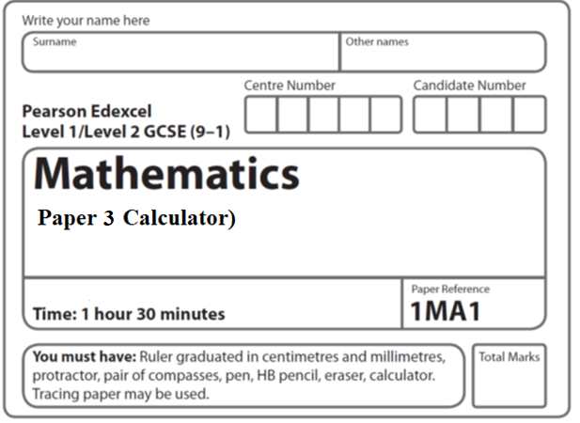

**Aiming for 7**

**Practice Paper**

**Instructions**

* Use **black** ink or ball-point pen.
  + **Fill in the boxes** at the top of this page with your name,  
    centre number and candidate number.
* Answer **all** questions.
* Answer the questions in the spaces provided  
  *– there may be more space than you need.*
* You must **show all your working.**
* Diagrams are **NOT** accurately drawn, unless otherwise indicated.
* **Calculators may be used.**
* If your calculator does not have a *π* button, take the value of *π* to be3.142

unless the question instructs otherwise.

**Information**

* The total mark for this paper is **80**. There are **22** questions.
* Questions have been arranged in an ascending order of mean difficulty, as found by all students in the June 2019 examinations.
* The marks for **each** question are shown in brackets  
  *– use this as a guide as to how much time to spend on each question.*

**Advice**

* Read each question carefully before you start to answer it.
* Keep an eye on the time.
* Try to answer every question.
* Check your answers if you have time at the end.

**1** (*a*)Show that (2*x* + 1)(*x* + 3)(3*x* + 7) can be written in the form *ax*3 + *bx*2 + *cx* + *d­*,

where *a*, *b*, *c* and *d* are integers.

**(3)**

(*b*)Solve (1 – *x*)2< 

.......................................................

**(3)**

**(Total for Question 1 is 6 marks)**

**___________________________________________________________________________**

**2** Work out (3.42 × 10−7) ÷ (7.5 × 10−6)

Give your answer in standard form.

.......................................................

**(Total for Question 2 is 2 marks)**

**___________________________________________________________________________**

**3** *ABC* is a right-angled triangle.

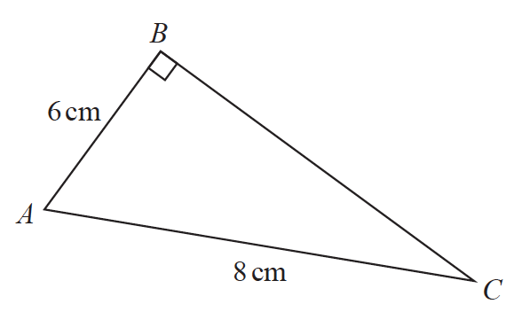

Here is Sarah’s method to find the length of *BC*.

*BC* 2 = *AB* 2 + *AC* 2

= 62 + 82

= 100

*BC* = 10

(*a*)What mistake has Sarah made in her method?

......................................................................................................................................................

......................................................................................................................................................

......................................................................................................................................................

**(1)**

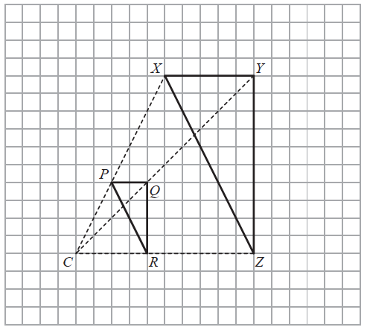

Roy is going to enlarge triangle *PQR* with centre *C* and scale factor 1

He draws triangle *XYZ*.

(*b*)Explain why Roy’s diagram is **not** correct.

......................................................................................................................................................

......................................................................................................................................................

......................................................................................................................................................

**(1)**

**(Total for Question 3 is 2 marks)**

**___________________________________________________________________________**

**4** The graph shows the volume of liquid (*L* litres) in a container at time *t* seconds.



(*a*)Find the gradient of the graph.

.......................................................

(**2**)

(*b*)Explain what this gradient represents.

......................................................................................................................................................

......................................................................................................................................................

(**1**)

The graph intersects the volume axis at *L* = 4

(*c*)Explain what this intercept represents.

......................................................................................................................................................

......................................................................................................................................................

(**1**)

(**Total for Question 12 is 4 marks**)

**___________________________________________________________________________**

**5** Starting with *x*0 = 2,

use the iteration formula *xn* + 1 = three times to find an estimate for a

solution of *x*3 + *x* = 7

.......................................................

(**Total for Question 5 is 3 marks**)

**___________________________________________________________________________**

**6** Here are the first six terms of a quadratic sequence.

|  |  |  |  |  |  |
| --- | --- | --- | --- | --- | --- |
| −1 | 5 | 15 | 29 | 47 | 69 |

Find an expression, in terms of *n*, for the *n*th term of this sequence.

.......................................................

**(Total for Question 6 is 3 marks)**

**___________________________________________________________________________**

**7** There are only red counters and blue counters in a bag.

Joe takes at random a counter from the bag.

The probability that the counter is red is 0.65

Joe puts the counter back into the bag.

Mary takes at random a counter from the bag.

She puts the counter back into the bag.

There are 78 red counters in the bag.

How many blue counters are there in the bag?

..............................................................

**(Total for Question 7 is 2 mark)**

**___________________________________________________________________________**

**8** There are 30 students in Mr Lear’s class.

16 of the students are boys.

Two students from the class are chosen at random.

Mr Lear draws this probability tree diagram for this information.



(*a*)Write down **one** thing that is wrong with the probabilities in the probability tree diagram.

......................................................................................................................................................

......................................................................................................................................................

**(1)**

Owen and Wasim play for the school football team.

The probability that Owen will score a goal in the next match is 0.4.

The probability that Wasim will score a goal in the next match is 0.25.

Mr Slater says,

“The probability that both boys will score a goal in the next match is 0.4 + 0.25”

(*b*)Is Mr Slater right?

Give a reason for your answer.

......................................................................................................................................................

......................................................................................................................................................

**(1)**

**(Total for Question 8 is 2 marks)**

**9** Jean invests £12 000 in an account paying compound interest for 2 years.

In the first year the rate of interest is *x*%

At the end of the first year the value of Jean’s investment is £12 336

In the second year the rate of interest is %

What is the value of Jean’s investment at the end of 2 years?

£......................................................

(**Total for Question 9 is 4 marks**)

**___________________________________________________________________________**

**10** (*a*) Simplify 

.......................................................

**(3)**

(*b*)Make *v* the subject of the formula 

.......................................................

**(3)**

**(Total for Question 10 is 6 marks)**

**___________________________________________________________________________**

**11** Jeremy has to cover 3 tanks completely with paint.

Each tank is in the shape of a cylinder with a top and a bottom.

The tank has a diameter of 1.6 m and a height of 1.8 m.

Jeremy has 7 tins of paint.

Each tin of paint covers 5 m2

Has Jeremy got enough paint to cover completely the 3 tanks?

You must show how you get your answer.

**(Total for Question 11 is 5 marks)**

**___________________________________________________________________________**

**12** The graph shows the speed of a car, in metres per second, during the first 20 seconds of

a journey.



(*a*)Work out an estimate for the distance the car travelled in the first 20 seconds.

Use 4 strips of equal width.

....................................................... metres

(**3**)

(*b*)Is your answer to part (*a*) an underestimate or an overestimate of the actual distance

the car travelled in the first 20 seconds?

Give a reason for your answer.

......................................................................................................................................................

......................................................................................................................................................

(**1**)

(**Total for Question 12 is 4 marks**)

**___________________________________________________________________________**

**13** Here are four graphs.

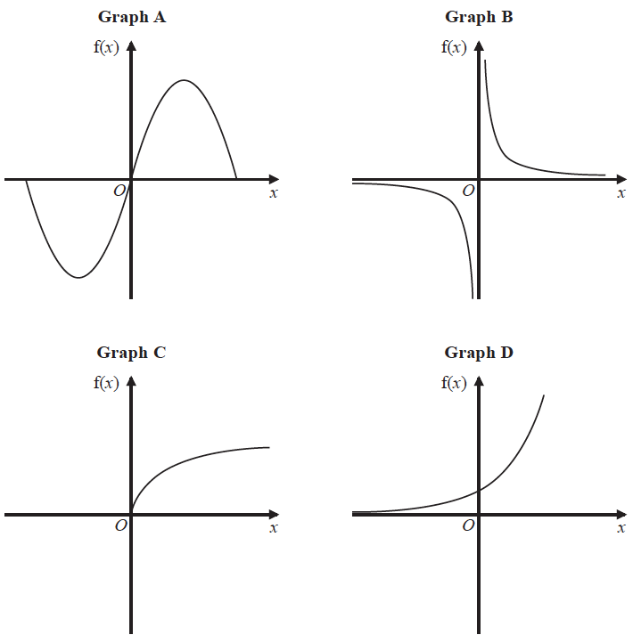

The graphs represent four different types of function f.

Match each description of the function in the table to the letter of its graph.

|  |  |
| --- | --- |
| **Description of function** | **Graph** |
| f(*x*) is inversely proportional to *x* |  |
| f(*x*) is a trigonometrical function |  |
| f(*x*) is an exponential function |  |
| f(*x*) is directly proportional to |  |

**(Total for Question 13 is 2 marks)**

**___________________________________________________________________________**

**14**

**

*ONQ* is a sector of a circle with centre *O* and radius 11 cm.

*A* is the point on *ON* and *B* is the point on *OQ* such that *AOB*

is an equilateral triangle of side 7 cm.

Calculate the area of the shaded region as a percentage of the area of the sector *ONQ.*

Give your answer correct to 1 decimal place.

......................................................%

**(Total for Question 14 is 5 marks)**

**___________________________________________________________________________**

**15** The table shows information about the distances 570 students travelled to a university

open day.

|  |  |
| --- | --- |
| **Distance (*d* miles)** | **Frequency** |
| 0 < *d* ⩽ 20 | 120 |
| 20 < *d* ⩽ 50 | 90 |
| 50 < *d* ⩽ 80 | 120 |
| 80 < *d* ⩽ 150 | 140 |
| 150 < *d* ⩽ 200 | 100 |

Draw a histogram for the information in the table.



**(3)**

**(Total for Question 15 is 3 marks)**

**___________________________________________________________________________**

**16** The number of animals in a population at the start of year *t* is *Pt*

The number of animals at the start of year 1 is 400

Given that

*Pt* + 1 = 1.01*Pt*

work out the number of animals at the start of year 3

.......................................................

**(Total for Question 16 is 2 marks)**

**___________________________________________________________________________**

**17** A car moves from rest.

The graph gives information about the speed, *v* metres per second, of the car *t* seconds

after it starts to move.

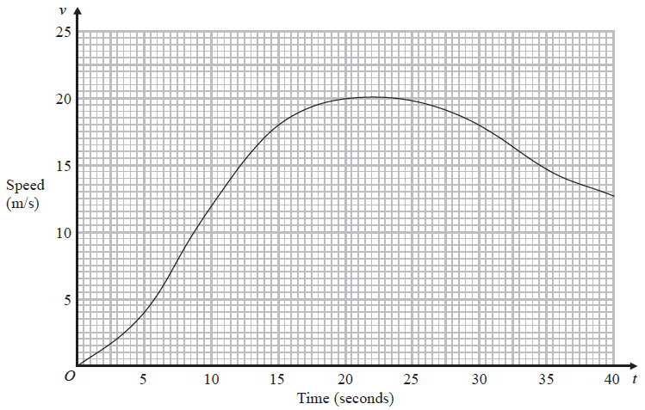

(i) Calculate an estimate of the gradient of the graph at *t* = 15

.......................................................

**(3)**

(ii) Describe what your answer to part (i) represents.

......................................................................................................................................................

**(1)**

**(Total for Question 17 is 4 marks)**

**___________________________________________________________________________**

**18**



Write down the three inequalities that define the shaded region.

.......................................................

.......................................................

.......................................................

**(Total for Question 18 is 4 marks)**

**___________________________________________________________________________**

**19** At the beginning of 2009, Mr Veale bought a company.

The value of the company was £50 000.

Each year the value of the company increased by 2%.

(*a*) Calculate the value of the company at the beginning of 2017.

Give your answer correct to the nearest £100.

£......................................................

**(2)**

At the beginning of 2009 the value of a different company was £250 000.

In 6 years the value of this company increased to £325 000.

This is equivalent to an increase of *x*% each year.

(*b*) Find the value of *x*.

Give your answer correct to 2 significant figures.

......................................................

**(3)**

**(Total for Question 19 is 5 marks)**

**___________________________________________________________________________**

**20** The straight line **L** has the equation 3*y* = 4*x* + 7

The point *A* has coordinates (3, −5)

Find an equation of the straight line that is perpendicular to **L** and passes through *A*.

..................................................................................

**(Total for Question 20 is 3 marks)**

**___________________________________________________________________________**

**21** Show that 6 +  simplifies to where *a*, *b*, *c* and *d* are integers.

**(Total for Question 21 is 4 marks)**

**___________________________________________________________________________**

**22** *OXYZ* is a parallelogram.

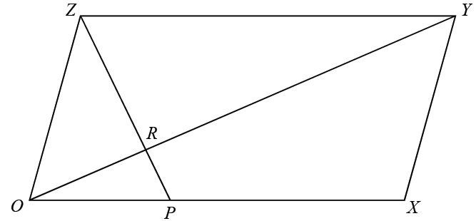

 = **a**

 = **b**

P is the point on *OX* such that *OP* : *PX* = 1 : 2

R is the point on *OY* such that *OR* : *RY* = 1 : 3

Work out, in its simplest form, the ratio *ZP* : *ZR*

You must show all your working.

.......................................................

**(Total for Question 22 is 5 marks)**

**TOTAL FOR PAPER IS 80 MARKS**