Curriculum
The KS3 curriculum is designed to develop students’ understanding of the world as the home of humankind and the important role they play within it. As students’ progress on their learning journey, will consolidate and extend their knowledge of the world’s major countries and their physical and human features. Develop their understanding of how geographical processes interact to create distinctive human and physical landscapes that change over time. Meaning that learners become aware of increasingly complex geographical systems in the world around them. Learners will also develop greater competence in using geographical knowledge, approaches and concepts and geographical skills in analysing and interpreting different data sources. In this way learners will continue to enrich their locational knowledge and spatial and environmental understanding.
Source:https://assets.publishing.service.gov.uk/government/uploads/system/uploads/attachment_data/file/239087/SECONDARY_national_curriculum_-_Geography.pdf
Year 7 learning Journey 2022-2025
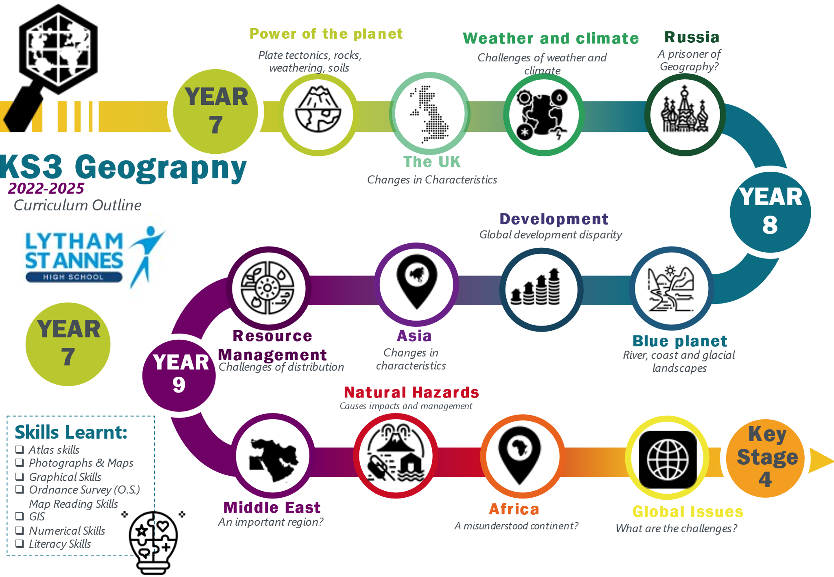
Year 8 learning journey 2021-2024
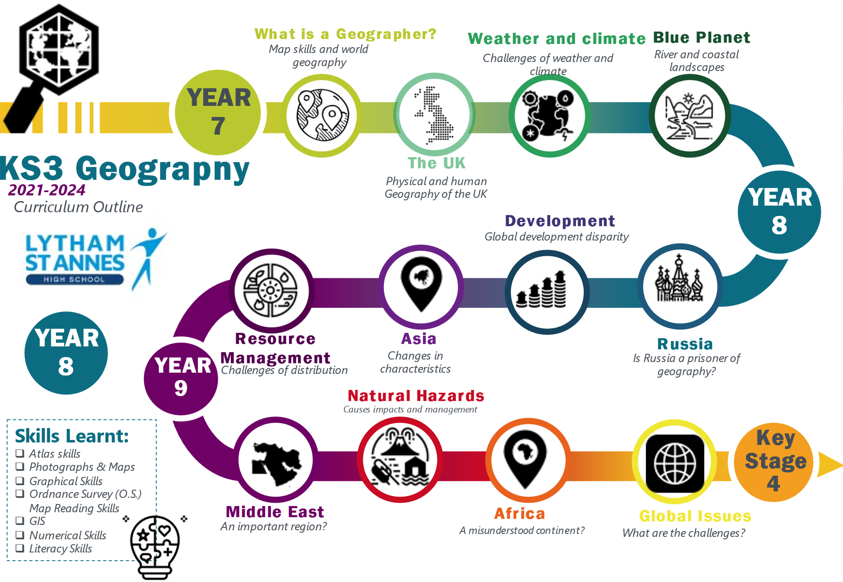
Year 9 learning journey 2020-2023
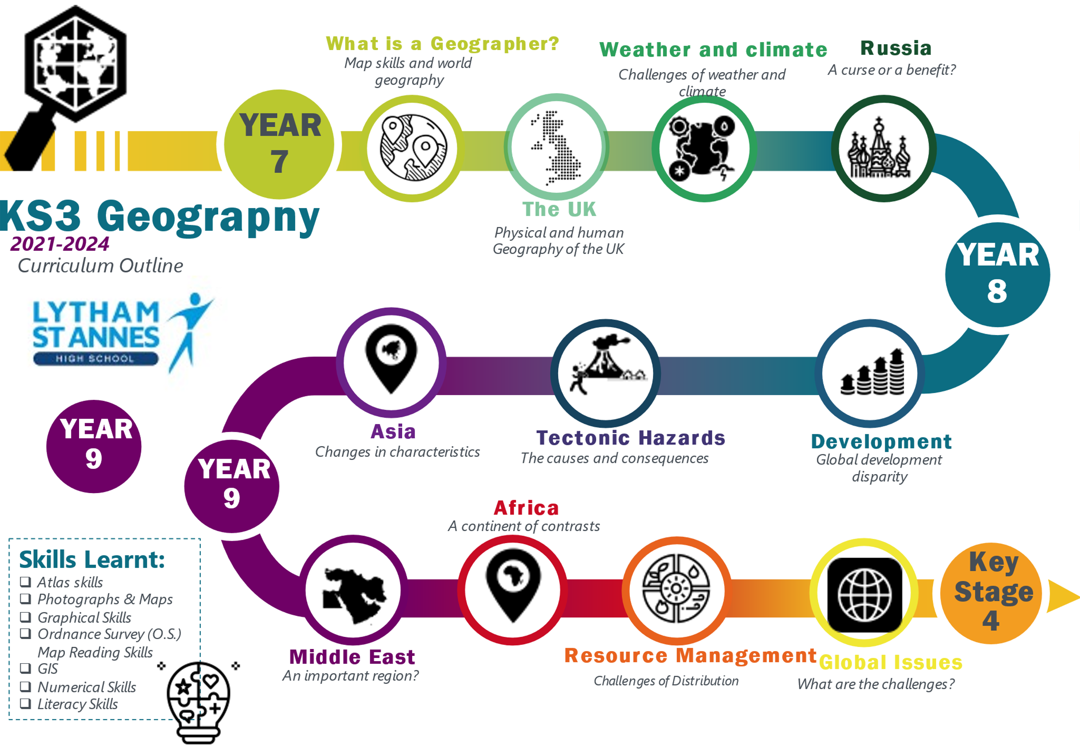
KS4 (years 10-11) The GCSE course covers key elements from the physical and human world helping students to develop the geographical skills that are essential to understand the world around them and the interaction of physical and human processes. Students will explore examples and case studies in the United Kingdom, higher income countries, newly emerging economies and lower income countries. The topics covered over the GCSE course include; the challenge of natural hazards, the living world (ecosystems, tropical rainforests and hot deserts) physical landscapes in the UK (coasts and rivers), urban issues and challenges, the changing economic world and the challenge of resource management, as well as an issue evaluation paper which provides opportunities for fieldwork.
For more information: https://www.aqa.org.uk/subjects/geography/gcse/geography-8035/specification-at-a-glance
Year 10 learning journey 2022-2024
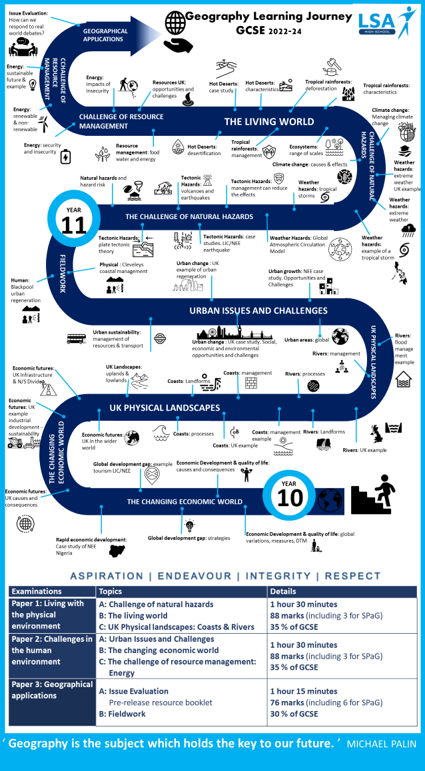
Year 11 learning journey 2021-2023
