Curriculum Map for Creative Media Production Years 10 to 11
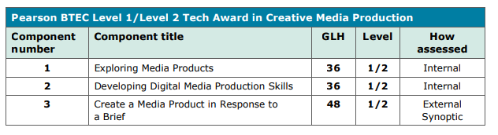
The three components focus on the assessment of knowledge, skills and practices. These are all essential to developing a basis for progression and, therefore, learners need to achieve all components to achieve the qualification.
The components are interrelated, and they are best seen as part of an integrated whole rather than as totally distinct study areas. Due to the nature of the content and assessment they are taught in component order. In Year 10 Component 1 will be delivered and internally assessed. Additionally, Component 2 will be started and finished in Year 11. Component 3 will start in the Spring Term of Year 11.
Internal assessment
Components 1 and 2 are assessed through internal assessment. The components focus on:
- The development of core knowledge and understanding, including the range of different types of media products, production processes and techniques
- The development and application of skills such as research skills and stylistic and technical skills
- Reflective practice through the refinement of learners’ own media products that allows them to respond to feedback and identify areas for improvement.

Internal assessment is through assignments that are subject to external standards verification.

External synoptic assessment
There is one external assessment, Component 3, which provides the main synoptic assessment for the qualification. Component 3 builds directly on Components 1 and 2 and enables learning to be brought together and related to a real-life situation. It requires learners to apply their production skills to the creation of a media product in response to a brief. The design of this external assessment ensures that there is sufficient stretch and challenge, enabling the assessment of knowledge and understanding at the end of the learning period. The external assessment is based on a key task that requires learners to demonstrate that they can identify and use effectively an appropriate selection of skills, techniques, concepts, theories and knowledge from across the whole qualification in an integrated way. The external assessment takes the form of a set task taken under supervised conditions that is then marked and a grade awarded by Pearson.

