Test 1 Revision Topics 1-4
Topic 1 | The maximum safe load of a bridge is 1500 kg to the nearest 10 kg.  An average soldier is 75 kg to the nearest kilogram.  Work out an estimate for the maximum number of soldiers that can safely cross the bridge at the same time. | In human blood, the ratio of white blood cells to red blood cells is  1 : 700 where 700 is given to the nearest 100.  A man has 3 × 10¹³ red blood cells to one significant figure.  Calculate the minimum number of white blood cells in this man’s blood.  Give your answer in standard form. | x = 400 to 1 significant figure.  y = 25 to 2 significant figures.  Work out the maximum integer value of $\frac{x}{y}$ . |  | The area of this trapezium is  280 cm² to the nearest 10 cm²  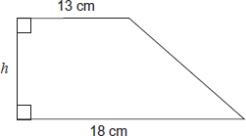  The lengths 13 cm and 18 cm are given to the nearest centimetre.  Work out the maximum possible value of the height h.
Topic 1 | Express $0.3\dot{2}$ as a fraction in its simplest form. | Express $0.\dot{2}1\dot{7}$ as a fraction in its simplest form. | Using algebra, prove that  $0.1\dot{3}\dot{6}×0.\dot{2}$ is equal in value to $\frac{1}{33}$ |  | $x=0.0\dot{4}\dot{5}$ Prove algebraically that x can be written as $\frac{1}{22}$
Topic 2 | a) x² + a x + b ≡ (x – 3)² – a where a and b are integers.  Work out the values of a and b.  b) What is the smallest possible value of (x – 7)² + 2 | Express 2x ² − 12x − 7 in the form a(x + b)² + c | The n^{th} term of a different sequence is n² – 6n + 14  By completing the square, or otherwise, show that every term is positive. |  | 2x² – 6x + 5 can be written in the form a(x – b)² + c  where a, b and c are positive numbers.  Work out the values of a, b and c
Topic 3 | The box plot shows the time spent revising by pupils in a class.  If 21 pupils spent more than 2 hours revising, how many pupils were in the class?  0 1 2 3 4 5 6 hours | The box plot displays the heights of 60 plants.  How many plants were smaller than 12 cm?  How many plants were taller than 12.7 cm?  11 12 13 cm | 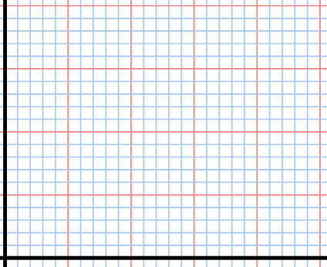  Test mark  0 5 10 15 20  20  10  Cumulative freq |  | What was the median mark out of 20?  What was the interquartile range?  If 85% of people must pass the test, what should the score to pass be?
Topic 4 | Write these numbers in order of size starting with the smallest.  You must show your working. | Work out the value of  Work out the value of | Put these in order starting with the smallest.  You must show the value of each number in your working.  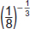 |  | Work out all solutions of the equation  $8^{m}=2^{m^{2}}$
Topic 4 | Rationalise $\frac{12}{\sqrt{3}}$  Rationalise $\frac{2}{\sqrt{12}}$ | Rewrite in surd form $\sqrt{20}$  Rewrite in surd form $\sqrt{75}$ | Expand and simplify  $$\left(\sqrt{2}+5\right)\left(2\sqrt{2}-2\right)$$ | Rationalise $\frac{5}{\sqrt{3}+2}$

