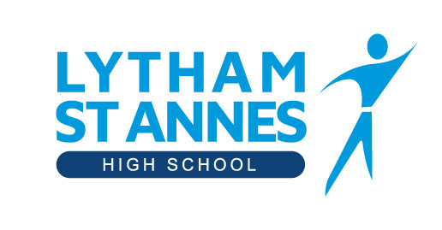

Governing Body Membership 2020-21
Name Type of Governor Term of Office ends
Mr John Cronin Foundation Governor September 2023
Vacancy Foundation Governor
Mr Tim Armit Co-Opted Governor September 2024
Mrs Lynn Davies Co-Opted Governor September 2023
Mr Allan Foster Co-Opted Governor September 2023
Mrs Beverley Harrison Co-Opted Governor July 2022
Mr Neil Harvey Co-Opted Governor September 2023
Mr Andrew Mills Co-Opted Governor December 2023
Miss Sarah Nicholson Co-Opted Governor July 2022
Mrs Mandy Palmer Co-Opted Governor December 2020
Ms Laura Gibbons Staff Governor September 2023
Mrs Joanna Allitt Parent Governor September 2023
Mrs Caroline Goodridge Parent Governor June 2023
Mr Mike Hardaker Parent Governor September 2023
Mrs Carmel Lynskey Parent Governor December 2023

