Guide for Students using online lessons in Teams
Load up teams on your computer / laptop
Click on the Calendar

Find today’s date and click on the lesson for period 1 | 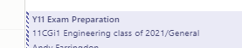
This will give information about the lesson and the opportunity to Join. Click Join | 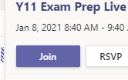
The screen will allow you to select your camera and mic options.  Most lessons will expect you to leave your camera off and your mic may be muted when the teacher is presenting. Click on the join now button when you are ready to enter the lesson. | 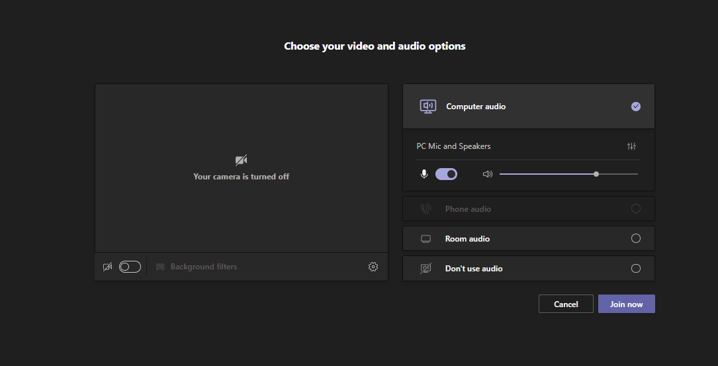
Now you are in the lesson you will have some control options. These allow you to change your camera and mic setting, raise your hand and add to the in-meeting chat. | 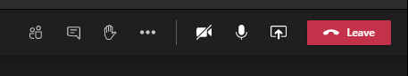
Your teacher will start the lesson. Please be aware that all lessons are recorded and saved ion the post section of the team in case you need to refer back to the information. | 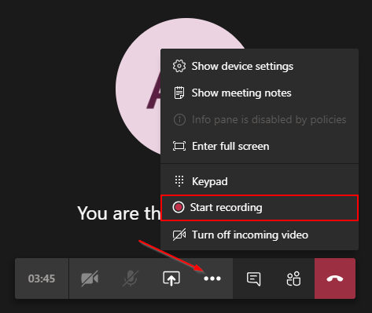
During your lessons you are likely to be asked to complete a range of different tasks for different subjects. Your teacher will explain how to do this.

When the lesson is complete then you must click the Leave button in the top right of the screen to exit the lesson. | 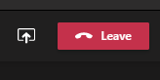
You are now ready to join your next lesson. Follow the same instructions but this time click on the period 2 lesson.

