IMPACT SUMMARY

OUR IMPROVEMENT JOURNEY
What changed in 2025/26 and what comes next
For Parents and Carers | September 2026
Proud to be LSA
Celebrating the progress of 2025/26 and setting out how the 2026/27 priorities will move our school forward.
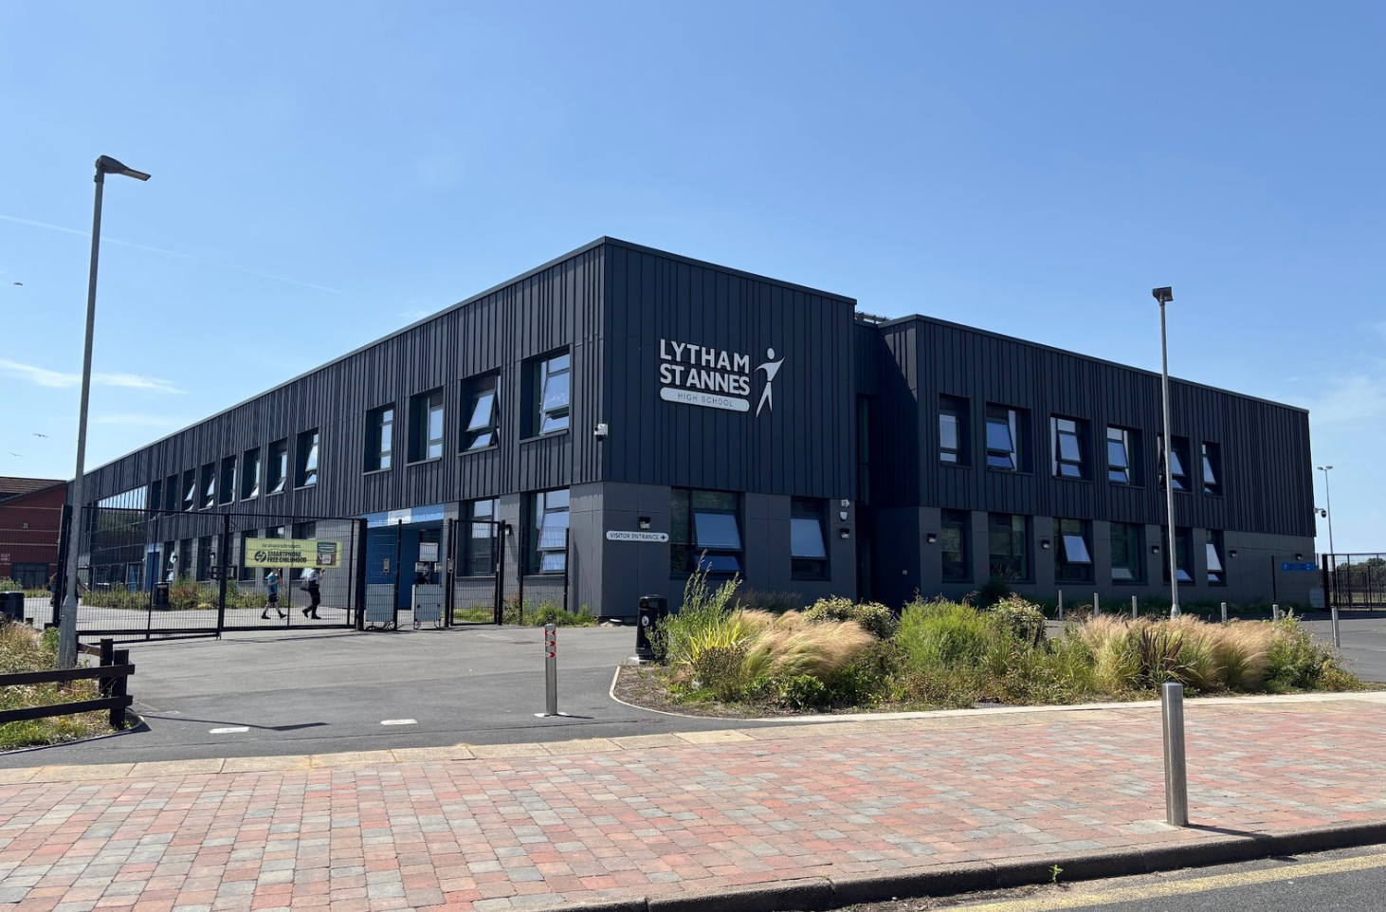

A message to families
During 2025/26, Lytham St Annes High School focused on building strong foundations for lasting improvement. We introduced clearer routines, strengthened safeguarding and attendance systems, improved curriculum planning and used evidence more carefully to decide what should happen next. There is much to celebrate, alongside important work still to do.
In simple terms
The school is moving forward. Students are benefiting from clearer expectations, stronger systems and improving support. In 2026/27, our focus is to make these improvements consistent in every classroom and to ensure that students who face additional barriers make faster progress.

What improved in 2025/26?
Our focus | Progress in 2025/26 | What families should see in 2026/27
Clear leadership | The school now has a more focused improvement cycle, clearer accountability and stronger use of information to guide decisions. | Parents and carers will receive regular, straightforward updates about progress and next steps.
Learning | KS3 curriculum plans are established, lesson starts and routines improved, and reading support developed. | A new KS3 assessment framework and stronger adaptive teaching will help teachers identify gaps and respond more quickly. Parents of key stage 3 students will receive detailed academic information
Results | 2026 results were strong, with improved higher grades and sustained gains for disadvantaged students and students with SEND compared. | Targeted support in English, mathematics, reading and key subjects will focus on helping more students secure strong outcomes.
Attendance | Whole-school attendance improved and persistent absence reduced, although attendance remains below national levels. | The school will work earlier and more closely with students and families, aiming for attendance and persistent absence to be better than national levels.
Behaviour | Internal truancy reduced, uniform standards remained strong and school routines became clearer. | More consistent routines, rules and focused help for students with repeated difficulties. Aim to reduce lost learning and improve student behaviour.
Safety and support | Safeguarding structures, communication and oversight were strengthened. SEND and inclusion systems also improved, though their impact is not yet consistent enough. | Earlier safeguarding support, reviewed risk assessments, joined-up vulnerability tracking and timely SEND reviews will improve coordination and confidence.
Wider opportunities | The school provides a wide enrichment offer and strong careers education. | The plan aims to increase participation for all students and use student feedback to strengthen wellbeing support.

What the 2026/27 targets mean for your child

More consistent lessons
Staff training, coaching and checks on classroom practice will help ensure students experience clear routines, appropriate challenge and support that responds to their needs.

Earlier identification of need
Reading assessments, KS3 assessment and a single vulnerability tracking system will help staff spot barriers earlier and coordinate the right support.

Better attendance and fewer lost learning days
Focused support, earlier contact and joined-up work between attendance, pastoral, safeguarding and SEND teams will help more students attend regularly and remain engaged in lessons.

Stronger outcomes for students who face barriers
The plan gives specific attention to disadvantaged students, students with SEND and vulnerable learners, with targets for attendance, reviews, reading and English and mathematics outcomes.

A stronger voice for families and students
Regular communication, parent and student voice, and published impact reports will help the community understand progress and contribute to improvement.

A richer school experience
The school will continue to develop enrichment, personal development, careers and wellbeing so that success includes confidence, participation, belonging and readiness for the future.

How families can support the next stage
- Promote excellent attendance and punctuality wherever possible, and contact school early when support is needed.
- Encourage daily reading, independent study and participation in revision or intervention when offered.
- Reinforce school routines, uniform and phone expectations so that learning time is protected.
- Use school communication channels and share feedback constructively.
- Encourage your child to join clubs, activities, leadership opportunities and careers events.
- Celebrate effort, improvement, attendance and positive contribution, as well as examination results.

Our promise to the community
We will be open about progress
We will celebrate success, identify concerns honestly and explain the actions being taken. Improvement will be judged by the difference it makes to students: their safety, attendance, learning, wellbeing, participation and future opportunities.

Together, we are moving forward
The progress made in 2025/26 reflects the commitment, expertise and care of our staff, the effort and resilience of our students, and the confidence and partnership of our families and wider community. The next stage is ambitious because our young people deserve the very best. By working together, reviewing impact honestly and acting with consistency, we will turn stronger systems into stronger daily experiences and stronger outcomes for every learner.
To every colleague, student, family member, governor, trustee and community partner: thank you for the part you have played. We celebrate what has been achieved, we are clear about what must improve, and we look ahead with confidence. Proud to be LSA.

