Non-Calculator Overlap questions November 2019 Paper 1

20/1 Find the Lowest Common Multiple (LCM) of 108 and 120

.......................................................
(3)

___________________________________________________________________________________________________________________________________________________________________________________________________________________________________________________________________________________________________________________________________________________________________________________________________________________________________________________________________

21/2 There are 60 people in a choir.
Half of the people in the choir are women.
The number of women in the choir is 3 times the number of men in the choir.
The rest of the people in the choir are children.
the number of children in the choir : the number of men in the choir = n : 1
Work out the value of n.
You must show how you get your answer.

n = .......................................................
(4)

___________________________________________________________________________________________________________________________________________________________________________________________________________________________________________________________________________________________________________________________________________________________________________________________________________________________________________________________________
22/3 Work out
Give your answer as a mixed number.

.......................................................
(3)

___________________________________________________________________________________________________________________________________________________________________________________________________________________________________________________________________________________________________________________________________________________________________________________________________________________________________________________________________

23/4 Use a ruler and compasses to construct the line from the point P perpendicular to the line CD.
You must show all construction lines.

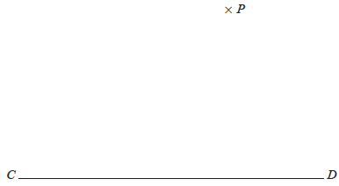

(2)

___________________________________________________________________________________________________________________________________________________________________________________________________________________________________________________________________________________________________________________________________________________________________________________________________________________________________________________________________

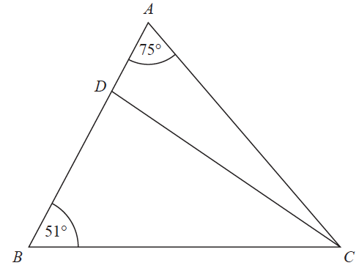
24/5 The diagram shows triangle ABC.

ADB is a straight line.
the size of angle DCB : the size of angle ACD
= 2 : 1
Work out the size of angle BDC.

....................................................... °
(4)

___________________________________________________________________________________________________________________________________________________________________________________________________________________________________________________________________________________________________________________________________________________________________________________________________________________________________________________________________

25/6 4 red bricks have a mean weight of 5 kg.
5 blue bricks have a mean weight of 9 kg.
1 green brick has a weight of 6 kg.
Donna says, “The mean weight of the 10 bricks is less than 7 kg.”
Is Donna correct? You must show how you get your answer.

(3)

___________________________________________________________________________________________________________________________________________________________________________________________________________________________________________________________________________________________________________________________________________________________________________________________________________________________________________________________________
26/7 (a) Simplify (p²)⁵

.......................................................
(1)
(b) Simplify 12x⁷y³ ÷ 6x³y

.......................................................
(2)

___________________________________________________________________________________________________________________________________________________________________________________________________________________________________________________________________________________________________________________________________________________________________________________________________________________________________________________________________

27/8 The accurate scale drawing shows the positions of port P and a lighthouse L.

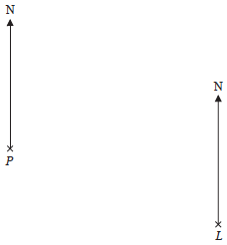

Scale: 1 cm represents 4 km.

Aleena sails her boat from port P on a bearing of 070°
She sails for $1\frac{1}{2}$ hours at an average speed of 12 km/h to a port Q.
Find (i) the distance, in km, of port Q from lighthouse L,
(ii) the bearing of port Q from lighthouse L.

distance QL = ....................................................... km
bearing of Q from L = ....................................................... °
(4)

TOTAL FOR PAPER: 26 MARKS

