Calculator Overlap questions November 2019 Paper 2

21/1 The table shows some information about the weights of 50 potatoes.
Weight (w grams) | Frequency
10 < w ≤ 20 | 6
20 < w ≤ 30 | 21
30 < w ≤ 40 | 13
40 < w ≤ 50 | 7
50 < w ≤ 60 | 3

Iveta drew this frequency polygon for the information in the table.
The frequency polygon is not fully correct.
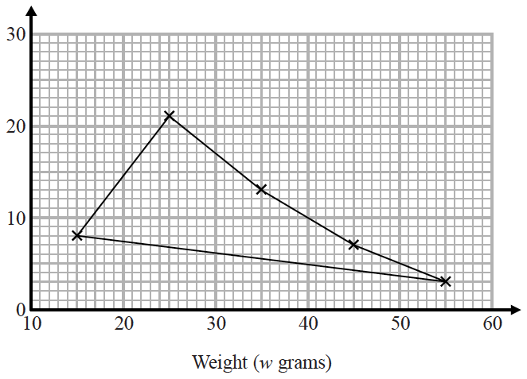

Write down two things that are wrong with the frequency polygon.
1....................................................................................................................................................
2....................................................................................................................................................
(2)

___________________________________________________________________________________________________________________________________________________________________________________________________________________________________________________________________________________________________________________________________________________________________________________________________________________________________________________________________

22/2 The length of a pencil is 128 mm correct to the nearest millimetre.
Complete the error interval for the length of the pencil.

......................... mm ⩽ length < ......................... mm
(2)

___________________________________________________________________________________________________________________________________________________________________________________________________________________________________________________________________________________________________________________________________________________________________________________________________________________________________________________________________

27/7 Work out (3.42 × 10⁻⁷) ÷ (7.5 × 10⁻⁶)
Give your answer in standard form.

.......................................................
(2)

___________________________________________________________________________________________________________________________________________________________________________________________________________________________________________________________________________________________________________________________________________________________________________________________________________________________________________________________________
23/3 Tom and Adam have a total of 240 stamps.
The ratio of the number of Tom’s stamps to the number of Adam’s stamps is 3 : 7
Tom buys some stamps from Adam.
The ratio of the number of Tom’s stamps to the number of Adam’s stamps is now 3 : 5
How many stamps does Tom buy from Adam?
You must show all your working.

.......................................................
(4)

___________________________________________________________________________________________________________________________________________________________________________________________________________________________________________________________________________________________________________________________________________________________________________________________________________________________________________________________________

Gift | Number of people
sports bag | 17
gym towel | 7
headphones | 11
voucher | 15
24/4 Each person in a fitness club is going to get a free gift.
Stan is going to order the gifts.
Stan takes a sample of 50 people in the fitness club.
He asks each person to tell him the gift they would like.
The table shows information about his results.

There are 700 people in the fitness club.
(i) Work out how many sports bags Stan should order.

.......................................................
(2)
(ii) Write down any assumption you made and explain how this could affect your answer.
......................................................................................................................................................
......................................................................................................................................................
......................................................................................................................................................
(1)

___________________________________________________________________________________________________________________________________________________________________________________________________________________________________________________________________________________________________________________________________________________________________________________________________________________________________________________________________

25/5 Here are six graphs.
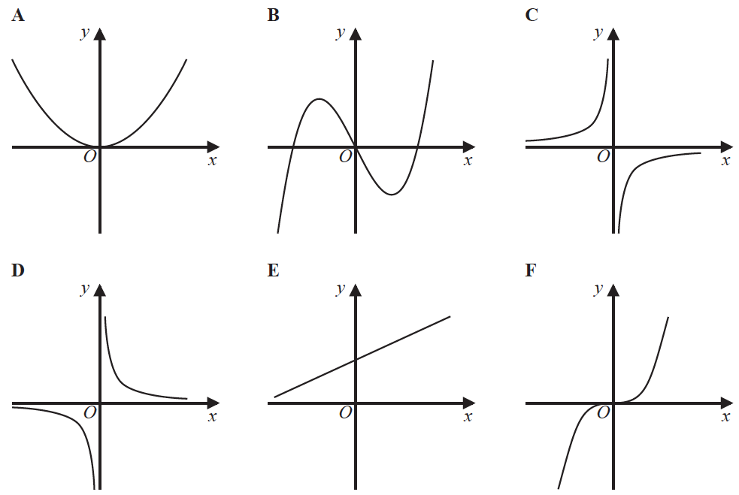
Write down the letter of the graph that could have the equation
(a) y = x³

.......................................................
(1)
(b) y =
.......................................................
(1)

___________________________________________________________________________________________________________________________________________________________________________________________________________________________________________________________________________________________________________________________________________________________________________________________________________________________________________________________________

26/6 The nth term of a sequence is 2n² − 1
The nth term of a different sequence is 40 − n²
Show that there is only one number that is in both of these sequences.

(3)

___________________________________________________________________________________________________________________________________________________________________________________________________________________________________________________________________________________________________________________________________________________________________________________________________________________________________________________________________

28/8 The number of days, d, that it will take to build a house is given by
d =
where n is the number of workers used each day.
Ali’s company will take 40 days to build the house.
Hayley’s company will take 30 days to build the house.
Hayley’s company will have to use more workers each day than Ali’s company.
How many more?

.......................................................
(3)

___________________________________________________________________________________________________________________________________________________________________________________________________________________________________________________________________________________________________________________________________________________________________________________________________________________________________________________________________
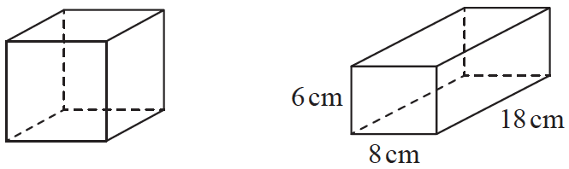
29/9 The diagram shows a cube and a cuboid.

The total surface area of the cube is equal to the total surface area of the cuboid.
Janet says, “The volume of the cube is equal to the volume of the cuboid.”
Is Janet correct?
You must show how you get your answer.

(5)

___________________________________________________________________________________________________________________________________________________________________________________________________________________________________________________________________________________________________________________________________________________________________________________________________________________________________________________________________
TOTAL FOR PAPER IS 26 MARKS

