Calculator Overlap questions November 2019 Paper 3

22/1 (a) Expand and simplify (x + 5)(x – 9)

.......................................................
(2)
(b) Factorise fully 9x² + 6x

.......................................................
(2)

___________________________________________________________________________________________________________________________________________________________________________________________________________________________________________________________________________________________________________________________________________________________________________________________________________________________________________________________________
23/2 (a) Use your calculator to work out
Write down all the figures on your calculator display.

..................................................................................
(2)
(b) Write your answer to part (a) correct to 4 significant figures.

.......................................................
(1)

____________________________________________________________________________________________________________________________________________________________________________________________________________________________________________________________________________________________________________________________________________________________________________________________________________________________________________________________

26/5 Write 37 cm³ in mm³

.......................................................mm³
(1)

___________________________________________________________________________________________________________________________________________________________________________________________________________________________________________________________________________________________________________________________________________________________________________________________________________________________________________________________________

24/3 The scatter graph shows information about the marks a group of students got in a Science
test and in a Maths test.
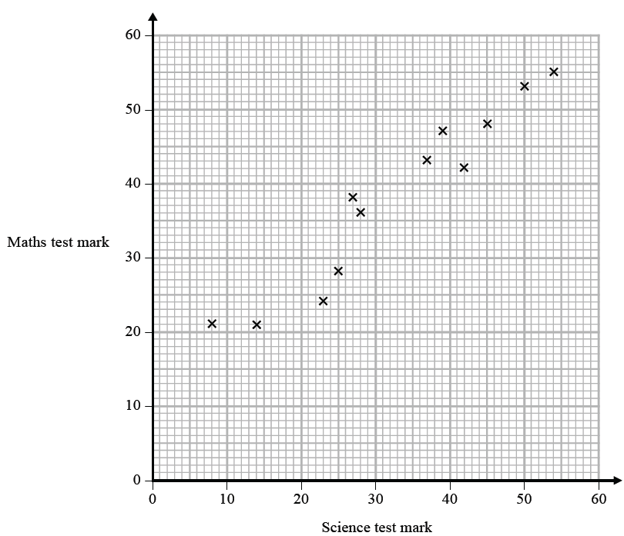

Jamie got a mark of 34 in the Science test.
Using the scatter graph, find an estimate for Jamie’s mark in the Maths test.

.......................................................
(2)

___________________________________________________________________________________________________________________________________________________________________________________________________________________________________________________________________________________________________________________________________________________________________________________________________________________________________________________________________

25/4 The table gives information about the times taken, in seconds, by 18 students to run a race.

Time (t seconds) | Frequency
5 < t ≤ 10 | 1
10 < t ≤ 15 | 2
15 < t ≤ 20 | 7
20 < t ≤ 25 | 8

Work out an estimate for the mean time.
Give your answer correct to 3 significant figures.

....................................................... seconds
(3)

___________________________________________________________________________________________________________________________________________________________________________________________________________________________________________________________________________________________________________________________________________________________________________________________________________________________________________________________________

28/7 (a) Write 32 460 000 in standard form.

.......................................................
(1)
(b) Write 4.96 × 10⁻³ as an ordinary number.

.......................................................
(1)

Asma was asked to compare the following two numbers.
A = 6.212 × 10⁸ and B = 4.73 × 10⁹
She says, “6.212 is bigger than 4.73 so A is bigger than B.”
(c) Is Asma correct? You must give a reason for your answer.

......................................................................................................................................................
......................................................................................................................................................
......................................................................................................................................................
(1)

___________________________________________________________________________________________________________________________________________________________________________________________________________________________________________________________________________________________________________________________________________________________________________________________________________________________________________________________________
27/6 Nimer was driving to a hotel.
He looked at his Sat Nav at 13 30

Time | 13 30
Distance to destination | 65 miles

Nimer arrived at the hotel at 14 48
Work out the average speed of the car from 13 30 to 14 48
You must show all your working.

.......................................................mph
(4)

___________________________________________________________________________________________________________________________________________________________________________________________________________________________________________________________________________________________________________________________________________________________________________________________________________________________________________________________________
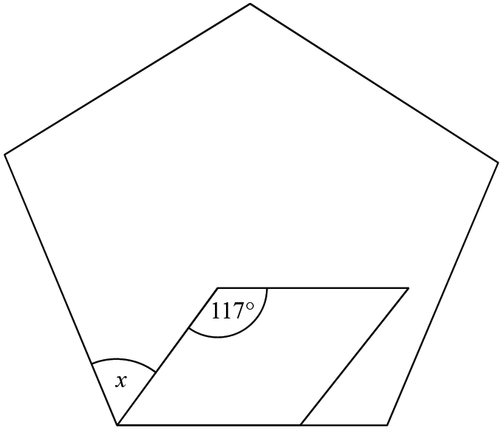
29/8 The diagram shows a regular pentagon and
a parallelogram.

Work out the size of the angle marked x.
You must show all your working.

.......................................................°
(4)

___________________________________________________________________________________________________________________________________________________________________________________________________________________________________________________________________________________________________________________________________________________________________________________________________________________________________________________________________
TOTAL FOR PAPER IS 24 MARKS

