Student Leadership
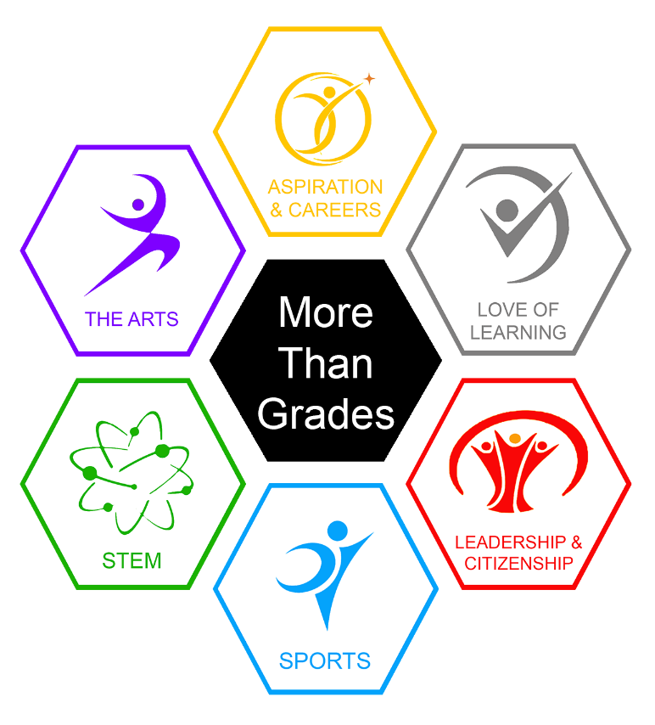
& Citizenship

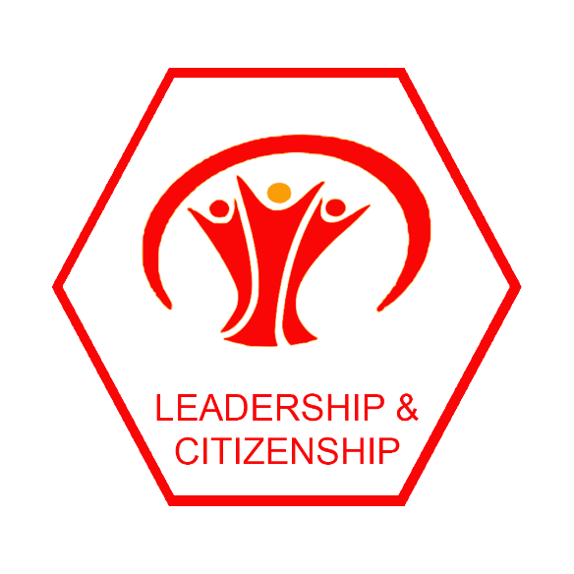

At LSA we expect all pupils to take part in activities that enable them to develop their leadership and citizenship skills. That may be taking on the role of team leader during orienteering in PE or leading a quiz team, or it may be something more formal like becoming a Prefect or a member of the Eco Council.
Here are some of the main opportunities in school for pupils to participate as an active citizen or take a leadership role in school.

 | Avaliable to year | Page
Student Council | 7-11 | 4
Library Leaders | 8-11 | 5
Online Safety Ambassadors | 7-11 | 6
Sports Leaders | 9-10 | 7
Peer Tutors | 11 | 8
Prefects | 11 | 9
Wellness Warriors | 8-11 | 10
Eco Council | 7-11 | 11
Equality Strategy Group | 7-11 | 12

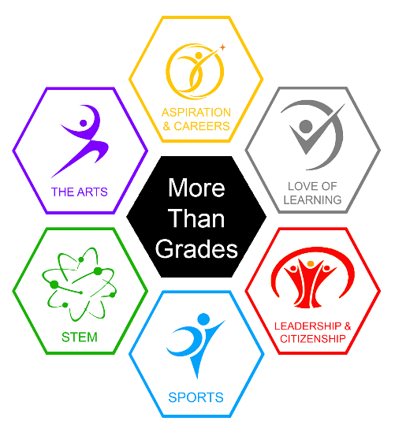
The More than Grades Programme
At Lytham St Annes High School we know that the best education takes place both inside and outside the classroom.
Each one of our pupils is more than a collection of grades; you are unique individuals each with different talents, skills and abilities, some of which you haven’t even discovered yet.
In each year of school the More than Grades Programme will introduce you to experiences or events in each of the 6 areas.
- Aspiration & Careers
- Love of Learning
- Leadership & Citizenship
- Sports
- STEM
- The Arts
Every year you must participate in at least one activity or event in each of the 6 areas and complete your More Than Grades Logbook.
This booklet is designed to help you decide what you would like to do to help you achieve your Leadership and Citizenship section.
Who can help you?
Your Form Tutors will help by encouraging you to get involved and sharing the Friday Pupil Bulletin with you. They can also help you with applying for any opportunities that you’re interested in.
For any help with “Careers & Aspiration” and “Leadership & Citizenship” you can also see Miss Peloe, the Careers Coordinator, in the Library. She will help you with becoming a Prefect, the Duke of Edinburgh Award, joining committees or any other queries about how to get involved in the wider life of our school.
Remember that any leadership roles you have outside of school count too! If you are a captain of a local team or you are involved in charity work, they are great examples of you developing skills as a leader and as an active citizen. You can write these up in your log book as evidence that you have achieved something in Leadership and Citizenship this year.

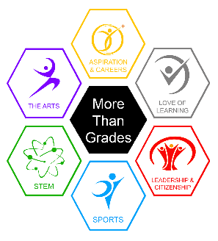
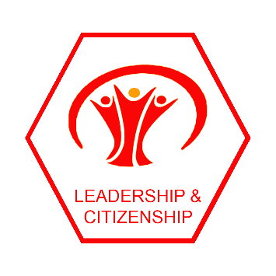
Leadership and Citizenship Roles
Student Council - Years 7 to 11

When we meet.
The Student Council meets every week usually on Tuesdays. Sometimes we meet in person during the school day. Mrs Clegg (Deputy Head Teacher) attends the meeting so that the people running the school always know what issues really matter to us.
Who are we?
The Student Council is run by students and the Chairperson, Deputy Chair, Secretary and Treasurer have been elected by the rest of the Student Council each year.
What we do.
We discuss what issues matter to students and lobby the Senior Leadership Team for change. We work together to organise Pupil Voice - Full Sessions when hundreds of students are invited to come to an event and share their views to help inform new things happening in school. So far these Youth Council sessions have been on mental health, LSA’s behaviour system, the environment and we have worked with the Equality Strategy Group organising events with a focus on Equality and Diversity. After every event we were able to change things in school.
How to join.
If you want to be a member you just need to give your name to Mrs Clegg, Miss Peloe or any member of the Student Council. You can ask your Form Tutor to e mail Mrs Clegg to tell her you would like to join. You’ll be invited to come along to the next meeting to see if you enjoy it.
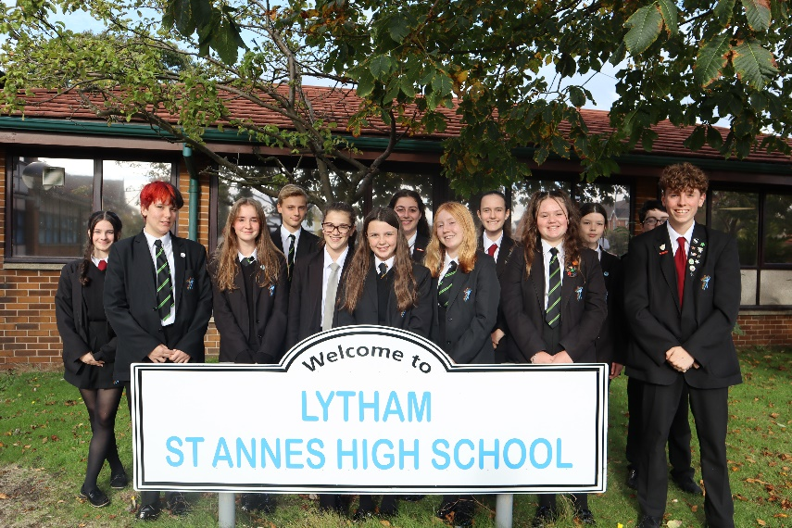

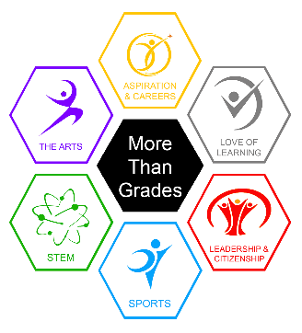
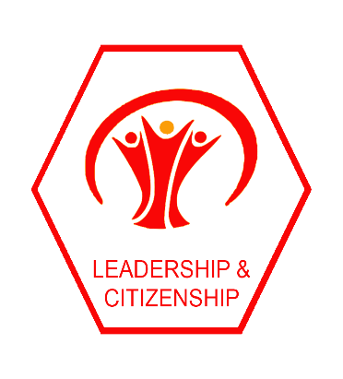
Leadership and Citizenship Roles
Library Leaders - Years 8 to 11

When we meet.
We meet Tuesdays after school in the Library (Year 8) and other years will meet at various lunchtimes across the school fortnight.
Who are we?
We are interested in books, authors, reading and helping to organise the library and its large collection. We wear a Library badge.
What we do.
We put the quarantined books back on the shelves when they're ready and help keep the place tidy. We engage each other with book talk about what we're reading (no pressure). We get early access to new library books and get to decide which books the library should buy. We shadow book awards such as the Carnegie Medal and Lancashire Book of the Year. In normal circumstances, a small group of Library Leaders represent the school at County Level, at the annual SLA Lancashire Pupil Librarian Conference. We meet our school's visiting authors for breakfast. We help the Library Staff issue and return books from the Library Service Desk at busy times when social distancing measures make it possible again. We're proud to promote books, reading and our lovely school library across school. We learn how to use a Library Management System and other technology in the library.
How to join.
If this sounds like something you would be interested in joining, come along and speak to Mr Bruen or Mrs Hirst in the Library.
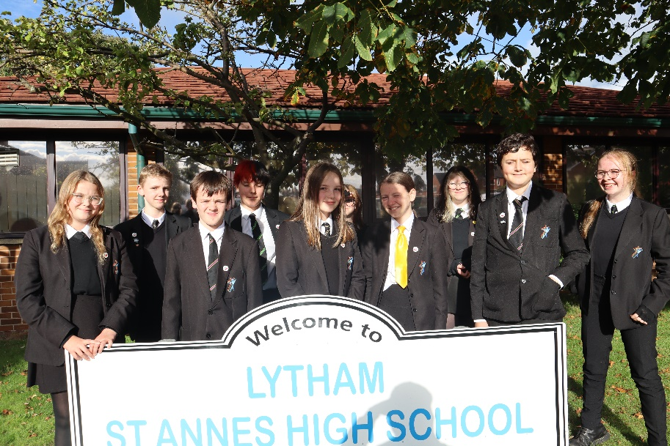

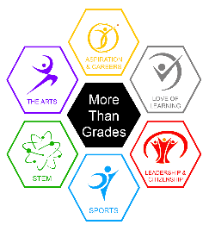
Leadership and Citizenship Roles
Online Safety Ambassadors - Years 7 to 11

When we meet.
The online safety ambassadors meet online on teams every Monday at 4pm. Mrs Hoyle attends every meeting and Mrs Lawson will attend these meetings from September. We will be meeting in person from September and Mrs Lawson will keep you updated with any changes.
Who are we?
The online safety ambassadors are a group of Year 7 to 11 students who are committed to helping improve online safety in school.
What we do.
We discuss key issues, concerns and updates around keeping safe online. We have distributed be kind online badges, we plan and deliver presentations during tutor times, we help organise safer internet day, help write termly newsletters for parents/carers and help address any issues around online safety.
How to join.
If this sounds like something you would be interested in helping with, please speak to Mrs Lawson whose office is next door to Thrive.
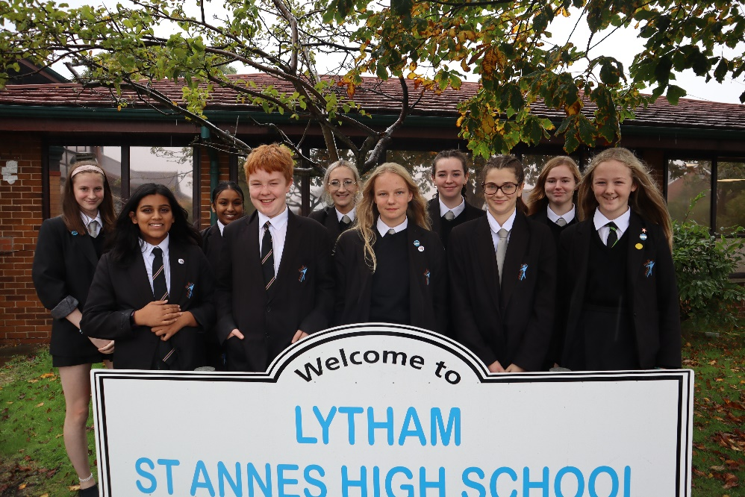

Leadership and Citizenship Roles
Sports Leaders - Years 9 and 10

When we meet.
Sports Leaders meet throughout the year with Mrs Harrison and other PE staff. These meetings tend to be in person and are usually outside of school hours.
Who are we?
The sports leaders are a group of year 9 and 10 students who attend extracurricular activities, volunteer to help with the running of younger year groups extracurricular activities and have an excellent attitude towards PE.
What we do.
We engage in some level of coaching, officiating or organising depending on your strengths. We work to assist staff to ensure equipment, kit and facilities are fit for purpose. We promote sporting events to other students and the schools four values in all areas of sport. Work with partners outside of school for the benefit of current and future students at LSA.
How to join.
If this sounds like something you would like to join, please speak to any member of PE staff in school.

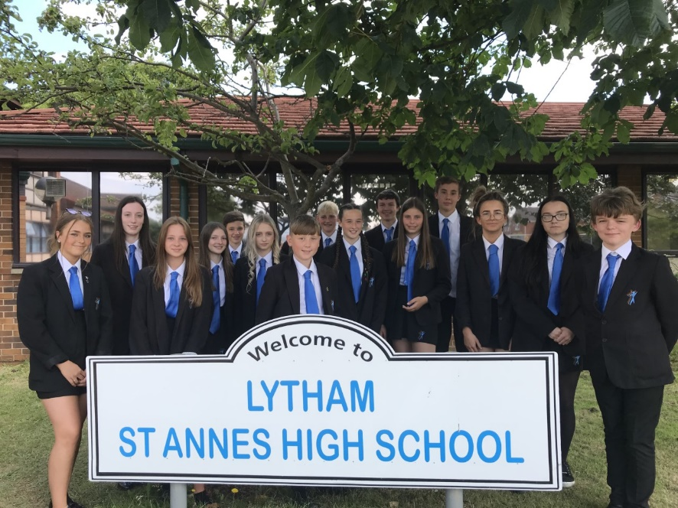

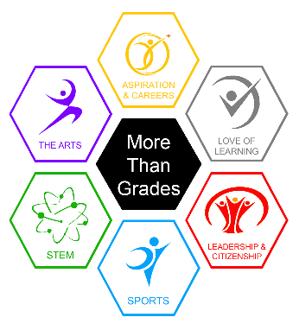
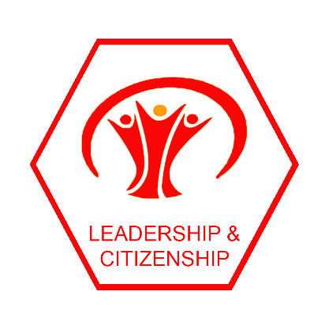
Leadership and Citizenship Roles
Peer Tutors – Year 11

When we meet.
Tutoring will take place each half term / full term depending on the student in the Library.
Who are we?
Peer Tutors are a group of year eleven students who deliver subject specific tutoring to year nines. We are trained to deliver effective tutoring and aim to build feelings of confidence and well being within school.
What we do.
We opt in to give one to one tutoring to selected year nine students to help them with a chosen subject which could be anything from science to English. We do this to build confidence in our tutees but also improves our confidence and ability to communicate. Although we only meet during form time, we have found that this consistent contact really improves the abilities of our tutees and gives us a great feeling of pride.
How to join.
If this sounds like something you would like to help with, please get in touch with Mrs Donnelly in the head of year offices.
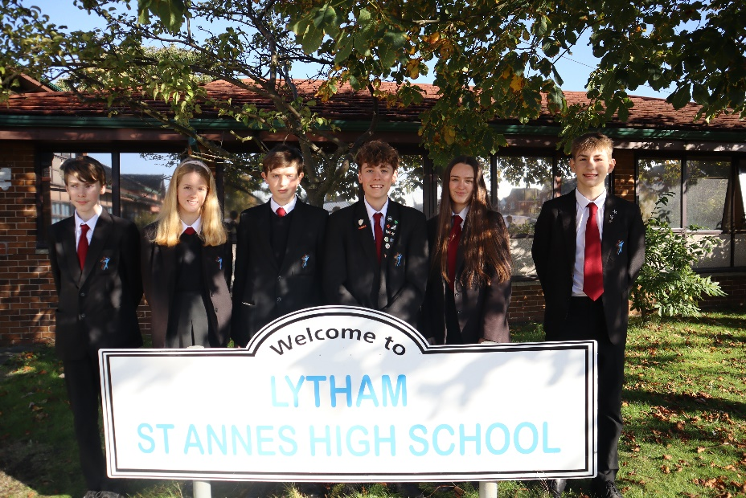

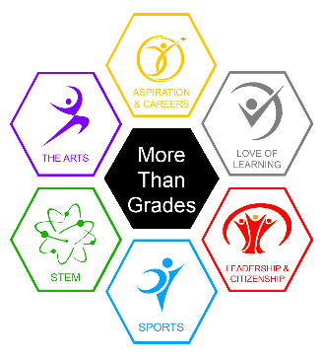
Leadership and Citizenship Roles
Prefects – Year 11

When we meet.
Prefects will officially meet every other week but sometimes these meetings are more often if needed.
Who are we?
Prefects are year 11 pupils who uphold our values and want to contribute to the wider life of the school. They set the standard for how to behave in and around school and act as role models for the younger years. Anyone in year 11 can be a prefect, as long as they uphold the schools’ values and want to give up their time to support other pupils and events in school. Prefects are the key Year 11 pupil representatives. We have over 100 prefects in Year 11 and 6 Senior Prefects who are elected by the rest of the prefect team and staff.
What we do.
We assist with all the activities in school, We meet parents and other visitors, support all key events in school and help the smooth running of the school. This could be from organising charity events, organising lending sports equipment on breaks/lunch to putting displays together or giving tours of the school. We also help with tutoring younger students in school to help them make progress. We always lead by example and adhere to the uniform rules.
How to join.
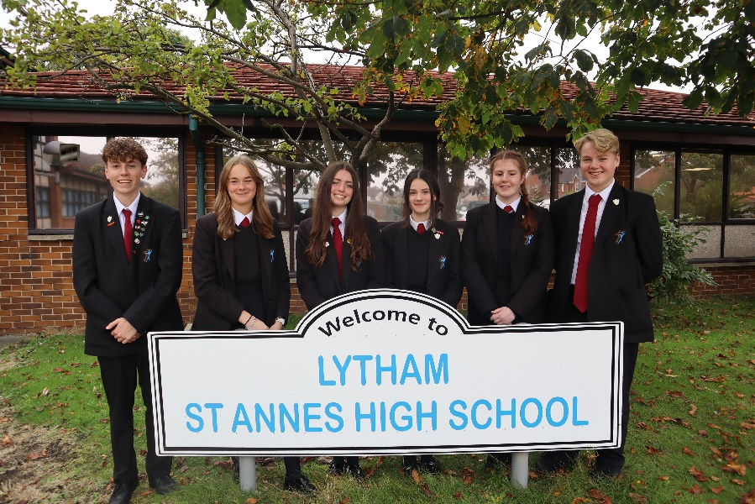
Do you think you have what it takes to wear the prestigious burgundy tie? See Miss Peloe or Mr Anderton in the Library for more information.

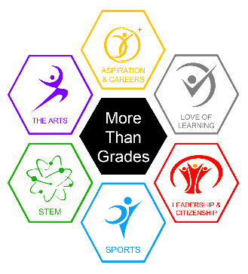
Leadership and Citizenship Roles
Wellness Warriors – Years 8 to 11

When we meet.
The Wellness Warriors meet weekly online on Teams but will combine online meetings alongside meetings in person when Covid restrictions allow. Mrs Lee attends every meeting.
Who are we?
We are a group of students and staff all around school. These are students who have expressed an interest in being a Wellness Warrior then applied and been chosen from their year group. Students are identified by a yellow tie and / or a Bee Kind Badge. Staff who have expressed an interest in promoting positive mental wellbeing for staff and students and been trained by an outside agency to support and offer strategies. Staff are identified by wearing a Yellow “I can …. You can … We can “Lanyard.

What we do.
We offer support and strategies that promote positive mental health. We arrange assemblies to raise Mental Health Awareness and display artwork with positive messages, we also work with and signpost to outside agencies who offer support to students and their families. We keep the website up to date with support agencies contact details and add positive messages
How to join.
You can apply expressing why you want to join the Wellness Warriors by email, illustration, presentation or letter. If you want more details, you can ask your form tutor, Head of Year or Mrs Lee in Thrive – Student Hub.
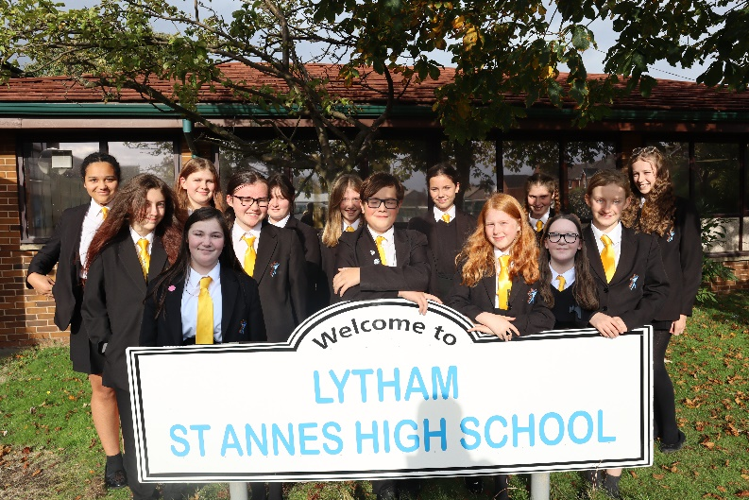

Leadership and Citizenship Roles
Eco Council – Years 7 to 11

When we meet.
The Eco Council meets every other week usually online on Tuesdays at 4.30pm on Teams. When we can, we usually meet in the morning before period 1. Mrs Evans (Head of Geography) attends every meeting so that matters that arise can be communicated to the school leaders and vice versa.
Who are we?
The Eco Council is run by students and the Co-Chairs, Secretary are all students who have been nominated by the rest of the Eco Council and the year group leaders have all volunteered.

What we do.
The eco council are monitoring and improving the environmental actions and sustainability. We hope this approach engages, motivates and empowers young people to care for our planet now and throughout their lifetime. We are working on an action plan and is what us as a council must put together to say how we are going to improve the school and local area in 3 areas which are: Biodiversity, Marine, Litter. We are aiming to get the Bronze Eco Schools award by the end of this school year (2021-2022).
How to join.
If you want to be a member you just need to give your name to Mrs Evans or get your Form Tutor to e mail Mrs Evans to tell her you would like to join. You’ll be invited to come along to the next meeting to see if you enjoy it.
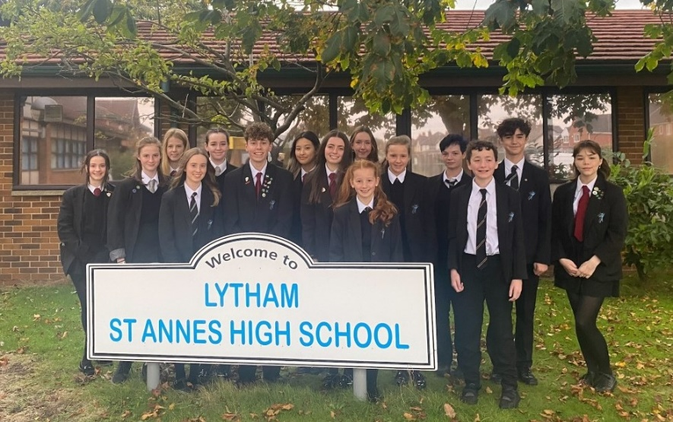

Leadership and Citizenship Roles
The Equality Strategy Group – Years 7 to 11

When we meet.
The Equality Strategy Group meetings are advertised in the Student Bulletin on a Friday. When we are working on a project these meetings are every week for that half term. At other times we meet once a half term.

Who are we?
The Equality Strategy Group includes pupils, parents and staff working together as equal members of the group. We share our work with all the school community including school governors.

What we do.
The Equality Strategy Group discuss issues of equality and how we can promote both equality and equity within our school. A key focus is on eradicating any forms of prejudice. So far the group have issued a pupil questionnaire, which over 1000 pupils completed, and are working on this becoming an annual event. They have organized an Anti Discrimination Day and have written a 3 year plan. We are now setting up staff Equality Ambassadors to make the reporting of discrimination even easier for pupils. Members of the group seek the opinions of other students on issues of discrimination and are advocates for equality around school. They take an active part in all discussions and decide ways in which we can make progress as a school.
How to join.
If you want to be a member, just look out for our next meeting advertised in the student bulletin and come along.

