The More than Grades Programme
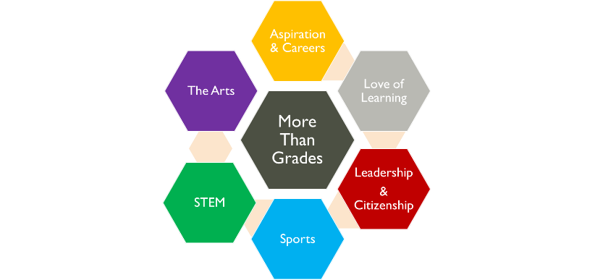
At Lytham St Annes High School we know that the best education takes place both inside and outside the classroom.
Each one of our pupils is more than a collection of grades; they are unique individuals each with different talents, skills and abilities. Some of which they haven’t even discovered yet.

In each year of school the More than Grades Programme seeks to introduce every pupil to new experiences or events out with the classroom in each of the following 6 areas
- Aspiration & Careers
- Love of Learning
- Leadership & Citizenship
- Sport
- STEM
- The Arts
To ensure our pupils get the best experience possible during their time in school, every year all pupils must participate in at least one activity or event in each of the 6 areas and document it in their More Than Grades Logbook.
Of course we hope pupils will get involved in lots more than that and there are no limits on how many events and activities pupils can experience.
Form Tutors are vitally important in supporting ALL pupils to get involved, helping them to decide what to do and to make sure they have all the information they need. The Programme is also designed to develop independence and it is every pupil’s own responsibility to make sure they participate in something within each of the 6 More Than Grades areas across the year.
On completion of each section in their logbook pupils will receive an Achievement Point in one of our 4 values.
The weekly Pupil Bulletin is available on our website and e mailed home.
Answers to common queries:
- Pupil Logbooks are kept by Form Tutors in school.
- Pupils use Form Time on a Friday to complete their log books.
- Parents, carers & guardians will be able to see the More Than Grades Logbook at Meet the Form Tutor Evening.
- Pupils can include events that they participate in outside of school too. They should document anything extra that fits into one of the 6 More Than Grades areas.
- Pupils can take part in as many activities as they like; there are no limits.
- We know some pupils will specialise in one area but we still want them to explore each of the 6 areas. Who knows what new skills they may discover!
- Extra Curricular activities at school are all advertised in the Pupil Bulletin on a Friday which Form Tutors will go over during Form Time. The Pupil Bulletin is displayed around the school and in form rooms too.
- Sometimes activities that take place during the school day are worth recording in the logbook too. (E.G. If pupils experience a theatre performance, work with a visiting poet or complete a science workshop; perhaps take part in a STEM competition or an athletics workshop with an Olympian. Anything out of the ordinary is worth documenting as a record of the experiences they have had.)
- Pupils may wish to bring in a photograph of an event to glue into their logbook as evidence of what they have taken part in.
- At the end of Year 11 pupils will be given their 5 completed logbooks to support them in their applications for colleges, apprenticeships, employment and/or university.

We hope that this programme will ensure that ALL our pupils are introduced to Science, Technology, Engineering, Maths, The Arts and Sport in ways that are not simply class based. We hope to nurture a true love of learning and support our pupils in being able to evidence the ways in which they are aspirational and endeavour to give their best. To encourage pupils to be both team players and independent thinkers. We hope that they will have more confidence in applying for leadership roles because of their wider experiences. In short we hope we continue to encourage every pupil in our learning community to be the very best they can be.
If you have any questions about the More Than Grades Programme or would like to offer to deliver an activity or workshop please contact Gill Clegg Deputy Head Teacher on 01253 733192 or via e mail gillian.clegg@lythamhigh.lancs.sch.uk

