Uniform guidelines
Please support our attempts to maintain high standards of appearance. The school reserves the right to send home any student who does not meet these expectations.
It is important that the uniform is worn correctly and with pride. It is expected that the overall appearance is smart and in keeping with the fantastic reputation of the school in the local community.
Uniform guidelines have been created with support from the student council and parents.
If you need any further information or advice, please do not hesitate to contact school via one of the methods on the ‘contact us’ tab on the website.

Guidance | Examples
No facial piercings  No body Piercings | Applies to any face piercing not in ears.  For example nose, lip, eyebrow etc.  This applies to any piercings that are not in the ears for example stomach, wrist etc t  These are a health and safety hazard.
No rings, only a wristwatch can be worn. Earrings are allowed as studs/sleepers (no stipulation on number). | Smart watches can be worn – however if they are being used as a source of communication, they will be confiscated.  Students can wear studs or sleepers – see picture. There is no limit to how many studs. However, school staff will use their discretion if we feel there is a health and safety concern.  A sleeper earring is a small hoop that is close to the ear  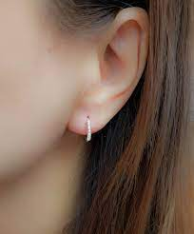  The following cannot be worn for health and safety reasons:  - A hoop earring that is large enough to be caught or has a gap between the earring and the ear  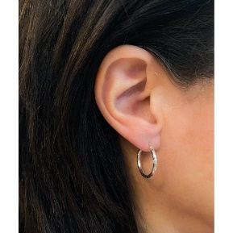  - A bar earring  - Long or dangly earrings.
Make up must be discreet | This is any make up that is obvious. Natural make up is acceptable.  Obvious make up may include:  - Brightly coloured eye shadow  - Heavy eyeliner  - Fake eyelashes (These vary incredibly in length and style. If you can see that they are fake – this is not discreet and they need to be removed.)  - Fake tan
Shoes- Some may be a cross between shoe/trainer  Footwear Change for PE | Footwear cannot have contrasting sports logos, writing or patters e.g. a white NIKE tick on a black trainer. See pictures  Acceptable:  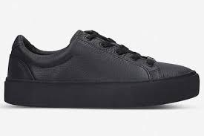  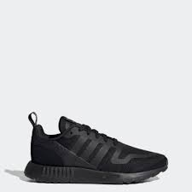  Not acceptable:  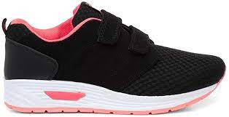  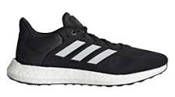  Exceptions – Some of our students may have medical conditions that require them to wear trainers – for example if they have specially made insoles. School need a medical note to confirm this. If this is the case, HoY will communicate with home that in future trainers need to be plain black. A uniform pass needs to be issued for these students.  During PE lessons footwear can become wet/muddy. All students need to change into footwear that is appropriate for lesson location and for the PESSPA being taught. Footwear that is fit for purpose and appropriate to the surface and conditions is essential for student safety. Footwear should demonstrate effective grip and support and reasonable protection for PESSPA for indoor and outdoor game.
Nails must be neat, tidy and short. | Long nails are a health and safety hazard and therefore are not acceptable.  Nail varnish/colour on nails is acceptable.  Gel/Acrylic nails are not acceptable.  Example of acceptable nails: 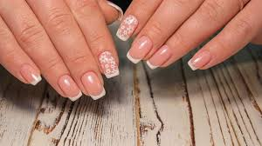  Unacceptable nails due to length and acrylic/gel:  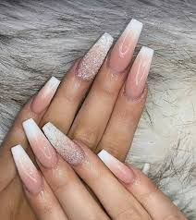
Extreme hairstyles are discouraged. | This will only apply to hair that is unreasonable/distracting.  Dying hair, having coloured flecks, short hair cuts are all acceptable.  We advise that parents/carers speak to Heads of Year for guidance prior to any major changes as they will make the decision whether the hairstyle is extreme.  Example of acceptable hair colour:  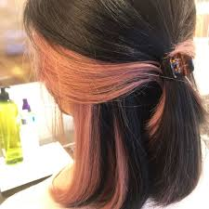  Unacceptable hair due to style and colour:  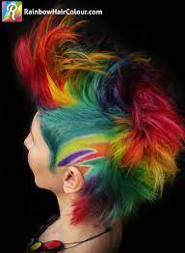
The skirt waistband must be visible | If wearing a skirt, this can not be rolled up and the waistband must be visible.
No additions to the uniform | Hooded tops, fleeces, tracksuit tops, baseball caps and denim jackets should not be worn at school. Outdoor garments displaying obscene or offensive words or images are not appropriate for school. In cold weather, hats can be worn when outside the building.  If needed, students can wear a plain, black V neck jumper under their blazer.  In the summer term, tailored trousers of at least knee length may be worn.  Where additional items of uniform are worn for religious reasons, these should be in black (the school uniform colour).

