Year 10 Review HW ASSESSMENT 2 CALCULATOR Core Standard

Name ____________________ Teacher ______________________

Shape 1 | /10 | Proportion | /10 | Sequences | /10 | Probability | /10

 | Shape 1
1. | Find the area of the trapezium  4cm  3cm  12cm  …………………………………… | (3)
2. | OAB is a sector of a circle, centre O.  Angle AOB = 55º. OA = OB = 12 cm.  Work out the length of the arc AB. Give your answer to 3 significant figures.  ………………………………… | (3)
3. | Two identical circles fit inside a rectangle as shown.  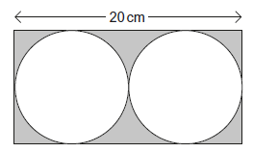  The length of the rectangle is 20 cm. Work out the area of the shaded section.  ……………………………… | (4)
 | TOTAL | /10
 | Proportion
1. | To make 12 biscuits you need  100 g butter  100 g sugar  150 g flour  50 g cocoa  30 ml milk  (a) How much cocoa do you need to make 36 biscuits?  …………………………  (b) You need 100 g of butter to make 12 biscuits.  You have 250 g of butter.  You have plenty of everything else.  What is the maximum number of biscuits you can make?  ………………………… | (2)  (2)
2. | At a school the number of boys : number of girls = 5 : 7  There are 60 more boys than girls.  Work out the total number of students at the school.  ………………………… | (3)
3. | There are 100 balls in a bag. The balls are red, blue, green or white.  The ratio of blue to red is 5 : 1  There are twice as many blue as green. ¼ of the balls are green.  How many white balls are in the bag?  ……………………….. | (3)
 | TOTAL | /10
 | Algebra - Sequences
1. | Here are the first five terms of an arithmetic sequence.  8 17 26 35 44  (a) Write down an expression, in terms of n, for the nth term of the sequence.  ………………………………………  The expression 3n² + 2 is the nth term of a different sequence.  (b) Find the 3rd term of this sequence.  ........................................................... | (3)
2. | Here are the first 5 terms of a quadratic sequence.  6 9 14 21  Find an expression, in terms of n, for the nth term of this quadratic sequence.  …........................ | (3)
3. | Work out the common ratio and the 6th term in this geometric sequence  4, 12, 36, 108, ……………  Common Ratio = ………………… 8th term = ………………… | (2)
4. | Write down the next three terms in this Fibonacci-type sequences.  2, 9, 11, 20, ………… , …………, ………… | (2)
 | TOTAL | /11
 | Probability
1. | The probability that Ben is late for school is 0.3  The probability that Bill is late for school is 0.2  a) Complete this tree diagram  Bill  Ben  Late  On time  Late  Late  On time  On time  b) Calculate the probability that at least one of them is late on a particular day  …………………… | (4)
2. | A bag has only red, white, blue and yellow counters.  A counter is taken from the bag at random.  Here are some of the probabilities.  Colour Red White Blue Yellow  Probability 0.1 0.3  - The probability of taking a white counter is twice the probability of taking a yellow counter. Complete the table.  There are 500 counters in the bag altogether.  - Complete the table.  Colour Red White Blue Yellow Total  Number of Counters 500 | (2)
3. | 50 people took a test.  Before the test, they predicted whether they would pass or fail.  30 people predicted they would pass.  26 of the people who predicted they would pass did pass.  37 people passed altogether.  Complete the frequency tree.  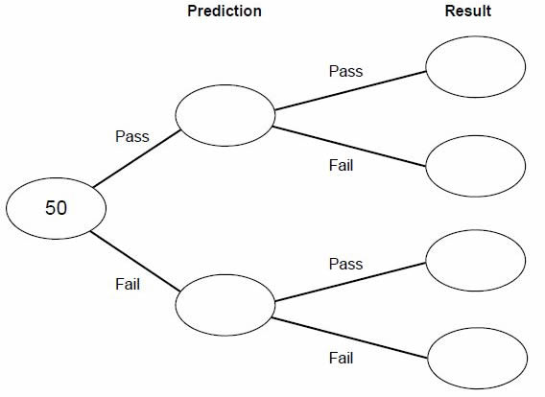  . | (2)  (2)
 | TOTAL | /10

