YEAR 11 TEST 6 Review Homework calculator allowed ENHANCED

Name ____________________ Answer sheet

 | Algebra: Tangents and Area
1.  M | Here is a speed time graph for a train.  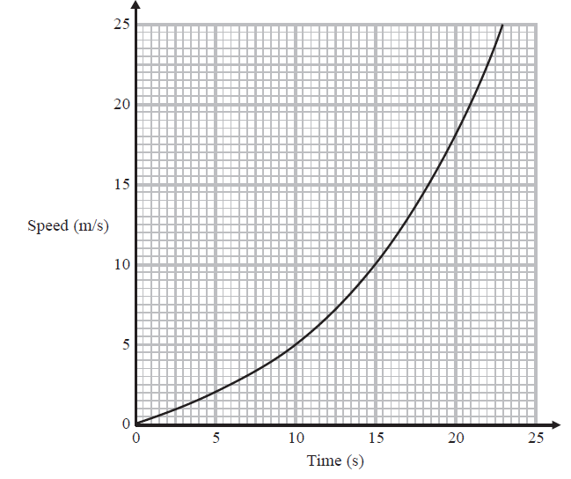  a) Work out an estimate the distance travelled by the train in the first 20 seconds.  Use four strips of equal width.  ………………… m  b) Is your answer to a) an over estimate of an under estimate of the actual distance travelled by the train?  Give a reason for your answer.  ……………………………………………………………………………………………………………………………………………………  …………………………………………………………………………………………………………………………………………………… | (3)  (1)
2.  F | 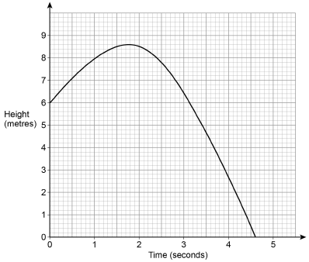  A ball is thrown from a point 6 metres above the ground.  The graph shows the height of the ball above the ground, in metres.  Estimate the speed of the ball in m/s after 1 second.  You must show your working. | (2)
 | Geometry: Transformations
1.  F | Square OABC is drawn on a centimetre grid.  O is (0, 0)  A is (2, 0)  B is (2, 2)  C is (0, 2)  a) OABC is translated by the vector $\left(\begin{aligned}0 \\ 2\end{aligned}\right)$  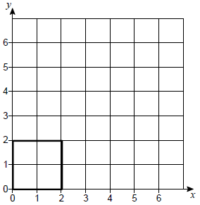  Circle the number of invariant points on the perimeter of the square.  0 1 2 4  b) OABC is enlarged, scale factor -1, centre (2, 2)  Circle the number of invariant points on the perimeter of the square.  0 1 2 4  c) OABC is reflected in the line y = 4 - x  Circle the number of invariant points on the perimeter of the square.  0 1 2 4 | (1)  (1)  (1)
2.  F | 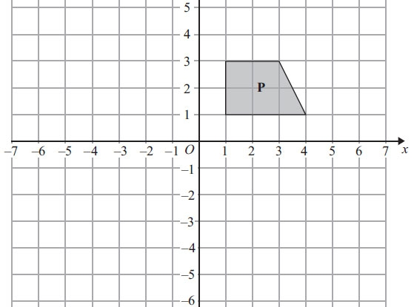  Shape P is reflected in the line y = –1 to give shape Q.  Shape Q is reflected in the line x = 4 to give shape R.  Describe fully the single transformation that maps shape P onto shape R.  ……………………………………………………………………………………………………………………………………………………  …………………………………………………………………………………………………………………………………………………… | (3)
3.  F | This diadram shows triangles CDE and PQR.  CDE is mapped tp PQR by combining two single transformations.  The first is a rotation of 90° anticlockwise about E.  Describe the second transformation.  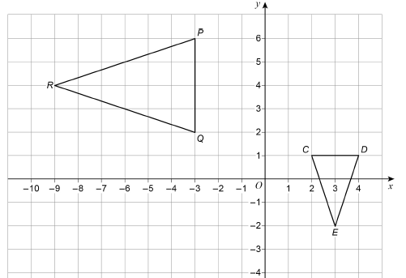  ……………………………………………………………………………………………………………………………………………………  …………………………………………………………………………………………………………………………………………………… | (3)
4.  M | 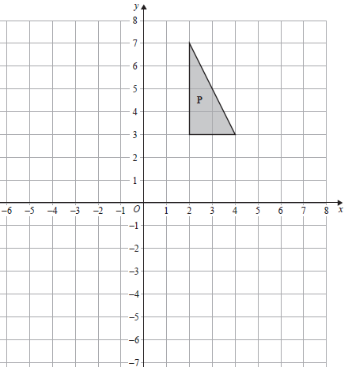  Enlarge shape P by  scale factor - ½ with centre of enlargement (0,0) | (3)
5.  M | On the grid, enlarge the triangle by scale factor –1½, centre (2, 0)  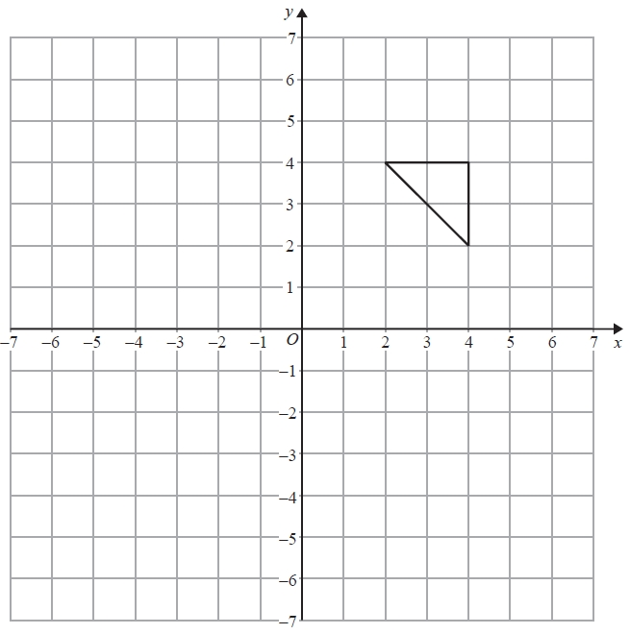 | (3)

