YEAR 9 TEST 2 Homework Assessment CALCULATOR ALLOWED Higher

NAME _______________________ TEACHER _______________________

Area | /10 | Ratio | /10 | Sequences | /10

 | Area
1.  S | Work out the area of this triangle.  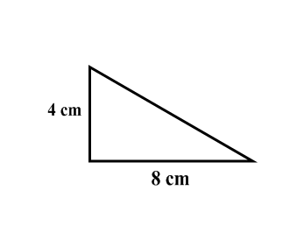  ………………………… cm² | (2)
2.  F | 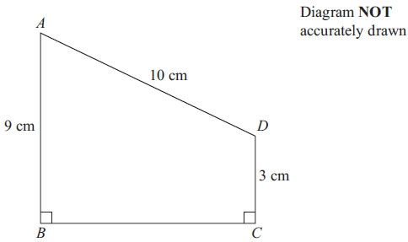  ABCD is a trapezium.  7 cm  Calculate the area of the trapezium.  ………………………… cm² | (2)
3.  F | Here is a circle.  The radius of the circle is 4 cm.  Work out the area of the circle.  Give your answer in terms of π.  ………………………… cm | (3)
4.  M | The diagram shows a tile.  The tile is in the shape of a semicircle of radius 8 cm.  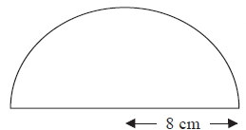  Work out the area of the tile.  Give your answer correct to one decimal place.  ………………………… cm | (3)
 | TOTAL | (10)
 | Ratio
1.  F | The cost of 6 cups is £8.40  Work out the cost of 10 of these cups.  £……………………… | (2)
2.  F | A street map has a scale of 1 : 25000.  Church Road is 4 cm long on the map.  What is the actual length of Church road in kilometres?  ………………… km | (2)
3.  M | Soap powder is sold in three sizes of box.  2 kg of soap powder costs £1.79  5 kg of soap powder costs £4.35  9 kg of soap powder costs £8.54  Which size of box is the best value for money? Explain your answer. | (3)
4.  F | A student bought a pair of sunglasses in the USA. He paid $34.50  In England, an identical pair of sunglasses costs £27.99  The exchange rate is £1 = $1.32  In which country were the sunglasses cheaper, and by how much?  Show all of your working. | (3)
 |  | (10)
 | Sequences
1.  F | Here are the first four terms of a number sequence.  11 14 17 20  a) Find the 10th term in this sequence. …………………………  b) The number 100 is not a term in this sequence.  Explain why.  ...........................................................................................................................................  ........................................................................................................................................... | (1)  (1)
2.  F | Here are some patterns made from sticks.  pattern 1 pattern 2 pattern 3  a) How many sticks are needed for pattern number 9?  …………………………  Sam says that there is a pattern which will need 78 sticks.  b) Is Sam correct?  You must give a reason for your answer.  ...........................................................................................................................................  ........................................................................................................................................... | (1)  (1)
3.  F | Here are the first five terms of a number sequence.  41 37 33 29 25  Write an expression, in terms of n, for the n^{th} term of this sequence.  ………………………… | (2)
4.  F | The nth term of a different sequence is 3n² – 2  Find the 3rd term of this sequence.  ………………………… | (2)
5.  M | Here are the first four terms of a quadratic sequence.  4 7 12 19 28  What is the rule for the n^{th} term of this sequence  ………………………… | (2)
 |  | (10)

