YEAR 10 TEST 1 Review Homework NON-CALCULATOR ENHANCED

Number 1 | /8 | Statistics | /16 | Number 2 | /15

 | Number: Recurring decimals
1.  S | Convert that the recurring decimal $0.\dot{3}\dot{9}$ into a fraction in its simplest form. | (2)
2.  F | Express $0.7\dot{6}$ as a fraction in its simplest form. | (3)
3.  M | Express $2.30\dot{5}$ as a fraction in its simplest form. | (3)
 | TOTAL | /8
 | Statistics: Cumulative frequency, box plots and histograms
1.  S | 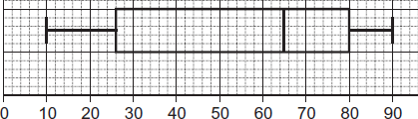  The diagram shows a box plot.  a) Write down the median.  b) Work out the interquartile range. | (2)
2.  F | Rob played in 15 basketball matches.  The stem-and-leaf diagram shows the number of points he scored in each match.  Key: 0 | 5 represents 5 points  0 5  1 2 2 4 5 6 7 8  2 2 2 3 6 6 9  3 0  a) Draw a box plot to represent the data for Rob.  b) This box plot represents the points that Jack scored in 15 basketball matches.  Jack says, “I am better at basketball than Rob.” Give two reasons that support this. | (4)  (2)
3.  F | In the UK in 2000: 25% of the population were under 24 years old  50% of the population were under 37 years old  the inter-quartile range of the ages was 32 years  the oldest person was 107 years old.  Show the information on a box plot.  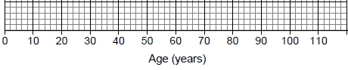 | (4)
4.M | The histogram shows the time it takes 270 students to travel to school.  Travel to school  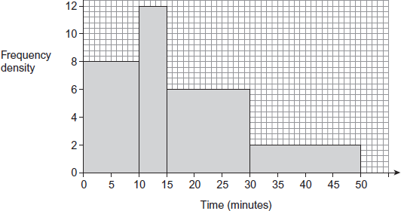  Kirsty says 30% of the students take more than 25 minutes to travel to school.  Is she correct?  Use the histogram to decide.  You must show your working. | (4)
 | TOTAL | /16
 | Number: Indices and Surds
1.  S | Calculate  (i) 10⁰ (ii) 10⁻¹ | (2)
2.  F | Evaluate  (i) 3⁻² (ii) (iii) (iv) | (4)
3.  S | a) Write √48 in surd form  b) Calculate √20 x √5. | (1)  (1)
4.  F | Express $5\sqrt{27}$ in the form $n\sqrt{3}$ , where n is a positive integer. | (2)
5.  S | Express $\frac{6}{\sqrt{12}}$ in the form $a\sqrt{b}$, where a and b are positive integers. | (2)
6.  M | Expand $\left(\sqrt{6}+3\sqrt{5}\right)\left(\sqrt{6}-3\sqrt{5}\right)$  Express your answer as simply as possible. | (3)
 | TOTAL | /15
YEAR 10 TEST 1 Review Homework CALCULATOR ENHANCED
Number 1 | /18 | Algebra | /15 | Statistics | /9

 | Number: limits and bounds
1.  S | The time to run 400m was measured as 56.0 seconds to 3 significant figures.  Write the error bound as an inequality. | (2)
2.  S | Amy and Kate each catch three fish.  The weight of each fish, to the nearest tenth of a kilogram, is shown.  Amy 6.8 kg 4.3 kg 5.2 kg  Kate 8.2 kg 3.4 kg 4.5 kg  Kate says that the total weight of her fish is more than the total weight of Amy’s fish.  Show that this could be true. | (4)
3.  F | Correct to 2 significant figures, the area of a rectangle is 470 cm².  Correct to 2 significant figures, the length of the rectangle is 20 cm.  Calculate the upper bound for the width of the rectangle. | (3)
4.  F | In 2010 the total population of Barrow was 71 000 to the nearest thousand.  The number of people aged 65 years or over was 13 000 to the nearest thousand.  Work out the maximum value for the percentage of people who were aged 65 years or over in Barrow in 2010  You must show your working. | (4)
5.  M | Sam uses his trailer to carry logs.  He has 2800 kilograms of logs.  His trailer can carry 200 kilograms when full.  Both weights are correct to 2 significant figures.  What is the least number of times the trailer could be loaded to be sure he can carry all the logs?  You must show your working. | (5)
 | TOTAL | /18
 | Algebra: Factorise, solve and sketch quadratics
1.  S | a) Factorise x² + 11x + 24  b) Hence solve x² + 11x + 24 = 0 | (3)
2.  S | Solve the equation x² – 20x + 36 = 0 | (3)
3.  F | Solve 9x² – 100 = 0 | (3)
4.  M | Solve 3x² − 2x − 8 = 0 | (3)
5.  M | For all values of x, x ² – 4 x - 11 = (x – p)² + q  Find the value of p and the value of q. | (3)
 | TOTAL | /15
 | Statistics: Cumulative frequency, box plots and histograms
1.  S | 24 students took a test. The table shows information about their marks.  Mark (m) Frequency  20 < m < 40 3  40 < m < 60 5  60 < m < 80 12  80 < m < 100 4  a) Draw a cumulative frequency diagram for their marks. Use the same scale as below.  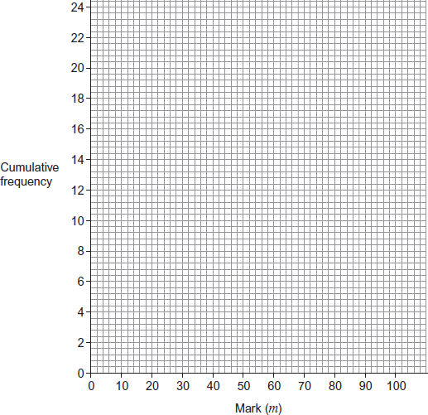  b) Use the cumulative frequency diagram to estimate the interquartile range. | (3)  (2)
M | The histogram shows information about the ages of 100 employees.  Work out an estimate of the median age of the employees.  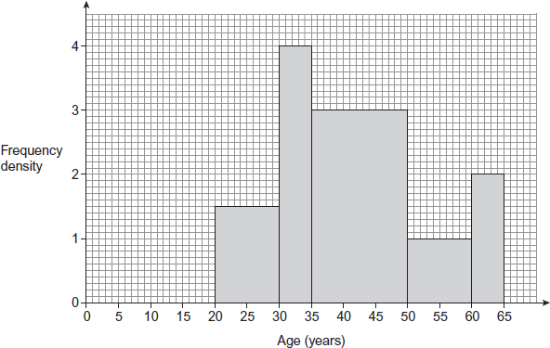 | (4)
 | TOTAL | /9

