Year 7 Core Standard: Assessment 1 Revision Name ___________________________

 | Topic 1: Negative Numbers | Mark
1. | Here is a list of numbers.  −9 −5 −3 −1 0 3 4 6  (a) Write down two numbers from the list that add up to 5  Answer ................................ and ................................  (b) Write down two numbers from the list that have a difference of 13  Answer ................................ and ................................  (c) Write down two numbers from the list that multiply to give −15  Answer ................................ and ................................ | (3)
2. | The temperature was recorded at the same time each day.  Day Mon Tue Wed Thu Fri Sat  Temperature (°C) 2 0 1 −3 −1 −2  (a) How much colder was it on Thursday than on Wednesday?  Answer ................................................................. °C  (b) On Sunday, the temperature was 3°C lower than on Saturday.  What was the temperature on Sunday?  Answer ................................................................. °C | (2)
3. | Which of these numbers is 6 less than –1.4?  Circle your answer.  –8.4 –7.4 –2.0 –4.6 | (1)
4. | Calculate  (a) 3 + - 2 = ……………… (b) 3 - - 4 = ………………  (c) -5 x -2 = ……………… (d) 15 $÷$ - 5 = ……………… | (4)

 | Topic 2: Algebraic Manipulation | Mark
1. | A car has 4 wheels.  A bicycle has 2 wheels.  Write down an expression for the total number of wheels on x cars and y bicycles.  Answer ...................................................................... | (1)
2. | (a) Circle the expression that is equivalent to 4 × x  x⁴ 4x 4^{x} x × x × x × x  (b) Circle the expression that is equivalent to y × y × y  3y y² 3y² y³  (c) Circle the expression that is equivalent to a + b  b + a ab ba 2ab | (3)
3. | Here are three expressions.  $\frac{b}{a}$ a − b ab  When a = 2 and b = −6 which expression has the smallest value?  You must show your working.  ..................................................................................................................................................................................  ..................................................................................................................................................................................  Answer ............................................ | (2)
4. | Pay = £8 × number of hours worked  (a) Donna worked for five hours. Work out her pay.  ...................................................................................................................................................................................  Answer £ ...................................................................  (b) Lee’s pay is £96. How many hours did he work?  ..................................................................................................................................................................................  Answer ............................................................ hours | (2)  (2)

 | Topic 3: Averages | Mark
1. | Here are seven numbers.  13 6 12 7 6 4 8  (a) Work out the range of the seven numbers. Circle your answer.  5 6 7 8 9  (b) What is the mode of the seven numbers? Circle your answer.  5 6 7 8 9 | (1)  (1)
2. | (a) The scores on four ordinary, six-sided dice are put in order.  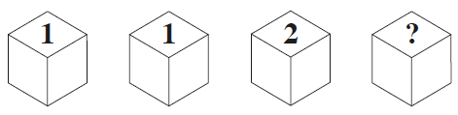  The median of the four scores is 0.5 less than the mean of the four scores.  Circle the value of the fourth score.  2 3 4 5 6  (b) The dice are rolled again. The median of the scores is 0.5 less than the range. Work out a possible set of scores.  Answer ................... , ................... , ................... , .................. | (1)  (2)
3. | The table shows information about water used in a household.  Calculate the mean amount of water used.  Month Water used (m³)  January 20  February 12  March 8  April 15  May 20  June 9  Answer ............................................................................. m³ | (3)
4. | I am thinking of three positive numbers.  The mode is 5.  The median is 5.  The range is 9. Work out the three numbers.  Answer ....................... , ....................... , ....................... | (2)

 | Topic 4: Number Properties | Mark
1. | ξ = {1, 2, 3, 4, 5, 6, 7, 8, 9, 10, 11, 12}  S = square numbers E = even number Complete the Venn diagram.  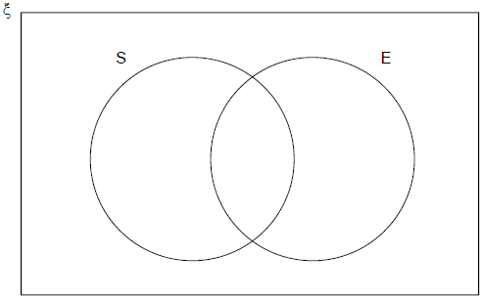 | (3)
2. | (a) Work out the Highest Common Factor (HCF) of 24 and 42  Answer ......................................................................  (b) As a product of prime factors 36 = 2² × 3²  Write 48 as a product of prime factors.  Answer ...................................................................... | (2)  (2)
3. | Two electric cars are driven around a 10 kilometre track.  Both cars leave from the start line at the same time.  Car X travels at exactly 40 km/h  Car Y travels at exactly 30 km/h  How many minutes will it be before they pass the start line together again?  Answer ......................................................... minutes | (3)

