YEAR 7 TEST 2 ASSESSMENT HOMEWORK– NO CALCULATOR Core

Name ______________________ Teacher ______________________

Perimeter and Area | /10 | Ratio and Proportion | /10 | Sequences | /10 | Probability | /10

 | Perimeter and Area
1.  S | Complete the following:  5 cm = ________ mm 4 m = ________ cm  25 mm = ________ cm 2350 m = ________ km | (4)
2.  S | Find the perimeter of this rectangle:  7 cm  6 cm  Perimeter = ………………………… cm | (2)
3.  M | This rectangle has an area of 48cm².  height  12 cm  What is the height? ……………… | (2)
4.  M | Find the area of this right angled triangle.  60mm  3cm  Area = ……………………… cm² | (2)
 | TOTAL | (10)
 | Ratio and Proportion
1  S | a) Shade the circles so that the ratio of white : black is 3 : 2  b) What fraction of the circles are black?  ……………  c) What fraction of the circles are white?  …………… | (1)  (1)  (1)
2.  F | Write the following ratios in their simplest form:  18 : 30 25 : 35 24 : 48  ………………………… ………………………… ………………………… | (3)
3.  M | 40 of the students walk to school.  50 of the students cycle to school.  Write the ratio of the number of students who walk to school to the number of students who cycle to school.  Give your ratio in its simplest form.  ………………………… | (2)
4.  M | 5 books cost £30.  a) How much will 1 book cost?  ………………………  b) How much will 4 books cost?  ……………………… | (1)  (1)
 | TOTAL | (10)
 | Sequences
1.  S | Write down the rule for each number pattern:  a) 1, 5, 9, 13, 17, … Rule: ……………………………………………  b) 47, 45, 43, 41, 39, … Rule: ……………………………………………  c) 2, 4, 8, 16, 32, … Rule: …………………………………………… | (3)
2.  F | Write down the missing numbers in these sequences.  Write down the rule for each sequence.  a) 3, _____ , 300 , 3000 , _____ Rule: ………………………………  b) _____ , 200 , 100 , 50 , _____ Rule: ……………………………… | (2)  (2)
3.M | Here is a sequence of counters:  a) Draw the next pattern in the sequence.  b) How many counters are needed for the sixth pattern? …………  c) How many counters are needed for the tenth pattern? ………… | (3)
 | TOTAL | (10)
 | Probability
1.  S | List the different outcomes that can happen if a coin is thrown.  ……………………………………………………………………………………………………………………………… | (1)
2.  F | The diagram shows a probability scale:  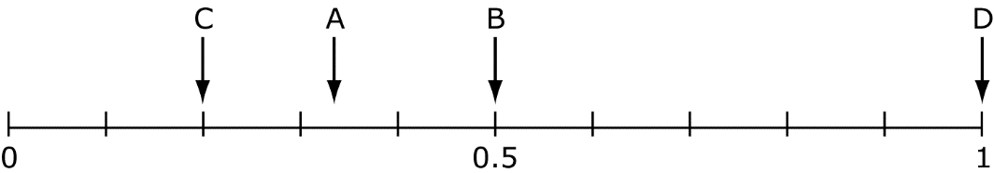  Which arrow shows:  a) The probability of scoring an odd score when a fair die is thrown?  ……………  b) The probability of picking the letter A from the word MATHS?  ……………  c) The probability of the sun rising every morning ? ……………  d) The probability of having a baby being a girl ? …………… | (4)
8.  M | The letters from the word RHOMBUS are written onto pieces of card and placed in a bag.  R H O M B U S  a) What is the probability of picking the letter H? ……..  b) What is the probability of picking a vowel ? ……… | (2)
9.  M | Some number cards from 1 to 8 are placed in a bag.  1 2 3 4 5 6 7 8  What is the probability of  a) picking an even number? ………  b) picking a number greater than 12? ………  c) picking a factor of 8? ……… | (3)
 | TOTAL | (10)

