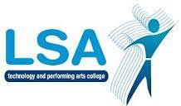
LSA Long Term Plan 2021-22: Y7
Focus: Beliefs and symbolism
Weeks 1-11 | Weeks 12-22 | Weeks 23-31 | Weeks 31-38
Topic: Christianity: | Topic: Hinduism | Topic: Islam | Topic: Buddhism
 | What do we see? | Isla: Factfile | Buddhism: Factfile
What is religion
Signs and symbols | History of Hinduism | The 5 Pillars of Islam | The Buddha: early life
Christian signs and symbols. | One God: many forms | Shahadah | The Four sights
The Trinity | The Law of Karma | Salah | The Noble Eighfold Path
One Church; many branches | Moksha | Zakah | Buddhism in practice
Baptism | The Caste System | Sawm | Buddhsim in Britain
weddings | Hindu worship | Hajj
Planning Lesson | Planning
Assessment | Assessment
Dirt | Dirt

