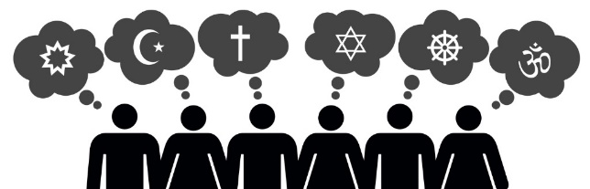
Year 7 Tier 3 RS Vocabulary words
Christianity

Christians: followers of the religion of Christianity.
Bible: the Christian holy book.
Monotheism: the belief in one God.
Symbol: Represent something, can be easily identified.
Cross: A Christian symbol which represents the cross Jesus died on.
Crucifix: A Christian symbol with the body of Jesus on.
Holy Spirit: Represented by a dove, shows the spirit of God on earth.
Crucifixion: Jesus sentenced to death by being nailed to the cross.
Resurrection: Jesus rose from the dead.
Atonement: Making amends for something you have done wrong.
Faith: A strong belief based on spiritual feelings.
Worship: To show adoration to a God through prayer or celebration
Sacrifice: To give an offering
Holy Trinity: The Father, the Son, the Holy Spirit
Church: A religious building or a community of Christians
Roman Catholic: A form of Christianity which is led by the Pope
Church of England: A form of Christianity which is led by the Archbishop of Canterbury
Lectern: A stand for the Church Bible
Pulpit: A raised box where sermons are delivered.
Altar: It is a special table which holds the items for the Communion service
Font: The Font is filled with water and used for baptisms
Pews: the special seats that people sit on in church.
Jerusalem: The Holy city for Christians where Jesus preached, died and was resurrected.
Baptism: ceremony that symbolises a commitment to living a life as a Christian
Initiation: The act of beginning something.
God parents: People who will help to guide a Christian through their life.
Wedding: A legal union between two people, usually religious ceremony exchanging vows.
Cohabitation: Two people living together without being married.
Civil Partnership: A legal union between two people without any religious beliefs.
Vows: Promises exchanged during a wedding to each partner and witnessed by God.

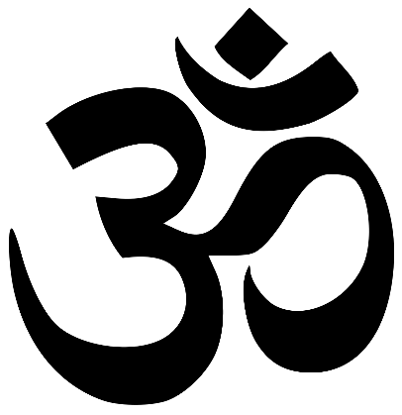
Hinduism

Hindu: A follower of Hinduism
Brahman: The one divine God for Hindus.
Saguna Brahman: Brahman represented in the form of different God and Goddesses.
Murti: images or statues that Hindus worship as representations of Saguna Brahman
Trimurti: Brahman represented by three Gods; Brahma, Vishnu and Shiva.
Tridevi: Saguna Brahman represented by three Gods; Lakshmi, Parvati and Saraswati. Seen as the female counterparts of the Trimurti.
Brahma: The creator of the world and all its creatures.
Vishnu: The preserver of the world, keeps order.
Shiva: The destroyer of the universe in order to recreate it.
Mandir: A Hindu temple
Bhajans: Religious songs
Vedas: a collection of hymns praising the Vedic gods. Veda means 'knowledge'.
Vedic Scriptures: Rg, Yajur, and Sama
Ramayana: long epic poems about Rama and Sita.
Mahabharata: which includes the Bhagavad Gita.
Puranas - a collection of stories about the different incarnations and the lives of saints.
Aum: is a Hindu sacred sound that is considered the greatest of all mantras.
Karma: The belief that every action has an equal reaction.
Atman: The spirit or soul beyond the human body.
Samsara: The cycle of life and death.
Dharma: A duty that everyone has in their life to bring about good.
Reincarnation: To be reborn into another life.
Sanskrit: The ancient language of Hinduism
Moksha: To be liberated from the cycle of life and death.
Liberation: The action of being set free from something.
Realm: Different life forms in the cycle of Samsara.
Caste: A group within Hindu society that one is born into.
Brahmins: Teachers or Priests
Khatriyas: Warriors and leaders
Vaishyas: Merchants, traders and farmers
Shudras: Manual workers and labourers
Dalits: Those seen as too low for status in society
Puja: Prayer
Arti lamp: A lamp used on a Puja tray to perform worship.
Shrine: A place where gods or goddesses are worshipped either in the home or at the Mandir.

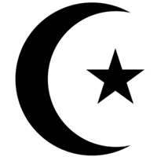
Islam
Islam: submission or peace. The religion followed by Muslims.
Muslim: a person that follows the religion of Islam.
Arabic: the traditional language of Islam.
Allah: the Arabic word for God (the name Muslims use for God).
Tawhid: the belief in the oneness of God.
Monotheism: the belief in one God.
Mosque: the place of worship in Islam.
Prophet: a messenger of God.
Prophet Muhammad: the final Prophet and founder of Islam.
Peace be upon him: a blessing that is often said by Muslims immediately after saying the Prophet Muhammad’s name.
Crescent Moon and Star: the symbol of Islam.
Qur’an: the holy book for Islam.
Day of Judgement: a day when Muslims will be judged for their actions and behaviour which will determine whether they will go to heaven or hell.
Makkah: the birthplace of the Prophet Muhammad and the holy city to Muslims. Makkah is in Saudi Arabia.
Ka’aba: the shrine to Allah which is located in the centre of the Grand Mosque in Makkah.
Angel Jibril: an angel who revealed the Qur’an to Muhammad.
Hafiz: a Muslim who has learned the Qur’an by heart.
Shari’ah Law: Islamic law which originates from the Qur’an.
Allah Akbar: God is great.
Submission: a Muslim must try to live their daily lives by showing faith in Allah.
Idolatry: Worshipping something or someone as they were God when they are not.
5 Pillars of Islam: The five core beliefs and practices in Islam.
Shahadah: The declaration of Faith
Salah: The act of prayer
Zakah: The act of compulsory giving
Sawm: Fasting during the month of Ramadan
Hajj: A pilgrimage to Makkah.
Pilgrimage: A religious or spiritual journey to a place of worship, either alone or with a group. Usually to feel closer to God and strengthen ones faith.
Sadaqah: The act of voluntary giving
Ramadan: The twelfth month of the Islamic calendar where Muslims will fast from sunrise to sunset to show obedience to Allah.
Safa and Marwa: The two hill in Makkah where Hijrah ran between to find water for Ismail
The ZamZam well: The spring Allah blessed Hijrah and Ismail with whilst in Makkah.
Ihram: sacred state into which a Muslim must enter in order to perform the haj
Tawaf: Circling the Ka’aba seven times in an anti-clockwise direction during Hajj.
Arafat: When Prophet Muhammad preached his last sermon.
Jamarat: Three stone walls in Mina which represent temptation and the devil.
Sermon: A public talk on a religious topic.
Sacrifice: To give an offering
Buddhism

Buddhists – followers of the religion of Buddhism.
Dhamma – The teachings of Buddha
Monastic – is a way of living that's religious, isolated from other people, and self-disciplined.
Monks – someone who dedicates their life to Monastic living
Theraveda – A form of Buddhism originating in South and South-East of India
Mahayana - A form of Buddhism originating in North and North-East of India
Vajrayana - A form of Buddhism originating in Tibet
Ritual – an action used again and again in exactly the way
Mantra - a word or sound repeated to help concentration in meditation.
Siddartha Guatama – the founder of Buddhism
Buddha – A title meaning the enlightened one, given to Siddhartha the founder of Buddhism
The four sights – The four people Siddhartha saw that made him change his view of life.
Enlightenment – An understanding about what is true and real.
Renunciation - Rejecting something, for example a certain way of life.
Golden mean – Having neither too much or too little of material things
Meditation – Thinking about something deeply or reflecting
Mara – A evil source of temptation which can take many different forms
The four noble truths – Four teachings about change and suffering in life
Eightfold path – The Buddha’s teaching on the way to live so that a person can get rid of greed, hatred and ignorance. This is the way the reach Nirvana.
Nirvana – The end goal for Buddhists, a state of true happiness, wisdom and peace.
Truth – living a life of honesty
Temptation – The desire to do something, especially if it is wrong or unwise
Vegetarian - a person who does not eat meat or fish, and sometimes other animal products, especially for moral, religious, or health reasons.

Vegan - a person who does not eat any food derived from animals and who typically does not use other animal products.
The five precepts – Guidance about ways to become a better person
Abstain – To go without something.
Bodhi tree – The tree that Buddha sat under when he meditated
Mindfulness – To be fully present and aware of your surroundings, in a calming state.
Mandala – a spiritual and ritual symbol which represents the universe. Often used in mediation or for art purposes.
Reflection – Giving serious thought to the past.

