Year 8 Core Standard: Assessment 1 Revision Name _________________________________

 | Topic 1: Negative Numbers | Mark
1. | $<$means “is less than”  $>$means “is greater than”  Put the correct symbol between each pair of numbers.  The first one is done for you.  -1 $<$ 5 3 ……… -6 -4 ……… -7  -2.1 ……… –2.3 -3.21 ……… - 3.4 -4.08 ………-4.2 | 5
2. | Calculate  3 + -2 = ……… -4 + 2 = ……… -2 – 1 = ………  -3 - -4 = ……… 3 - -1 = ……… -5 + -2 = ……… | 6
3. | Complete the addition table  + 5 -4  -2 3 -1  3 -1  -4 -3 | 6
4. | Calculate:  - 2 + -3 + 7 = ……… 3 + -4 + -5 = ………  - 1 – 3 – +9 = ……… 3 - - 4 + - 2 = ……… | 4
5. | Fill in the blanks:  3 + ……… = 2 7 - ……… = -3  10 - ……… = 12 ……… + 4 = -2  ……… - -4 = 12 ……… + -9 = 3 | 6
6. | a) What is the difference between -3 and 5 ? …………  b) What is the difference between -23 and -12 ? …………  c) What is the difference between 9 and -15 ?  ………… | 1  1  1

 | Topic 2: Algebraic Manipulation | Mark
1. | Simplify the following expressions:  c + c + c = ………… 2c + 3d + 6 c + 2 d = ……………………  3a x 7a = ………… 7c + 5d – 2c – 4d = …………………… | 4
2. | 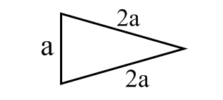  What is the perimeter of this triangle?  Perimeter = ……………… | 1
3. | Find an expression for the perimeter of the trapezium?  Give your answer in its simplest form.  Perimeter = ……………… | 2
4. | 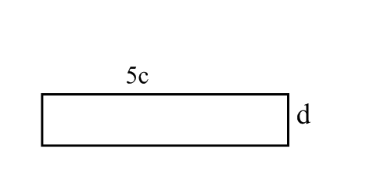  a) Write an expression for the perimeter of this rectangle.  Perimeter = …………  b) Write an expression for the area of the rectangle.  Area = ……………  c) If c = 3 and d = 4 find the area of the rectangle.  Area = …………… | 1  1  2
5. | A van hire charges using this formula  Amount charged = 10 + (5 x number of miles)  a) How much would it cost if Barry hires the van for 3 miles?  ……………  b) Dennis is charged £135. How many miles did he travel?  …………… | 2  2

 | Topic 3:Averages | Mark
1. | Here are 6 test scores. 2, 4, 5, 6, 9, 10  What was the modal score? ………………  What was the median test score? ………………  What was the range of scores? ………………  Calculate the mean test score?  ……………… | 1  2  1  2
2. | Write down 2 numbers with a mean of 6 and a range of 8.  ……………… and ……………… | 2
3. | Two teams received these scores in a competition.  Team A 0.9 2.1 2.3 3.6 1.1  Team B -1 5 -3 10 4  Mean result for team A Mean result for team B  Use your answers to decide which team is better and explain why.  ………………………………………………………………………………………………………………………………………………………………  ………………………………………………………………………………………………………………………………………………………………  Range for team A Range for team B  Use your answers to decide which team is more consistent. You must explain why.  ………………………………………………………………………………………………………………………………………………………………  ……………………………………………………………………………………………………………………………………………………………… | 4  1  2  1
4. | Helen recorded the number of hurdles were knocked over in each race on Sports Day.  Number hurdles knocked over Frequency Subtotal  1 7 1 x 7 = ………  2 4  3 2  4 6  5 1  Totals  a) What was the modal number of hurdles knocked over? ………………  b) What was the mean number of hurdles knocked over? ……………… | 2  1  1

 | Topic 4: Number Properties | Mark
1. | 12 9 40 17 2 18  From the list of numbers write down a number that is:  odd ……………… prime ………………  A factor of 6 ……………… A multiple of 8 ……………… | 4
2. | List the first 6 multiples of 6 ……… , ……… , ……… , ……… , ……… , ………  List the first 6 multiples of 15 ……… , ……… , ……… , ……… , ……… , ………  Use your list to write down the Lowest Common Multiple (LCM) of 6 and 15 ……… | 3
3. | Write down the factors of 28 …………………………………………………………………………………………….  Write down the factors of 30 …………………………………………………………………………………………….  What is the Highest Common Factor (HCF) of 28 and 30? …………….. | 3
4. | Write 36 as a product of its primes by completing the prime factor tree below.  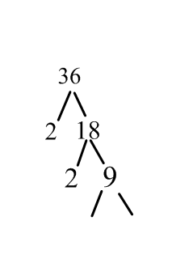 36 = ………………………….. | 2
5. | Write 70 as a product of its primes by drawing a prime factor tree below.  70 = ………………………….. | 3
6. | Calculate the following:  20 – 2 x 3 = 14 ÷ ( 2 + 5 )  = ………………………….. = …………………………..  = ………………………….. = …………………………..  2 x 4 + 5 x 7 6 + 21 ÷ 3  = ………………………….. = …………………………..  = ………………………….. = ………………………….. | 4

