YEAR 8 HOMEWORK ASSESSMENT TEST 2 – CALCULATOR Enhanced

NAME _____________________ TEACHER ___________________

Area | /10 | Ratio | /10 | Sequences | /10 | Probability | /10

 | Area
1.  F | Mr Wood's garden is in the shape of a rectangle. Part of the garden is a patio in the shape of a triangle. The rest of the garden is grass. Work out the area of the grass.  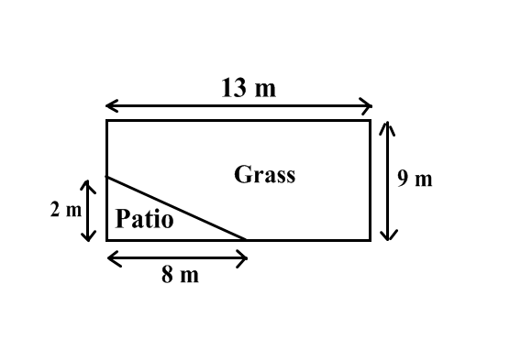  ………………………… cm² |  |  | (3)
2.  S | 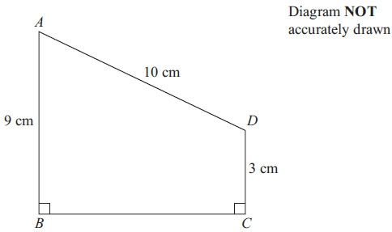  ABCD is a trapezium.  9.5 cm  Calculate the area of the trapezium.  ………………………… cm² |  |  | (2)
3.  S | Here is a circle.  The radius of the circle is 4 cm.  Work out the perimeter of the circle.  Give your answer correct to 1 decimal place.  ………………………… cm |  |  | (2)
4.  M | The diagram shows a tile.  The tile is in the shape of a semicircle of  radius 8 cm. Work out the area of the tile.  Give your answer correct to one decimal place.  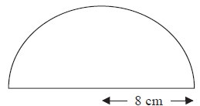  ………………………… cm |  |  | (3)
 |  |  |  | (10)
 | Ratio
1.  F | The cost of 7 cups is £8.40  Work out the cost of 10 of these cups.  £……………………… |  |  | (2)
2.  F | A street map has a scale of 1 : 25000.  Church Road is 4 cm long on the map.  What is the actual length of Church road in kilometres?  ………………… km |  |  | (2)
3.  M | Soap powder is sold in three sizes of box.  2 kg of soap powder costs £1.95  5 kg of soap powder costs £4.78  9 kg of soap powder costs £8.23  Which size of box is the best value for money? Explain your answer. |  |  | (3)
4.  M | A student bought a pair of sunglasses in the USA. He paid $30.50  In England, an identical pair of sunglasses costs £26.99  The exchange rate is £1 = $1.32  In which country were the sunglasses cheaper, and by how much?  Show all of your working. |  |  | (3)
 |  |  |  | (10)
 | Sequences
1.  S | Here are the first four terms of a number sequence.  10 13 16 19  a) Find the 10th term in this sequence.  …………………………  b) The number 101 is not a term in this sequence.  Explain why.  ...........................................................................................................................................  ........................................................................................................................................... |  |  | (1)  (1)
2.  F | Here are the first five terms of a number sequence.  40 36 32 28 24  Write an expression, in terms of n, for the n^{th} term of this sequence.  ………………………… |  |  | (2)
3.  F | The n^{th} term of a different sequence is 3n² – 2  Find the 3rd term of this sequence.  ………………………… |  |  | (2)
4.  M | Here are the first four terms of a geometric sequence.  8 20 50 125 …  a) Write down the value of the common ratio. …………………………  b) Work out the next term in the sequence.  ………………………… |  |  | (1)  (1)
5.  M | This is a quadratic sequence:  4, 10, 18, 28, 40  Find the rule for the n^{th} term.  ………………………… |  |  | (2)
 |  |  |  | (10)
 | Probability
1.  S |  | A bag contains coloured balls, all equal in size. A ball is selected at random.  The probability of choosing a blue ball is .  What is the probability of choosing a ball that is not blue. ……… | (1)
2.  F |  | There are 240 pupils in Year 8. There are 135 males.  There are 23 boys who wear glasses.  There are 18 girls who wear glasses.  Use this information to complete this frequency tree. | (2)
3.  F |  | A computer game selects characters for players to use in a game.  The table shows the probabilities of each character being chosen.  Amazing Alf Brilliant Bert Clever Chris Daring Dave Evil Ed  0.13 0.29 0.2 0.3  a) Complete the missing probability for Evil Ed.  b) Calculate probability that the character will be Clever Chris or Brilliant  Bert? ………… | (1)  (2)
4.  M |  | A coin is thrown twice and the following tree diagram is produced.  a) Complete this tree diagram. Use your tree diagram to calculate  H  T  H  ……  ……  ……  ……  ……  ……  ……  ½  ½  b) the probability of at least one head. ………… | (2)  (2)
 | TOTAL |  |  | (10)

