Year 8 Higher Standard: Assessment 3 Revision Name _____________________

 | Topic 9: Fractions | Mark
1. | a) Convert 30 % into a fraction ………  b) Convert 0.45 into a fraction ………  c) Convert ¾ into a percentage ………  d) By doing a division convert $\frac{3}{7}$ into a decimal.  3 7  e) Put these numbers in order of size smallest first  35% 0.4 $\frac{3}{5}$ $\frac{3}{4}$ 0.32  …….. ……… ……… ……… ………  f) What is the reciprocal of $\frac{2}{3}$ ? ……… | (3)  (1)  (1)  (1)
2. | Find $\frac{3}{10}$ of £24  ……………… | (2)
3. | Calculate:  a) $\frac{2}{5}+\frac{1}{6}$ b) $\frac{6}{7}-\frac{2}{3}$  …………………….……………………. …………………….…………………….  c) $\frac{2}{5}×\frac{3}{8}$ d) $\frac{4}{5}÷\frac{9}{10}$  …………………….……………………. …………………….……………………. | (2)  (2)
4. | Isobel receives £60 for her birthday.  She spends 25% on clothes.  She spends $\frac{1}{5}$ on a McDonalds meal.  How much has she got left over?  ……………… | (3)
 | Total | (15)

 | Topic 10: Angles | Mark
1. | Find the missing angles and give reasons for your answers.  25° a 205° b  a = …………………… b = ……………………  ………………………………………………………………………… ………………………………………………………………………… ………………………………………………………………………… ………………………………………………………………………… d 60° 85° 150°  100°  c  c = …………………… d = ……………………  ………………………………………………………………………… ………………………………………………………………………… ………………………………………………………………………… ………………………………………………………………………… | (4)  (4)
2. | Find the missing angles and give reasons for your answers.  110° a 125° b c  a = …………………… b = ……………………  ………………………………………………………………………… …………………………………………………………………………  ………………………………………………………………………… c = ……………………  ………………………………………………………………………… | (6)
3. | Calculate the bearing of:  N  N  N  124°  73°  A  B  C  - B from C  ………………  - C from B  ………………  - B from A  ……………… | (3)
 | Total | (17)

 | Topic 11: Graphs | Mark
1. | a) On the grid draw and label the following  x = 4  y = - 2  b) Complete the table and plot the graph of  y = 2x + 1  x -3 -2 -1 0 1 2 3  y -1 3  c) What is the gradient of the graph  y = 3x + 4 ? ……………………  d) What is the y intercept of the graph  y = 2x – 5 ? …………………… | (2)  (2)  (2)
2. | a) Circle the equations which have the same gradient.  y = 2x + 3 y = -4x + 3 y = 2x – 1 y = 7x + 1 y = x + 2  b) Circle the equations which have the same y intercept.  y = 2x + 3 y = -4x + 3 y = 2x – 1 y = 7x + 1 y = x + 2  c) Circle the equation which is steepest.  y = 2x + 3 y = -4x + 3 y = 2x – 1 y = 7x + 1 y = x + 2 | (3)
3. | 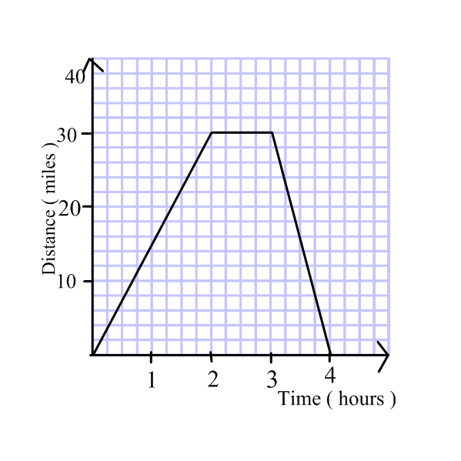  Alice cycles to the shops and back home again.  Here is her distance time graph.  a) How far has Alice travelled after 2 hours? ……………………  b) What speed is Alice travelling on the way to the shops? ……………………  c) How long does Alice stay at the shops? …………………… | (3)
 | Total | (12)

 | Topic 12: Statistics | Mark
1. | a) Complete the back to back stem and leaf diagram for the following heights (cm)  Male 112 121 123 124 134 135 138 145 160 176 187  Female 110 112 126 126 129 138 141 145 145 151 153  Female Male  1 1  1 2  1 3  1 4  1 5  1 6  1 7  1 8  Key: 134 = 4 │1 3 Key: 134 = 1 3 │ 4  b) What is the range of the Male heights? ……………………  c) What is the mode of the Female heights? ……………………  d) What is the median of the Male heights ? …………………… | (2)  (3)
2. | a) Draw a scatter graph for the following data for sparrow wing spans and length.  Length (cm)  Wing span (cm)  10  20  10  20  Wing span (cm) 20 15 9 11 14 12  Length (cm) 19 16 8 10 15 13  b) Describe the correlation  …………………….…………………….  c) Estimate the length of a sparrow with a  wing span of 10 cm.  …………………….  0 | (2)  (1)  (1)
3. | Mrs Leake decides to open an ice cream shop and  lists how many of each she sells one day.  a) Complete this table  Type Frequency Angle  Cornetto 8  99 15  Ice lolly 9  Choc Ice 4  Total  b) Draw a pie chart of these results. | (1)  (2)
 | Total | (12)

