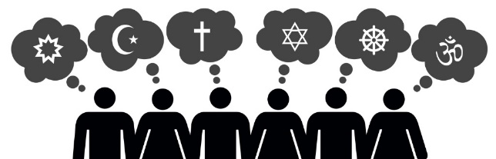
Year 8 Tier 3 RS Vocabulary words
Christianity

Christians: followers of the religion of Christianity.
Bible: the Christian holy book.
Old Testament: the first part of the Christian holy book which contains 39 books. This part of the Bible includes details about Jewish life before Jesus was born.
New Testament: the second part of the Christian holy book which contains 27 books. This part of the Bible is about Jesus and his life.
Gospels: four books in the Bible called Matthew, Mark, Luke, and John which detail Jesus’s life including his birth, miracles, crucifixion, resurrection, and ascension.
Law: rules about how to behave, such as the ten commandments, which affect a Christians life and are still relevant today.
Prophecy: books in the Bible which foretell what will happen in the future if people do not follow God’s teachings.
Letters: a type of writing in the Bible that was written by the Church to their new followers telling them how to be a good Christian.
History: books within the Bible which explain how the world was crated, the key events in the life of the Jewish people and the way God loves people and wants them to live.
Fundamentalist Christian: a Christian that believes every single word and every single event in the Bible is literally true.
Liberal Christian: a Christian that does not believe every single word and event in the Bible is true but that some of the stories are symbolic or metaphors to teach a lesson or greater truth.
Parable: a simple story used to illustrate a moral or spiritual lesson, as told by Jesus in the Gospels.
Creation Story: the story found in Genesis in the Bible which explains how God created the world in 6 days and rested on the 7th.
Big Bang Theory: the leading scientific explanation for how the universe began.
Disciples: the 12 personal followers of Christ.
Miracle: a seemingly impossible event, usually good, which cannot be explained by natural or scientific laws and is thought to be the action of God.
Levite: a member of the Hebrew tribe of Levi, which provided assistants to the priests for worship in the Jewish temple.

Good Samaritan: a kind, helpful person from Samaria who helped a Jewish man in need in the Parable of the Good Samaritan.

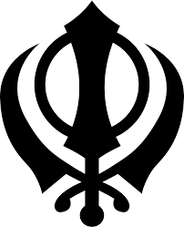
Sikhism

Sikh: learner or disciple, a person who follows the religion of Sikhism.

Guru: the title given to a religious leader in Sikhism.
Guru Nanak: the first Sikh Guru.

Guru Gobind Singh: the tenth and final human Guru who declared that there would be no more human Gurus after him.

Guru Granth Sahib: the final, eternal Guru – the holy book of Sikhism.

Mool Mantra: a section of the Guru Granth Sahib which summarises Sikh beliefs about God.

Adi Granth: a book containing copies of the key hymns from the Guru Granth Sahib.

Waheguru: wonderful Lord or Teacher. Sikhs refer to God as Waheguru.

Immanent: the belief that God is everywhere and close to people, he is a part of every living thing.

Transcendent: the belief that God is above and beyond creation.

Khanda: the symbol of Sikhism.

Gurdwara: the Sikh holy building and place of worship.

The Langar: the room in the Gurdwara where Sikhs come together to eat.

Sach Khand: the bedroom for the Guru Granth Sahib in the Gurdwara.

Chauri: the fan for the Guru Granth Sahib.

Ragis: musicians who perform hymns in the prayer hall.

Palki: the canopy cover for the Guru Granth Sahib at the front of the prayer hall.

Sikh Naming Ceremony: a ceremony which takes place within a few weeks of a baby’s birth where parents and friends gather to thank God for the baby and choose its name.

Karah Parshad: a sacred food in Sikhism which reminds Sikhs of the langar and the idea that all people are God's creation.

Arranged Marriage: a marriage arranged and agreed on by the parents of the couple concerned.

Anand Karaj: the Sikh Wedding Ceremony.

Chunni: a blessed head scarf worn by the bride.

Turban: a man's head covering consisting of a long length of material wound around a cap or the head, worn especially by Sikhs and Muslims.
Milni: the ceremony before the wedding ceremony where families meet to exchange gifts and eat a meal.

Lavan: the wedding hymn that is sung as the couple walk around the Guru Granth Sahib.

Vaishaki: the festival which marks the formation of the Khalsa.

Khalsa: the pure ones – the group of Sikhs that are truly committed to God.

Amrit: holy water.

Caste System: an ancient system of India which divides people into rigid hierarchical groups.

Singh: the surname Sikh men have which means lion.

Kaur: the surname Sikh women have which means princess.

5 K’s: 5 physical symbols worn by Sikhs who have been initiated into the Khalsa.
Kesh: one of the 5 K’s, long uncut hair. Sikhs believe their hair is a gift from God so should not be cut or destroyed.
Kanga: one of the 5 K’s, a wooden comb used to maintain their long uncut hair.
Kara: one of the 5 K’s, a steel bracelet that is worn around their right wrist which represents their eternal bond with God.
Kachera: one of the 5 K’s, white cotton underwear. A reminder to control desire.
Kirpan: one of the 5 K’s, a small sword that is always worn to protect the week and needy and for self-defence.
Sohila: a prayer said by every Sikh before they go to sleep at night. This is said at a Sikh funeral too.
Ardas Prayer: a prayer which remembers God and the Ten Gurus and asks God to bless the Sikhs and all humanity and to help them be faithful to the scriptures.
Akand Path: the reading of the Guru Granth Sahib all the way through from start to finish.
Reincarnation: the belief that when a person dies their soul is reborn into another body.
Mukti: liberation from the cycle of birth, death, and re-birth.
Karma: the belief that all actions have consequences, specifically they will influence reincarnation.

Islam
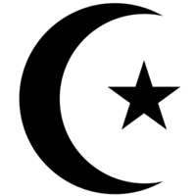
Islam: submission or peace. The religion followed by Muslims.
Muslim: a person that follows the religion of Islam.
Arabic: the traditional language of Islam.
Allah: the Arabic word for God (the name Muslims use for God).
Tawhid: the belief in the oneness of God.
Monotheism: the belief in one God.
Mosque: the place of worship in Islam.
Prophet: a messenger of God.
Prophet Muhammad: the final Prophet and founder of Islam.
Peace be upon him: a blessing that is often said by Muslims immediately after saying the Prophet Muhammad’s name.
Crescent Moon and Star: the symbol of Islam.
Qur’an: the holy book for Islam.
Day of Judgement: a day when Muslims will be judged for their actions and behaviour which will determine whether they will go to heaven or hell.
Surah: a chapter in the Qur’an.
Ayah: a verse in the Qur’an.
Arabic Calligraphy: the style of writing that the Qur’an is written in.
Makkah: the birthplace of the Prophet Muhammad and the holy city to Muslims. Makkah is in Saudi Arabia.
Khadija: the wife of Prophet Muhammad.
Ka’aba: the shrine to Allah which is located in the centre of the Grand Mosque in Makkah.
Angel Jibril: an angel who revealed the Qur’an to Muhammad.
Hafiz: a Muslim who has learned the Qur’an by heart.
Halal: anything which is permitted in Islam.
Haram: anything that is forbidden in Islam.
Shari’ah Law: Islamic law which originates from the Qur’an.
Allah Akbar: God is great.
Khalifah: stewardship, the idea that Muslims have a duty to look after and care for the environment for God.

Justice

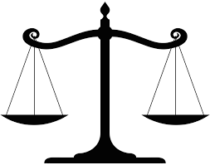
Justice: bringing about what it right and fair in accordance with the law and making up for a wrong that has been committed.
Injustice: the practice of being unfair.
Liberty: to have freedom.
Oppressed: to stop peoples freedom using an unjust force.
Jesus: the son of God in Christianity.

