

Year 9 PSHE Workbook
Autumn Term 1
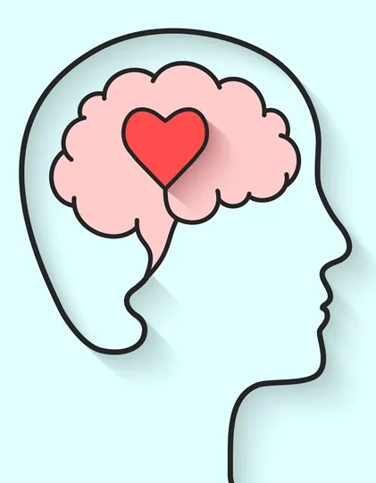

Mental Health and Wellbeing
Name:
Class & Teacher:
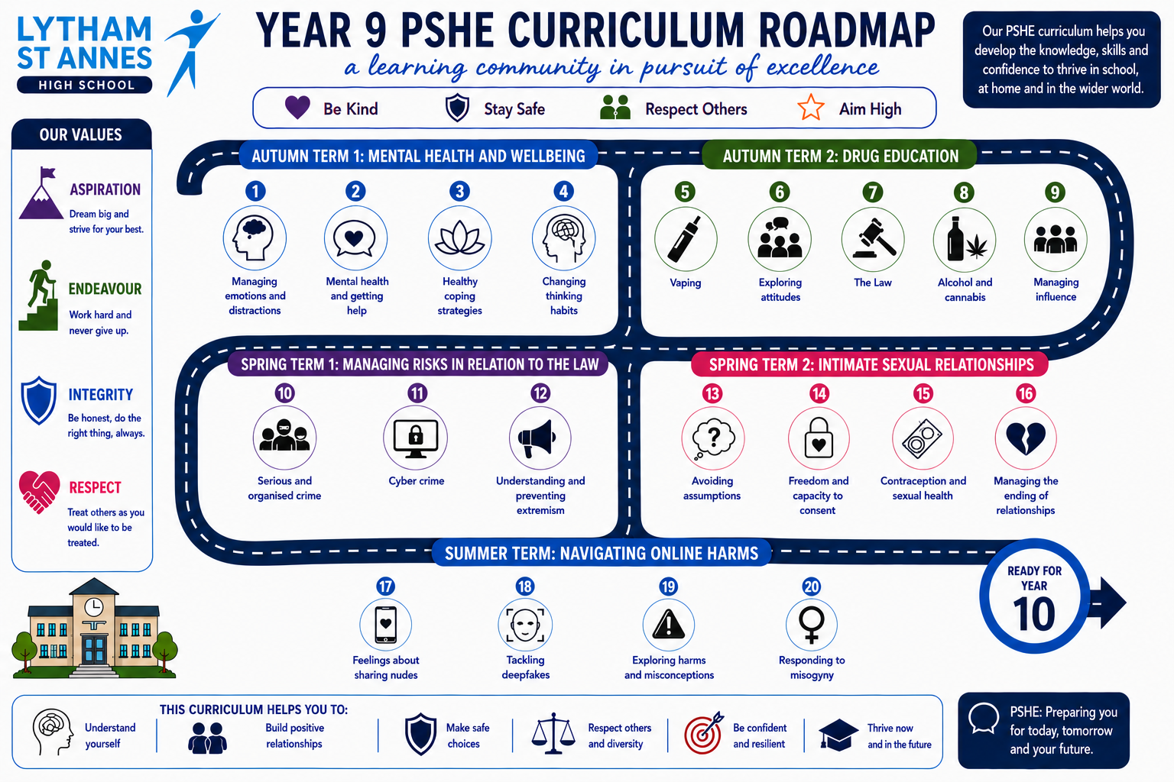

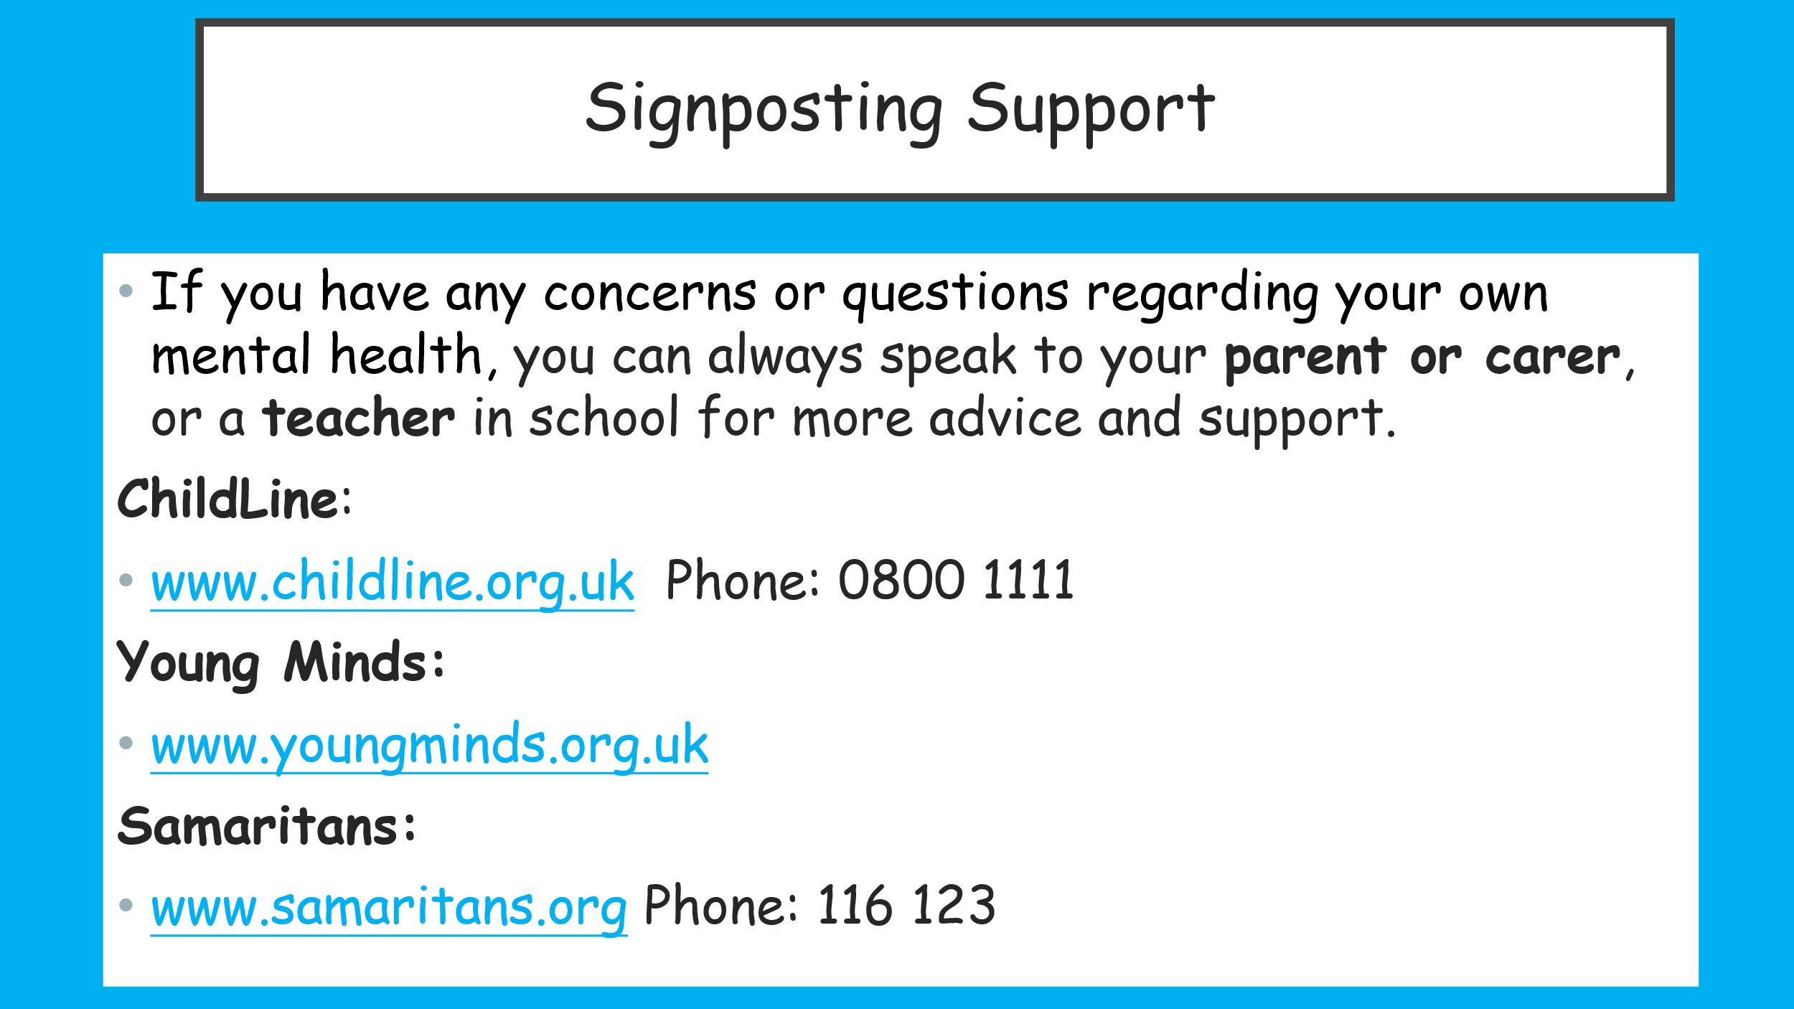
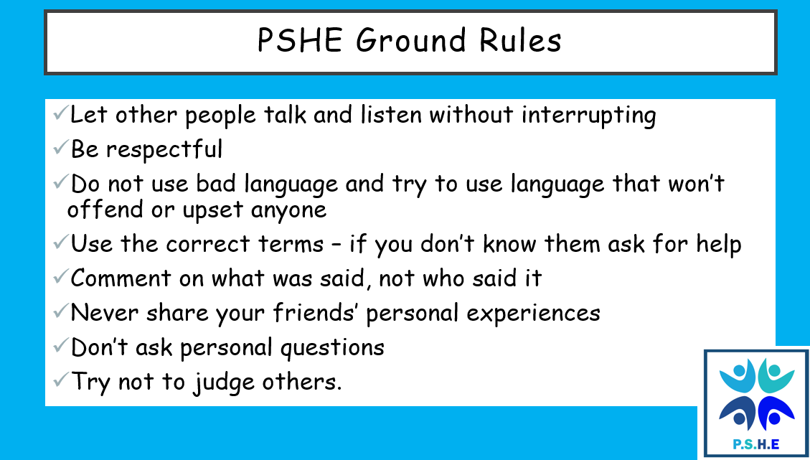
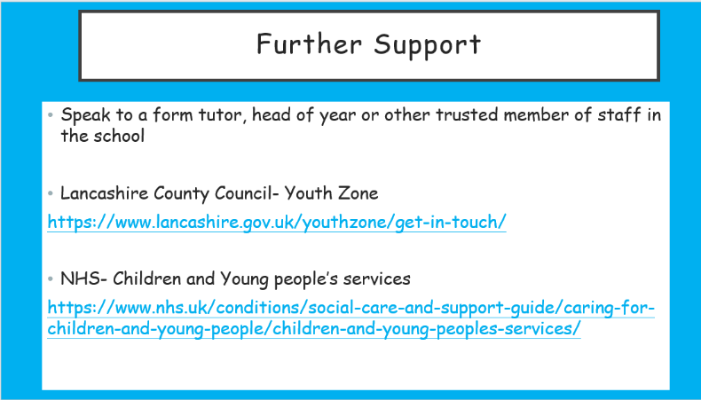
Sign: Date:
Baseline quiz
# | Question | A | B | C | D
1 | What is meant by wellbeing? | Being physically fit | Feeling happy all the time | How happy or content someone feels about their overall quality of life | Having no worries
2 | Which part of the brain helps with focus, problem-solving and managing emotions? | Amygdala | Hippocampus | Cerebellum | Prefrontal cortex (PFC)
3 | Which part of the brain acts like the body's alarm system? | PFC | Amygdala | Hippocampus | Cerebellum
4 | What is the main role of the hippocampus? | Controls breathing | Helps with learning and memory | Controls movement | Pumps blood
5 | Which hormone is linked to pleasure and reward? | Adrenaline | Serotonin | Dopamine | Insulin
6 | What is the fight, flight or freeze response? | A way to improve memory | The body's natural response to danger or stress | A type of exercise | A way to fall asleep
7 | Which of the following is a healthy coping strategy? | Ignoring your feelings | Staying up all night | Keeping everything to yourself | Talking to a trusted adult
8 | What is a helpful distraction? | Avoiding problems forever | An activity that helps you calm down before dealing with a situation | Spending all day on social media | Skipping school
9 | What is mental health? | Only mental illness | Only how someone feels when they are sad | Everyone's emotional, psychological and social wellbeing | Something only adults have
10 | Which of these is a common mental ill health condition? | Asthma | Diabetes | Chickenpox | Anxiety
11 | Which sign might suggest someone needs extra mental health support? | Feeling happy after a holiday | Persistent sadness lasting several weeks | Being excited before a party | Laughing with friends
12 | Who could a young person speak to if they were struggling with their mental health? | Nobody | Only friends | Social media influencers | A trusted adult, teacher or GP
13 | True or False: Everyone experiences worry and low mood sometimes. | False | True | Only adults do | Only teenagers do
14 | What does rumination mean? | Exercising regularly | Repeatedly thinking about something that has already happened | Sleeping too much | Talking to a friend
15 | What is a coping strategy? | A punishment | A type of illness | A way of managing difficult situations, thoughts or emotions | A school rule
16 | Which of these could be a physical sign of stress? | Growing taller | A racing heart | Better eyesight | Feeling hungry
17 | What is a negative thinking pattern? | Thinking positively all the time | An unhelpful way of thinking that focuses on the negative | Solving problems calmly | Learning from mistakes
18 | Why is it important to challenge negative thinking patterns? | They help you worry more | They help improve wellbeing and build balanced thinking | They make stress worse | They stop you learning
19 | What does it mean to reframe a negative thought? | Ignore it completely | Tell everyone about it | Replace it with a more balanced and realistic thought | Pretend it never happened
20 | Why is it important to ask for help early if someone is struggling with their mental health? | It wastes less time | It means they are weak | They should only ask when things are very serious | Early support can stop problems getting worse and improve wellbeing

Baseline score: /20
End of unit score: /20

21–25 = Outstanding
16–20 = Excellent
11–15 = Secure
6–10 = Developing
0–5 = Needs Further Support

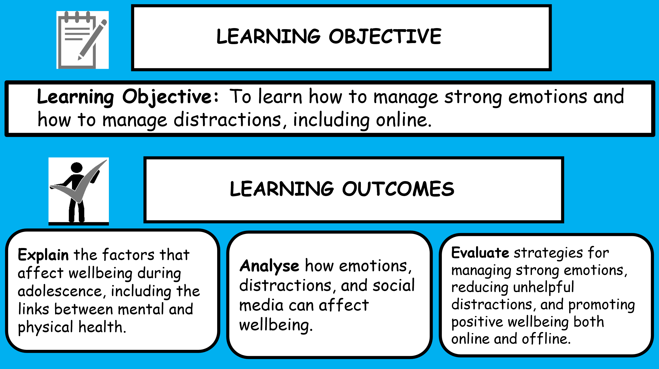
Lesson 1- Managing emotions and distractions
Task 1- Baseline what’s our starting point
Imagine someone, around your age, who wants to learn more about wellbeing. Can you explain:
What wellbeing means?
_________________________________________________________________________________________________________________________________________________________

What can affect someone’s wellbeing?
_________________________________________________________________________________________________________________________________________________________
What can help someone to support their own wellbeing and manage strong emotions?
_________________________________________________________________________________________________________________________________________________________
Task 1- What is wellbeing?
Teacher to share what wellbeing is.
Discuss as a class what can you remember about wellbeing and mental health
Task 2- Kaz’s day
Look a the event’s from Kaz’s day and ‘think, pair, share’ the questions below and use the graph to plot how Kaz’s emotions might change.
- Which experiences might have a positive effect on how Kaz feels throughout the day, and which might have a negative effect?
- How might these experiences
affect how Kaz behaves?
- What impact might these experiences have on Kaz’s wellbeing if, over time, they happen regularly?

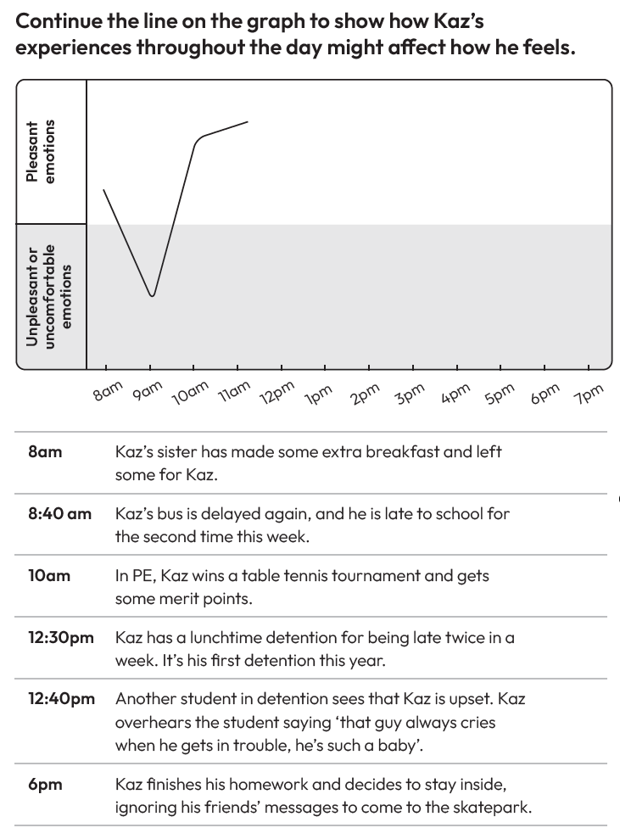
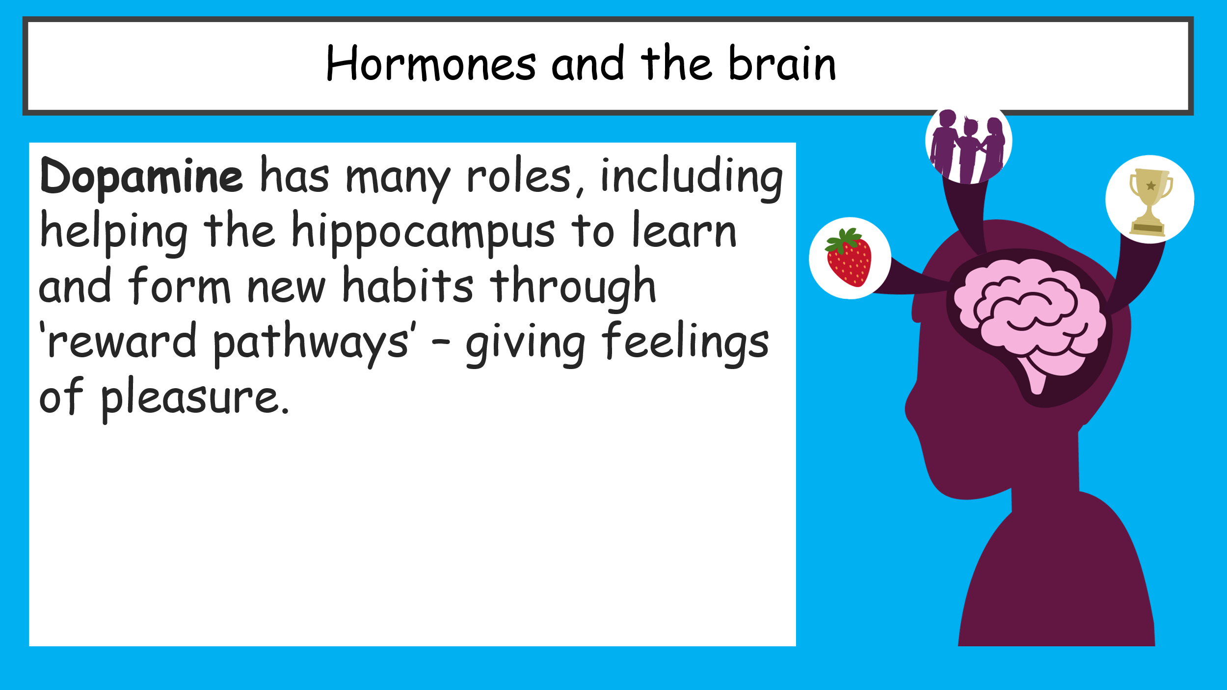
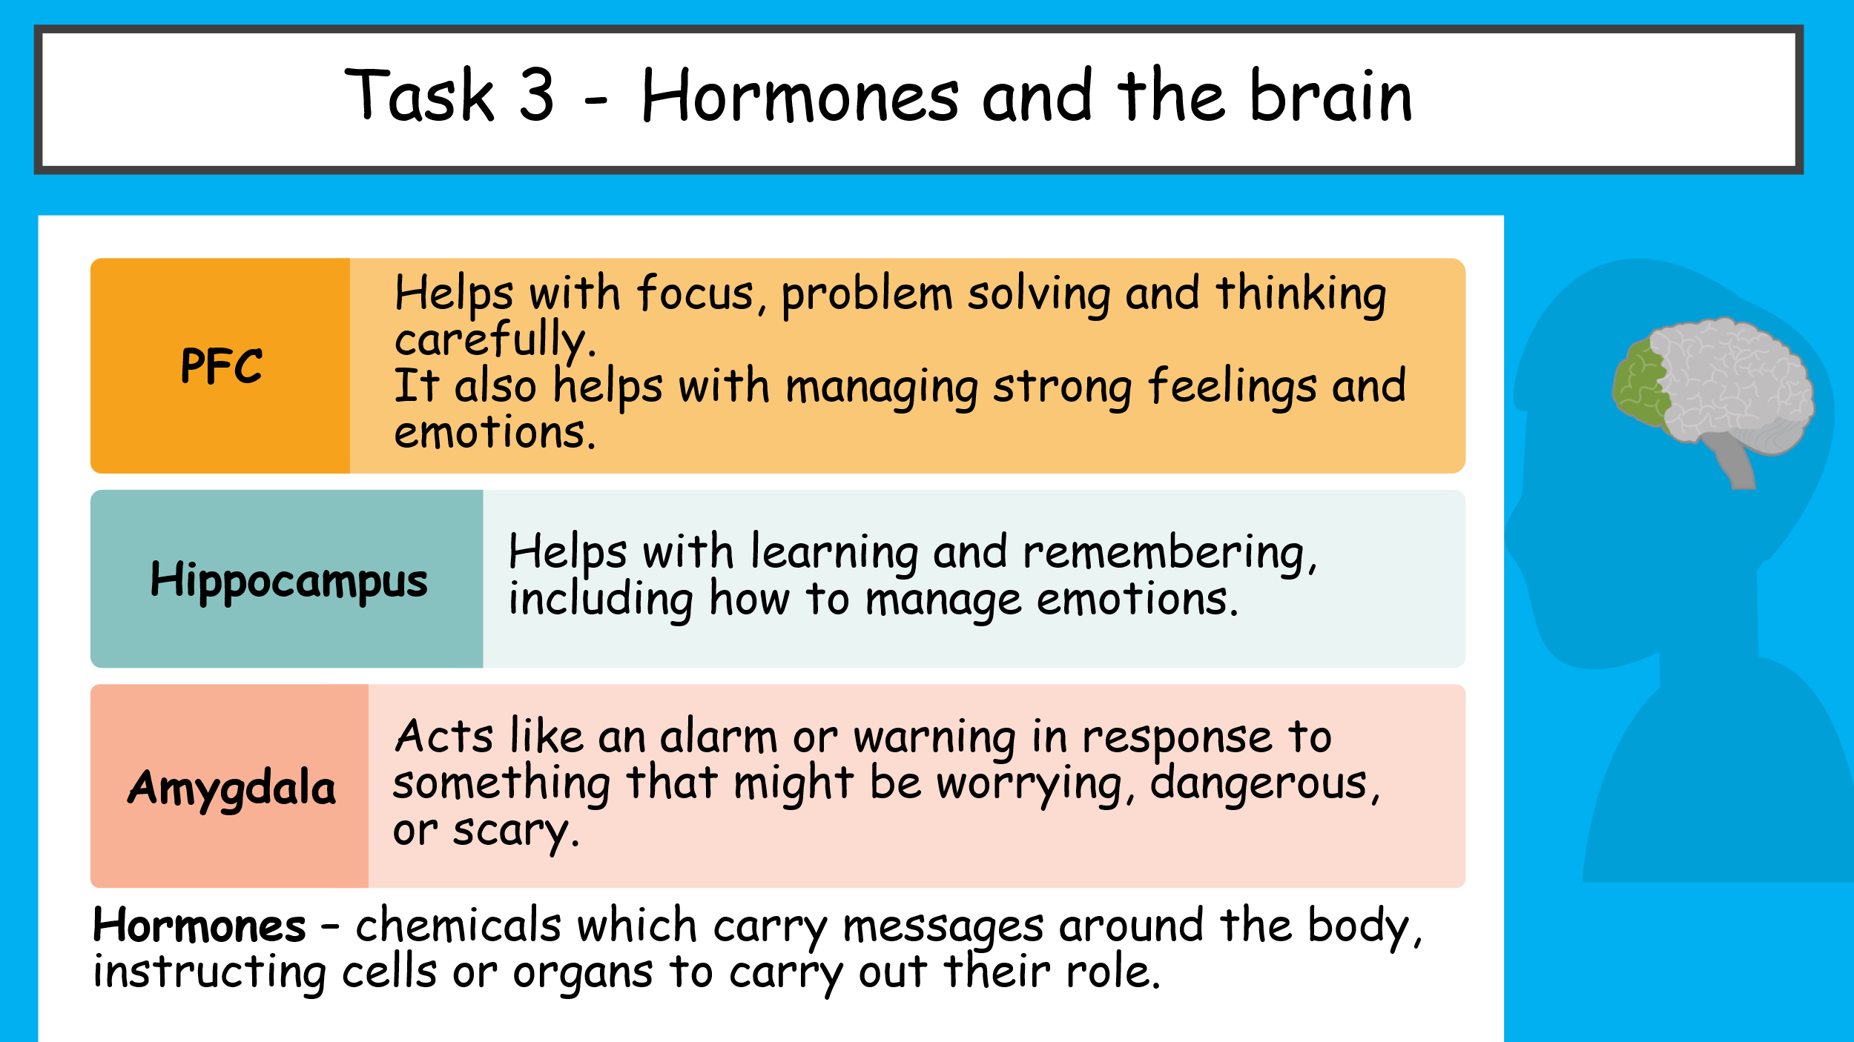
Task 3- Hormones and the brain

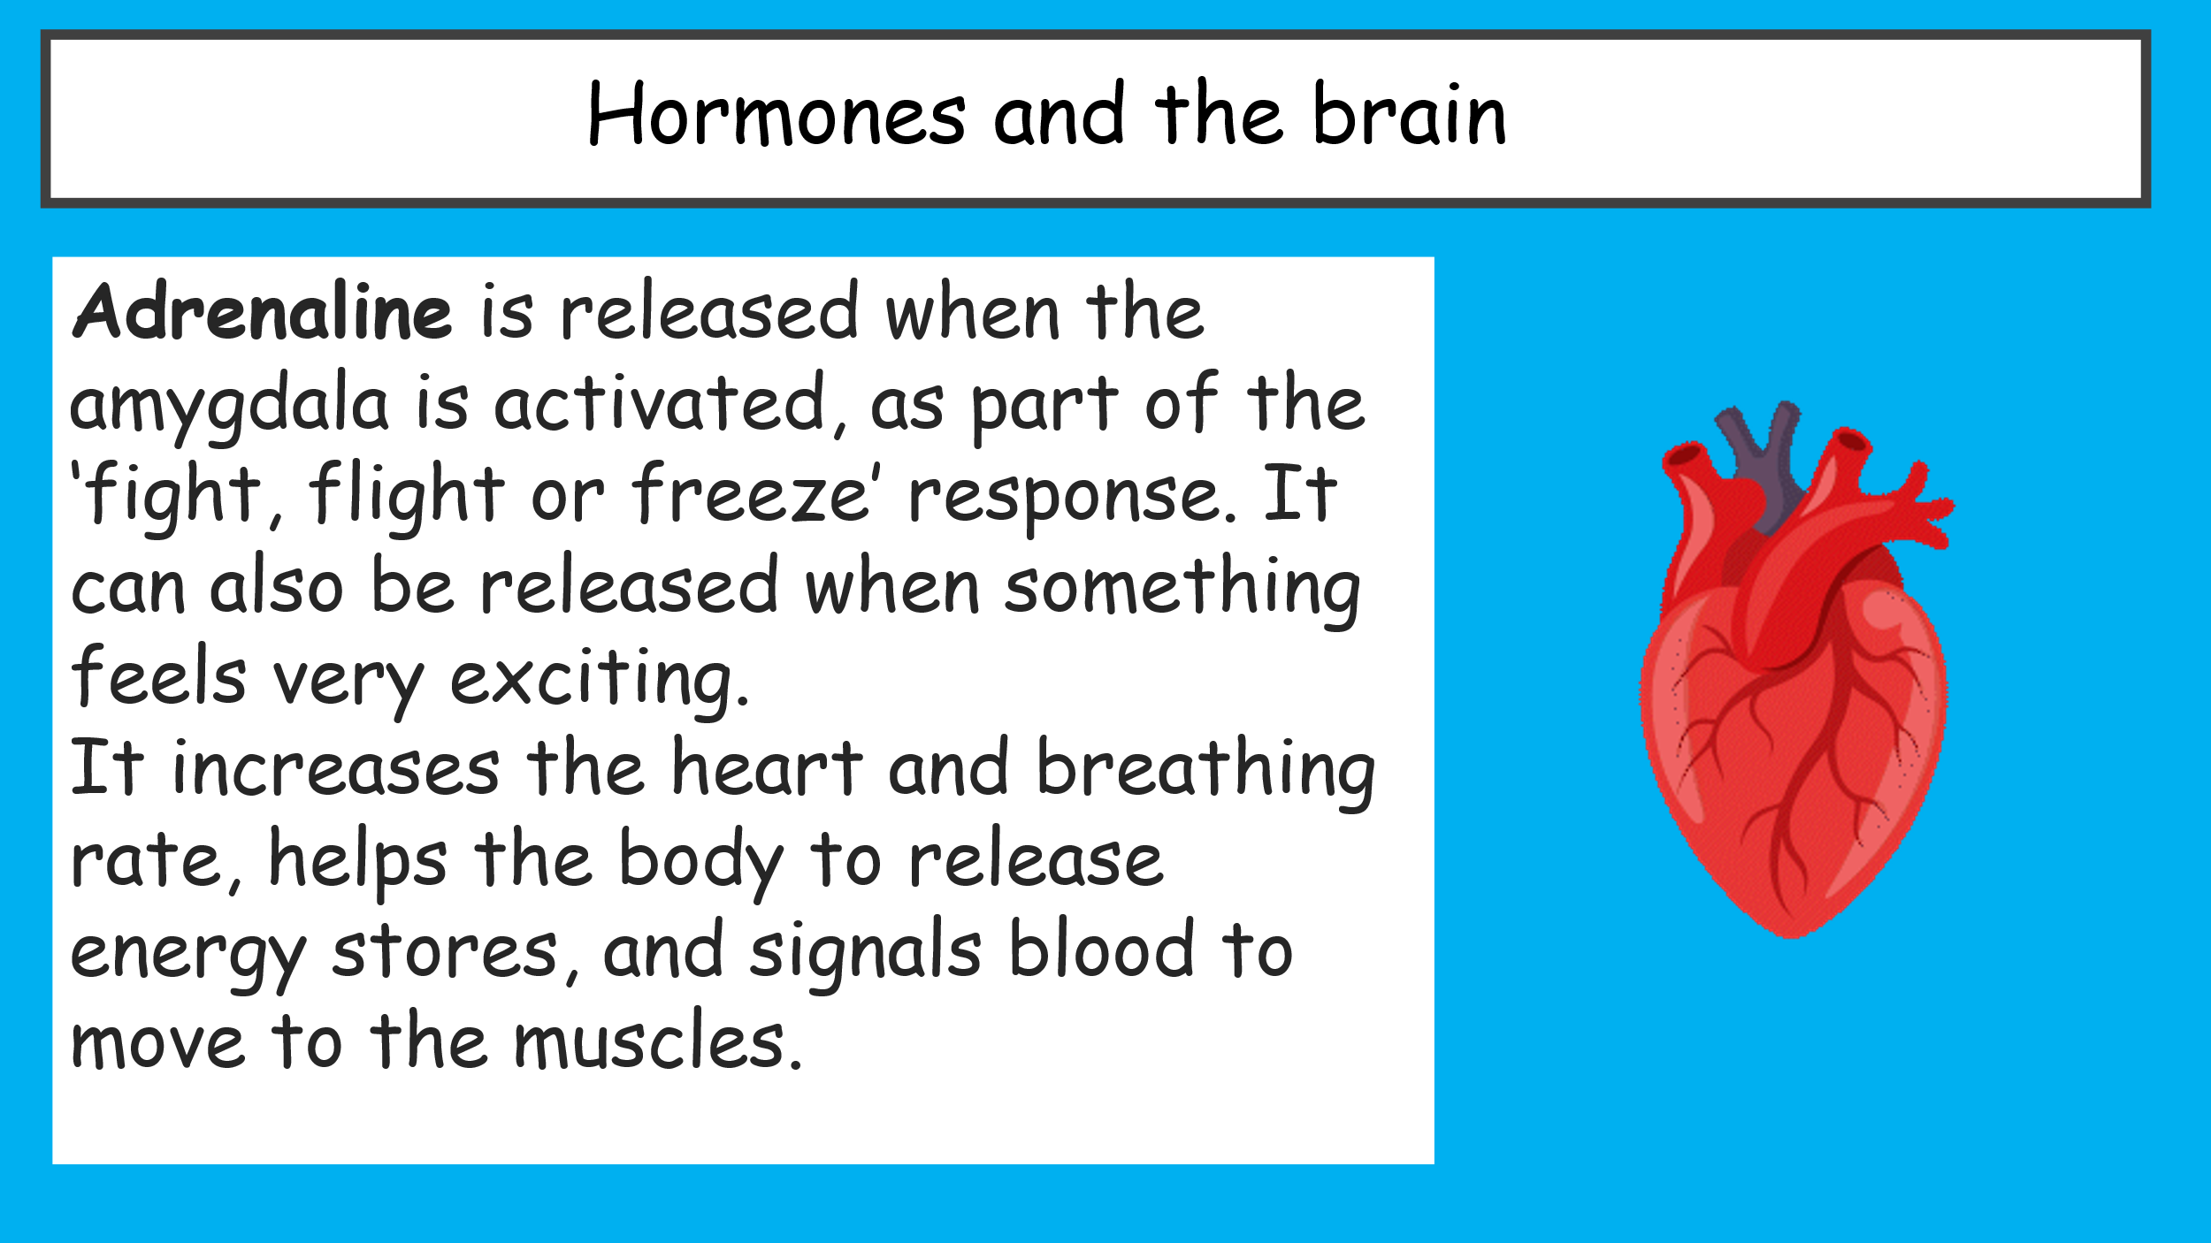
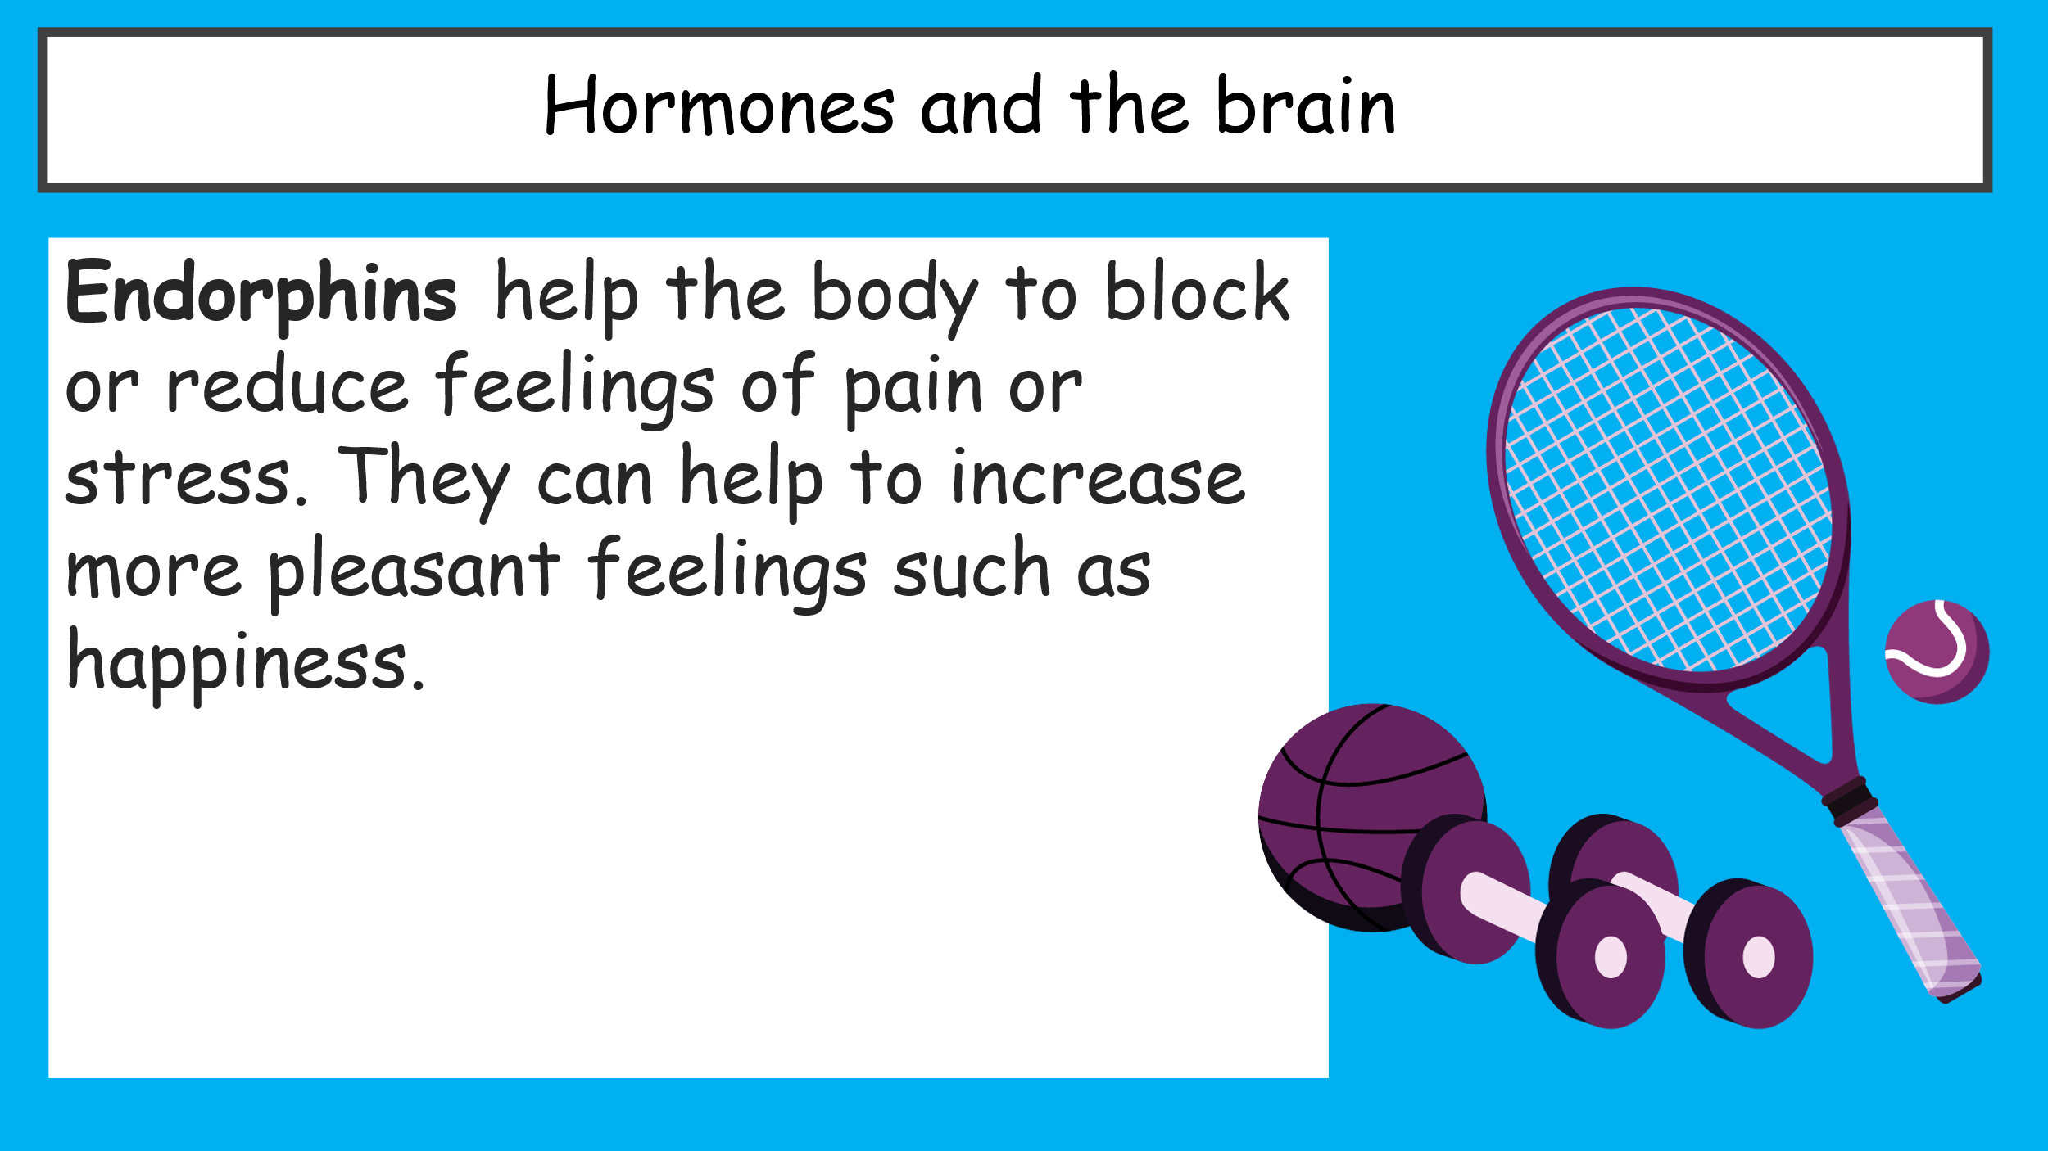

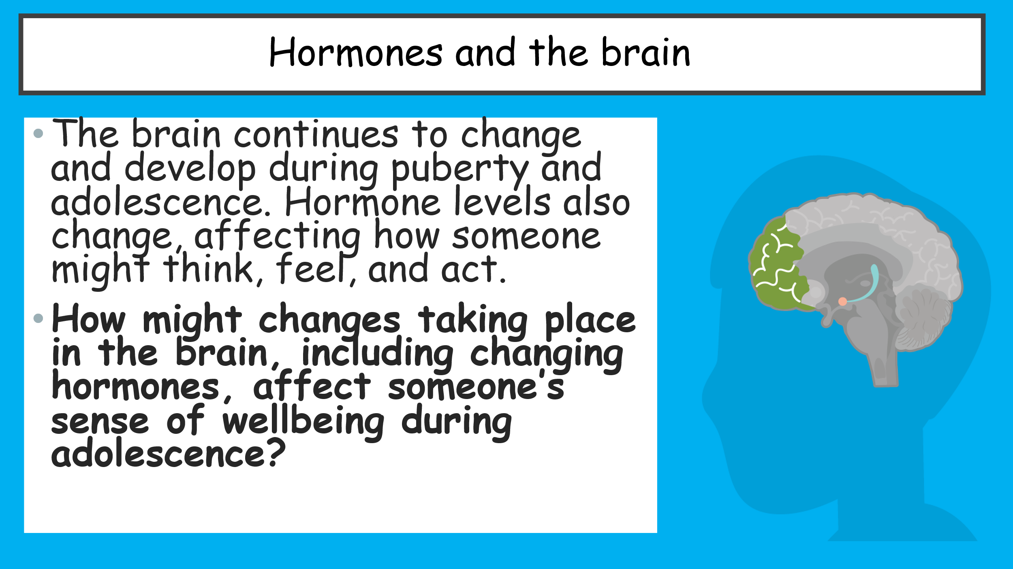
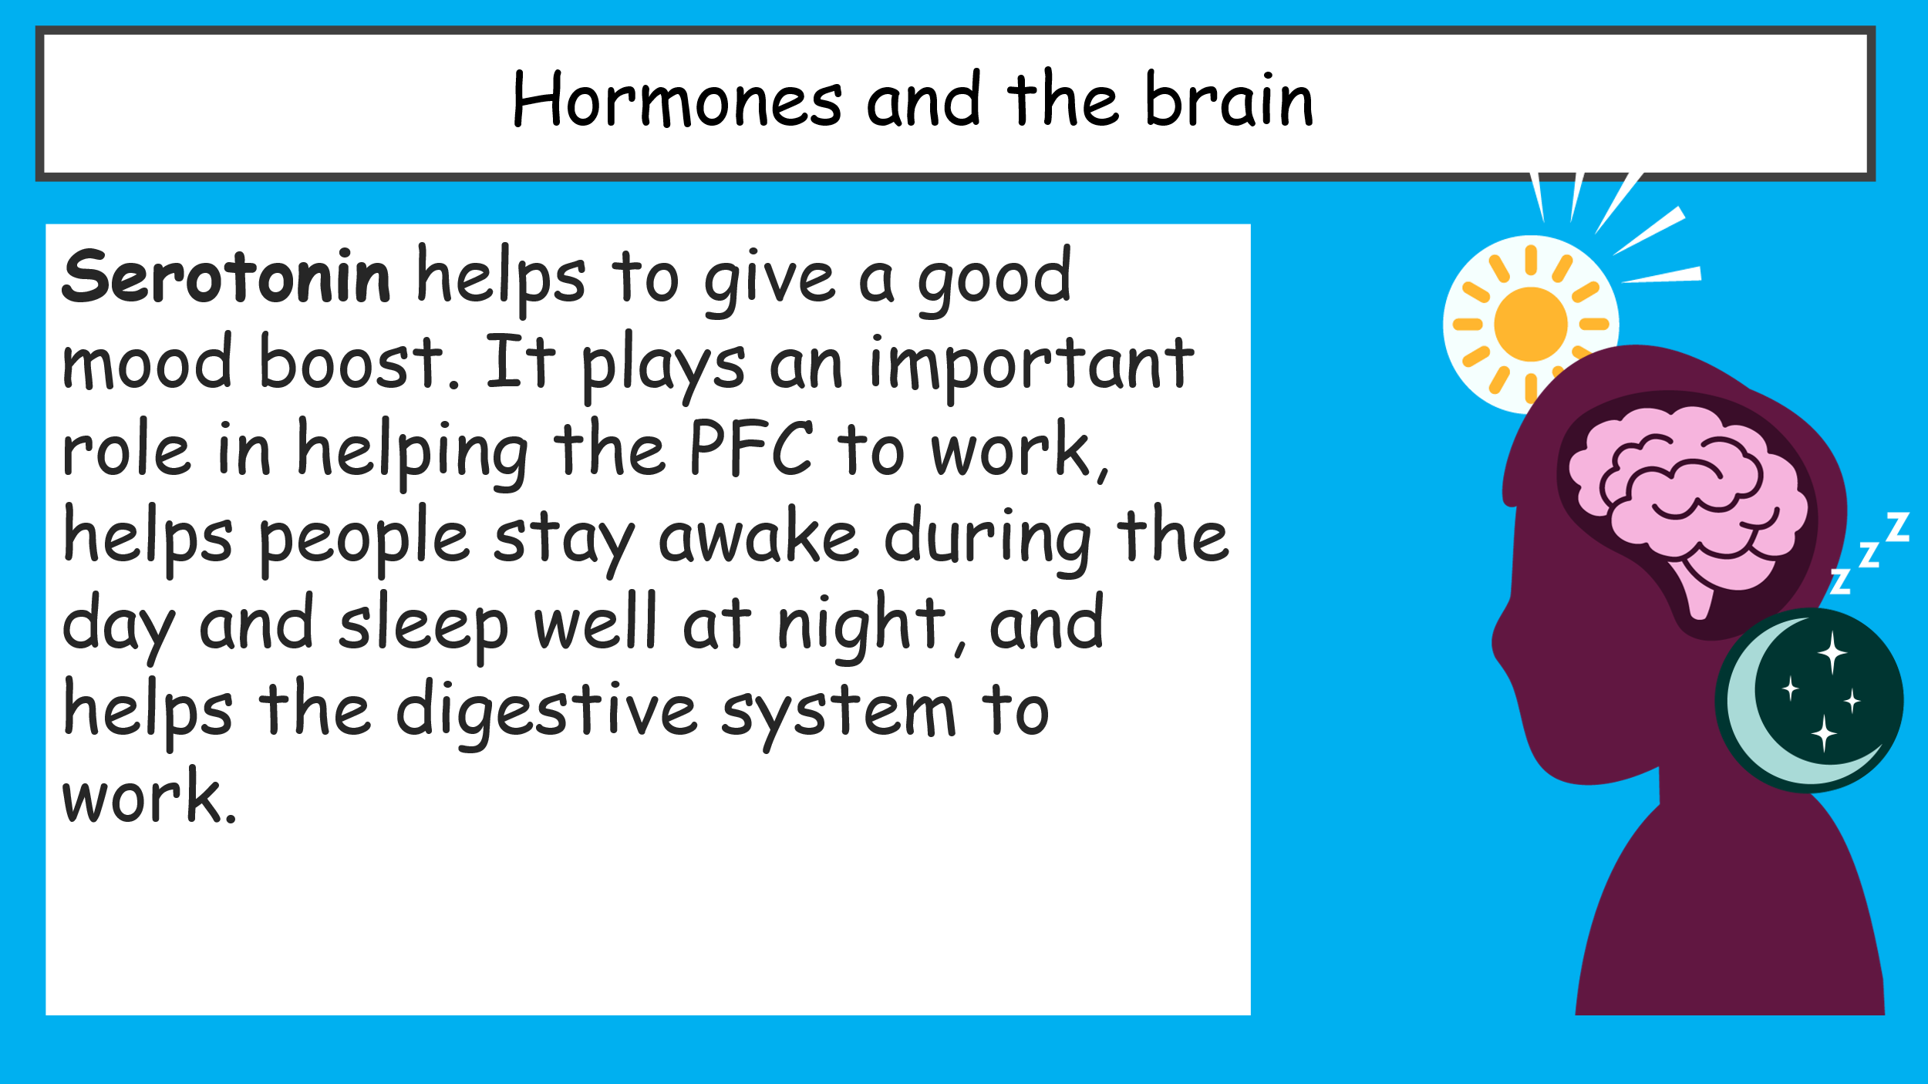
Task 4- Strategies to manage emotions
What strategies can we use to help us to be aware of and manage our emotions? List below:
- -
- -
- -
- -
- -
- -

Task 5- Kaz’s strong emotions
What strategies might be most effective to help Kaz manage his emotions?

Rank strategies from 1 most effective to 9 least effective strategy
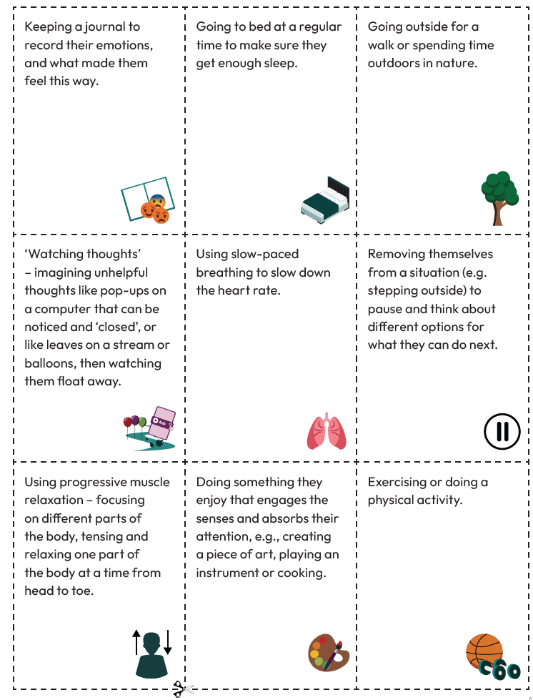
Task 6- Distractions
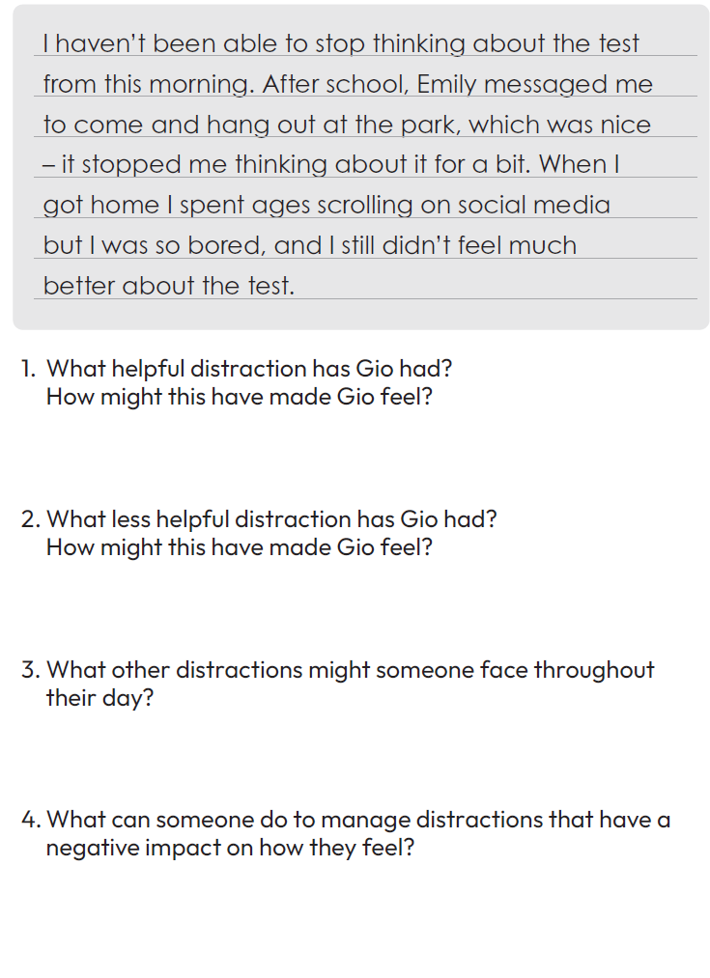
Read Gio’s Diary below and answer the questions.
Task 7- Understanding helpful distractions
Imagine a young person of your age who goes to a school like yours. In pairs, discuss the following:
- What distractions might a young person have in an average day?
- What is the difference between a helpful distraction and an unhelpful distraction?
- From the list of distractions you identified, which might be helpful, and which might be unhelpful?
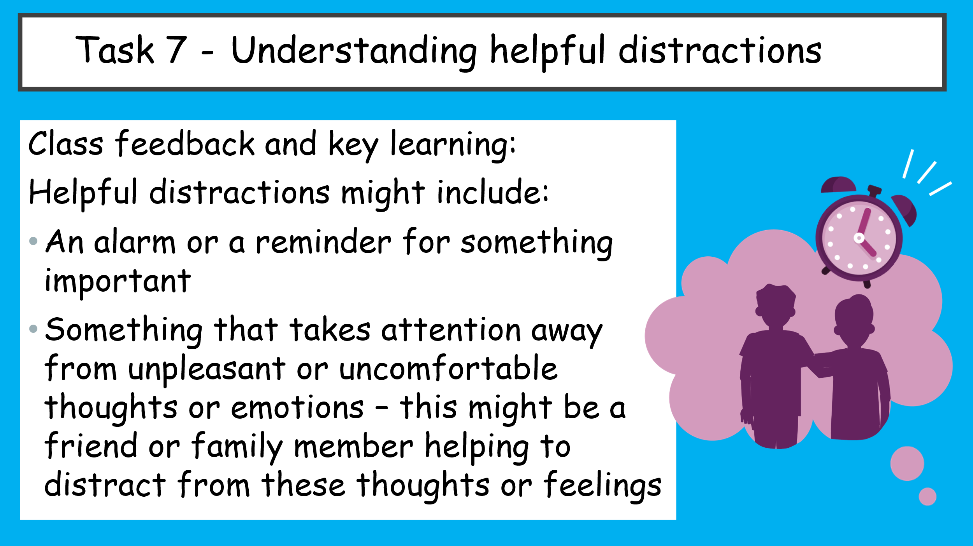
- How might helpful and unhelpful distractions make someone feel?

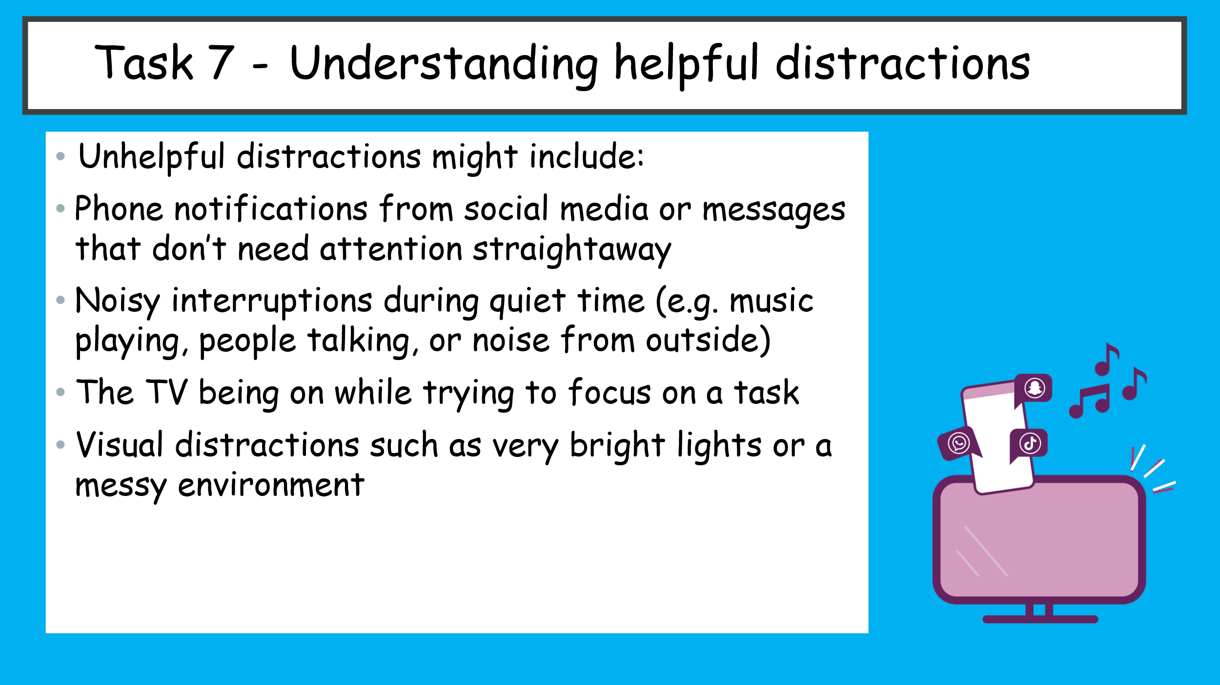
Task 8- Taylor’s Day
Social media can sometimes be an unhelpful distraction.
Taylor, is finding it hard to manage how much time she spends on social media.
Read Taylor’s day and highlight where Taylor might be experiencing pleasant emotions? In one colour and where is she experiencing unpleasant or uncomfortable emotions? in another colour.

Answer the following:
How might Taylor be using social media as a distraction?
________________________________________________________________________________________
What impact is social media having on how Taylor feels?
________________________________________________________________________________________
What impact is it having on Taylor’s behaviour?
________________________________________________________________________________________
How might Taylor’s use of social media impact her wellbeing in the long term?
________________________________________________________________________________________

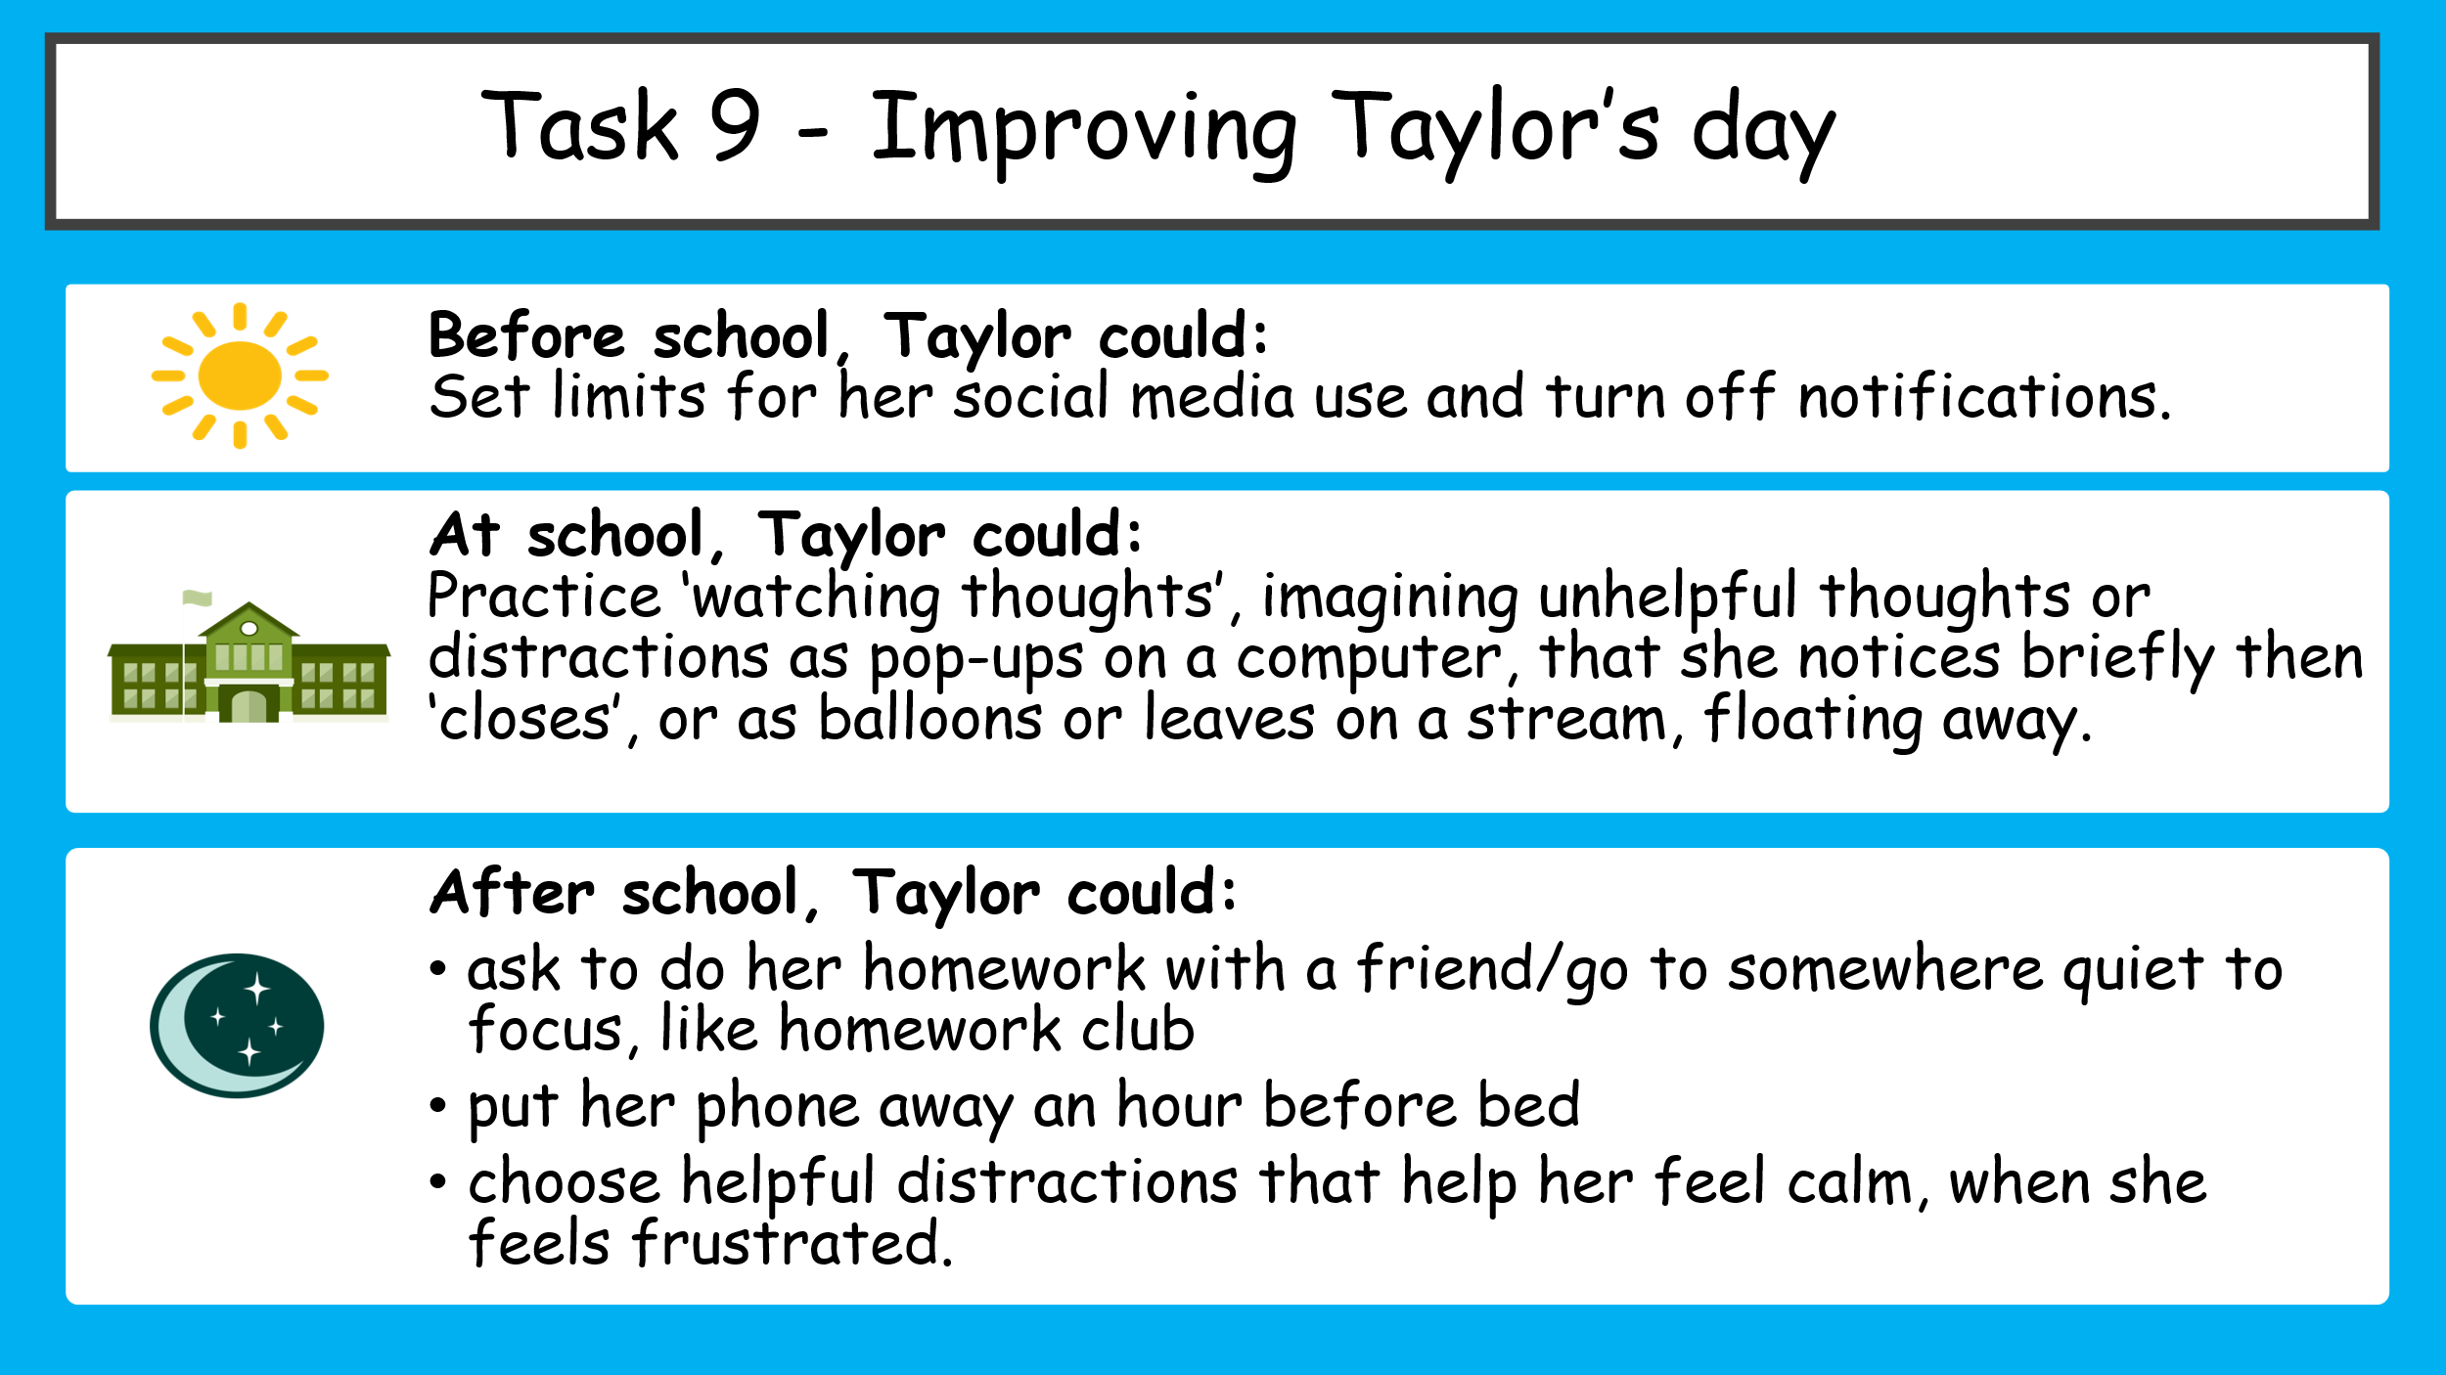
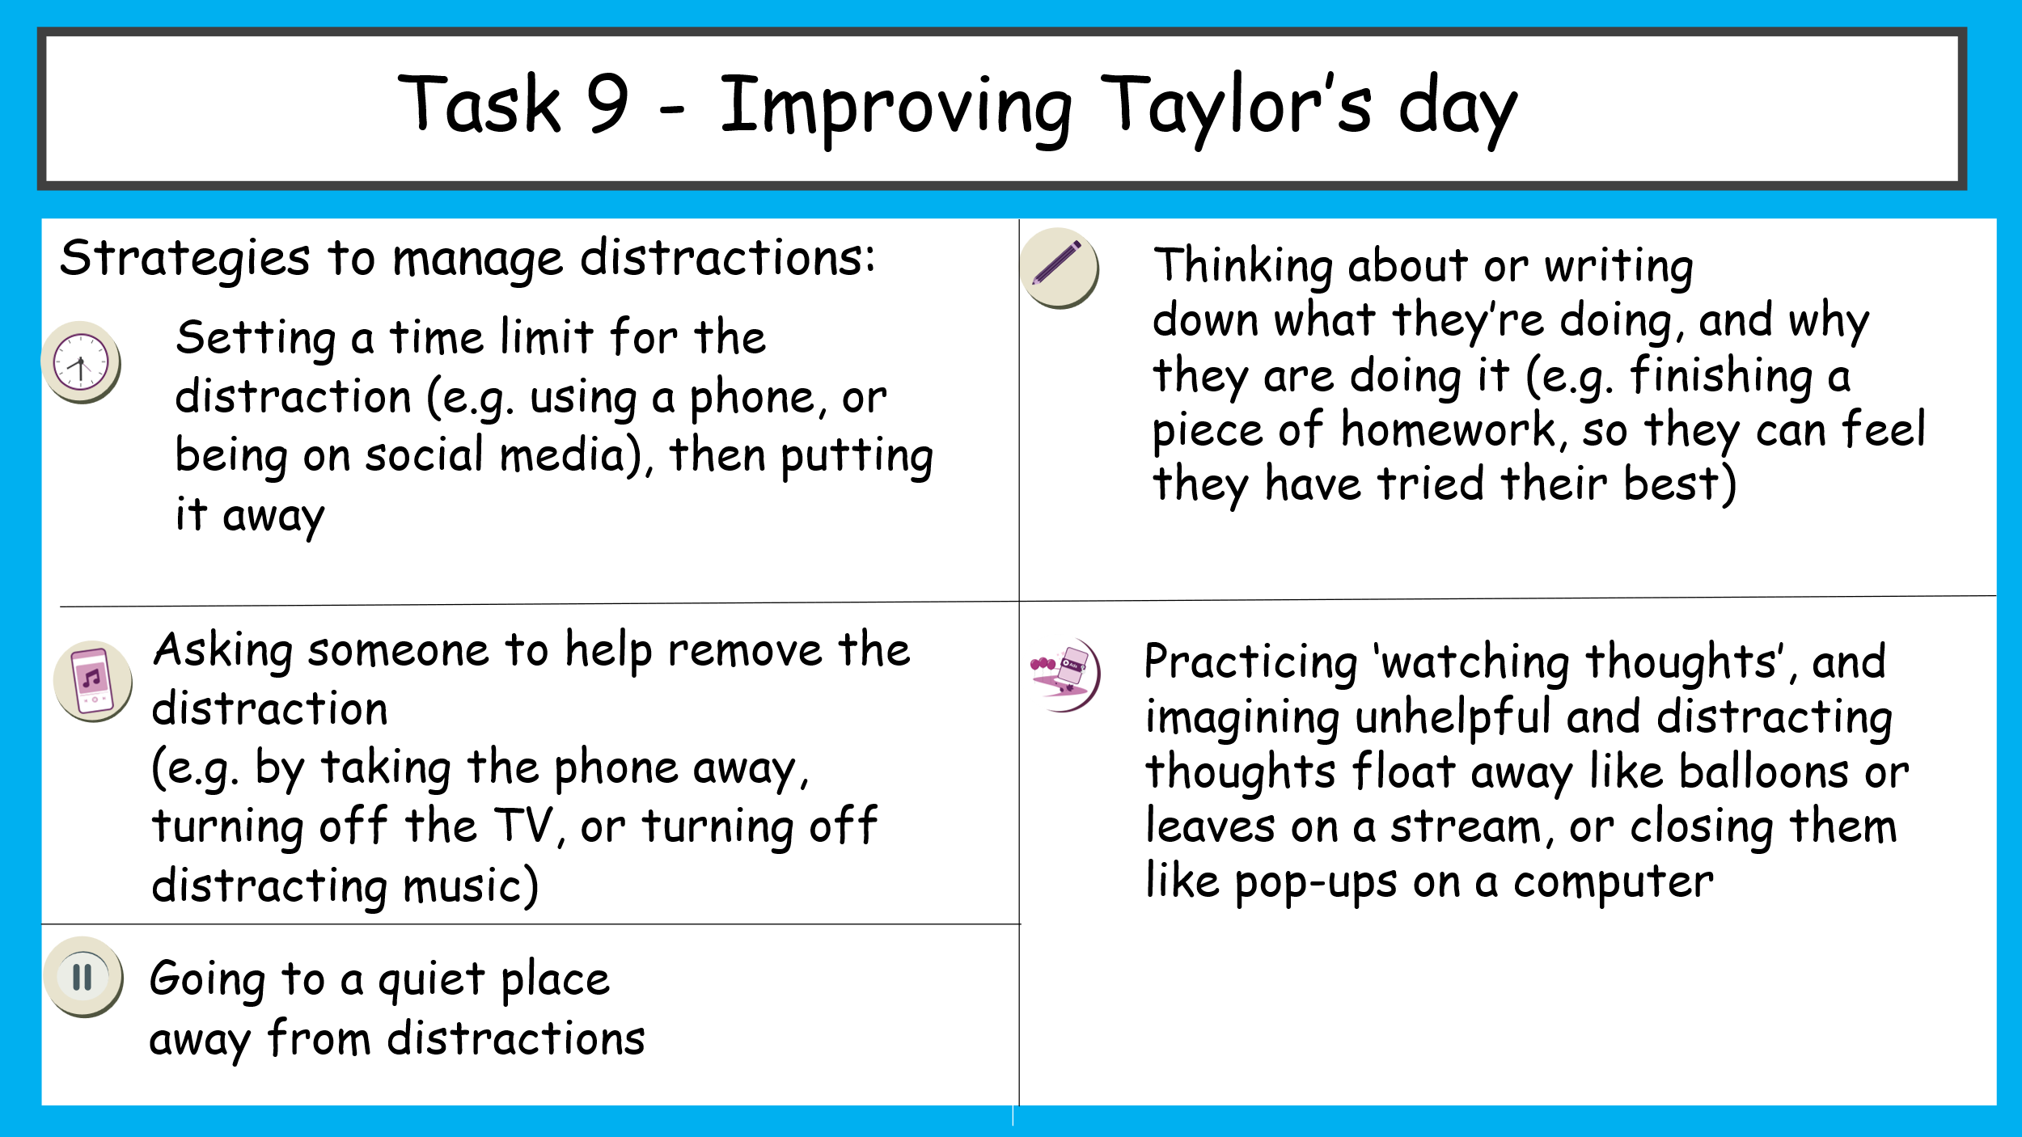
What have we learnt?
Gio would like some advice to help him manage distractions. Reflecting on the learning outcomes, write a piece of advice to Gio, using what you have learnt about helpful and unhelpful distractions. Use the following to help.
- How might managing distractions affect the way Gio feels?
- What can Gio do if he finds it hard to limit his social media use in the future?
- What can Gio do to manage or prevent other less helpful distractions?

____________________________________________________________________________________________________________________________________________________________________________________________________________________________________________________________________________________________________________________________________________________________________________________________________________________________________________________________________________________________________

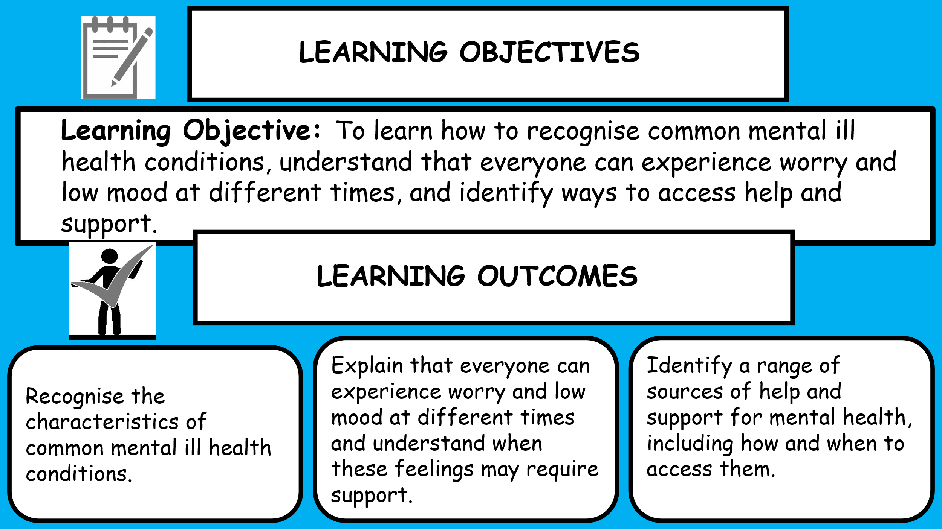
Lesson 2- Mental health conditions and getting help
Starter (Recap) ‘Do Now’
Answer the following questions:
- What is meant by 'wellbeing'?
________________________________________________________________________________________
- Name two hormones that affect emotions and explain one of their roles.
________________________________________________________________________________________
- Give two strategies that can help someone manage strong emotions.
________________________________________________________________________________________
- What is the difference between a helpful distraction and an unhelpful distraction?
________________________________________________________________________________________
- Give two ways someone can reduce distractions from social media
____________________________________________
Challenge- How can looking after your physical health help you manage your emotions?
________________________________________________________________________________________
Task 1- Knowledge check
Circle the correct answer:
Mental health is...
A. Something only adults have
B. Something everyone has
C. Only about mental illness
D. The same as physical health
Which of these is a healthy coping strategy?
A. Keeping worries secret forever
B. Talking to a trusted adult
C. Ignoring problems completely
D. Staying awake all night
True or False:
Everyone experiences difficult emotions at some point.
Task 2- Emotion continuum
Which emotions have you experienced before?
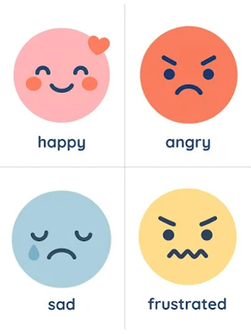
Happy
Calm
Worried
Nervous
Sad
Angry
Overwhelmed

Key facts
All emotions are normal
Mental health exists on a spectrum
Experiencing emotions does not automatically mean someone has a mental illness

Task 3- Mental health vs ill mental health
Mental health is everyone's emotional, psychological and social wellbeing.
Mental ill health refers to difficulties that significantly affect thoughts, feelings or behaviour over time.
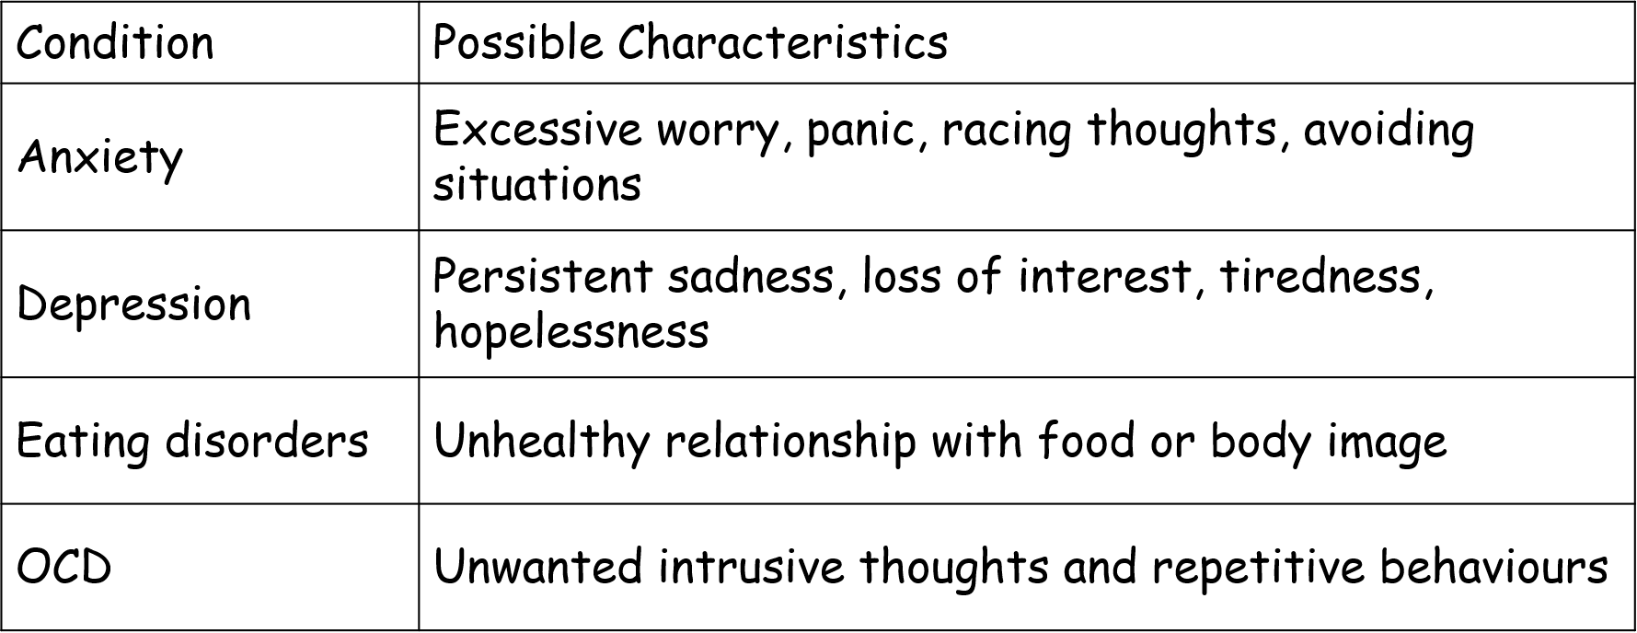
Common Mental Ill Health Conditions

Answer the following questions and feedback to he class
What can someone do to keep their teeth and mouth healthy?

Key Message:
Having a bad day is normal.

If difficult feelings:
last several weeks,
become overwhelming,
affect school, friendships or sleep,
it may be time to seek support.

Task 4- common conditions, challenges and strategies
Watch the videos and complete the table below:
- Signs that might mean someone has this mental health issue
- Strategies and treatments
- Ways others can help

Video Clip Topic | Signs that might mean someone has this mental health issue | Strategies and treatments | Ways others can help
Depression

Anxiety

Stress

Task 5- Is it normal or needs support?
Work in pairs.
- Read the scenarios below and decide if it is normal or needs support
A
Sam feels nervous before every maths test.
B
Luca has stopped seeing friends and hasn't enjoyed football for over a month.
C
Ella feels upset after arguing with a friend.
D
Ben worries constantly, struggles to sleep and feels anxious every day.

- Discuss as a class:
What helped you decide?
Task 6- Myth or fact?
Listen to the statements ad stand if a Fact or stay seated if a myth.

Task 7- Support network
Create a support network map with you in the middle and around the outside identify people or organisations you could speak to for support

What have I learnt?
Complete the following questions:
Name one common mental ill health condition.
____________________________________________What is the difference between everyday worry and needing support?
____________________________________________________________________________________________________________________________________
What can you do to support positive mental health?
____________________________________________________________________________________________________________________________________
Name two trusted people or organisations someone could contact if they were struggling.
________________________________________________________________________________________

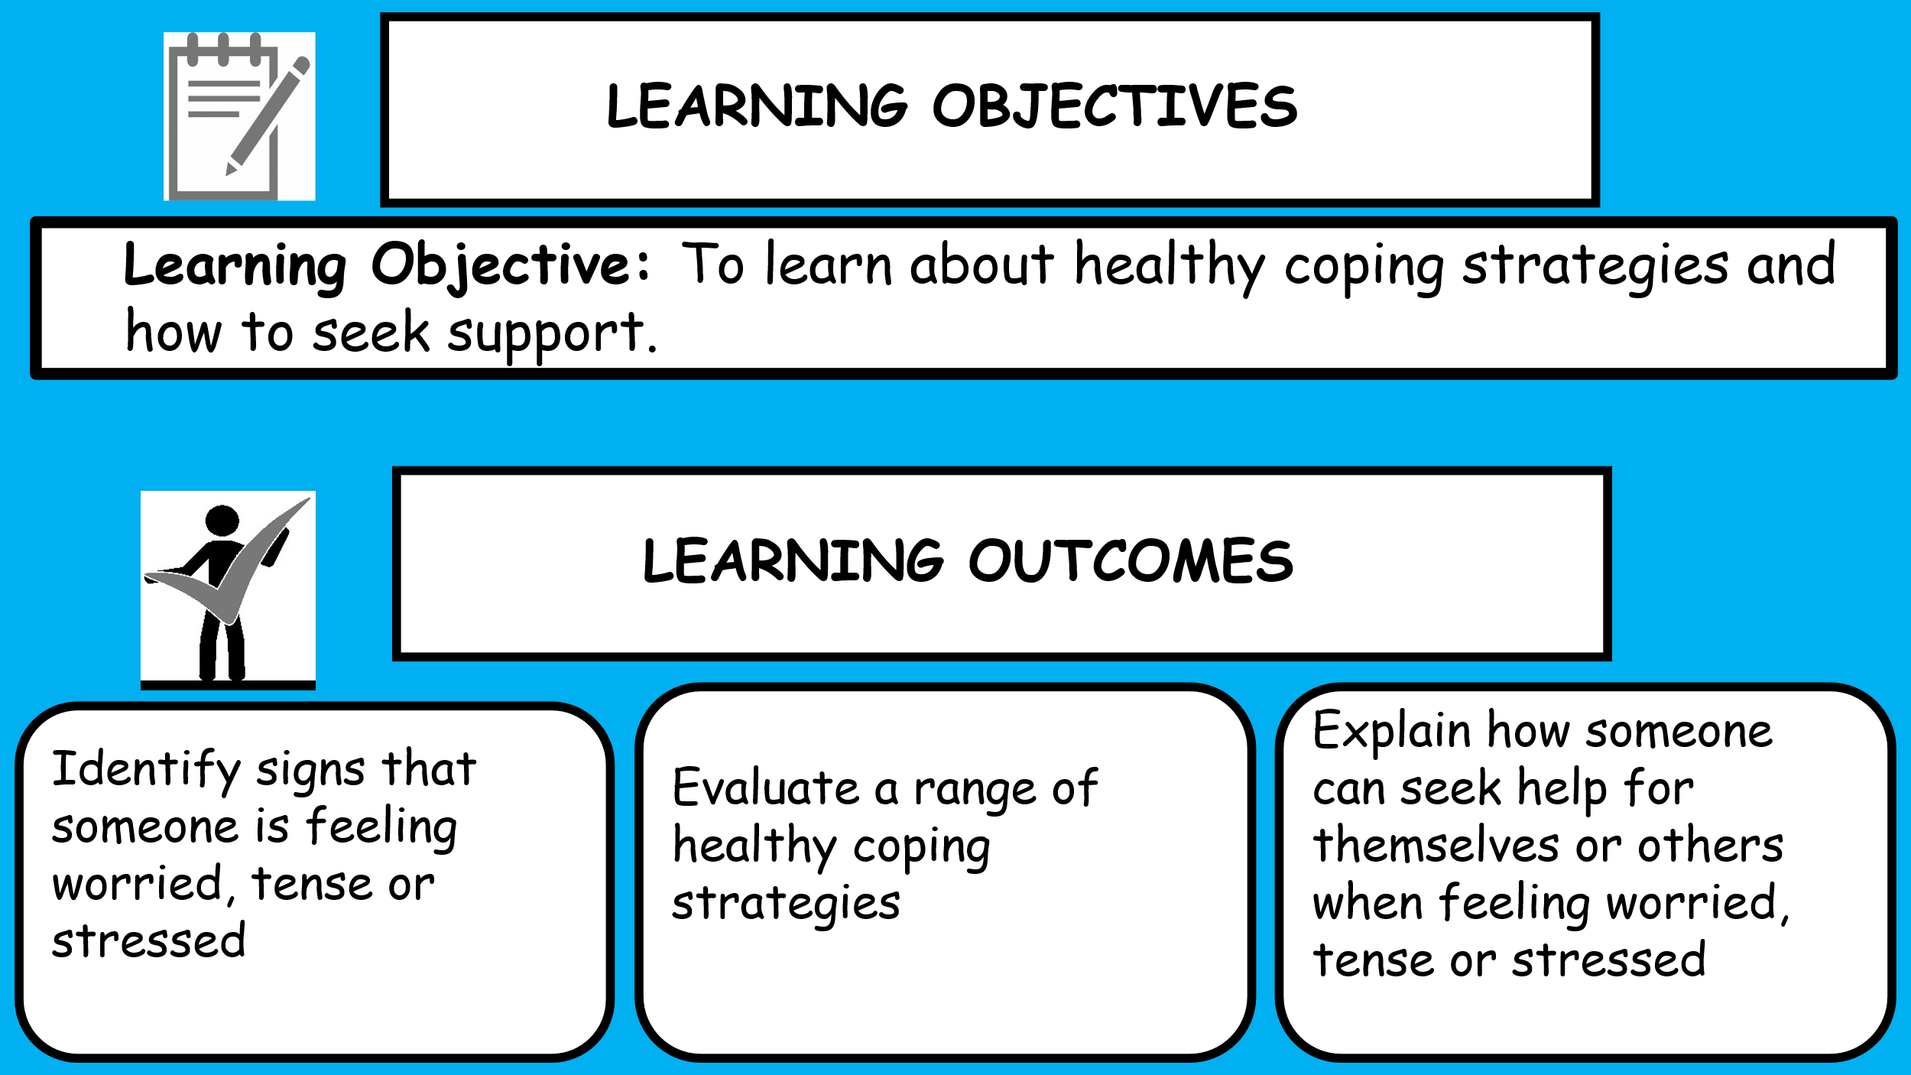
Lesson 3- Healthy coping strategies
Starter (Recap) ‘Do Now’
Answer the following questions:
- Name two common mental ill health conditions.
______________________________________________________________________________________
- What is the difference between everyday worry and a mental health condition that may need support?

- Give two signs that someone might need extra support with their mental health.
___________________________________________
___________________________________________
- Who are two trusted people or organisations that someone could speak to if they were struggling with their mental health?
___________________________________________
___________________________________________
- True or False: Talking to someone about your mental health is a sign of weakness

___________________________________________
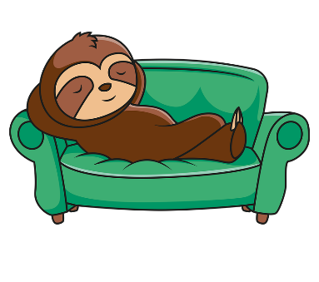
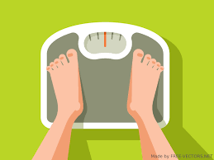

Challenge- Why is it important to ask for help early if someone is struggling with ________________________________________________________________________________________
Read the Key Terms on PowerPoint
Task 1- What’s our starting point?
- Draw a picture of a young person using a healthy coping strategy which helps them when they feel worried, tense or stressed.
- Annotate your drawing by responding to the following:
What is the young person doing?
What signs might there be that the young person is feeling worried, tense or stressed?
How might they feel when they use the healthy coping strategy?
What other healthy coping strategies might they use if they feel worried, tense or stressed?
Who could they talk to about how they feel?

Task 2- A gut feeling
In your groups respond to the following questions:
How might feeling worried, tense, or stressed affect someone’s thoughts?
____________________________________________________________________________________________________________________________________
If someone is feeling worried, tense, or stressed, what might this feel like in their body?
____________________________________________________________________________________________________________________________________
If someone is feeling worried, tense, or stressed, how might they behave?
____________________________________________________________________________________________________________________________________
‘think, pair, share’ the following:
Why might someone find it hard to tell that they are feeling worried, tense, or stressed?
________________________________________________________________________________________
What can help them to recognise these feelings?
________________________________________________________________________________________
Challenge: What signs might help someone to identify when someone else is feeling worried, tense or stressed
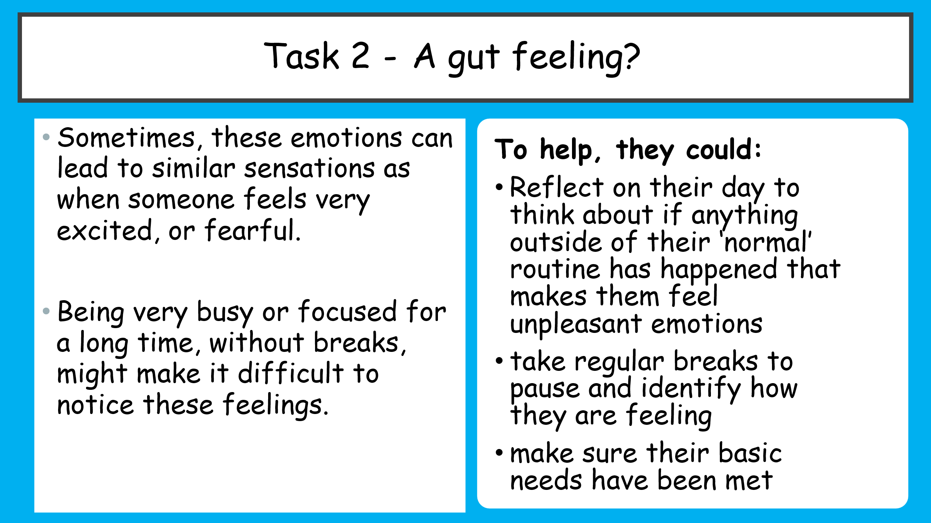
____________________________________________________________________________________________________________________________________
Task 3- Using healthy coping strategies
What healthy coping strategies might someone use when they experience feelings such as tension, worry or stress?
- -
- -
- -
- -

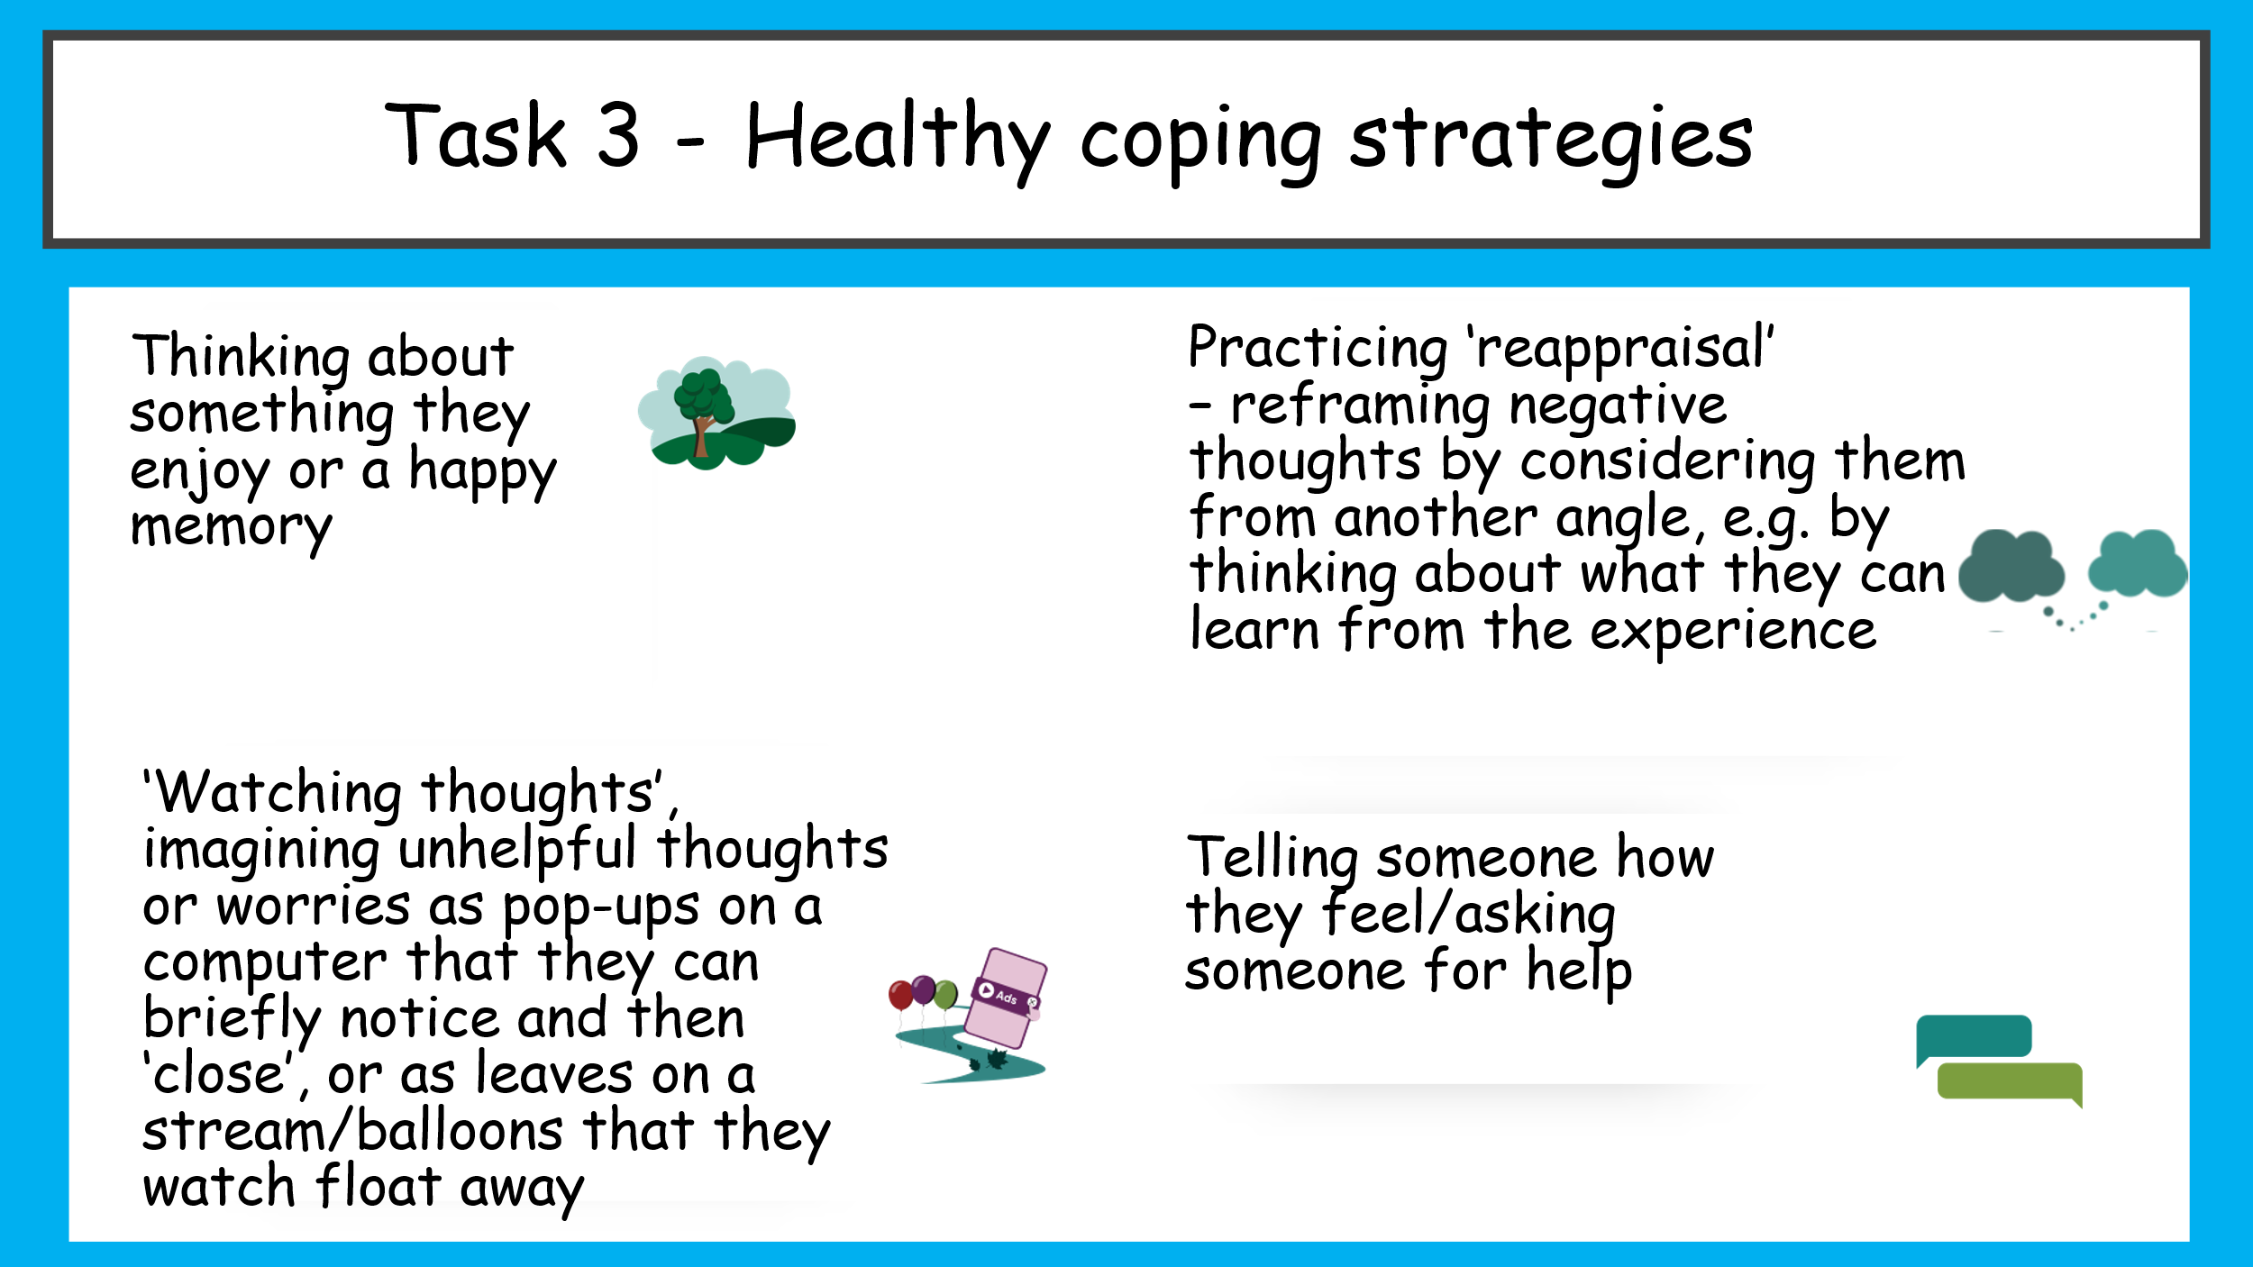
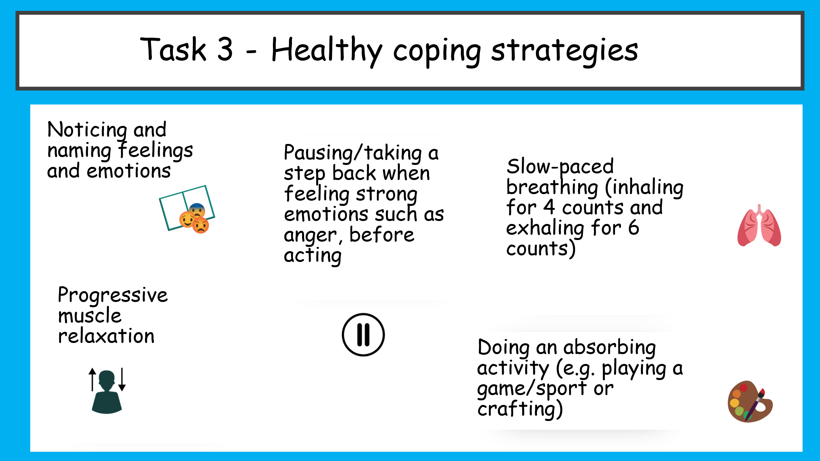
Task 4- Using healthy coping strategies
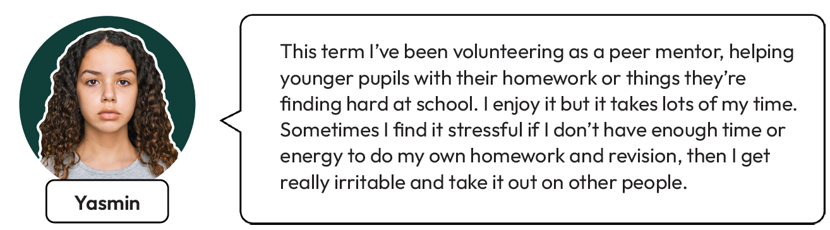
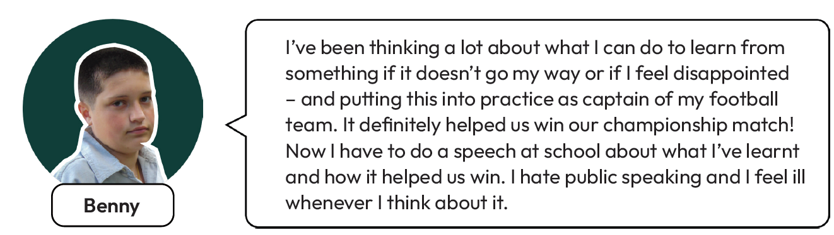
Read the scenario you have been given. Answer the following questions:
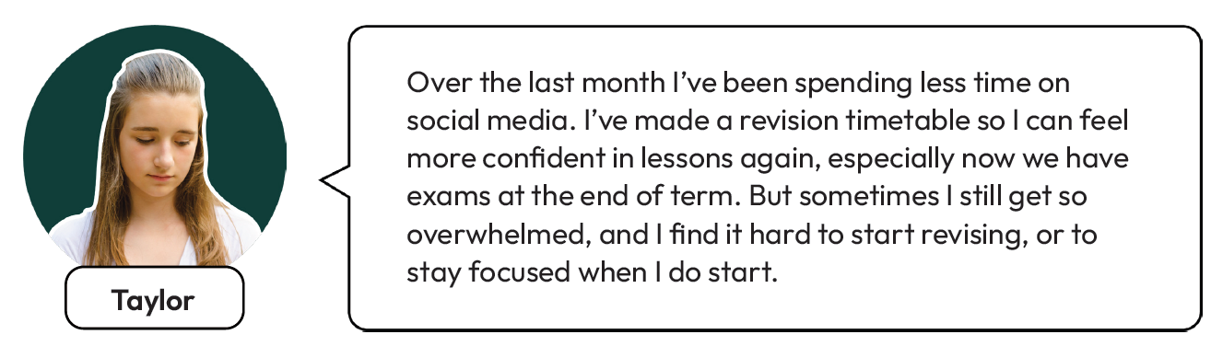
What three healthy coping strategies would be most helpful for your character to use?
____________________________________________________________________________________________________________________________________
How would these strategies help them to manage their feelings and emotions?
________________________________________________________________________________________
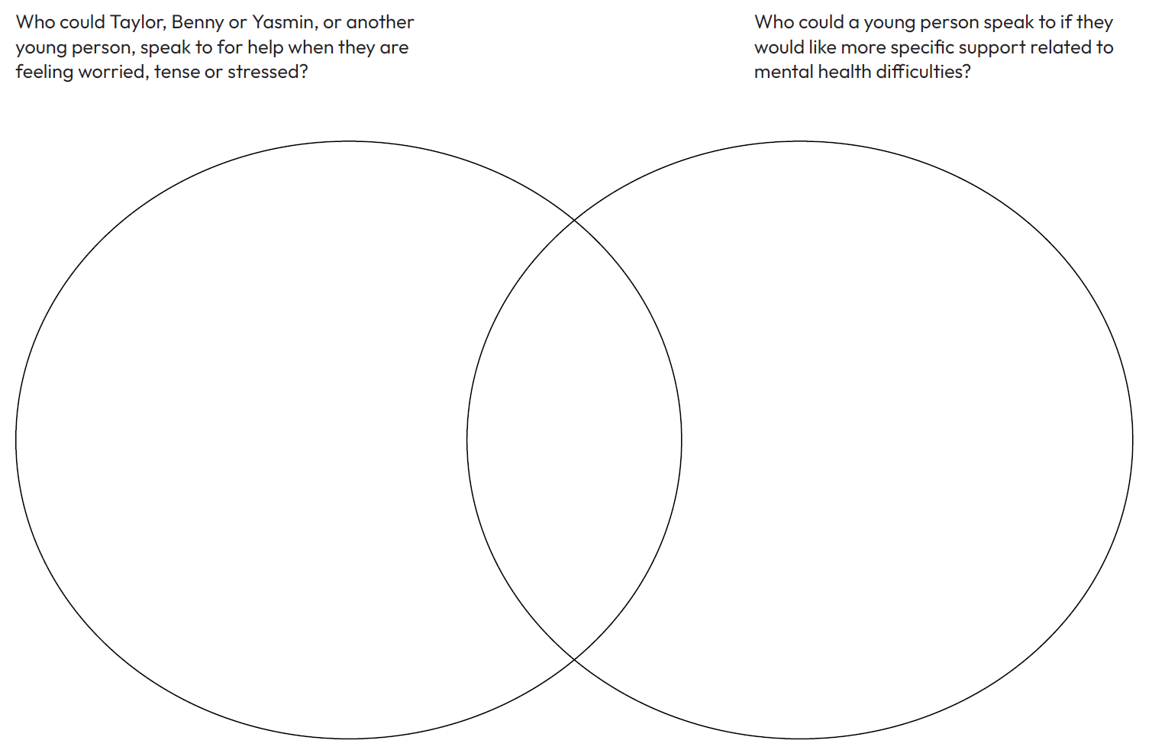
Task 5- Getting help and support? Complete the Venn diagram

Task 7- What have we learnt?
Add your new learning to your drawing from the beginning of the lesson, in a different colour.
Task 8- Reflection
Where have you used a healthy coping strategy to manage a difficult feeling or challenging situation? How has this helped you since?
____________________________________________________________________________________________________________________________________
What is a healthy coping strategy that you would like to use to support your wellbeing and mental health?
________________________________________________________________________________________
Who can you talk to for help managing difficult thoughts, feelings or emotions?
____________________________________________________________________________________________________________________________________

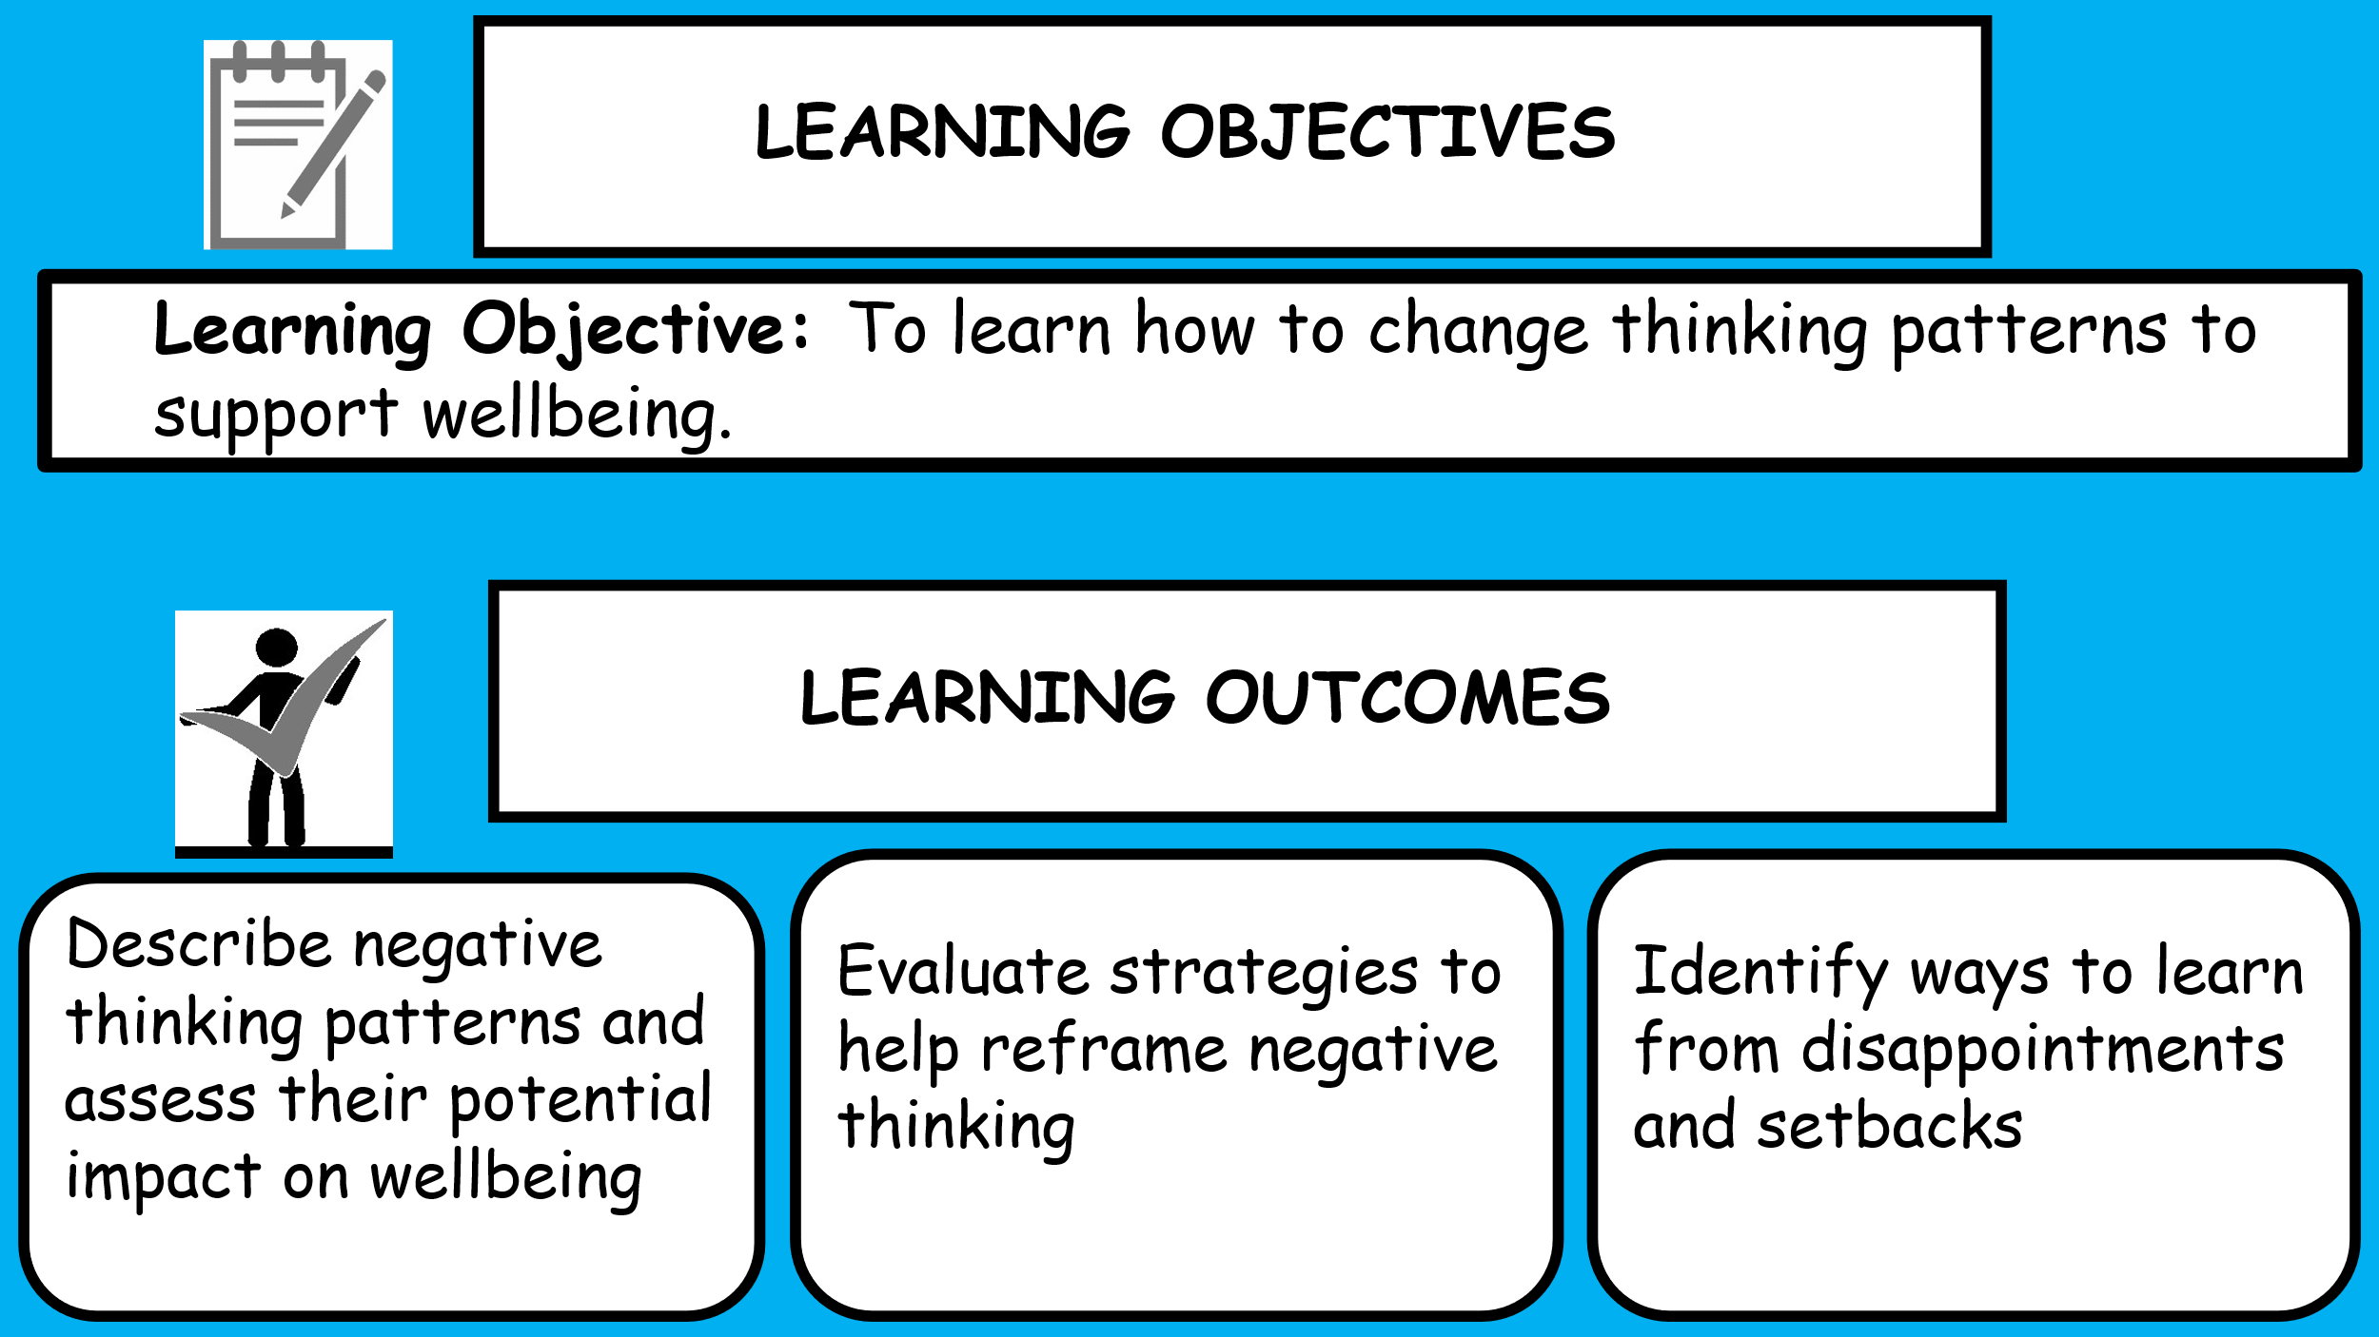
Lesson 4- Changing thinking habits
Starter (Recap) ‘Do Now’
Answer the following questions:
- What is a coping strategy?
______________________________________________________________________________________
- Name two signs that someone might be feeling worried, tense or stressed.
______________________________________________________________________________________

- Give two examples of healthy coping strategies
____________________________________________________________________________________________________________________________________
- Who could a young person talk to if they are worried or stressed?
______________________________________________________________________________________
- Why is it important to practise healthy coping strategies
______________________________________________________________________________________
Challenge- A friend says they feel overwhelmed before an important test. Which three healthy coping strategies would you recommend, and explain why each one could help them manage their stress?
_________________________________________________________________________________________________________________________________
Task 1- What’s our starting point?
Draw a circle on the line to show how much you agree or disagree with each statement.

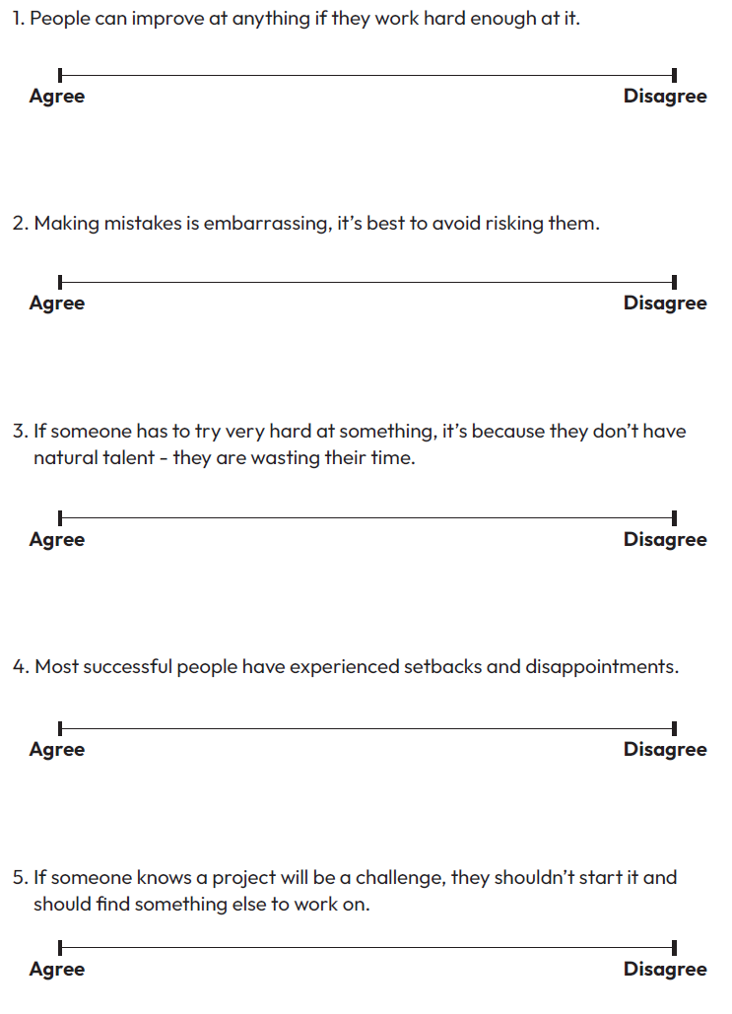
Task 2- Identifying negative thinking patterns
Match each thinking pattern to its definition and an example.
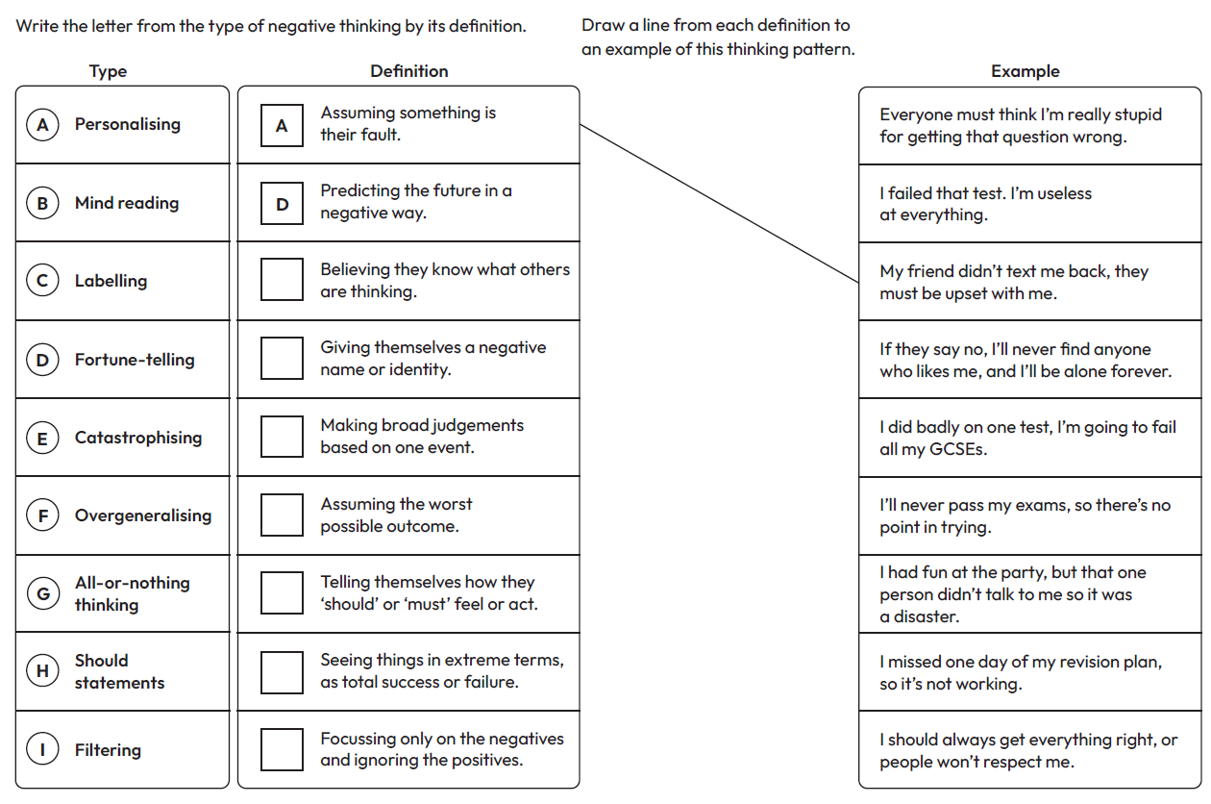

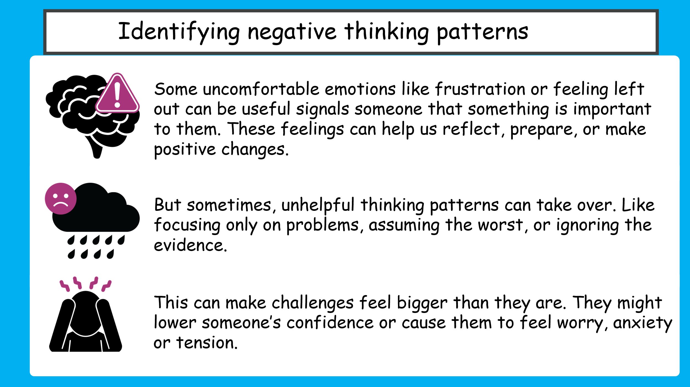
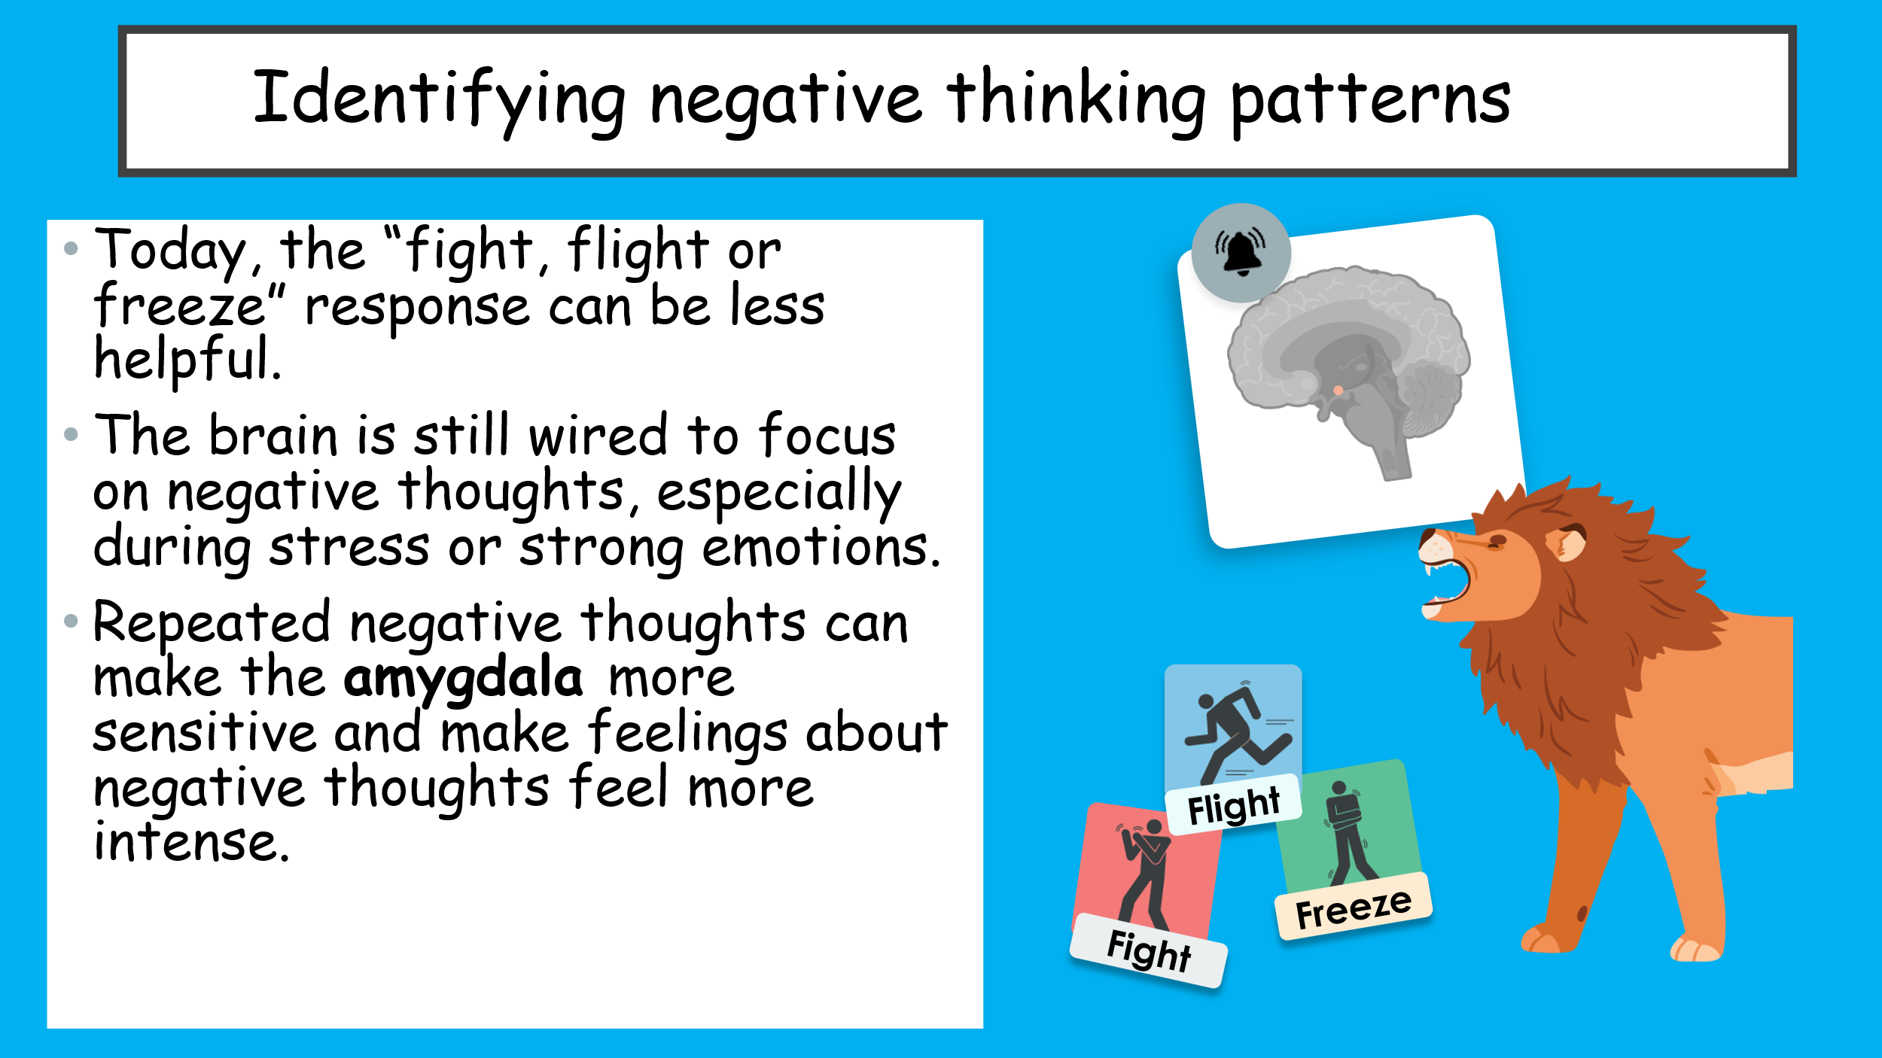

Task 3- Alternatives to negative thinking patterns
Re-read the examples of negative thinking patterns and discuss the questions below:
What emotion might someone be feeling when they have this thought?

What strategies might someone use if they feel this way?

Task- Rescript the other examples of negative ‘self-talk’ below:
- Why or when might someone find it more challenging to reframe their thoughts?

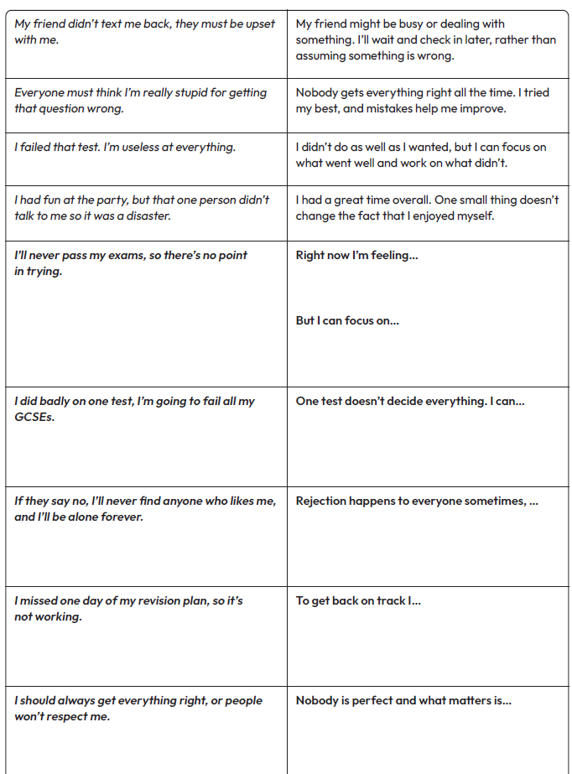
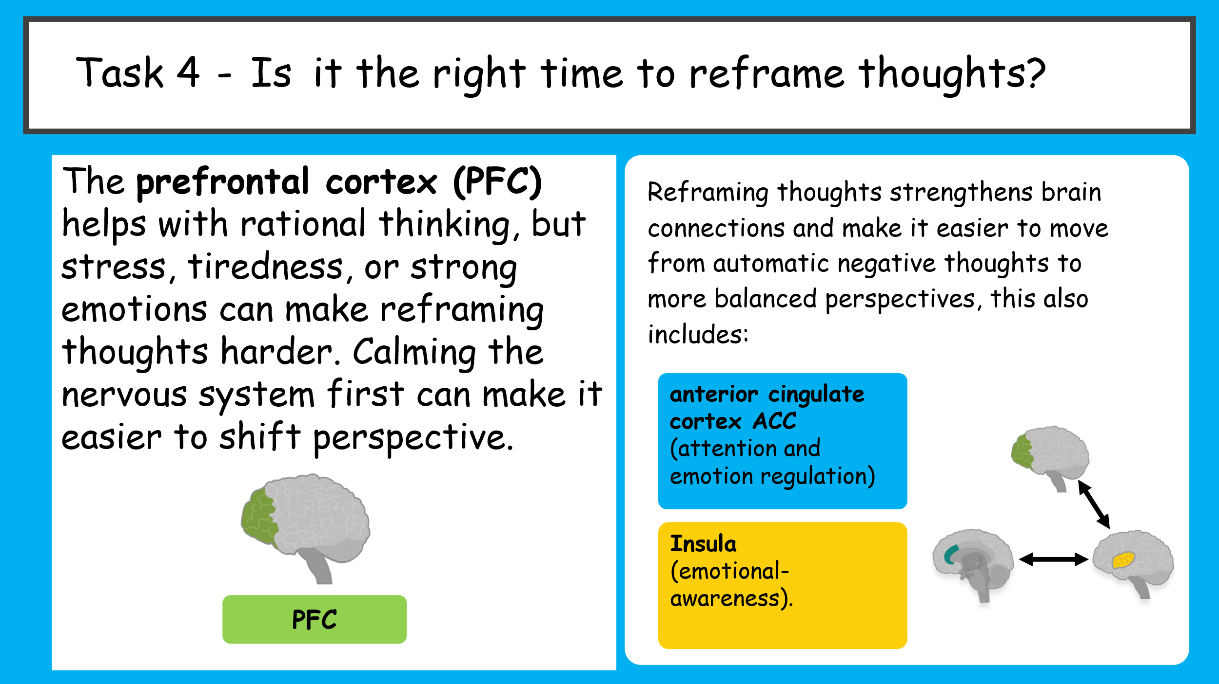
Task 5- Setback heads, hearts, hands
In groups read through the scenario- character you have been given and answer the questions below and be ready to feedback.
Character:_________________________________
What might the character be thinking?
____________________________________________________________________________________________________________________________________
How might the character be feeling?
____________________________________________________________________________________________________________________________________
What could the character do to:
- manage their feelings,
________________________________________________________________________________________
- learn from the experience,
________________________________________________________________________________________
- or reframe the setback?
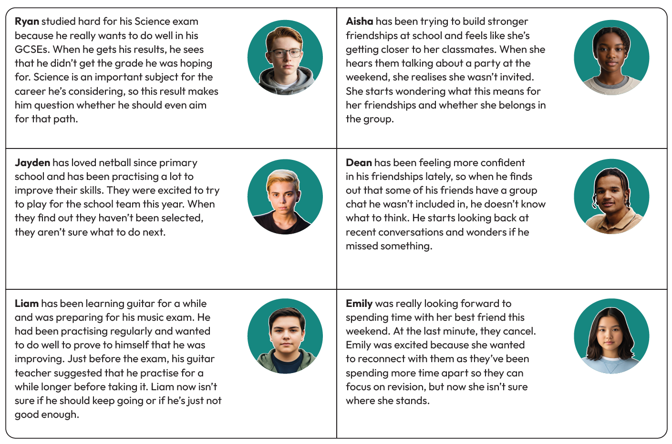
________________________________________________________________________________________
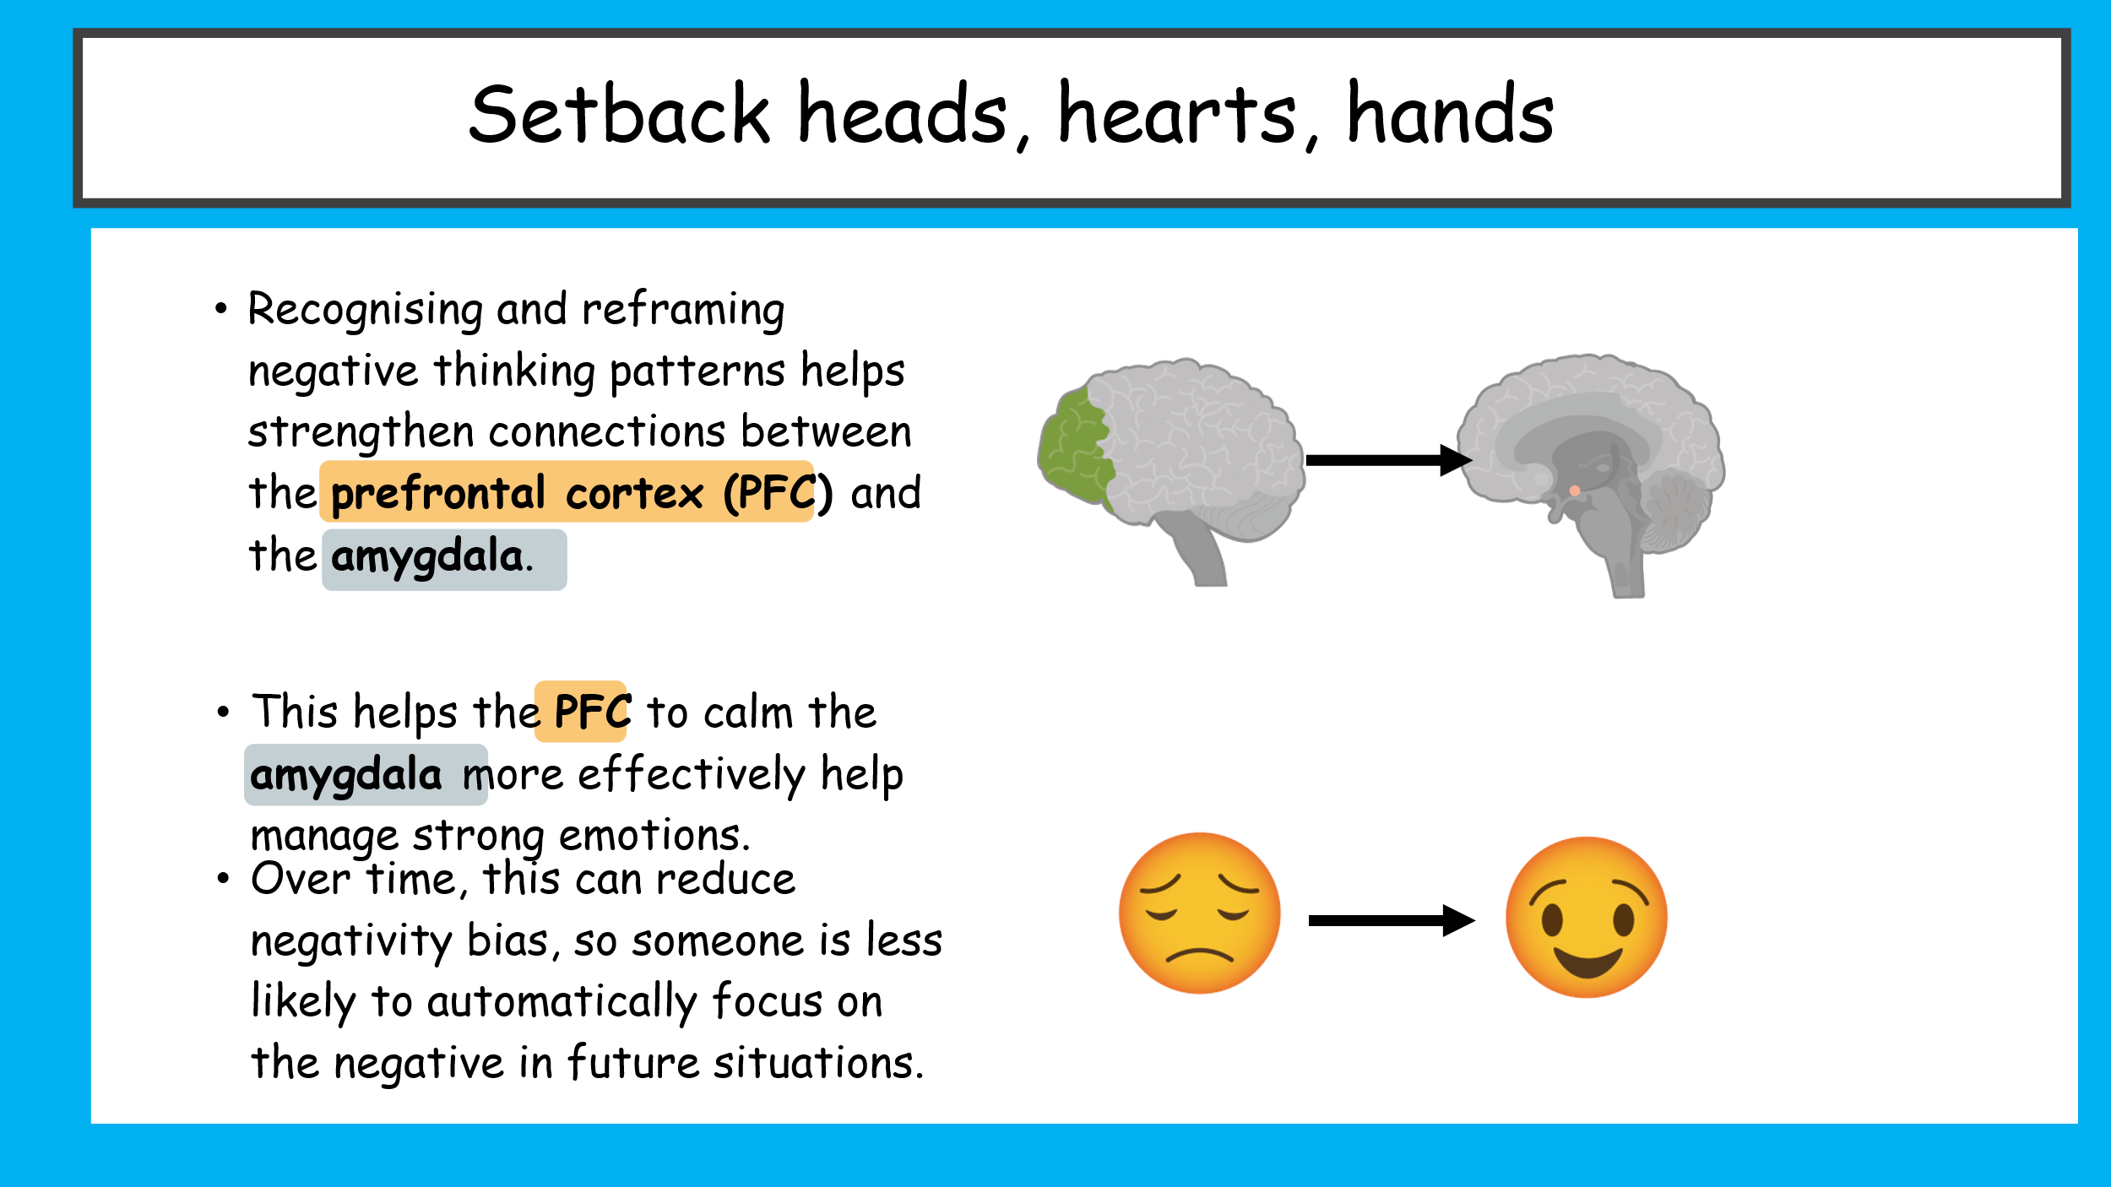
What have we learnt?
Revisit your continuums from the start of the lesson
Draw a square on the line to show if your thoughts on each statement have changed or not.
- If your answers have changed, explain what influenced this.
____________________________________________________________________________________________________________________________________
- If they have stayed the same, explain why.
________________________________________________________________________________________
Y9 PSHE
Unit of Study  Mental Health and wellbeing | Pre-learning check | Mid learning check | End of unit review
I can identify different emotions and explain how they can affect my thoughts and behaviour.
I can use healthy strategies to manage strong emotions.
I can recognise distractions, including online, and choose ways to manage them effectively.
I can recognise the signs of some common mental health conditions.
I can explain the difference between everyday feelings of worry or low mood and longer-term mental ill health.

I can identify trusted sources of help and support for myself or someone else.
I can explain why sleep is important for physical and mental health.
I can identify healthy coping strategies for managing difficult emotions.
I can explain why some coping strategies are more helpful than others.
I can describe how and where to seek support when I need it.
I can recognise unhelpful thinking patterns.
I can practise changing negative thoughts into more balanced and realistic ones.
I can explain how positive thinking habits can improve wellbeing and resilience.
End of unit quiz
# | Question | A | B | C | D
1 | What is meant by wellbeing? | Being physically fit | Feeling happy all the time | How happy or content someone feels about their overall quality of life | Having no worries
2 | Which part of the brain helps with focus, problem-solving and managing emotions? | Amygdala | Hippocampus | Cerebellum | Prefrontal cortex (PFC)
3 | Which part of the brain acts like the body's alarm system? | PFC | Amygdala | Hippocampus | Cerebellum
4 | What is the main role of the hippocampus? | Controls breathing | Helps with learning and memory | Controls movement | Pumps blood
5 | Which hormone is linked to pleasure and reward? | Adrenaline | Serotonin | Dopamine | Insulin
6 | What is the fight, flight or freeze response? | A way to improve memory | The body's natural response to danger or stress | A type of exercise | A way to fall asleep
7 | Which of the following is a healthy coping strategy? | Ignoring your feelings | Staying up all night | Keeping everything to yourself | Talking to a trusted adult
8 | What is a helpful distraction? | Avoiding problems forever | An activity that helps you calm down before dealing with a situation | Spending all day on social media | Skipping school
9 | What is mental health? | Only mental illness | Only how someone feels when they are sad | Everyone's emotional, psychological and social wellbeing | Something only adults have
10 | Which of these is a common mental ill health condition? | Asthma | Diabetes | Chickenpox | Anxiety
11 | Which sign might suggest someone needs extra mental health support? | Feeling happy after a holiday | Persistent sadness lasting several weeks | Being excited before a party | Laughing with friends
12 | Who could a young person speak to if they were struggling with their mental health? | Nobody | Only friends | Social media influencers | A trusted adult, teacher or GP
13 | True or False: Everyone experiences worry and low mood sometimes. | False | True | Only adults do | Only teenagers do
14 | What does rumination mean? | Exercising regularly | Repeatedly thinking about something that has already happened | Sleeping too much | Talking to a friend
15 | What is a coping strategy? | A punishment | A type of illness | A way of managing difficult situations, thoughts or emotions | A school rule
16 | Which of these could be a physical sign of stress? | Growing taller | A racing heart | Better eyesight | Feeling hungry
17 | What is a negative thinking pattern? | Thinking positively all the time | An unhelpful way of thinking that focuses on the negative | Solving problems calmly | Learning from mistakes
18 | Why is it important to challenge negative thinking patterns? | They help you worry more | They help improve wellbeing and build balanced thinking | They make stress worse | They stop you learning
19 | What does it mean to reframe a negative thought? | Ignore it completely | Tell everyone about it | Replace it with a more balanced and realistic thought | Pretend it never happened
20 | Why is it important to ask for help early if someone is struggling with their mental health? | It wastes less time | It means they are weak | They should only ask when things are very serious | Early support can stop problems getting worse and improve wellbeing

Baseline score: /20 End of unit score: /20
21–25 = Outstanding 16–20 = Excellent 11–15 = Secure 6–10 = Developing
0–5 = Needs Further Support

