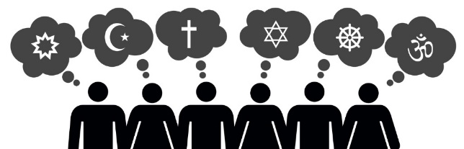
Year 9 Tier 3 RS Vocabulary words
Christianity
Omnipotent: having great power and influence.
Benevolent: well-meaning and kindly.
Omnipresent: God is present everywhere at the same time.
Trinity: The three persons of the Christian Godhead; Father, Son, and Holy Spirit.
Liturgical worship: a church service that follows a set structure or ritual.
Non-liturgical worship: a service that does not follow a set text or ritual.
Informal worship: a type of non-liturgical worship, sometimes ‘spontaneous’ or ‘charismatic’ in nature.
Private worship: when a believer praises or honours God on his or her own.
Betrayal: an act of betraying someone or something.
Denial: the refusal of something requested or desired.
Eucharist: the Christian service, ceremony, or sacrament commemorating the last supper, in which bread and wine are consecrated and consumed.
Passover: a Jewish festival where they remember being set free from Egyptian slavery. This is celebrated today by Jews all over the world with a special meal.
Disciples: One of the 12 personal followers of Christ.
Resurrection: 1. rising from the dead. 2. Jesus rising from the dead on Easter Sunday. An event recorded in all four gospels and the central belief of Christianity.
Heaven: a state of eternal happiness in the presence of God; the place of eternal peace ruled over by God.
Hell: the place of eternal suffering or the state of being without God.
Purgatory: the intermediate state where the soul are cleansed in order to enter heaven.
Satan: name for the Devil – the power and source of evil.
Moral evil and suffering- this is suffering caused by the actions of humans. Examples include acts of murder, and war.
Natural evil and suffering- this is suffering that is caused by nature and has nothing to do with the actions of humans. Examples include earthquakes, floods, tsunamis, and disease.
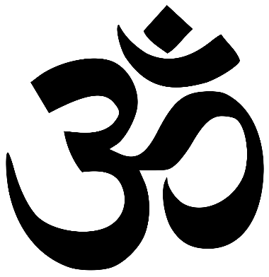
Diwali

Diwali: a Hindu festival with lights, held in the period October to November. It is particularly associated with Lakshmi, the goddess of prosperity, and marks the beginning of the financial year in India.

Hindi: an Indic language of northern India,
Deepawali: means a row of lights. The name Diwali evolved from Deepa – meaning lamp and vali meaning row.

Diya: means earthern oil lamp which is lit up during Diwali.

Rangoli: coloured sand designs made on the floor as part of Diwali decoration.

Toran: garland of flowers used to decorate doors and vehicles.

Dhanteras: the day of Diwali that is celebrated by businessman as the day of starting their new financial year. Gold is also bought on this day.

Laxmi pooja: Laxmi is the Hindu goddess of prosperity and wealth. She is worshipped through a special ceremony called pooja in order to receive her blessings

Bhai Dooj: it is a celebration of siblings where the brother is made to feel special by the sister, gifts are exchanged.

Saree: the traditional Indian garment is draped by women on Diwali.

Salwar kameez: is another traditional dress worn by women on Diwali.

Kurta: is the traditional garment worn by men on Diwali.

Judaism
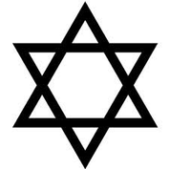
Monotheism: The belief in one God.
Omnipresent: God is always present.
Omniscient: God is all knowing.
Omnipotent: God is all powerful.
Gan Eden: Paradise or heaven.
Rabbi: Jewish leader
Shabbat: The holy day of the week from sunset on Friday to Saturday night.
Messiah: The anointed one, yet to come, who will bring in a time of peace and harmony.
Orthodox Jews: Jews who follow the rules in the Torah very strictly.
Reform Jews: Modern Jews- adapts to contemporary life.
G-d: This is how many Jews write God as a sign of respect.
Covenant: An agreement between two parties.
Talmud: A collection of Jewish Law.
Blasphemy: the action or offence of speaking sacrilegiously about God or sacred things.
Mitzvot: are commandments, traditionally understood to come from God and to be intended for the Jewish people to observe.
Torah: the law of God as revealed to Moses and recorded in the first five books of the Hebrew scriptures.
Covenant: an agreement between God and the Jews.
Decalogue: The 10 commandments.
Prejudice: preconceived opinion that is not based on reason or actual experience.
Discrimination: the unjust or prejudicial treatment of different categories of people, especially on the grounds of race, age, or sex.
Persecution: is the act of harassing or oppressing a person or a group of people, especially because of their identity. Throughout history, people have faced persecution because of their religion, race, ethnicity, political beliefs, sexual orientation, and many other factors.
Antisemitism: Prejudice or discrimination against the Jews.

Civil Rights
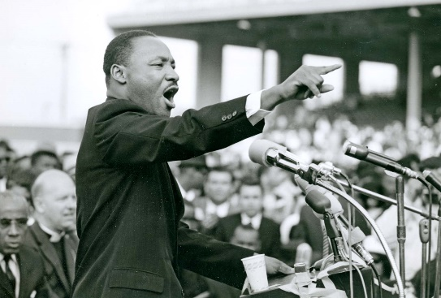
Discrimination: the unjust or prejudicial treatment of different categories of people, especially on the grounds of race, age, or sex.
Civil Rights Movement: a group protesting about the same things, with the same aims.
Segregation: The separation of facilities and living areas for black and white people.
Protest: to actively demonstrate (show) your disapproval about something.
Integration: The mixing of black and white people in state facilities.
Desegregation: A process to end segregation in public areas based on race.
Jim Crow Laws: These were laws passed to enforce segregation based on race. They allowed for separate schools, public transport, restaurants, and more based on race.
Suffrage: Suffrage is the right to vote in an election.
Apartheid: segregation on grounds other than race.
Oppression: The act of treating people in a cruel and unjust way.
Injustice: the practice of being unfair.
Boycott: the act of refusing to deal with someone to show disapproval.
Interposition: the action of a state whereby its power is placed between its citizens and the federal government.
Intimidation: the act of making fearful or deterring by threat.
Ordinance: laws set forth by a government authority.
Tyranny: oppressive power.

