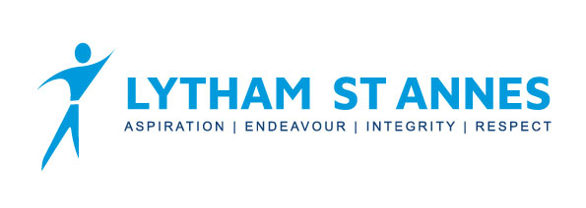
Yr10 French Curriculum Overview

 | Term 1 |  | Term 2 |  | Term 3
GCSE Theme | Theme 1 – Identity & culture | Theme 3 – Current & future study and employment | Theme 2 – Local, national, international & global areas of interest | Theme 1 – Identity & culture | Theme 1 – Identity & culture | All 3 themes
Sub topic | Free time & eating out | My studies & life at school | Travel & tourism | Relationships with family & friends  Marriage | Customs & festivals | Revision & exam skills
Assessment | Listening  Reading  Writing |  | Listening  Reading  Writing |  | Listening  Speaking  Reading  Writing

Yr10 German Curriculum Overview

 | Term 1 |  | Term 2 |  | Term 3
GCSE Theme | Theme 1 – Identity & culture | Theme 3 – Current & future study and employment | Theme 2 – Local, national, international & global areas of interest | Theme 1 – Identity & culture | Theme 1 – Identity & culture | All 3 themes
Sub topic | Free time & eating out | My studies & life at school | Travel & tourism | Relationships with family & friends  Marriage | Customs & festivals | Revision & exam skills
Assessment | Listening  Reading  Writing |  | Listening  Reading  Writing |  | Listening  Speaking  Reading  Writing

